SANGFOR VPN
Tunnel NAT and Tunnel Routing
Guide

SANGFOR Technologies Co., Ltd.
19.Oct 2019


Sangfor VPN Tunnel NAT and Tunnel Routing Guide
Sangfor VPN Tunnel NAT and Tunnel Routing Guide 2
1. Requirement Confirm 3
2. Solution Analysis 3
3. Sangfor Solution: Tunnel NAT & Tunnel Routing 4
4. Configuration Step 4
4.1 HQ side: 4
4.2 Branch side: 4
5. Detail Configurations 5
5.1 HQ side: 5
5.2 Branch Side: 7

1. Requirement Confirm
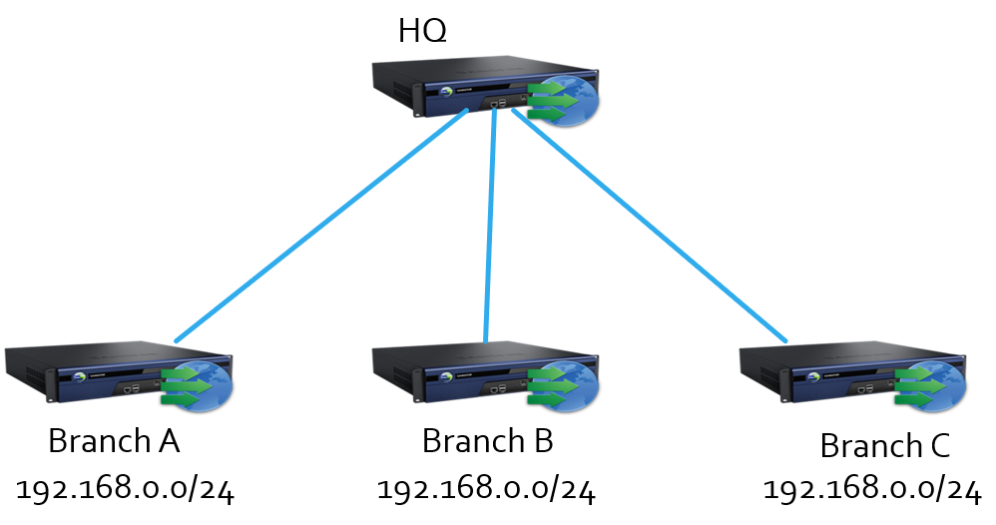
- Branch A/B/C has the same segment, but Branch need to visit HQ server
- Branch A/B/C need to visit each other
- Customer don’t want to change branch network segment

2. Solution Analysis
- Due to standard IPSec VPN requires set both side network segment, then automatic generate a routing to VPN tunnel. If two side has the same network segment, the VPN tunnel will can’t be built.
- If branch subnet is the same with HQ, no solution.

Sangfor Solution: Tunnel NAT & Tunnel Routing
Tunnel NAT Introduction:
NAT branch IP to a virtual IP in VPN tunnel, used for branches have network conflict issue but need to visit HQ scenario.
Tunnel Routing Introduction:
Used for branches can’t build VPN tunnel directly but branches have a same VPN service side and need to visit each other scenario, branches can visit each other via VPN service side.
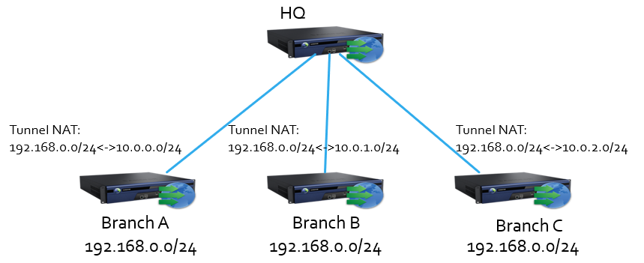
- When HQ server receive requests from 10.0.0.10, we know the real requests from Branch A 192.168.0.10.
- HQ users are able to visit Branch B server 192.168.0.11 by 10.0.1.11
- Branch A user 192.168.0.12 and Branch C user 192.168.0.12 visit each other by 10.0.0.12 and 10.0.2.12

Configuration Step

4.1 HQ side:
- Set Webagent
- Set VPN local subnet (If HQ has multiple network segment)
- Set virtual IP pool
- Create VPN user for branch and set tunnel NAT

4.2 Branch side:
- Build VPN connections
- Set VPN local subnet (If branch has multiple network segment)
- Set Tunnel routing (If branches need to visit each other)

Detail Configurations
(The configuration may in different page in different software version, this guide based on V9.5.1)

5.1 HQ side:
- Set Webagent used for branches find VPN service IP and port
Format:
IP:4009
IP#IP:4009
webagent.sangfor.com/xxxx/xxxx (Dynamic IP scenario)
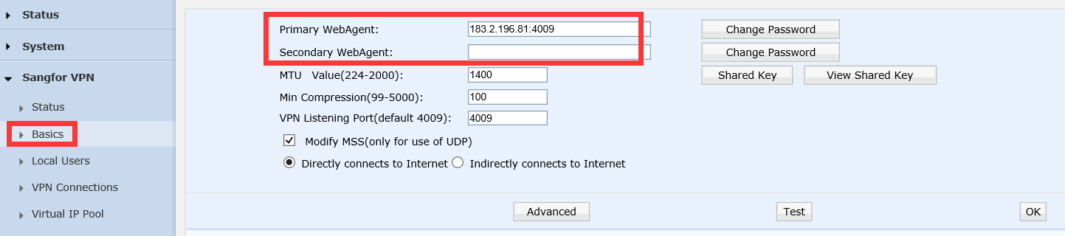
- Set VPN local subnet
Just like standard IPSec VPN Phase 2 local subnet, if site no multiple segment, no need this step.
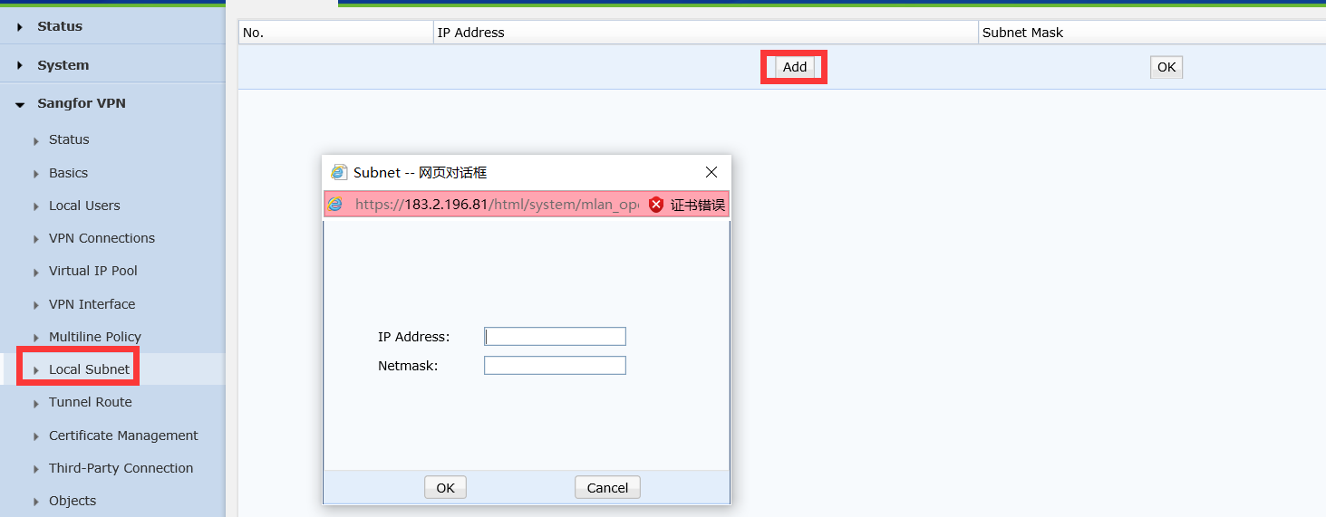

- Set Virtual IP pool
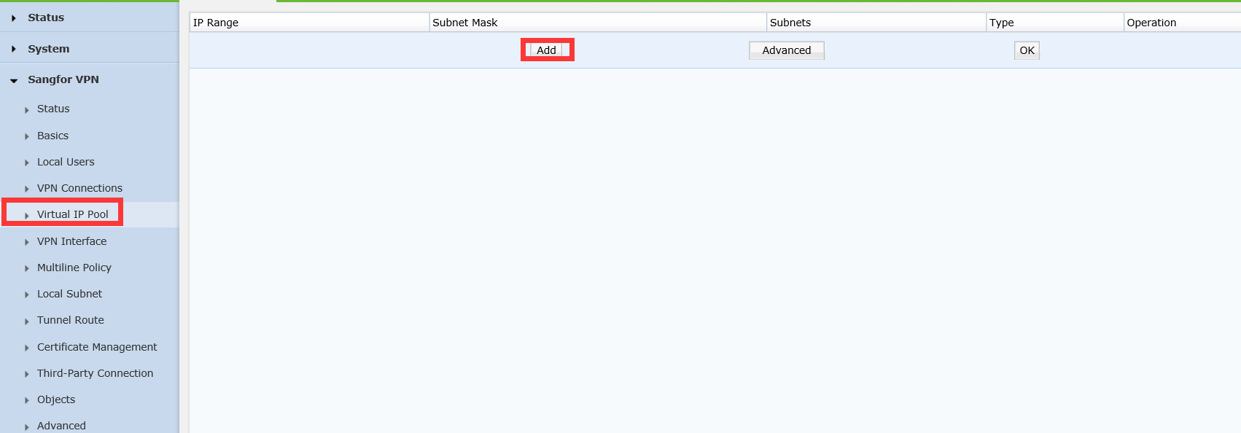
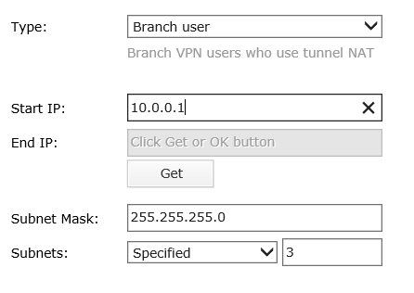
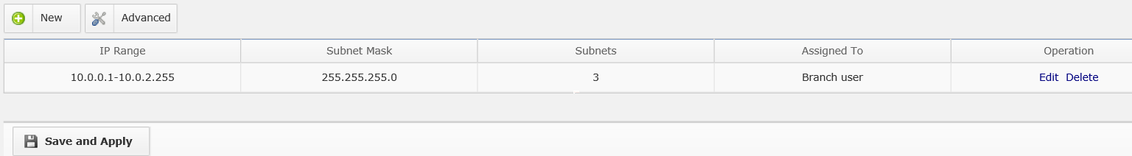

- Create VPN user for branch and set tunnel NAT
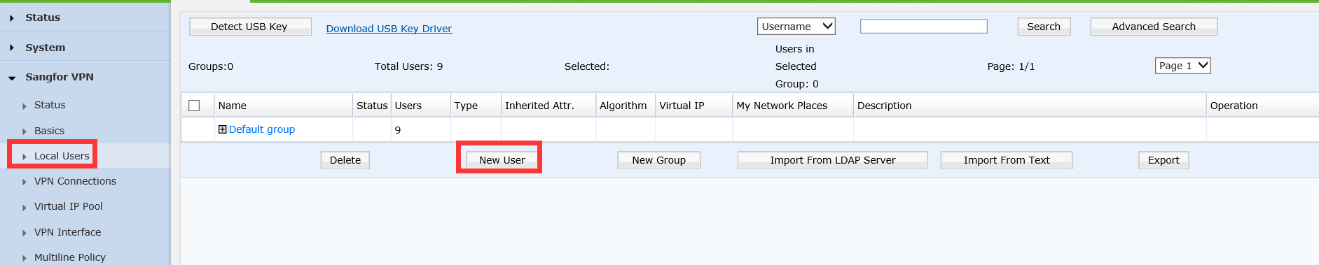
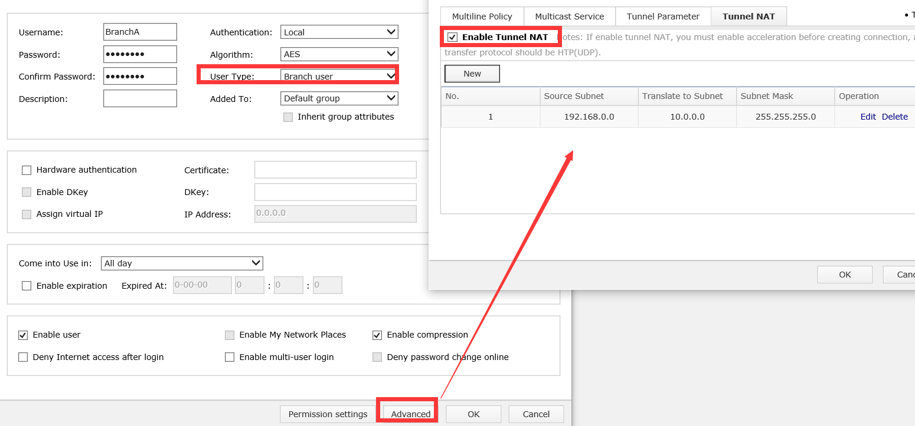

5.2 Branch Side:
- Build VPN connections
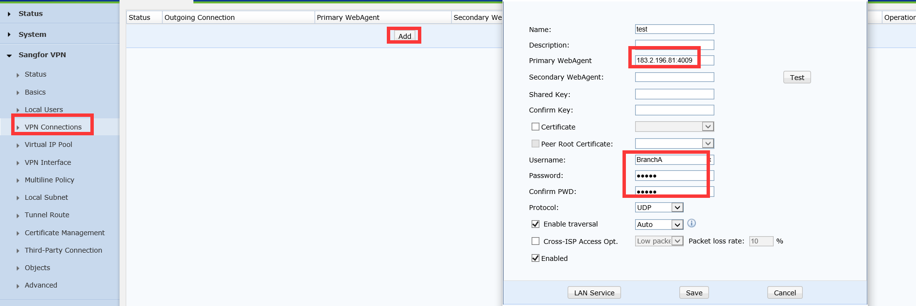
- Set VPN local subnet
Just like standard IPSec VPN Phase 2 local subnet, if site no multiple segment, no need this step.

- Set Tunnel routing
(If Branch A just only need to visit HQ, no need to visit each other, don’t need to set Tunnel routing)


