



Sangfor SD-WAN Proposal
For XXX

Sangfor Technologies Co., Ltd.
October 16, 2019


Copyright Statement
Copyright © SANGFOR Technologies Co., Ltd. All rights of interpreting and modifying this document and the Copyright Statement therein are reserved by the company.
The copyright and other related rights of any description, document format, figures, pictures, methods, and procedures in this document belong to SANGFOR unless otherwise specified. No part of this document may be reproduced, extracted, backed up, modified, transmitted, or translated in any form or by any means for partial or full commercial use without prior written consent of SANGFOR.
Disclaimer
This document is only used to provide information for end users. The information in this document may be subject to change without notice.
While every effort is made to ensure that the information provided in this document is accurate and reliable, SANGFOR disclaims any liability for damage or loss that may be caused as a result of any inaccuracy, error or omission in this document.
Feedback
For any suggestions, please contact us by any of the following means:
Address: Block A1,Nanshan iPark,No.1001 Xueyuan Road,Nanshan District,
Shenzhen,Guangdong Province,P.R.China(518055).
Hotline: +60 12711 7129 (7511)
Email: sales@sangfor.com/marketing@sangfor.com
Latest technology and product information is available at the official website of SANGFOR: www.sangfor.com.

Contents
Chapter 1: Preface 2
Chapter 2: Solution Overview 2
Chapter 3: Components Overview 2
3.1 Sangfor WANO (WAN Optimization) 2
3.2 Sangfor Central Manager/Branch Business Center (Optional) 3
Chapter 4: Proposed Solution 3
Chapter 5: Solution detail introduction 5
5.1 Quickly Build Reliable Connectivity 5
5.2 Smart WAN Network 5
5.2.1 Dynamic Path Selection 5
5.2.2 Automatic Fail-over 6
5.2.3 VPN Tunnel Bonding 6
5.3 Optimize Your User Application Experience 6
5.3.1 Data Reduction 7
5.3.2 Application Acceleration 8
5.3.3 Link Optimization 9
5.4 Maximize Bandwidth Values 10
5.4 Comprehensive Reporting and Visualization 10
Chapter 6: About Sangfor 12

Chapter 1: Preface
First of all we would like to thank XXX for giving us an opportunity to propose Sangfor SD-WAN solution. We strongly believe this solution enhance the productivity, improve the reliability and simplify O&M of the branch access network XXX has invested for.

Chapter 2: Solution Overview
SD-WAN is an acronym for software-defined (SD) networking in a wide area network (WAN). SD-WAN simplifies the management and operation of a WAN by decoupling the networking hardware from its control mechanism, an invaluable tool for branch network access of multi-branch enterprises and multi-level organizations.
Sangfor SD-WAN is based on Sangfor’s leading VPN technology, integrated security, WAN optimization and superior virtualization technology. Sangfor’s SD-WAN is designed to build a 3S branch access network for enterprise, making IT architecture simple, smart, speedy, helping enterprises increase productivity, reduce costs and speed up their digital transformation.

Chapter 3: Components Overview
  - Sangfor WANO (WAN Optimization)
- Build secure tunnels between branches to Data center.
- Dynamic path selection in multiple tunnels/WAN make the best of different WAN links.
- Automatic fail-over when some link failure to improve business reliability.
- Acceleration and optimization in WAN to enhance link throughput, improve user application experience, increase productivity.
- Bandwidth management on application or user based on priority to maximize bandwidth values.

  - Sangfor Central Manager/Branch Business Center (Optional)
- Email deployment to simplify deployment.
- Full visualization for all branches.
- Unified policy management to simplify policy update work.

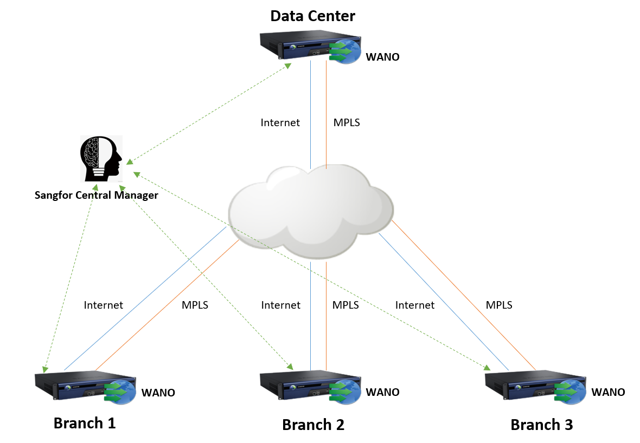
Chapter 4: Proposed Solution
Above are the proposed deployment of Sangfor SD-WAN in XXX.
The idea of proposal is Sangfor WANO support flexible deployment, Gateway mode with full function, bridge mode without any network changes and support hardware bypass, arm mode with zero down time. Sangfor WANO will builds both VPN and acceleration tunnels over internet and MPLS link, VPN tunnels used for data encryption and path selection, acceleration tunnels used for link optimization and data reduction. Besides Sangfor WANO provides access control and bandwidth management features to control user behaviors and bandwidth usage.
Sangfor Central Manager used for monitor and manage all branches, decrease large-scale branches operation and management difficulties.

The values of proposed solution are as below:
- Email deployment reduce deployment cycle and costs.
- VPN tunnels protect data transmission security
- Critical apps traffic always running in optimal link
- Automatic fail-over improve business reliability
- Optimized internal traffic of commonly used application from web, email to file transfer
- Business traffic has priority to use bandwidth.
- Simplify branches O&M

Chapter 5: Solution detail introduction
  - Quickly Build Reliable Connectivity
Sangfor WANO not only support built-in IPSEC VPN with other brand products, public cloud, but also has its own patented Sangfor VPN, quickly build connections with Sangfor network and security products with simple configurations. Based on link QoE (packet loss rate/latency/jitter) detection, Sangfor VPN supports critical applications by dynamically choosing the best quality link and fail-over without any user perception, improving business availability when the WAN link down. Deployment is easier and more cost effective when integrated with Sangfor Central Manager (SCM). Email deployment feature makes deployment easy for anyone in branch offices without the need for on-site engineers, thus
reducing cost and online business cycle.
  - Smart WAN Network
    - Dynamic Path Selection
Automatic link quality detection based on packets loss, latency and jitter, dynamically chooses the best quality link for critical application traffic, guaranteeing an optimal critical application user experience.
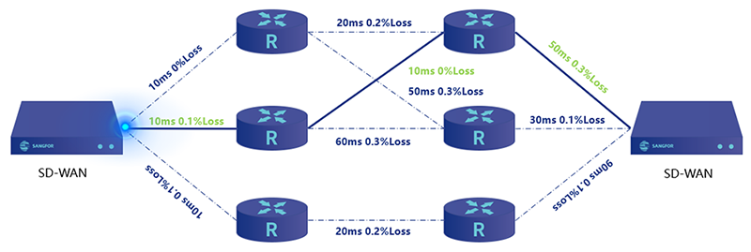

5.2.2 Automatic Fail-over
SD-WAN provides automatic, imperceptible fail-over in the event of link failure, dramatically improving business availability.
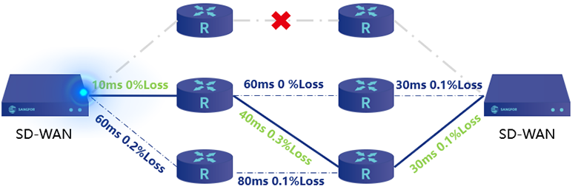
    - VPN Tunnel Bonding
SD-WAN bonds all WAN links as a resource pool and performs data load balancing on multiple WAN links, breaking through the single WAN bandwidth limitation and maximizing link utilization.
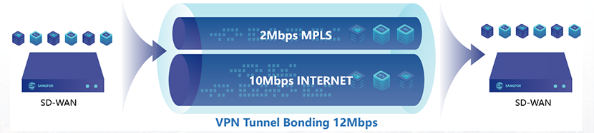
  - Optimize Your User Application Experience
Most business applications perform well on LAN, yet they don’t operate or transmit efficiently on WAN due to bandwidth constraints, protocol limitations and latency. Businesses often resort to upgrading their bandwidth to solve this problem, usually with less than effective results. With the deployment of Sangfor WAN, headquarters, branch offices and partners in different locations can experience accelerated network performance where business-critical applications aren’t hindered and data exchange is immediate. All told, Sangfor WAN provides a LAN-like experience over WAN.
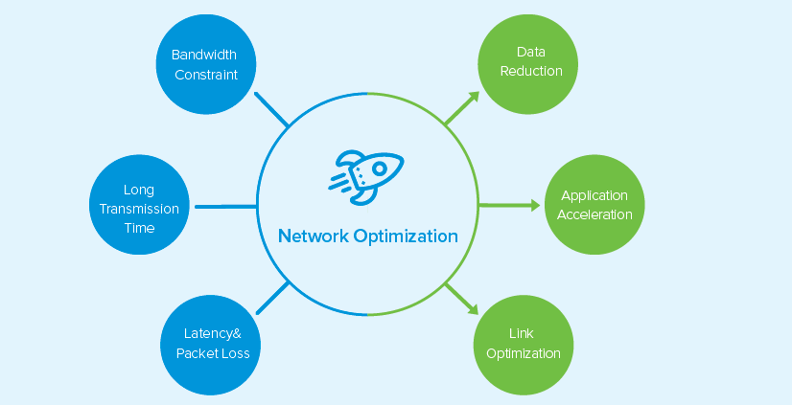

5.3.1 Data Reduction
Sangfor WANO uses leading Byte Cache Technology, allowing deduplication of data across WAN on subsequent transmissions. Once data is transmitted from one end to the other, it is cashed at byte level.
As we know, different compression algorithms have different compression efficiency for different data. A single compression algorithm is unable to achieve a maximum compression ratio. Equipped with 3 built-in compression algorithms and dynamic compression technology, Sangfor WANO and substantially minimize the amount of data transmission.
WANO also eliminates redundant data transmission which can occupy up to 95% of WAN trac, delivering cashed data at LAN speed!
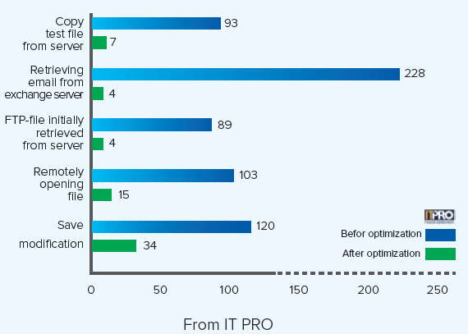

5.3.2 Application Acceleration
Sangfor acceleration technology is based on TCP acceleration technology which can accelerate virtually any application.
Sangfor application acceleration is specially designed to accelerate the most critical business applications up to 10X, performing proxy to protocols of MAPI, HTTP/HTTPS, CIFS, Oracle, EBS, Citrix, RDP and SMTP. In addition it boosts the performance of a wide range of applications including
Exchange, SharePoint, ERP, CRM, Lotus Notes, Backup, SAP, Disaster Recovery and FTP.
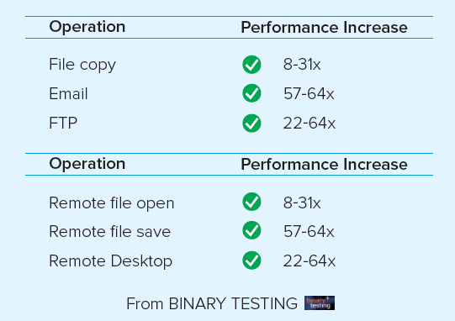

5.3.3 Link Optimization
HTP (High-Speed Transmission Protocol) technology is the equivalent of upgrading a dirt road to a highway. Based on the transmission layer, it improves link quality and transmission performance of applications, vastly improving user experience.
Sangfor WANO optimizes the TCP and UDP protocols, reducing the impact of latency and packet loss over long distance transmission.
HTP-TCP enhances WAN transmission by selective and quick re-transmission of lost packets, improving the efficiency of congestion control mechanisms in traditional TCP protocol and significantly boosting WAN link performance. HTP-UDP can also reduce UDP packet loss using two built-in algorithms; UDP Proxy and FEC Technologies, significantly improving transmission of UDP based applications like video conferencing.

  - Maximize Bandwidth Values
Where trac is uncontrolled, we find trac accidents and congestion. Branch user internet access is similar to road trac. Users playing online games, streaming videos or even accessing non-business-related sites within compliance occupies bandwidth with file sharing and P2P trac, causing poor performance of critical business applications.
Based on Sangfor’s +3000 application signature database and URL library of 10 million, Sangfor WANO is capable of intercepting non-compliant browsing activities and limiting unproductive trac. WANO’s effective trac management guarantees maximum core business application bandwidth and improves staff efficiency and productivity.
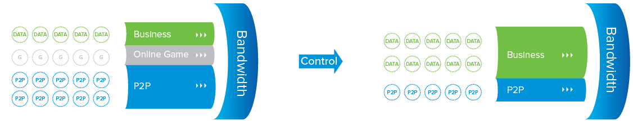

5.4 Comprehensive Reporting and Visualization
SANGFOR’s analytical reports enable IT managers to identify changing trends in network usage to better fine tune policies to match. The reports provide specific details by function and stores logs internally, but can export external syslog servers.
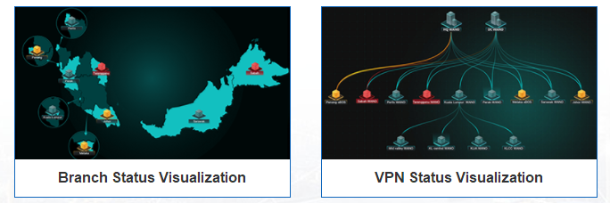
Displays live information on current traffic movement by application proxy and time segmented intervals. Easily see usage and statistical information to help empower system administrators take the right steps to manage bandwidth.
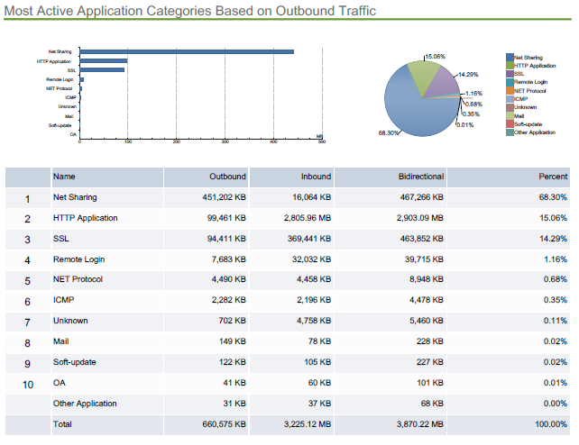
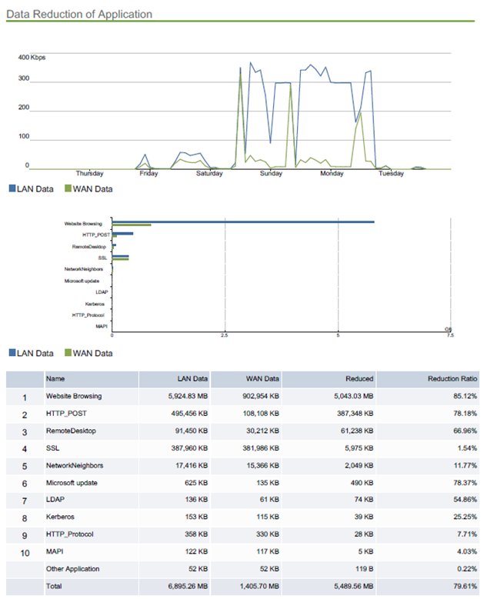
(Sample Report active application statistics)
(Sample Report data reduction statistics)

Chapter 6: About Sangfor
Sangfor Technologies is the leading and the most innovative vendor of network solutions in Asia. It is specialized in Virtualization, Network Security & Optimization with products including but not limited to: Virtual Desktop, Next Generation Firewall, Web Application Firewall, Internet Access Management, WAN Optimization, SSL & IPSec VPN and so on.
Through constant innovation, Sangfor always strives to create value for our customers by helping them achieve sustainable growth. We take customers’ business needs and user experience very seriously, placing them at the heart of our corporate strategy.
Established in 2000, Sangfor now has more than 55 branch offices in China and overseas (US, UK, Hong Kong, Malaysia, Thailand, Indonesia and Singapore). Sangfor currently has 2,300+ employees, with 40% of them dedicated to R&D. Furthermore, each year at least 20% of Sangfor’s revenue will be put into R&D to improve current products as well as develop new solutions for our customers.
Awards:
- “Technology Fast 500 Asia Pacific Region” Award for 8 consecutive years from 2005 to 2012 by Deloitte.
- “Best Companies to Work for in China” Award from 2009 to 2011 by the Fortune Magazine.
- “Best Practice Award in Asia-Pacific Region” in 2010 by Frost & Sullivan.
- “Management Action Award” in 2012 by Harvard Business Review.
- Sangfor SSL VPN no. 1 in Network Security market in China, Hong Kong & Taiwan according to Frost & Sullivan.
- No.1 for Secure Content Management Hardware and VPN Hardware segment in China according to IDC.
- Sangfor IAM listed for 5 consecutive years in the Gartner Magic Quadrant for Secure Web Gateways (2011- 2015).
- Sangfor WANO listed for 3 consecutive years in the Gartner Magic Quadrant for WAN Optimization (2013-2015).
- Sangfor NGFW listed in the Enterprise Network Firewalls Magic Quadrant by Gartner (2015).
- Reviewed by NSS Labs with a “Recommended” rating in 2014 for SANGFOR NGFW (WAF test).



