SD-WAN Demo Test Guide

(none-BBC version)

Content
SD-WAN Demo Test Guide 1
(none-BBC version) 1
1 Standardized Process: 3
2 Environment & Requirements Confirm 4
2.1 Environment: 4
2.2 Requirements: 4
3 Solution Design & Previous Preparation 4
3.1 Solution design: 5
3.2 Previous preparation: 5
4 Configuration 6
4.1 Configuration step: 6
4.2 Detail configuration: 6
4.2.1 Network 6
4.2.2 Multiple WAN Policy 7
4.2.3 VPN Configuration 9
4.2.4 SD-WAN Path Selection Policy 10
4.2.5 Acceleration Policy 11
5 Testing & troubleshooting 12
5.1 VPN Testing 12
5.2 SD-WAN path selection testing 14
5.2.1 JPerf tool introduction: 14
5.2.2 Specified line1 (line1 300Kb) 15
5.2.3 Specified line2 (line2 100Kb) 15
5.2.4 Fail-over test 16
5.2.5 VPN tunnel bonding test 17
5.2.6 Prefer the optimal path 17
5.2.7 Based on bandwidth ratio test 18
5.3 Acceleration testing 19
6 POC UAT & Conclusion 20

1 Standardized Process:
- Environment and requirements confirm
Refer to pre-poc check list
- Solution design & previous preparation
- Configuration
- Test & troubleshooting
- POC UAT and Conclusion

2 Environment & Requirements Confirm
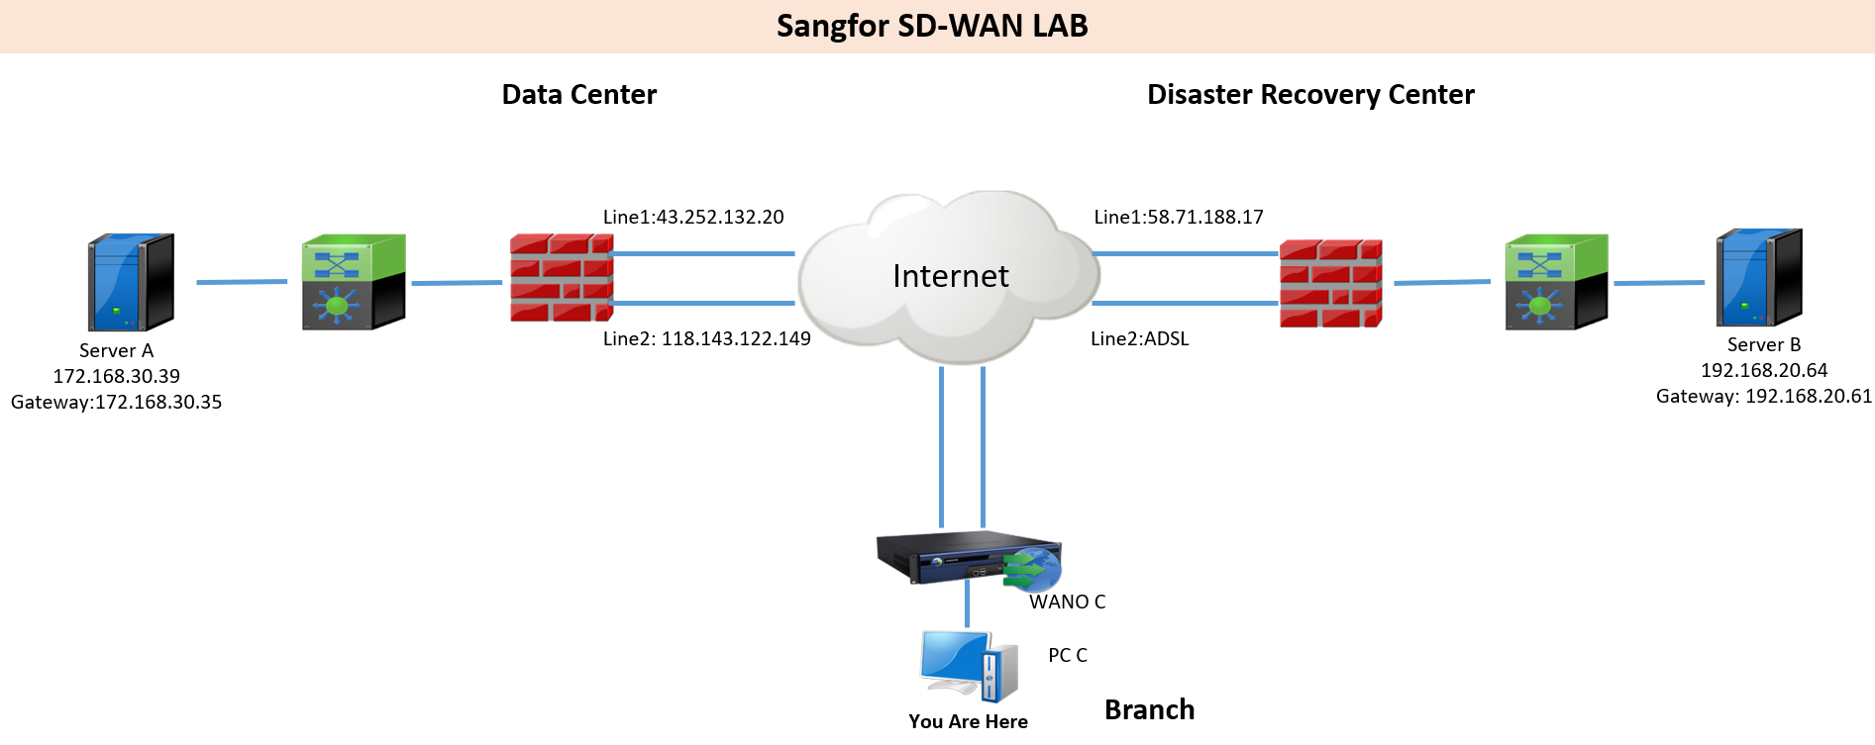

2.1 Environment:
Customer don’t want to replace any device and no down time to POC

2.2 Requirements:
- DC-DRC server can visit each other
- Improve server access speed
- Test line 1 access and line 2 backup
- Test automatic choose the optimal line to access
- Test bonding all WAN links to access

3 Solution Design & Previous Preparation
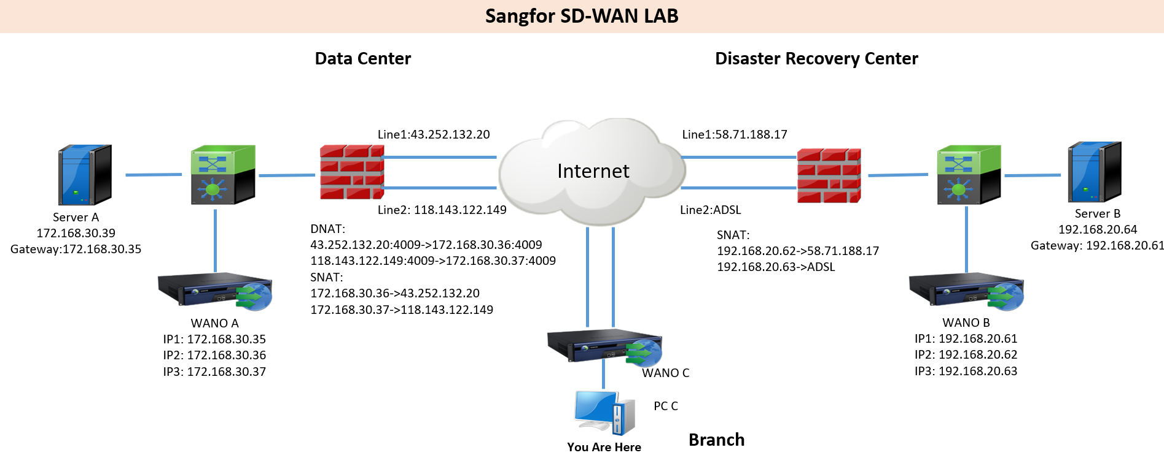

3.1 Solution design:
Customer don’t want to replace any device and no down time to POC
=> Single arm mode deployment

3.2 Previous preparation:
SD-WAN features require WANO version 9.5.3 or above
DC and DRC all have 2 lines, we need prepare 3 IPs for WANO in each site and bonding WANO IP with internet IP.
DC site WANO:
IP1: 172.168.30.35 (used for intranet traffic routing and device management)
IP2: 172.168.30.36 (bonding line1 43.252.132.20)
IP3: 172.168.30.37 (bonding line2 118.143.122.149)

DC site gateway previous preparation:
DNAT: (Both TCP & UDP 4009, used for branch WANO VPN access)
43.252.132.20:4009->172.168.30.36:4009
118.143.122.149:4009->172.168.30.37:4009
SNAT & Source policy-based routing: (Bonding WANO IP with internet IP)
172.168.30.36->43.252.132.20
172.168.30.37->118.143.122.149

DC site gateway or core switch previous preparation:
Add a static route or policy-based routing
Destination network 192.168.20.0/24 Next-Hop 172.168.30.35

DRC site WANO:
IP1: 192.168.20.61 (used for intranet traffic routing and device management)
IP2: 192.168.20.62 (bonding line1 58.71.188.17)
IP3: 192.168.20.63 (bonding line2 PPPoE IP)

DRC site gateway previous preparation:
SNAT & Source policy-based routing: (Bonding WANO IP with internet IP)
192.168.20.62->58.71.188.17
192.168.20.63->ADSL

DRC site gateway or core switch previous preparation:
Add a static route or policy-based routing
Destination network 172.168.30.0/24 Next-Hop 192.168.20.61

4 Configuration

4.1 Configuration step:
- Network
- Multiple WAN Policy
- VPN Configuration
- SD-WAN Path Selection Policy
- Acceleration Policy

4.2 Detail configuration:

4.2.1 Network
DC:
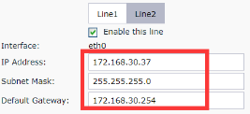
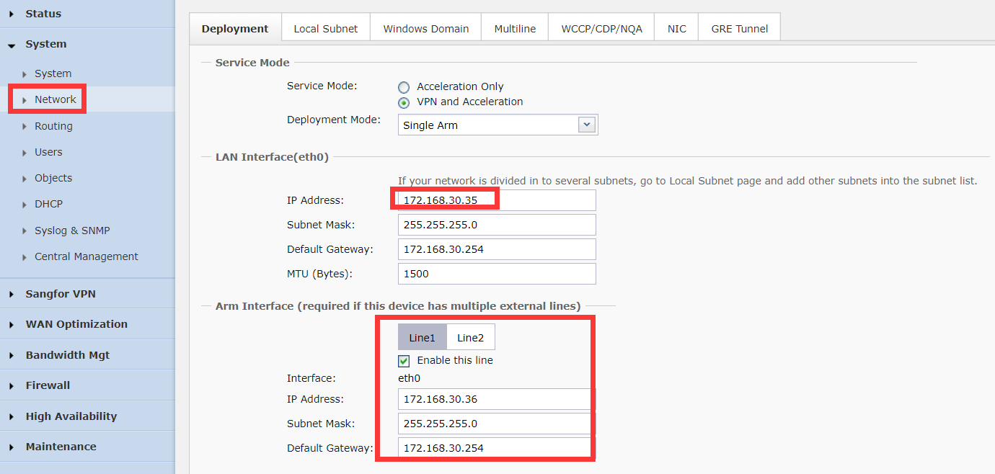
DRC:
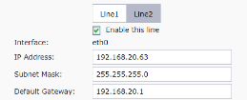
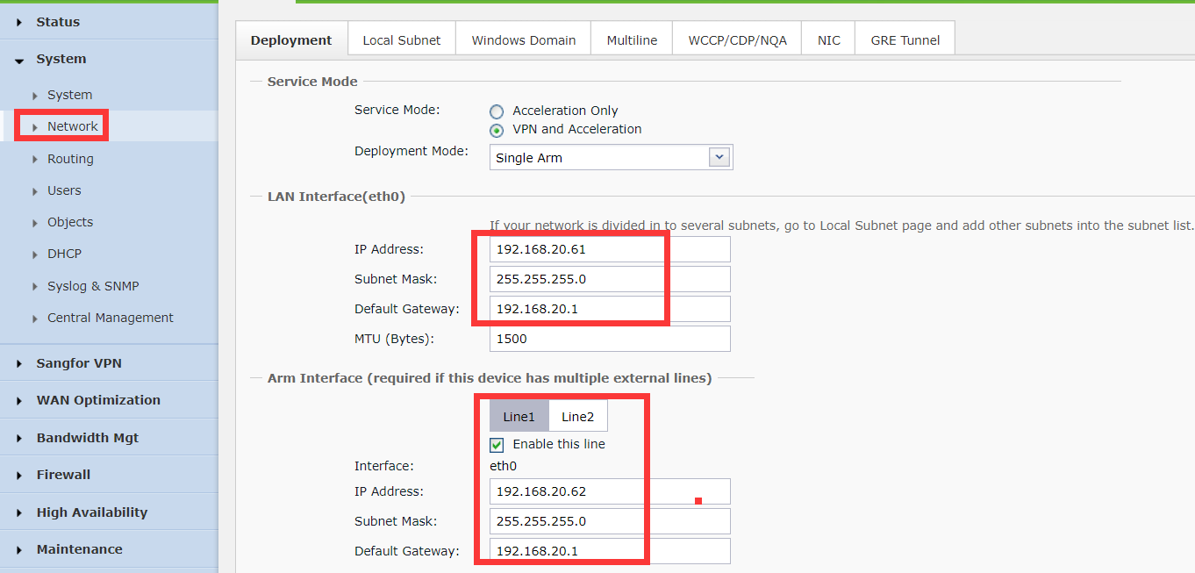

4.2.2 Multiple WAN Policy
DC:
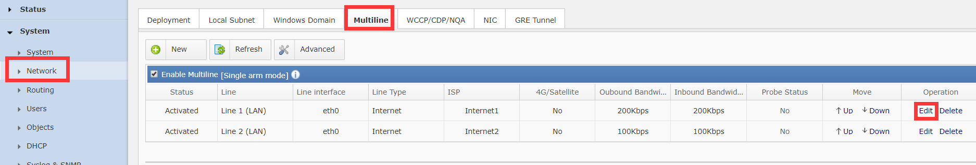
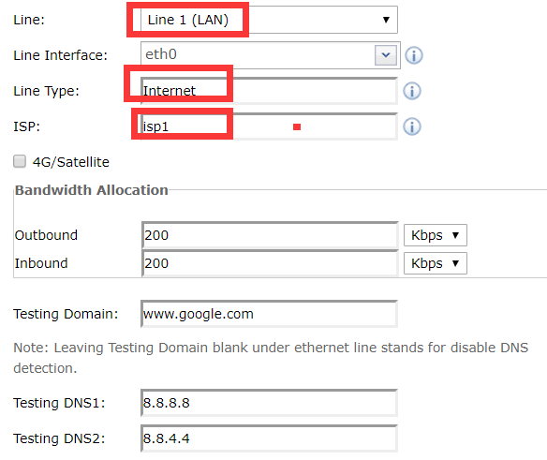
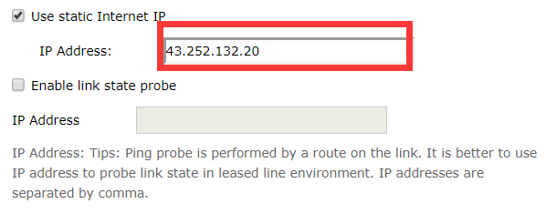
(If line is PPPoE and no static internet IP, don’t check ‘use static internet IP’)

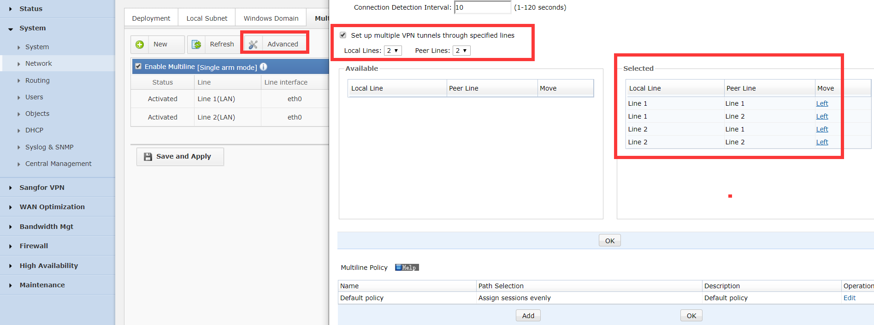
(For this test, all lines are internet, we can select all pairs and build 2*2 tunnels, in some case, customer has both MPLS and Internet, we need un-select MPLS-Internet)
DRC:
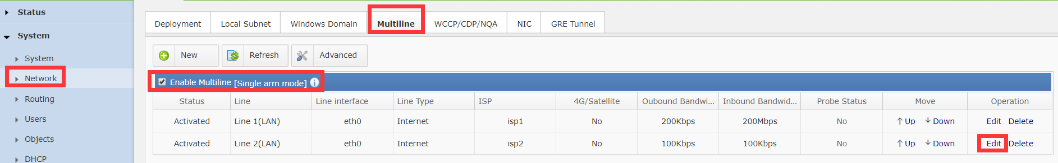
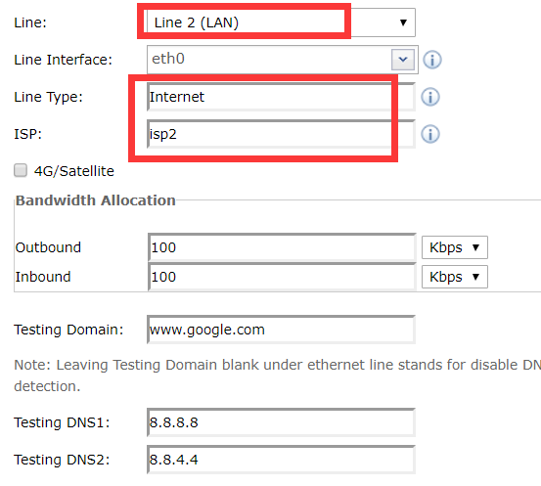
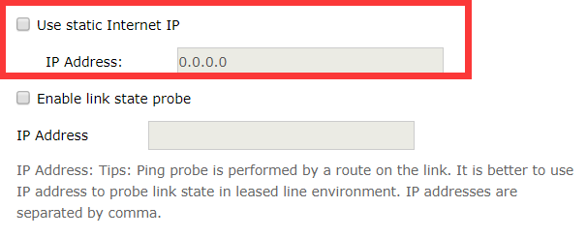
(Line 2 is PPPoE, no static IP)

4.2.3 VPN Configuration
DC:
Only VPN service site need to set webagent,
ip#ip#ip:4009 or primary & secondary webagent,
dynamic IP call TAC apply dynamic webagent
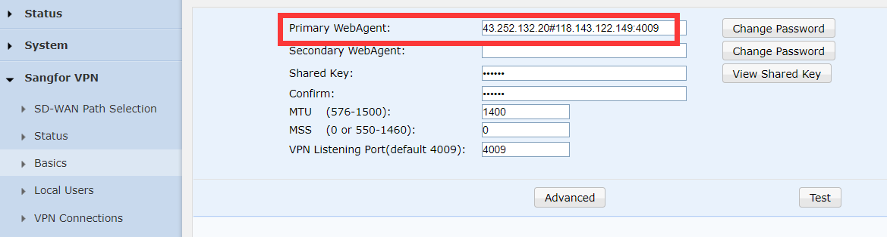
Create user for DRC
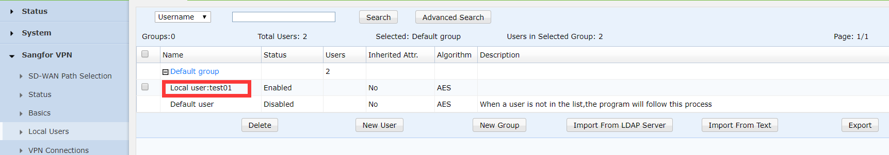
DRC:
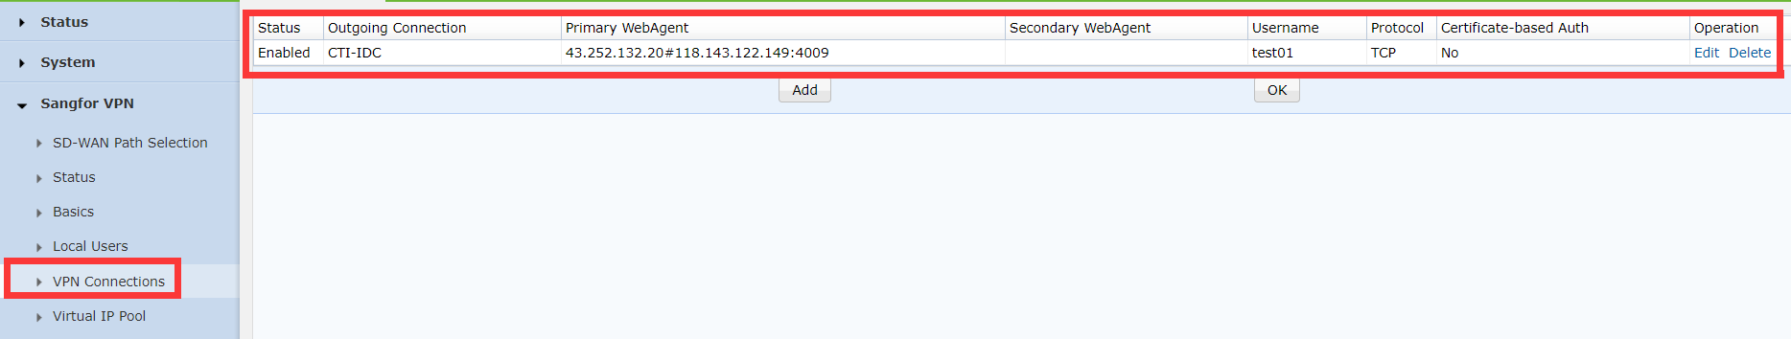

4.2.4 SD-WAN Path Selection Policy
(If there is no server in branch or drc, just only no need to set sd-wan path selection policy in DC, because traffic branch/DRC->DC match branch/DRC policy, for packets return from DC->branch/DRC will choose the original path)
DC:
Specified Line and other line backup
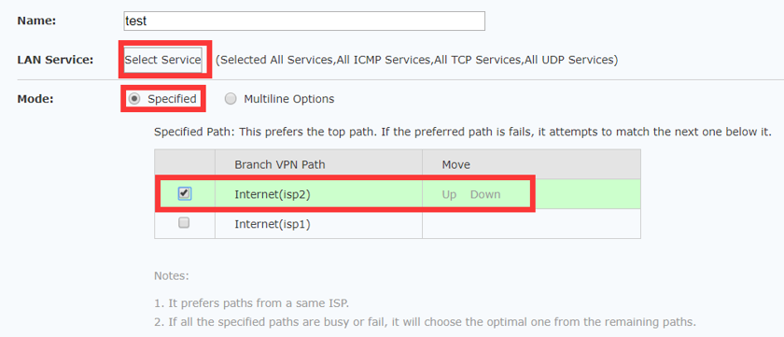
VPN tunnel bonding
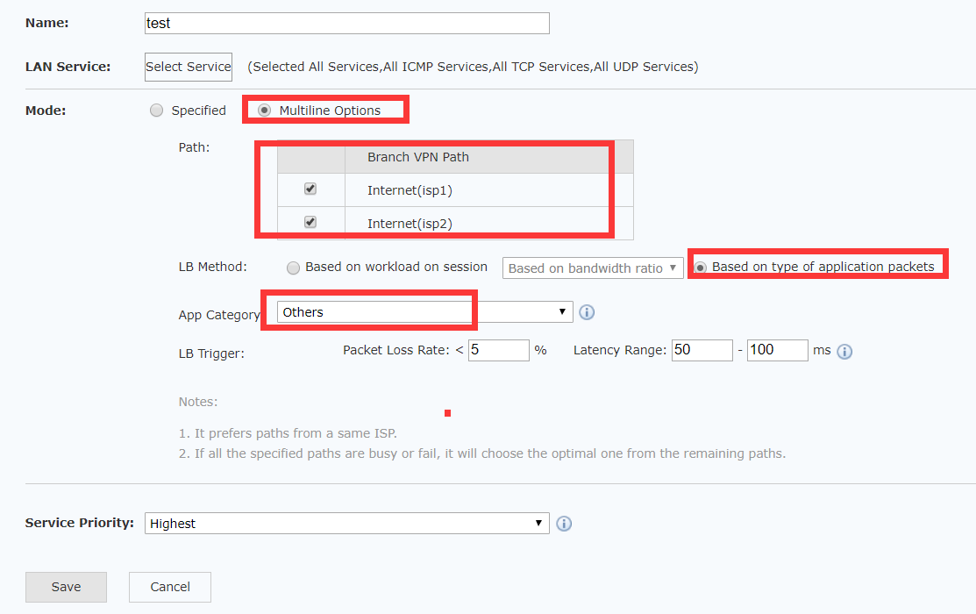
Automatic choose the optimal path
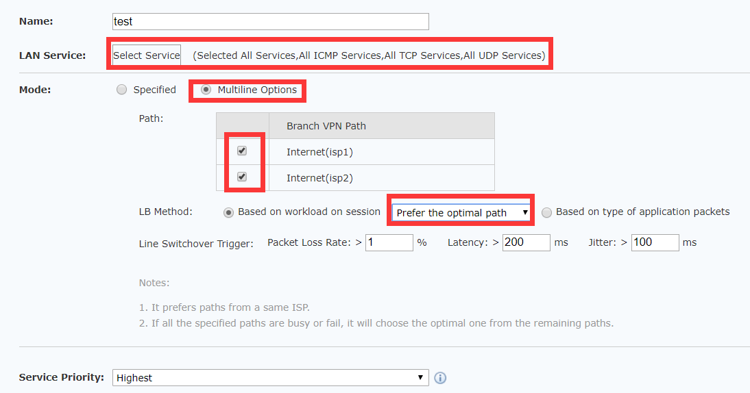
Based on bandwidth ratio
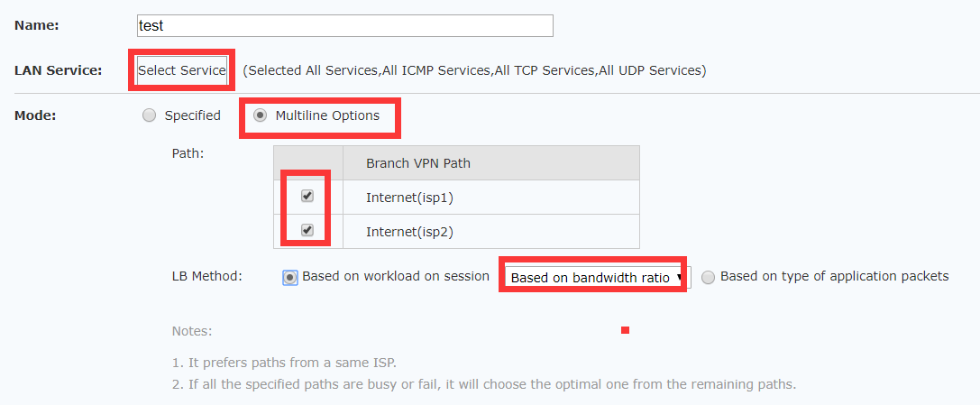

4.2.5 Acceleration Policy
DC:
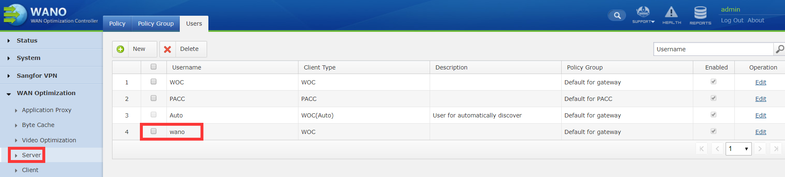
DRC:
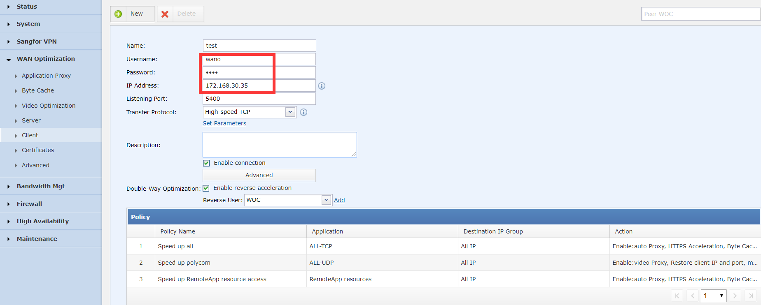

5 Testing & troubleshooting

5.1 VPN Testing
VPN status check:
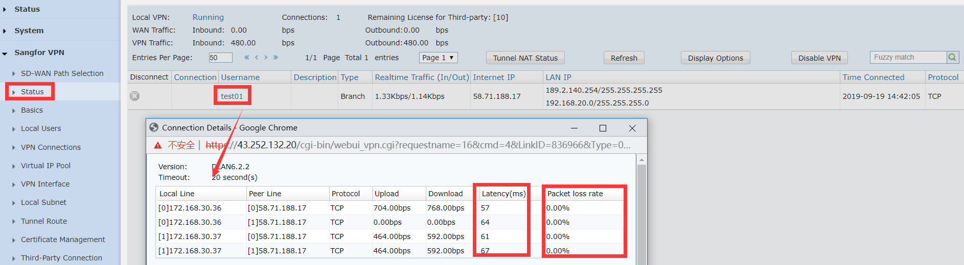
Reachable test:
Test ping or business access from user to server
Quality test:
- Test ping or user experience of business
- VPN speed test tool
Server side:
(1) Allow traffic: iptables -A INPUT -p tcp --dport 4008 -j ACCEPT
(2) Start service: conn_test_server -p 4008
(3) Close port after testing:
iptables -D INPUT -p tcp --dport 4008 -j ACCEPT
Client side:
(1) Start testing: conn_test_client -p 4008 -i xxx.xxx.xxx.xxx -c 100

Troubleshooting:
- Can’t build VPN tunnel
- VPN service port (default 4009) UDP & TCP reachable
(telnet test TCP port, capture packets in service side test UDP port)
- Check webagent & VPN username password
- Check VPN logs in both side device
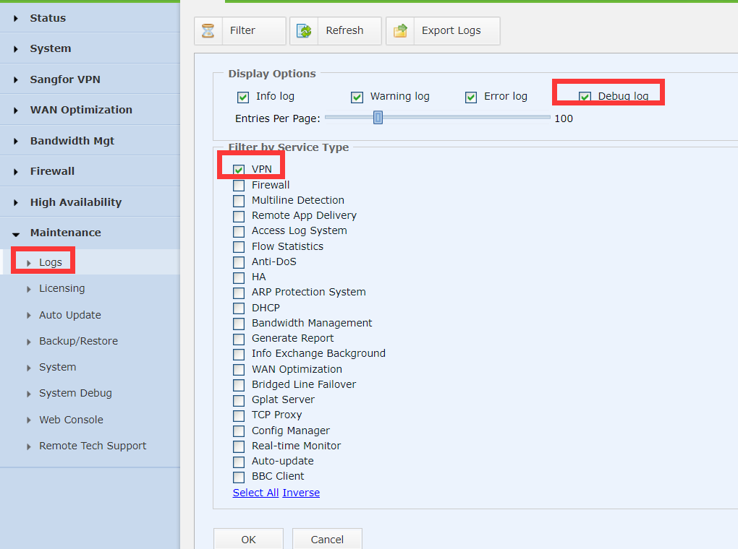
- VPN is unstable issue
- Latency & packets loss testing
(ping HQ public IP, intranet IP and internet public IP 8.8.8.8 from branch to HQ and HQ to branch)
- Change transmission protocol in vpn client side
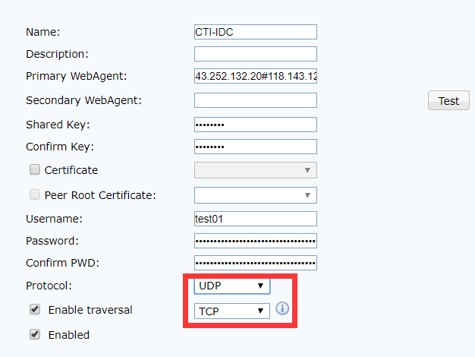
(In packets loss environment, TCP protocol may has high latency issue, UDP protocol may has high packets loss issue)

- Some user can’t visit some server
- Check both side VPN local subnet
- Check both side route to destination IP address
- Capture packets in both side vpntun/eth0 interface

4. VPN tunnel number issue
a. Check Multiple WAN policy, back to multiple WAN policy
b. Whether some link can’t build VPN, back to issue 1

5.2 SD-WAN path selection testing
PC(Client)—WANO(Client)<------>WANO(Server)—PC(Server)
Just only adjust SD-WAN path selection policy in WANO(Client) and don’t require VPN service restart

5.2.1 JPerf tool introduction:
- Two side prepare a windows PC and PC install JAVA
- Server side run Jperf.bat then run jperf.jar start jperf
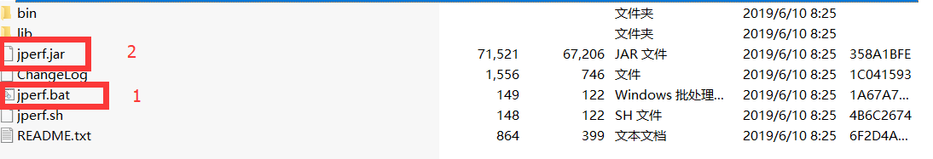
Choose Server and keep default configuration then to start JPerf.
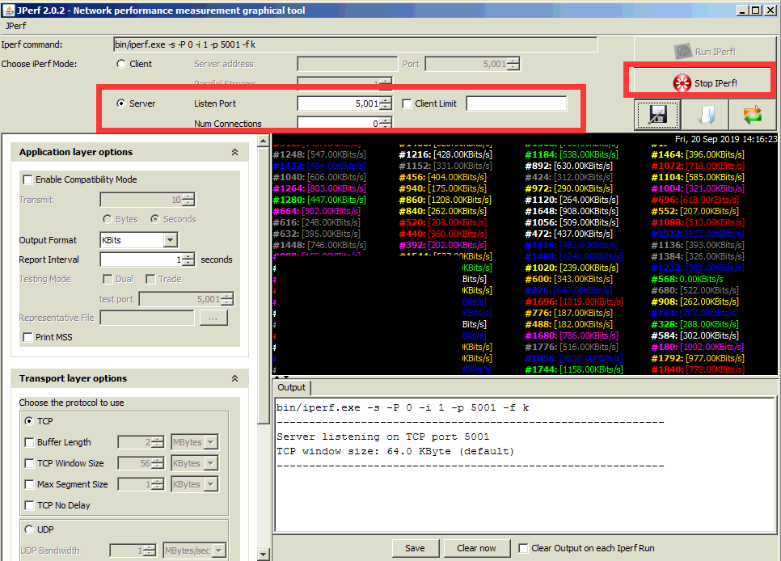
- Client side run Jperf.bat then run jperf.jar to start jperf
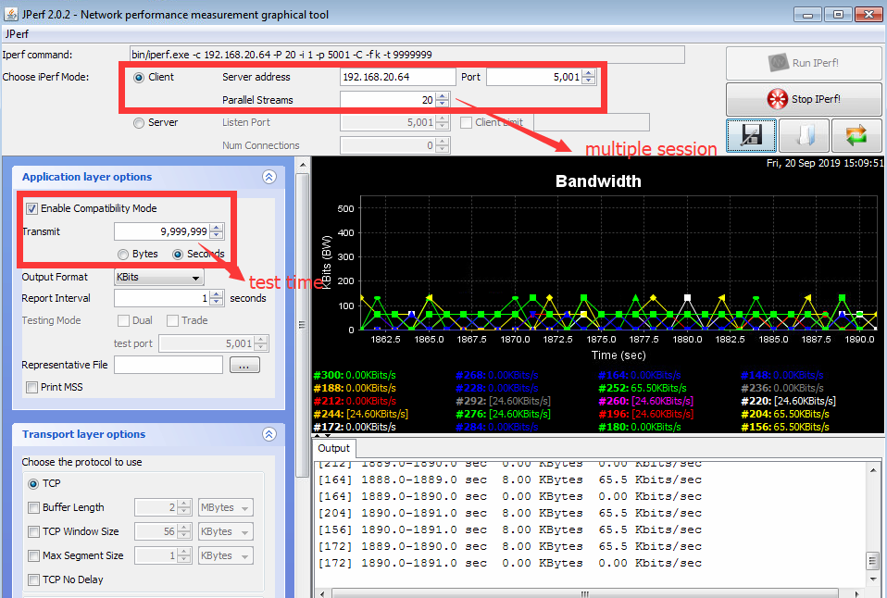

5.2.2 Specified line1 (line1 300Kb)
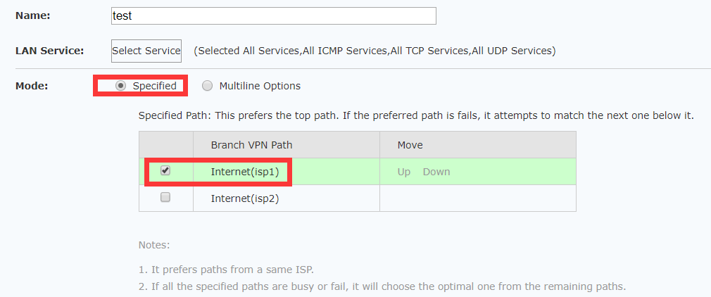
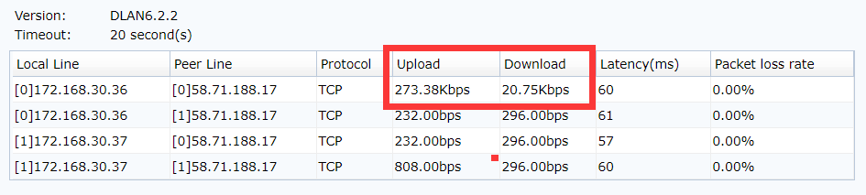
(Other line has little traffic is normal, because VPN tunnel need traffic to established)

5.2.3 Specified line2 (line2 100Kb)
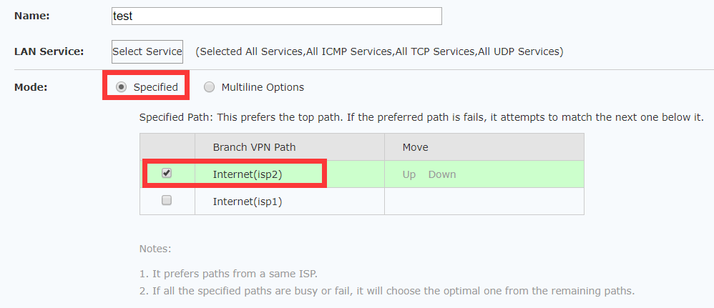
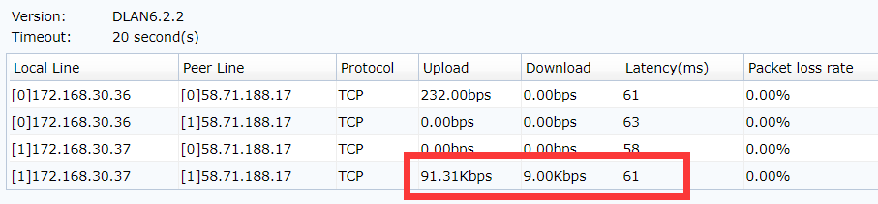

5.2.4 Fail-over test
Using pshell deny line 2 4009 port to disconnect line 2 when using specified line 2 policy.
（iptables -A INPUT -d 172.168.30.37 --dport 4009 -j DROP）
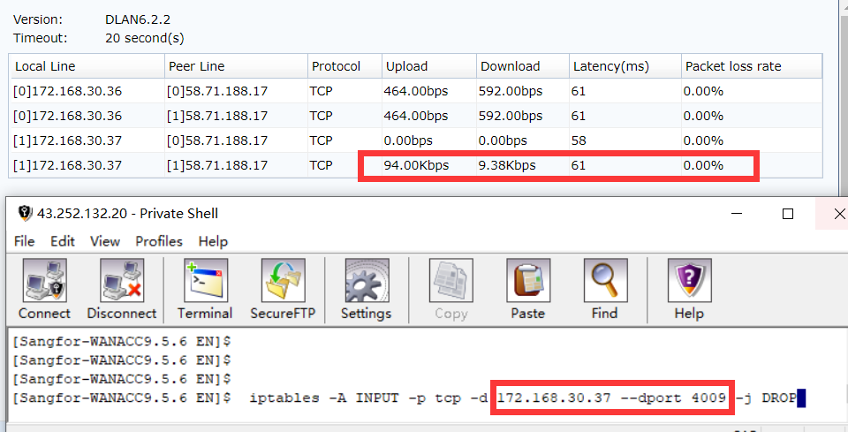
All vpn tunnels in line 2 are disconnect, traffic fail-over to line 1.
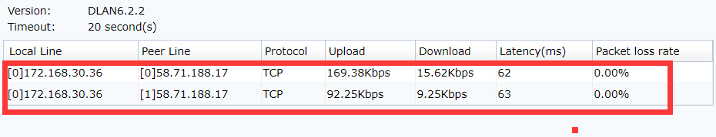
After fail-over test, we must restore iptables rules
（iptables -D INPUT -d 172.168.30.37 --dport 4009 -j DROP）
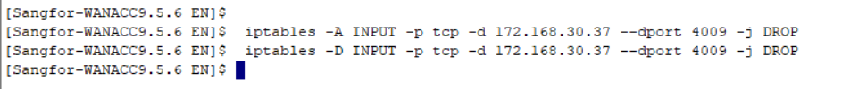

5.2.5 VPN tunnel bonding test
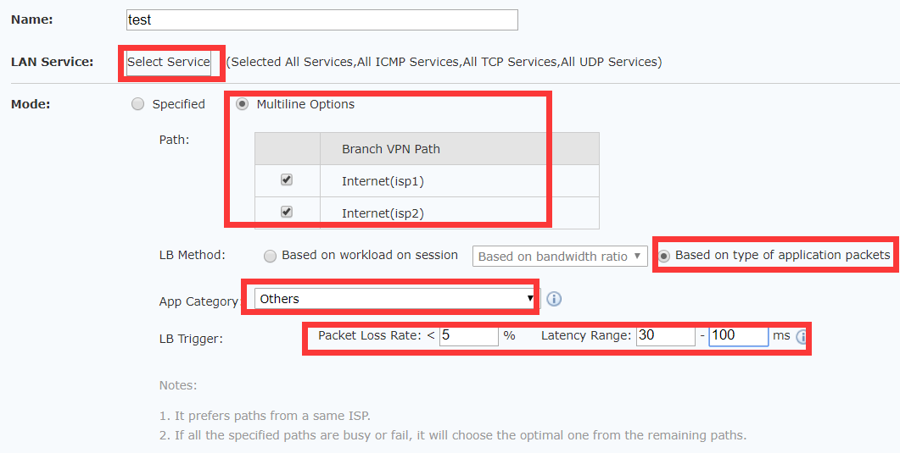

Line 1 300Kb, line 2 100Kb
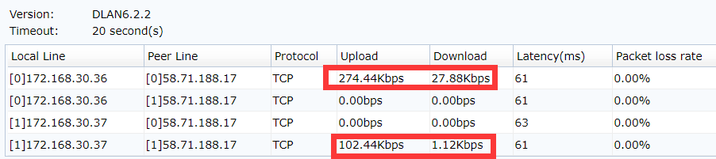

5.2.6 Prefer the optimal path
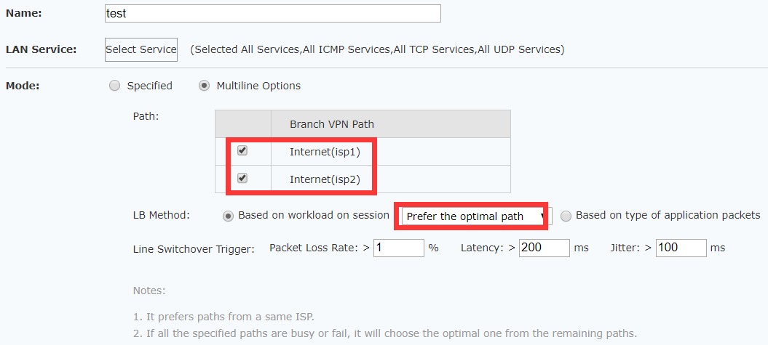
In our test environment, the quality of all tunnels almost the same , so the test result is not obviously.
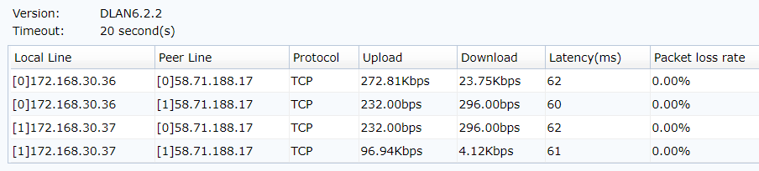

5.2.7 Based on bandwidth ratio test
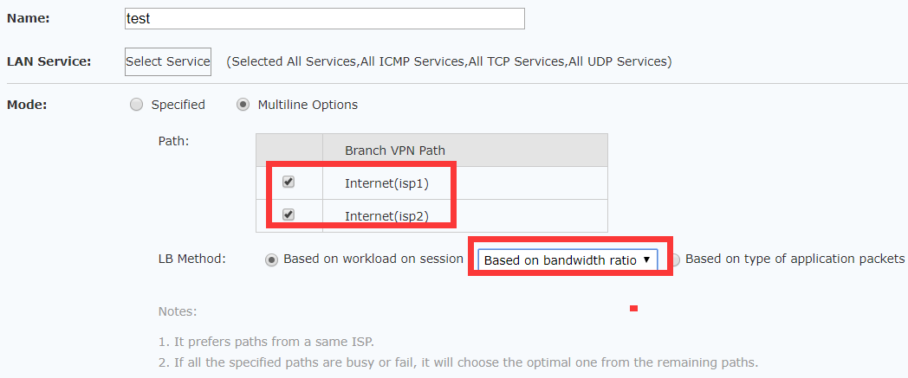

Line1 300Kb, line 2 100Kb, the result is line1
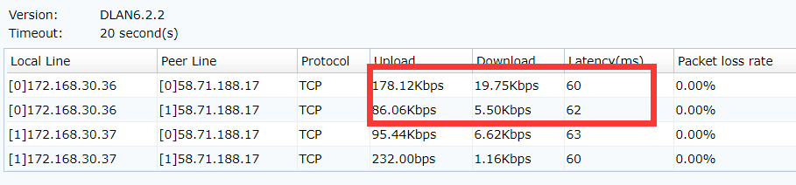

5.3 Acceleration testing
Acceleration status check:
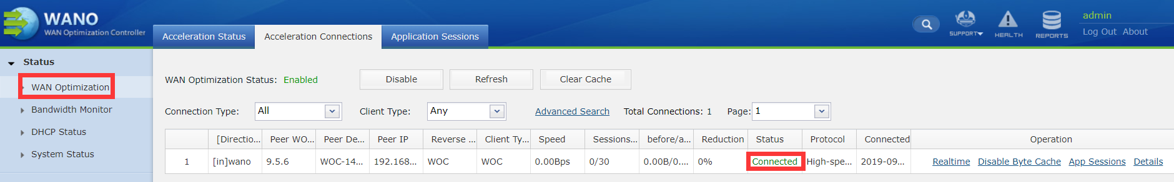
Test business:
Download files from HQ to branch one time, two times, three times and record the time.
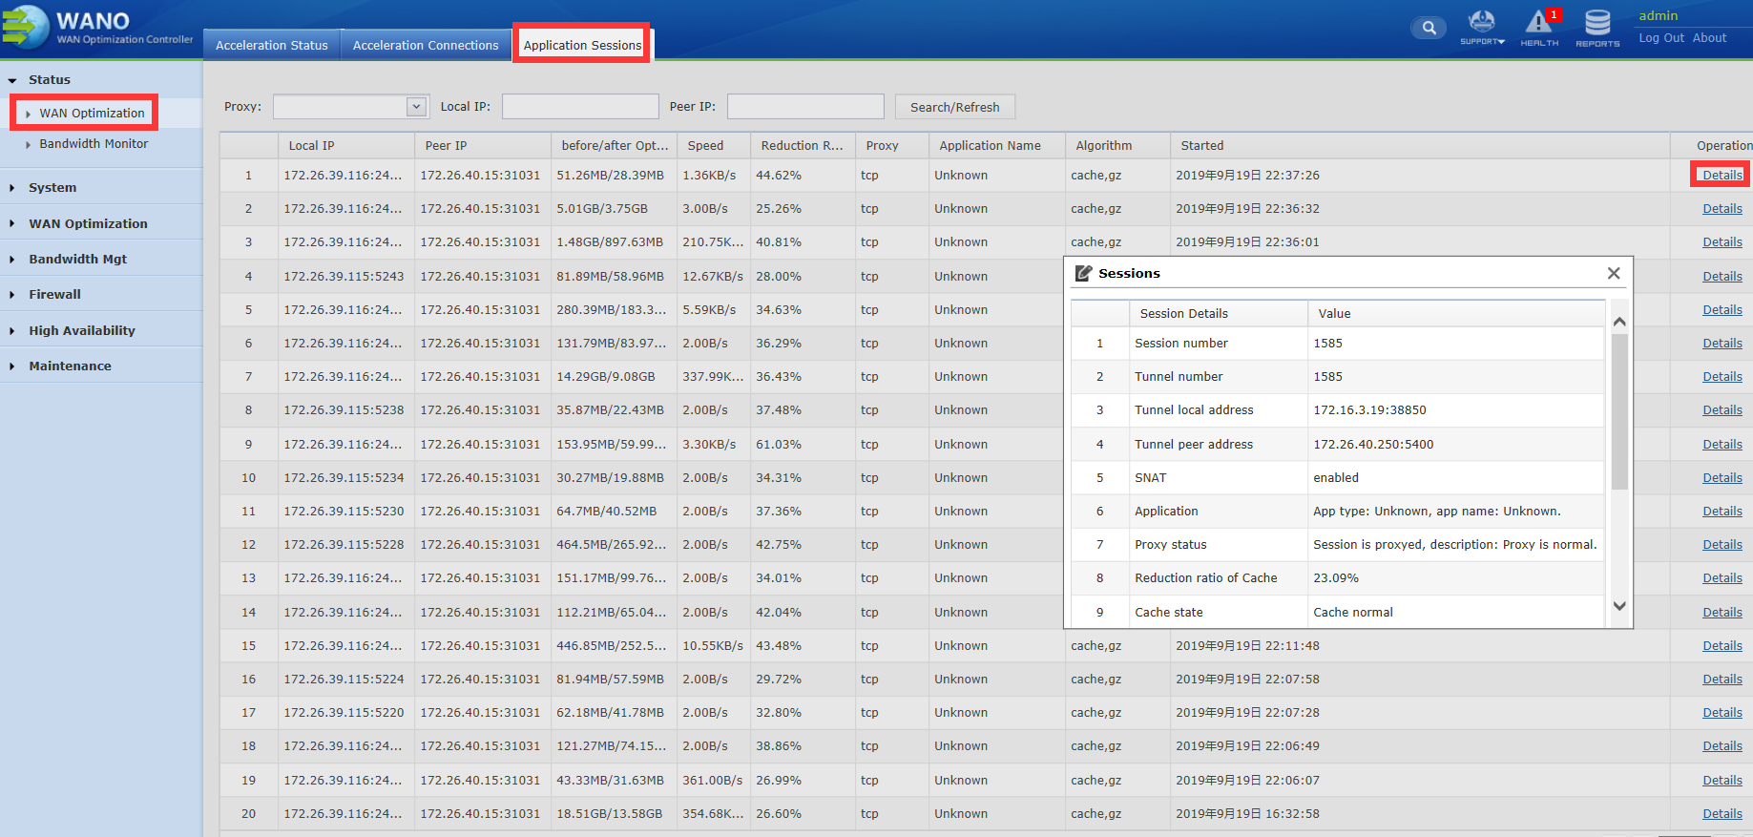

Troubleshooting:
- Can’t build acceleration tunnel
- Check acceleration service side IP and port reachable from client side
(ping HQ LAN IP from branch IP, telnet service port default TCP 5400)
- Check IP/acceleration username and password
- Check acceleration logs
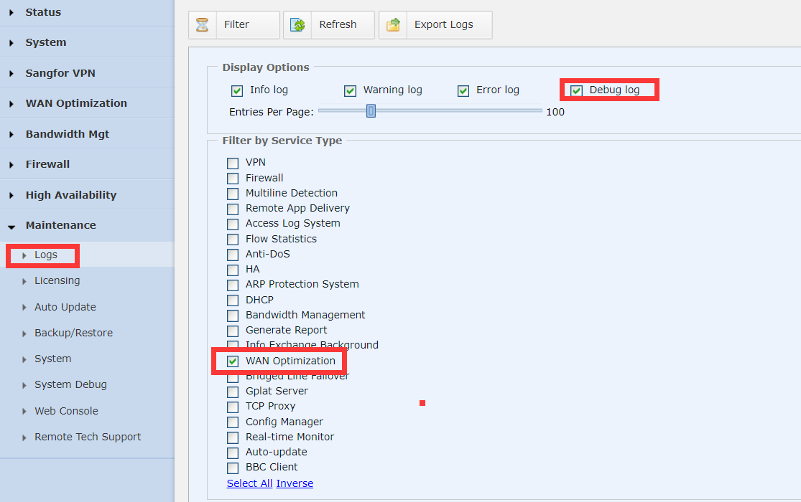
- No acceleration effect or acceleration effect not
- Confirm application traffic pass through both side device
(capture packets in both side eth0)
- Long session issue
(Close apps and restart after acceleration tunnel build)
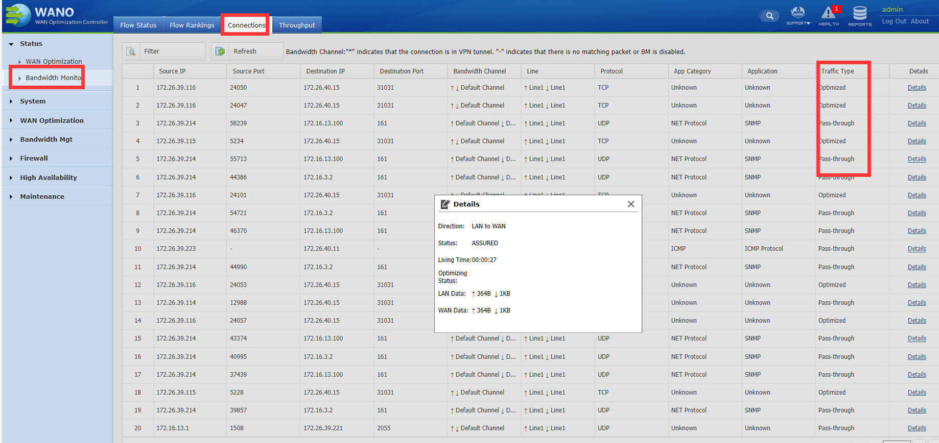
C. Different applications refer to POC test guide in community

6 POC UAT & Conclusion

