
BBC&WANO
SD WAN project POC guide
Version BBC2.5.1+WANO9.5.3
Change Log
Date | Change Description
Sep 28, 2018 | Introduction of SD WA project POC

CONTENT
Chapter 1 Introduction of SD WAN technology 4
Chapter 2 Testing Resource 4
Chapter3 POC Test Process Instruction 5
3.1 SD WAN requirement collection 5
3.2 BBC environment deployment 6
3.2.1 Deployment Mode 6
3.2.2 Deployment Scenario Description 7
3.3 WANO deployment 8
Chapter 4 POC Test Scenario 8
4.1 Auto deployment POC 8
4.2 BBC unified configuration delivery POC 11
4.3 Auto VPN POC 13

Chapter 1 Introduction of SD WAN technology
With the development of new technologies such as SDN and Hybrid WAN, the traditional networking solution faces the strong challenge of SD-WAN. According to IDC's forecast, the SD-WAN market revenue will exceed 8 billion US dollars by 2021. In the five years to 2021, the compound annual growth rate of this market will reach 69.6%. Along with the increased SD-WAN deployments, the sales of traditional routers have fallen sharply. Gartner predicts that router sales will fall 23% in 2020, with 50% of enterprise routers being replaced by SD-WAN devices.
WOC9.5.3 combines three SD WAN functions which are intelligent application routing, easy deployment of branch devices, and AutoVPN to meet the competitive needs of the market SDWAN solution.

Chapter 2 Testing Resource

Testing Material Name | Instruction
BBC installation pachage | BBC installation package download address:  BBC2.5.0_20180630.ova:  https://drive.google.com/open?id=1oKNxq8r12nSwHLb_XzKvDznZBNH_3IdR  BBC2.5.1EN(20180918).pkg:  https://drive.google.com/open?id=1wxnmMgk8ChgCaGtQ7yRG0Z04dxJp2eGd  Note: BBC2.5.0_20180630.ova is a Chinese version BBC
WANO upgrade pachage | package download address:  WANO9.5.3  https://drive.google.com/file/d/1mKJDrNzIpdFH4Z0hemyD9S0q7qsJKhS1/view  WANO 9.5.1:  https://drive.google.com/file/d/1lSh1Ytk0AftvNk0bVjTygw1H2NAK62HP/view
WOC9.5.3EN(20180915)_bbc file | package download address:  https://drive.google.com/file/d/1n-fdx3BxoVWD9sycg8DPXt7WkR97FP-n/view
BBC Sofeware platform | Ova Virtualization Deployment (Vmware, Sangfor HCI）
License Key | Currently, the test serial number authorization can only be applied through China domestic mobile number. If the local office requires test, you could seek for China local office personnel or CTI personnel to assist on the application.
Upgrade Tools | Upgrade6.0 downlaod address:  http://community.sangfor.com/plugin.php?id=service:download&action=tool

Chapter3 POC Test Process Instruction

3.1 SD WAN requirement collection

SD WAN requirement collection
Centralized Management | What’s type of Branch?Now we only support WANO to join BBC 2.5.1
Auto deployment requiremment | yes or not
Auto VPN requiremment | yes or not
SD WAN Intelligent routing | List detailed routing requirements and confirm with PM whether this requirement is supported
Alarms requirement | List detailed alarms requirements and confirm with PM whether this requirement is supported
Report requirement | List detailed alarms requirements and confirm with PM whether this requirement is supported
Other requirement | List detailed the other requirment and confirm with PM whether this requirement is supported
Test environment
Deployment Scenario confirm | - Ova Virtualization Deployment (Vmware, HCI）  - Hardware BBC device
Test environment confirm | - Public IP  - DNAT  - Deployment location(BBC and HQ WANO)  - Branch nun

3.2 BBC environment deployment

3.2.1 Deployment Mode

BBC Center device only supports single-arm deployment.
Connect the LAN port to the internal network core switch.
Port mapping is required on the front gateway device to map the TCP/UDP port 5000.
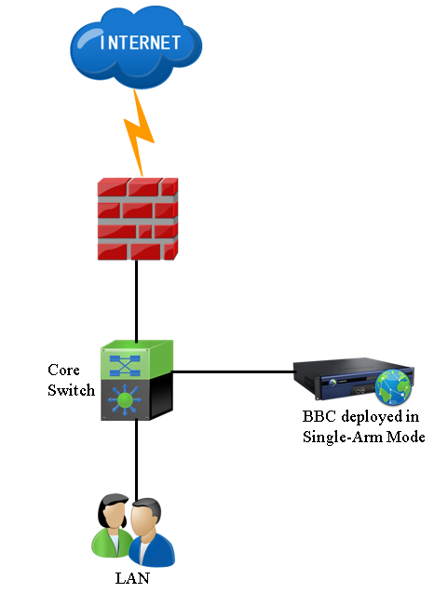

3.2.2 Deployment Scenario Description

BBC only supports single-arm deployment, but there are two supported modes:
- Ova Virtualization Deployment (Vmware, Sangfor HCI）
- Hardware BBC device
Note:Recommended ova mode deployment
BBC deployment reference specification as follows:
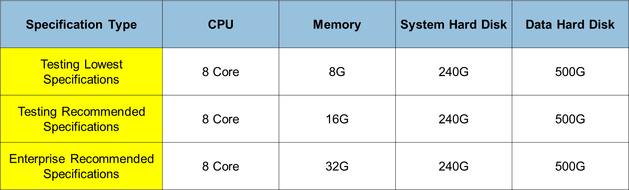
Deployment steps:
- Import BBC2.5.0_20180630.ova image into HCI or Vmware,and then configure an IP address for the BBC (Notes:This BBC is a Chinese version)
- Upgrate the BBC.2.5.0 to BBC 2.5.1_EN
Package: BBC2.5.1EN(20180918).pkg:
- License Key: Currently, the test serial number authorization can only be applied through China domestic mobile number. If the local office requires test, you could seek for China local office personnel or CTI personnel to assist on the application.
- Dnat: Port mapping is required on the front gateway device to map the TCP/UDP port 5000

3.3 WANO deployment

If you need to test SA WAN, The Version of WANO must be uesd 9.5.3:

Upgrade WANO to 9.5.3 Steps :9.1R2->9.5.1->9.5.3B

Chapter 4 POC Test Scenario

4.1 Auto deployment POC

Steps:

- Create a user account for the branch in BBC
BBC UI Path:【Sites】-【New Site】
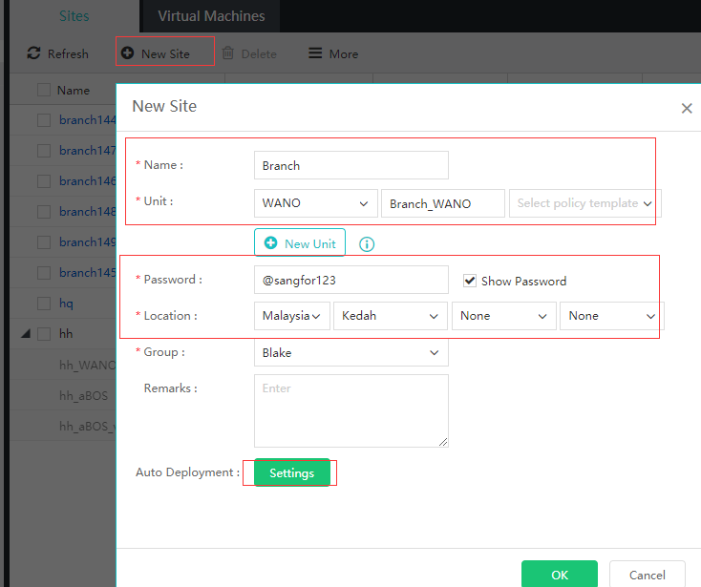

Click Seettings and configurate the Branch network:
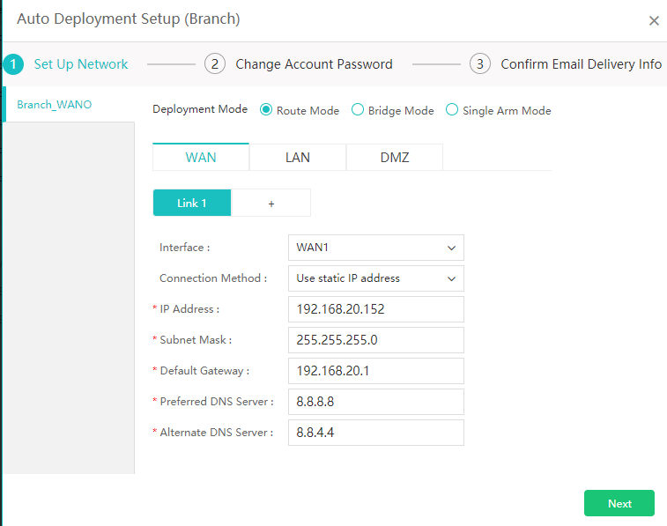

Click Next and then configurate the Password of the branch
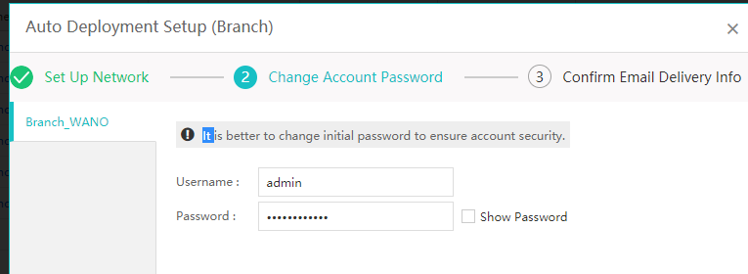

Click the Next and then configurate the Email delivery information:
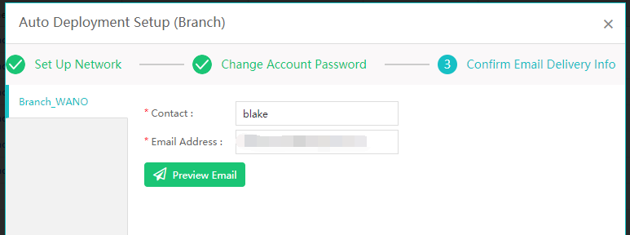

Click OK if you finish all the steps above.

At last,Click Send Email,The BBC will send an Email to the Branch Administrator and the Branch Administrtor can deploy the Branch device follow up the Email content.
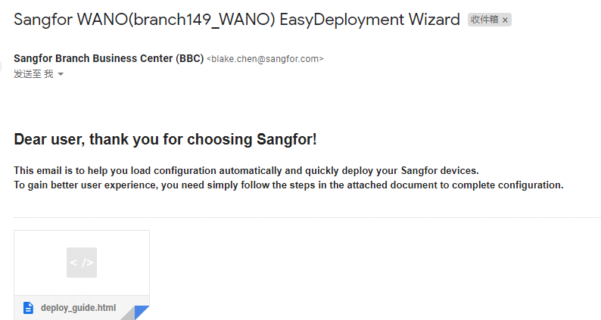
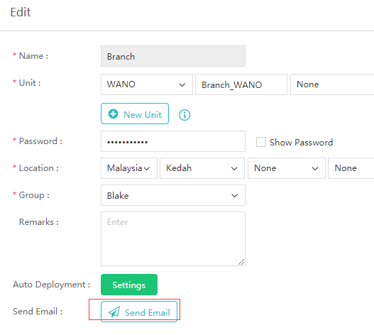

  - BBC unified configuration delivery POC

Steps：
- Import the WANO configutation template into BBC.
WANO configutation template download link:
https://drive.google.com/file/d/1n-fdx3BxoVWD9sycg8DPXt7WkR97FP-n/view
BBC UI path:【System】-【Upgrade】-【Site Unit Versions】
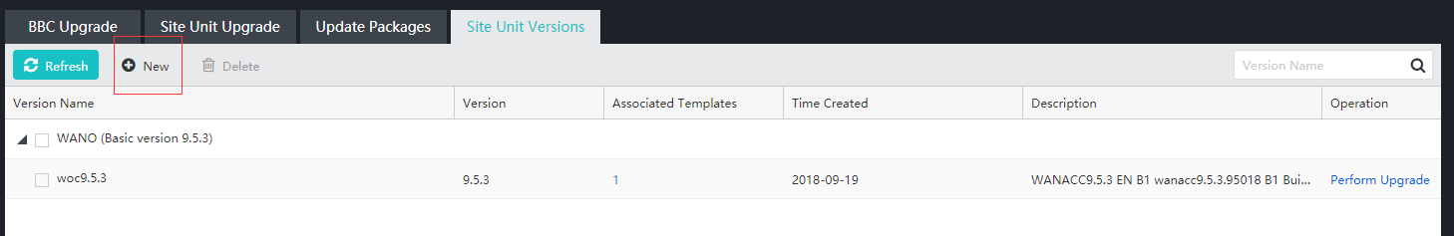
- Confirm than all the branch had joined the BBC successful.
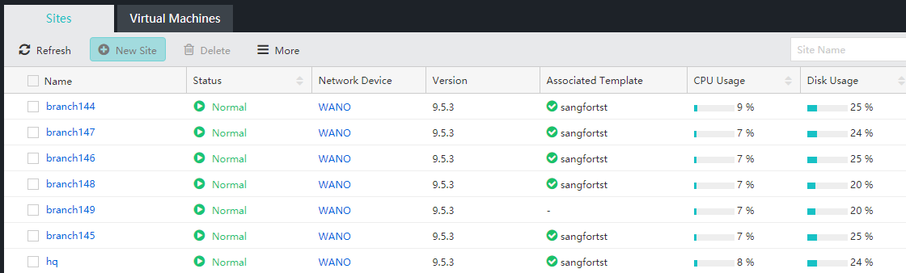
- Create a policy for the Branch which you want to configurate
Path:【Policies】-【New Template】
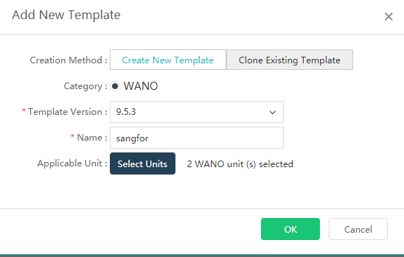
Configurate as above and then click OK
- Clcik the Template name and go into the configutation page as below:
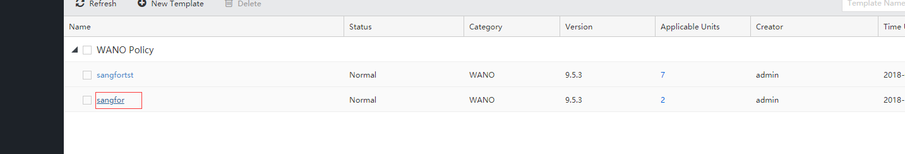
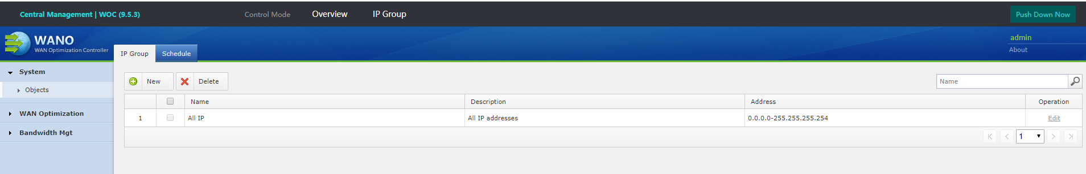
- Configurate the tempalte and then click the Push Down Now,after that,the configuration will delivery to the every branch.
  - Auto VPN POC

Steps:
- Confirm than all the branch had joined the BBC successful.
- Adding a new VPN topology
Path:【VPN】-【New VPN Topology】
Edit the basic information about this VPN topology:
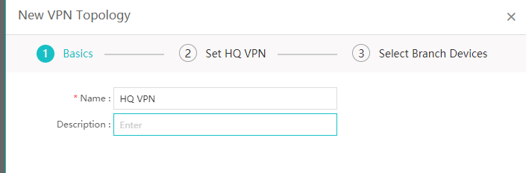
Set HQ VPN configuration:
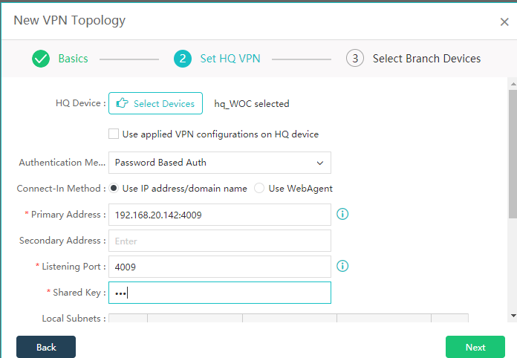

Select Branch Devices and click OK
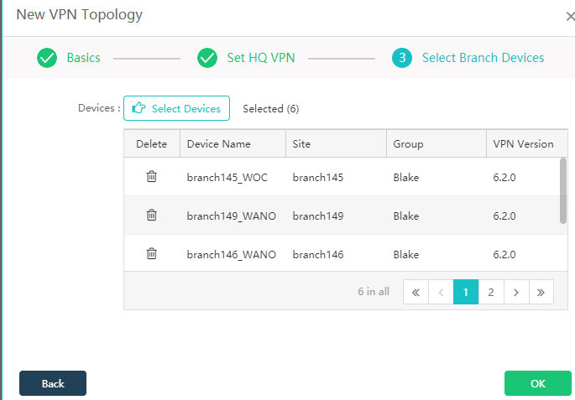
Then,Select the VPN topology and click Distribute VPN configurations:
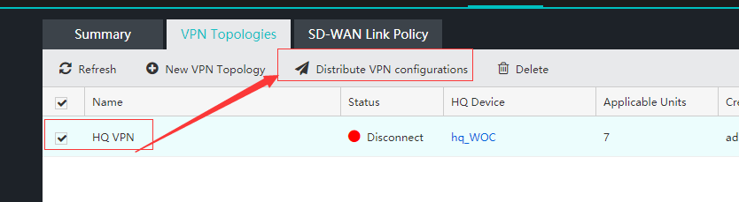
- Confirm the VPN configurations had distributed succssful.
Path:【VPN】-【Summary】-【VPN Topology】




