Sangfor SD-WAN POC Best Practice

Demo Test Guide

(BBC version)

Content
Sangfor SD-WAN POC Best Practice 1
Demo Test Guide 1
(BBC version) 1
1 Standardized Process: 4
2 Environment & Requirements Confirm 5
2.1 Environment: 5
2.2 Requirements: 5
3 Solution Design & Previous Preparation 6
3.1 Solution design: 6
3.2 Previous preparation: 6
4 Configuration 8
4.1 Configuration step: 8
4.2 BBC Basic Configuration 8
4.2.1 Set BBC IP 8
4.2.2 Set BBC DNS 9
4.2.3 Set public IP and service port for branch join BBC 9
4.2.4 Set decontrolled password and password 9
4.2.5 Set SMTP Server for alarm and email deployment 10
4.3 Deploy Branch Device and Branch Device join BBC 11
4.3.1 Existing branch device join BBC 11
4.3.2 Email deployment and new branch 12
4.3.3 Device status 13
4.4 VPN Path & Multiple WAN Policy 14
4.4.1 Set BBC VPN Path 14
4.4.2 Interface Multiple IP 14
4.4.3 Multiple WAN Policy 15
4.5 Auto VPN 16
4.6 SD-WAN Path Selection Policy 18
4.6.1 Add LAN Service 18
4.6.2 Specified Line and other line backup 19
4.6.3 Prefer Optimal Path 19
4.6.4 Based on bandwidth ratio 20
4.6.5 Packets Level Tunnel Bonding/Link Load Balancing 20
4.7 Unified Policy Update 21
5 Testing & troubleshooting 23
5.1 VPN Testing 23
5.2 SD-WAN path selection testing 25
5.2.1 JPerf tool introduction: 25
5.2.2 Specified line2 (line2 100Kb) 26
5.2.3 Fail-over test 28
5.2.4 Prefer the optimal path 29
5.2.5 Based on bandwidth ratio test 30
5.2.6 VPN tunnel bonding test 31
6 POC UAT & Conclusion 32

1 Standardized Process:
- Environment and requirements confirm
Refer to pre-poc check list
- Solution design & previous preparation
- Configuration
- Test & troubleshooting
- POC UAT and Conclusion

2 Environment & Requirements Confirm
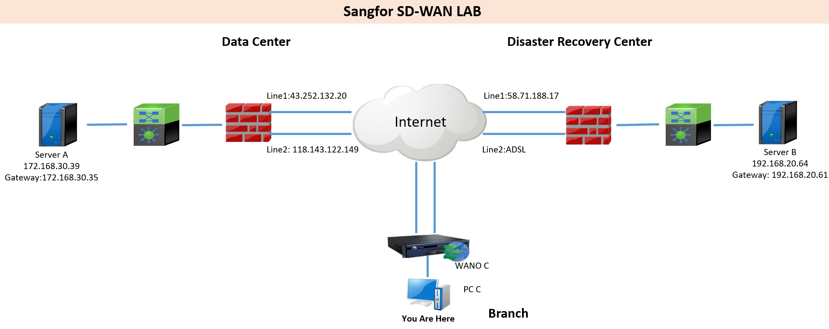

2.1 Environment:
Customer don’t want to replace any device and no down time to POC

2.2 Requirements:
- DC-DRC server can visit each other
- Improve server access speed
- Test line 1 access and line 2 backup
- Test automatic choose the optimal line to access
- Test bonding all WAN links to access

3 Solution Design & Previous Preparation
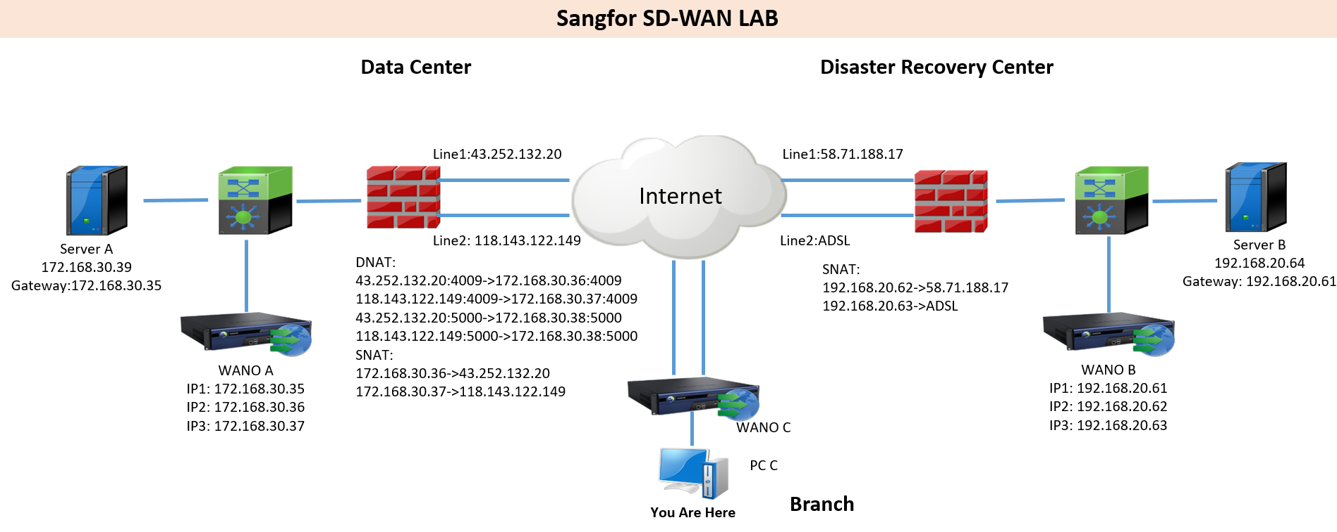

3.1 Solution design:
Customer don’t want to replace any device and no down time to POC
=> Single arm mode deployment

3.2 Previous preparation:
SD-WAN features require WANO version 9.5.3 or above
DC and DRC all have 2 lines, we need prepare 3 IPs for WANO in each site and bonding WANO IP with internet IP.
DC site WANO:
IP1: 172.168.30.35 (used for intranet traffic routing and device management)
IP2: 172.168.30.36 (bonding line1 43.252.132.20)
IP3: 172.168.30.37 (bonding line2 118.143.122.149)
DC Site BBC:
IP: 172.168.30.38
DC site gateway previous preparation:
DNAT: (Both TCP & UDP 4009, used for branch WANO VPN access)
43.252.132.20:4009->172.168.30.36:4009
118.143.122.149:4009->172.168.30.37:4009
(TCP 5000, used for branch WANO join BBC)
43.252.132.20:5000->172.168.30.38:5000
118.143.122.149:5000->172.168.30.38:5000
(If customer want to visit BBC from Internet , we also need DNAT BBC TCP443/5530 port)
SNAT & Source policy-based routing: (Bonding WANO IP with internet IP)
172.168.30.36->43.252.132.20
172.168.30.37->118.143.122.149
DC site gateway or core switch previous preparation:
Add a static route or policy-based routing
Destination network 192.168.20.0/24 Next-Hop 172.168.30.35

DRC site WANO:
IP1: 192.168.20.61 (used for intranet traffic routing and device management)
IP2: 192.168.20.62 (bonding line1 58.71.188.17)
IP3: 192.168.20.63 (bonding line2 PPPoE IP)
DRC site gateway previous preparation:
SNAT & Source policy-based routing: (Bonding WANO IP with internet IP)
192.168.20.62->58.71.188.17
192.168.20.63->ADSL
DRC site gateway or core switch previous preparation:
Add a static route or policy-based routing
Destination network 172.168.30.0/24 Next-Hop 192.168.20.61

4 Configuration

4.1 Configuration step:
- BBC Basic Configuration
- Deploy Branch Device and Branch Device join BBC
- VPN Path & Multiple WAN Policy
- Auto VPN
- SD-WAN Path Selection Policy
- Unified Update Policy

4.2 BBC Basic Configuration

4.2.1 Set BBC IP
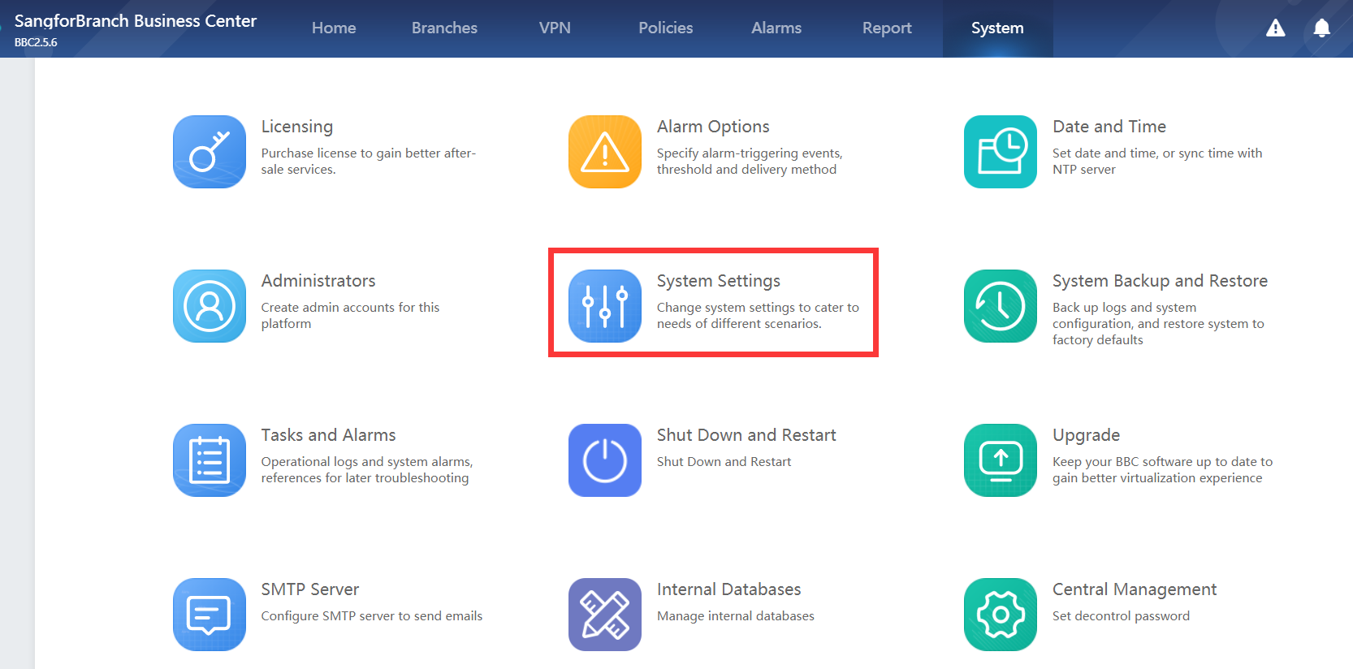
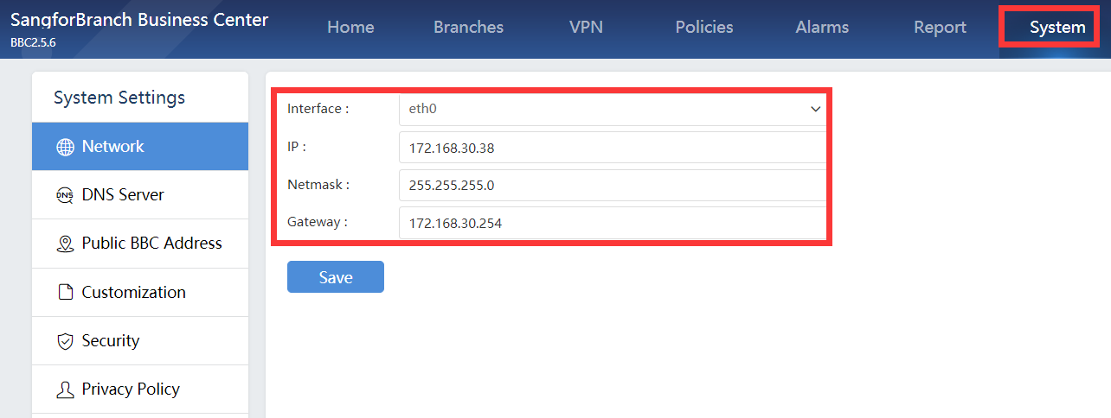

4.2.2 Set BBC DNS
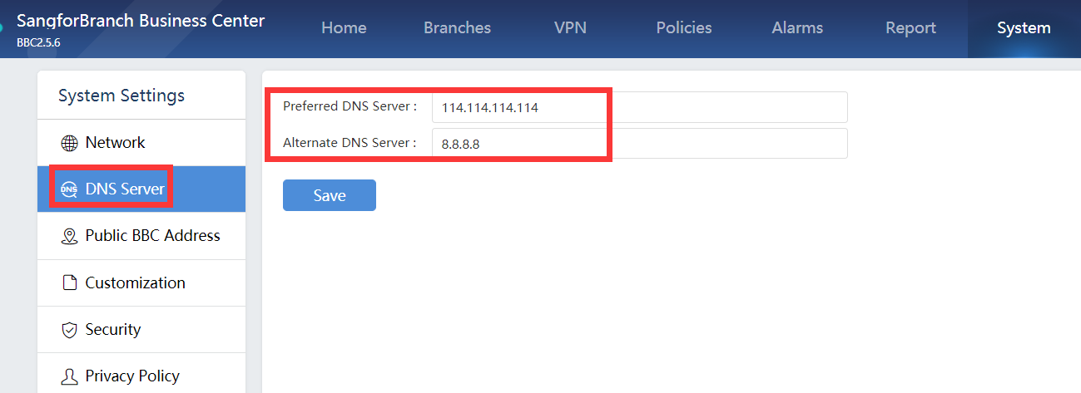

4.2.3 Set public IP and service port for branch join BBC
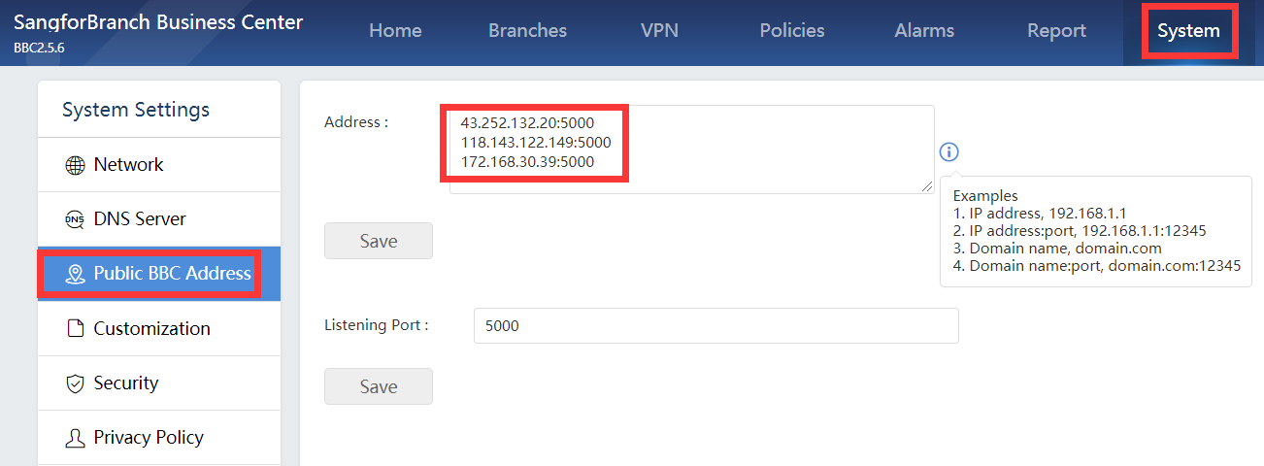

4.2.4 Set decontrolled password and password
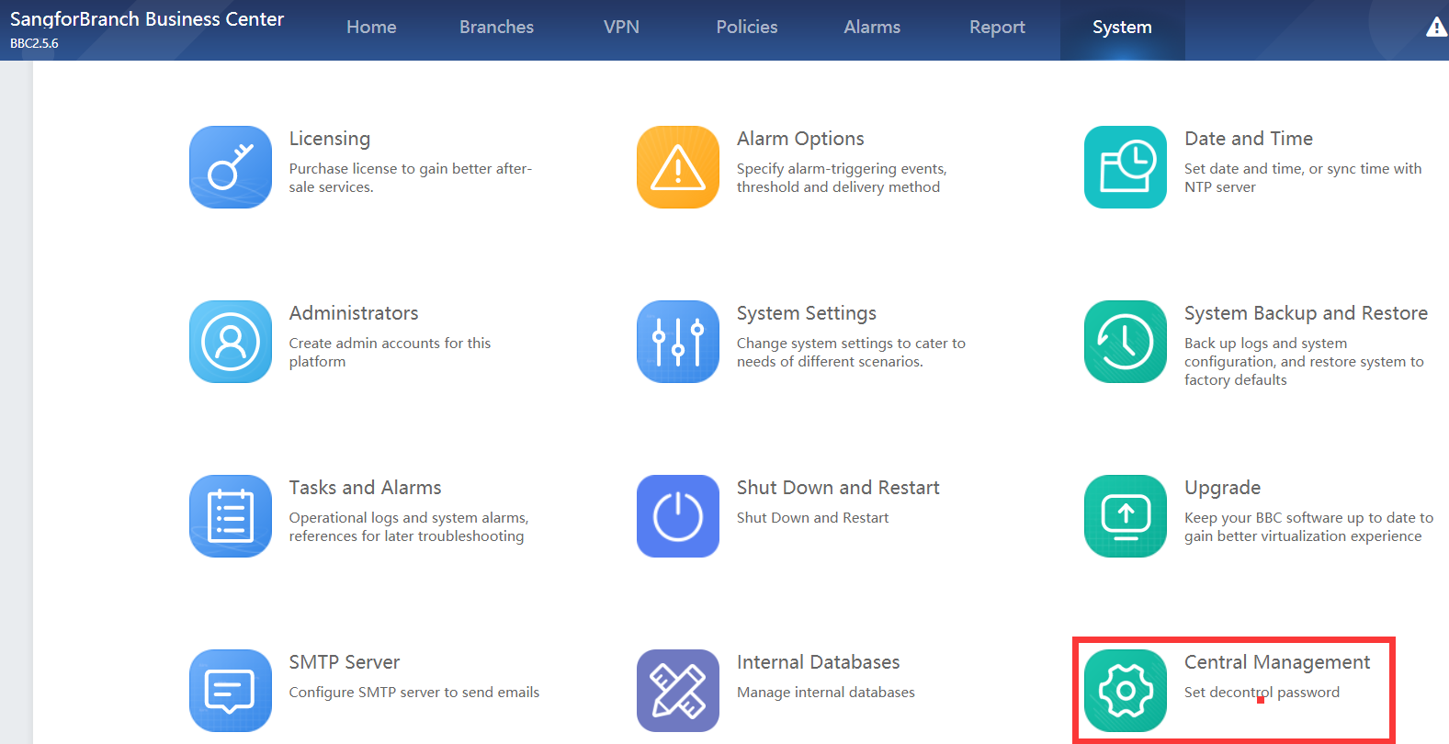
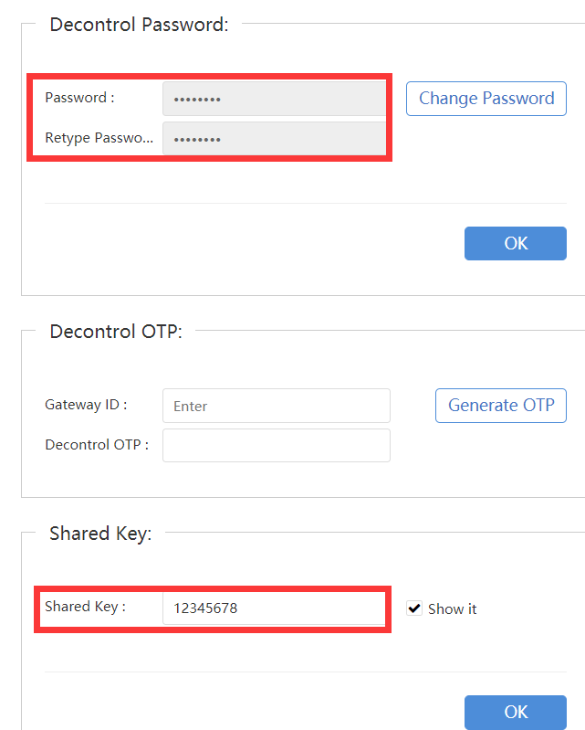

4.2.5 Set SMTP Server for alarm and email deployment
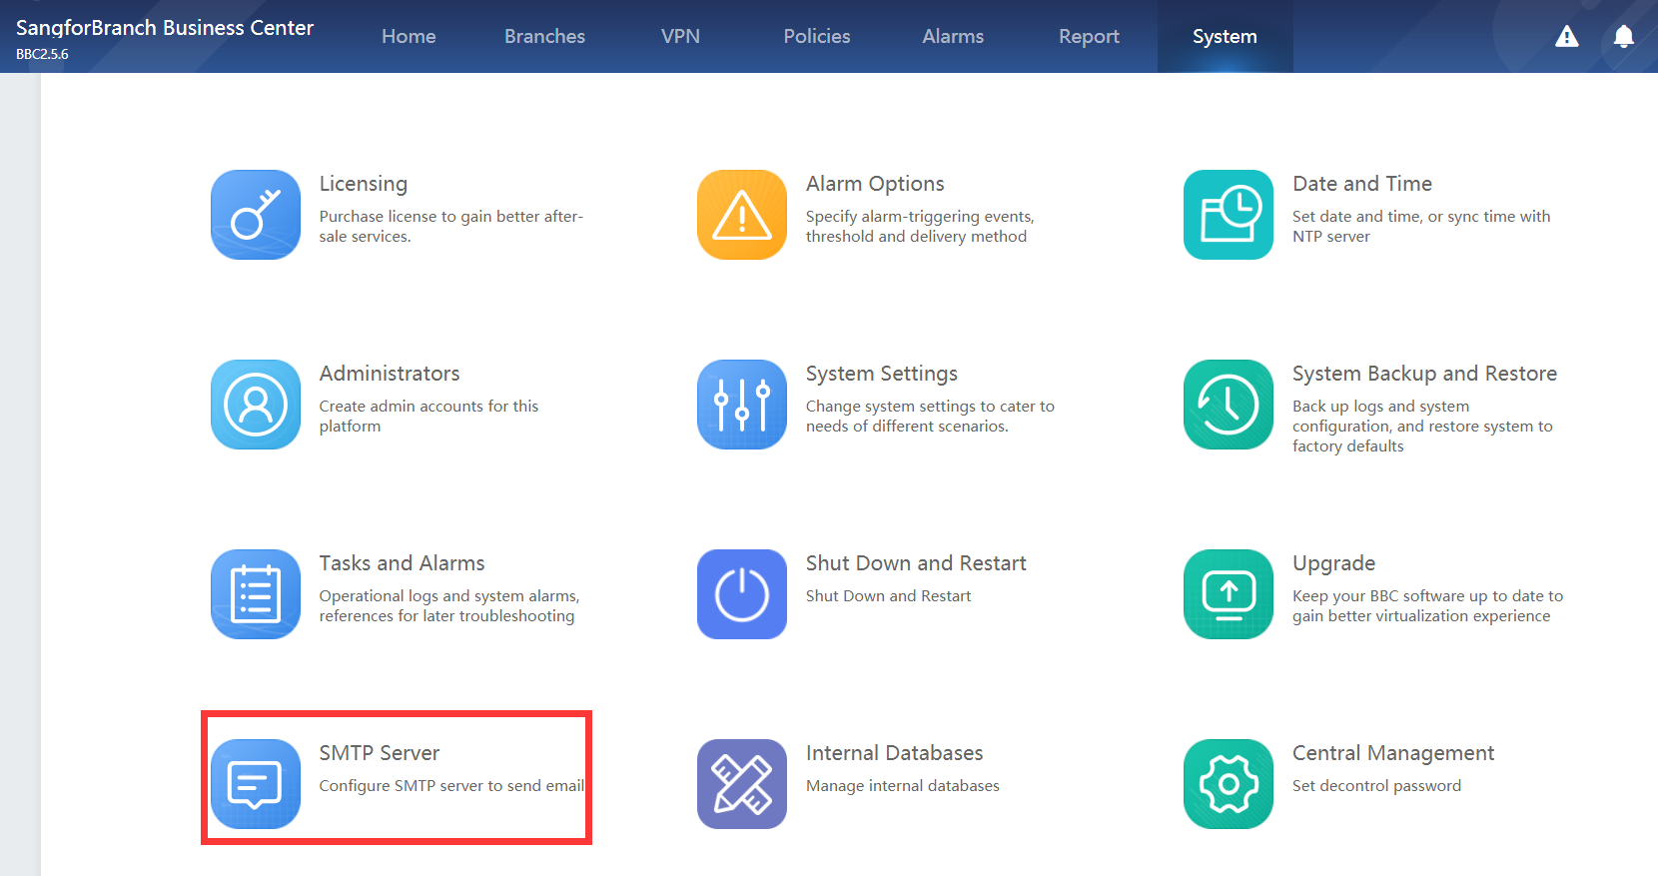

4.3 Deploy Branch Device and Branch Device join BBC
Two method:
- Existing branch device join BBC
- Email deployment and new branch

4.3.1 Existing branch device join BBC
1. BBC add new branch
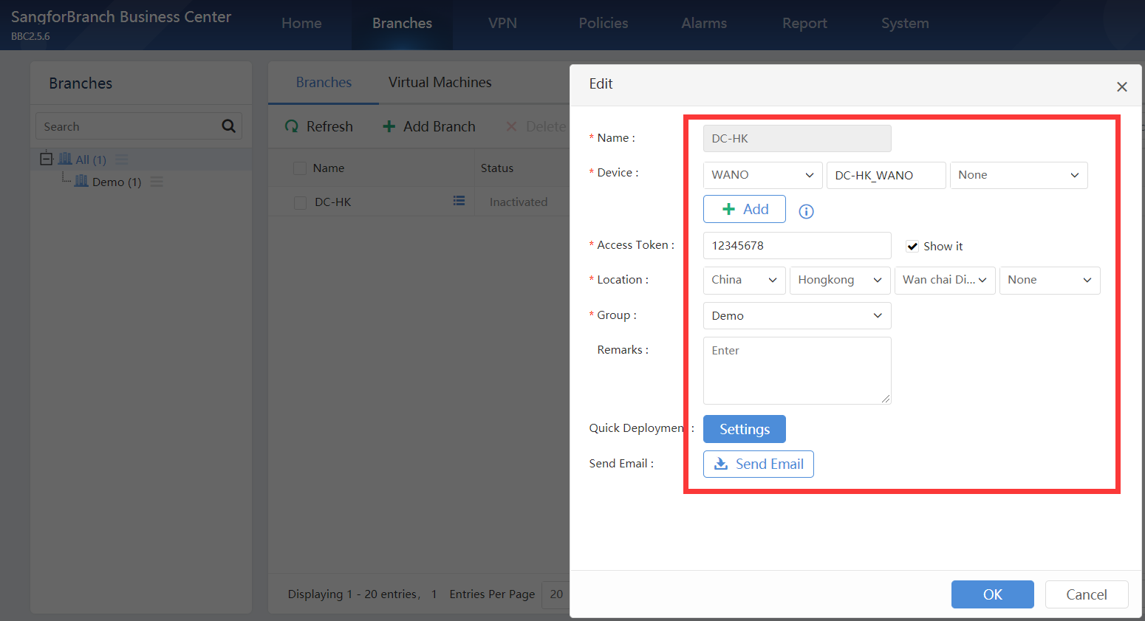
2. Branch join BBC
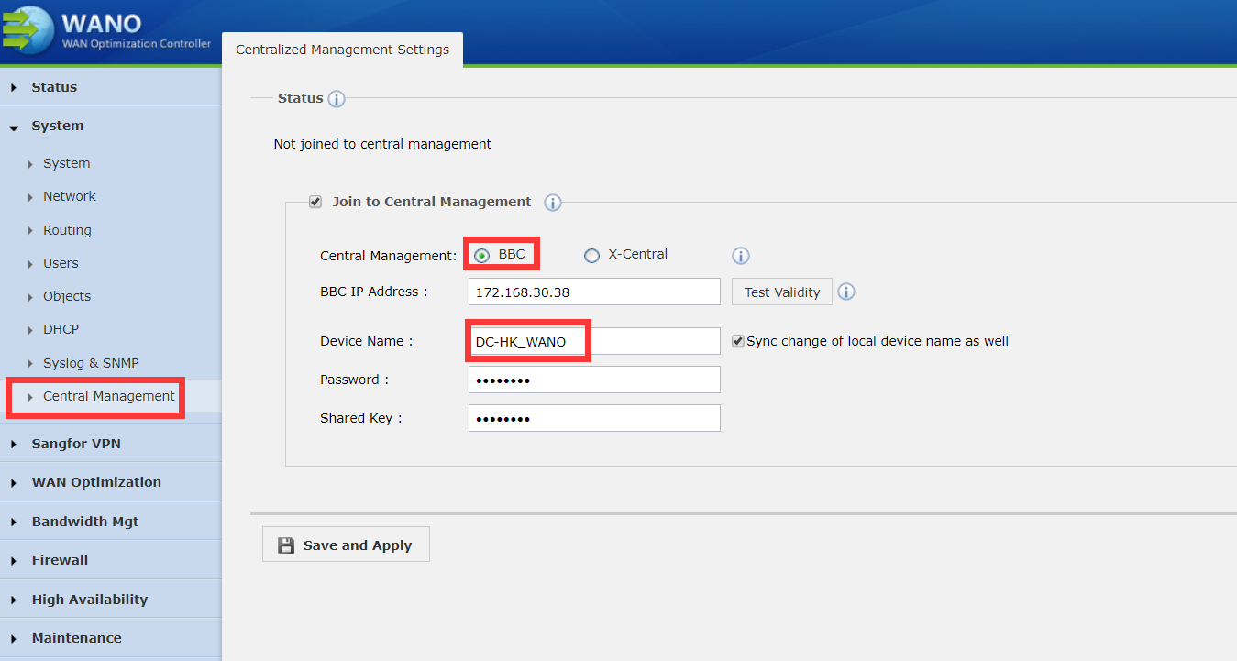
Notice: keep the device name the same with BBC device name, not the branch name

4.3.2 Email deployment and new branch
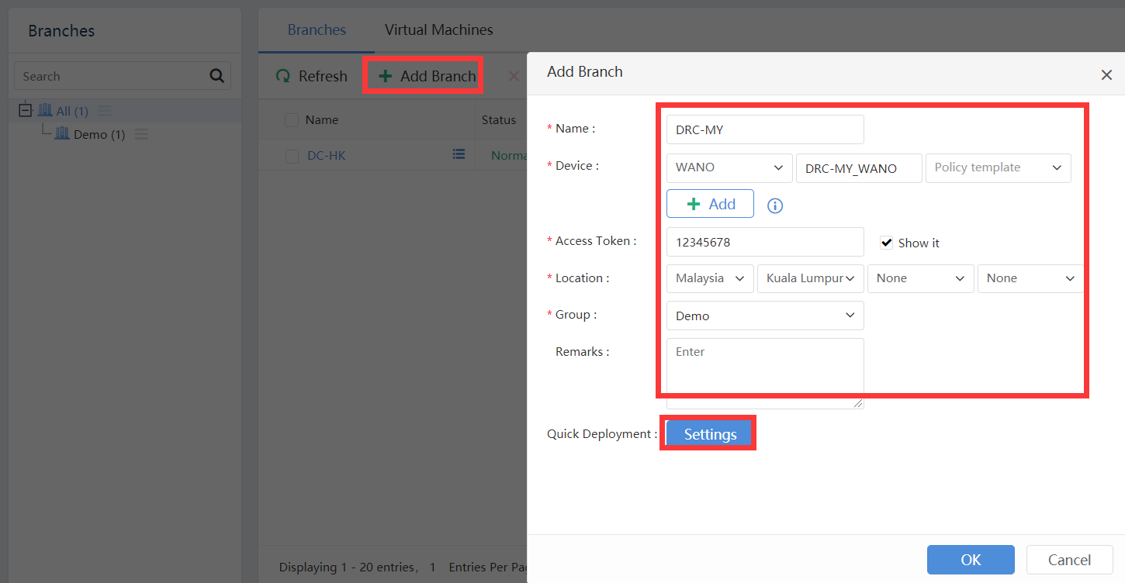
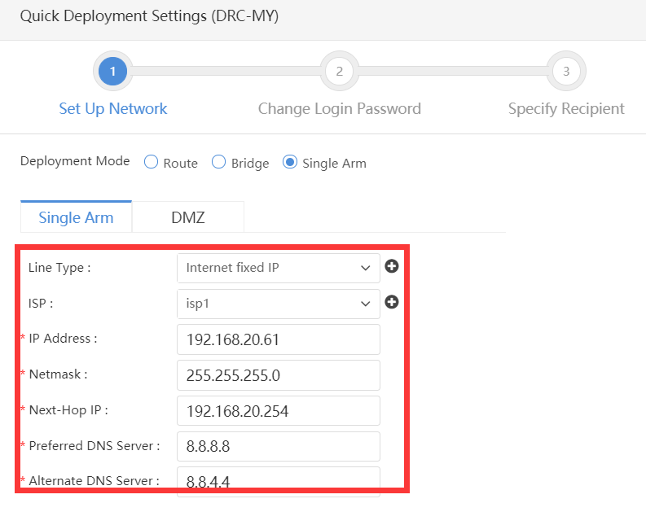
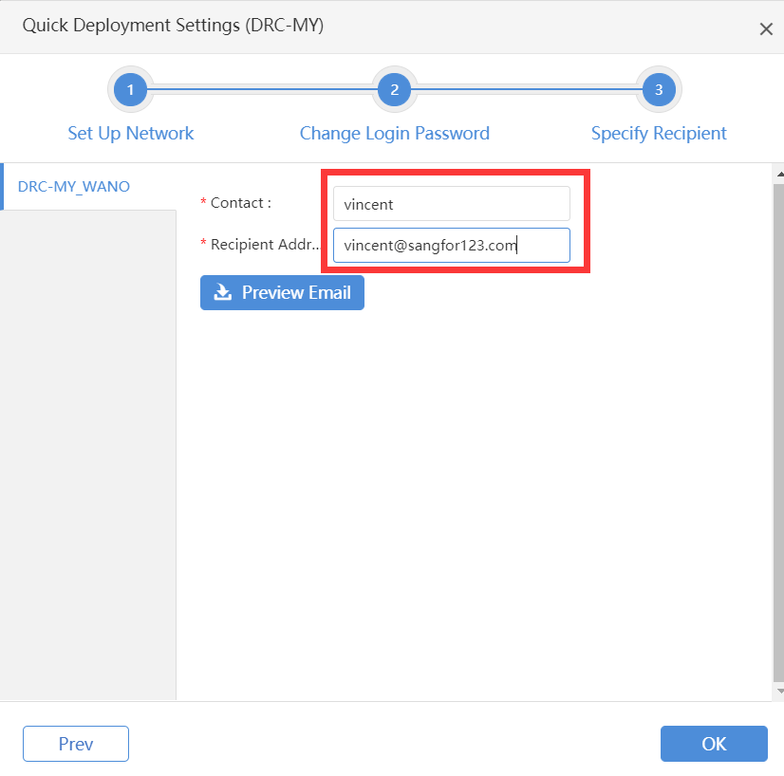
Branch user setting according to the guide received from BBC.

4.3.3 Device status
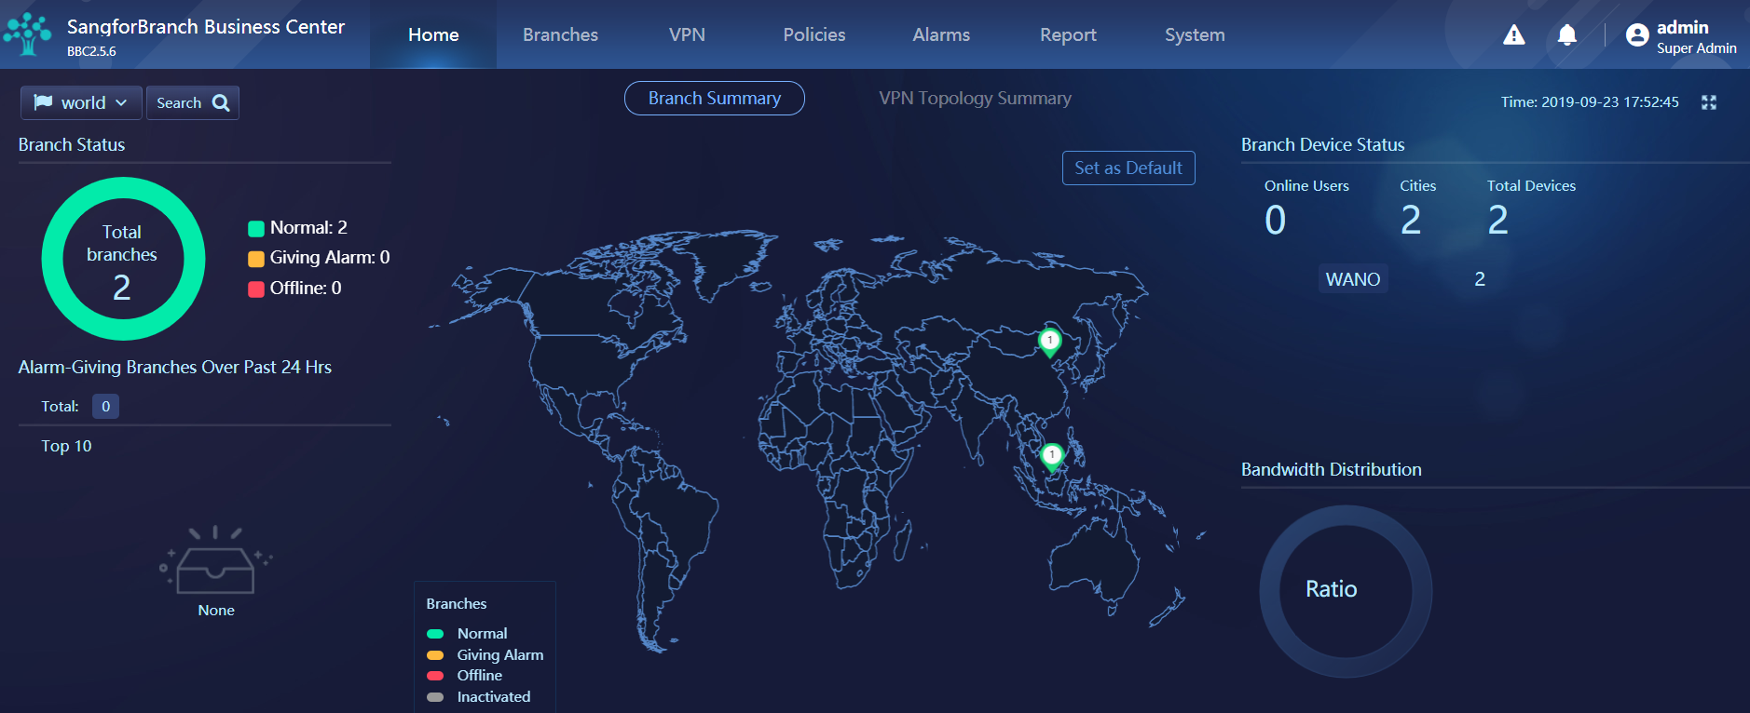
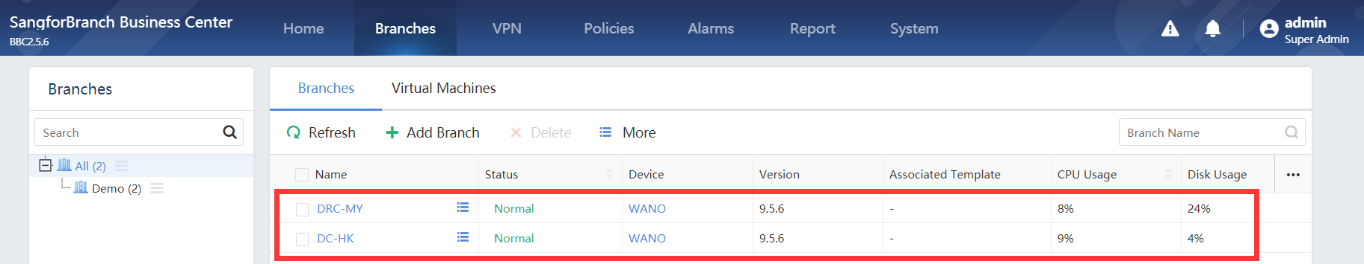

4.4 VPN Path & Multiple WAN Policy

4.4.1 Set BBC VPN Path
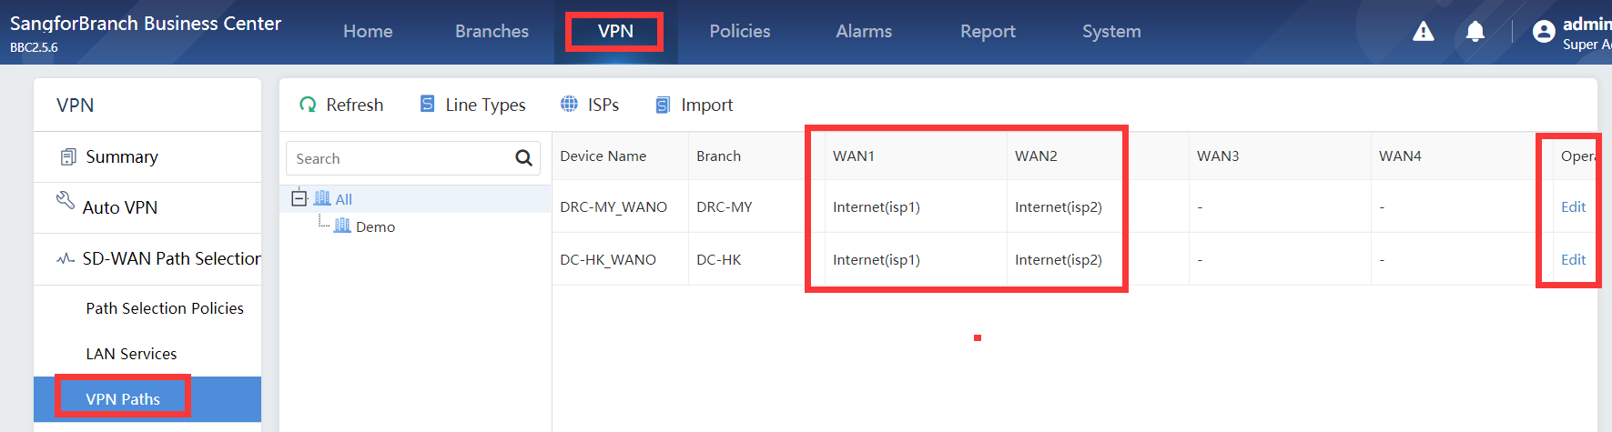

4.4.2 Interface Multiple IP
Login branch device from BBC
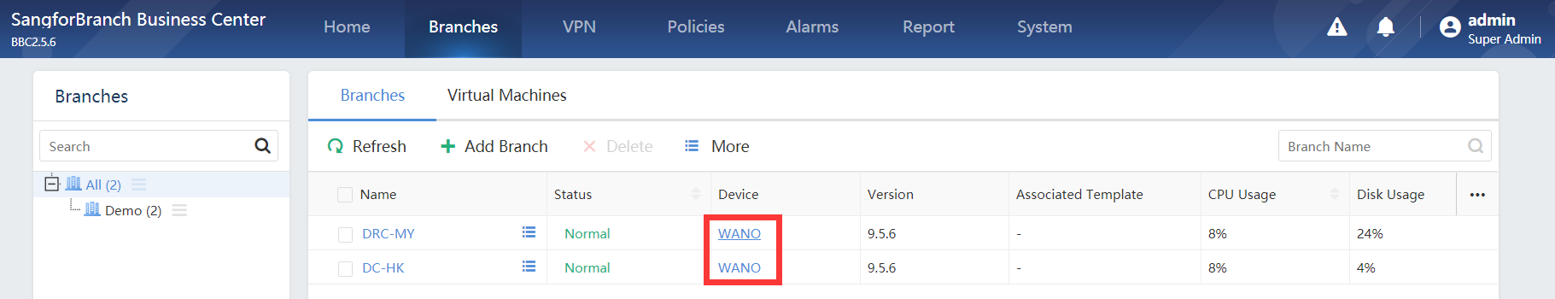
DC:
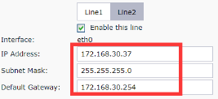
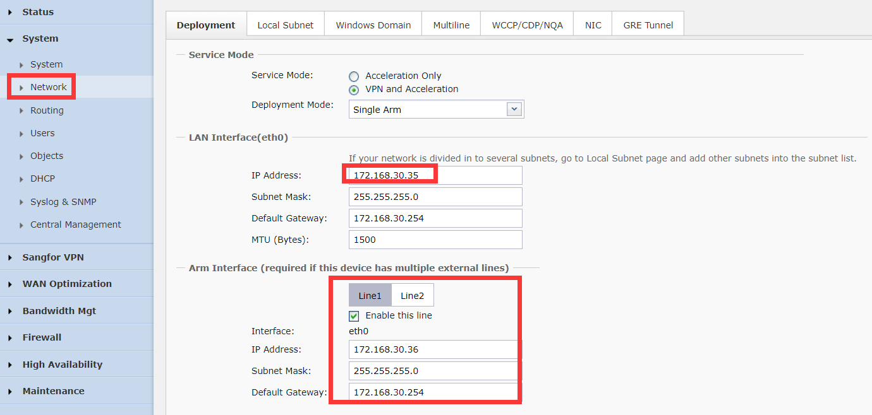
DRC:
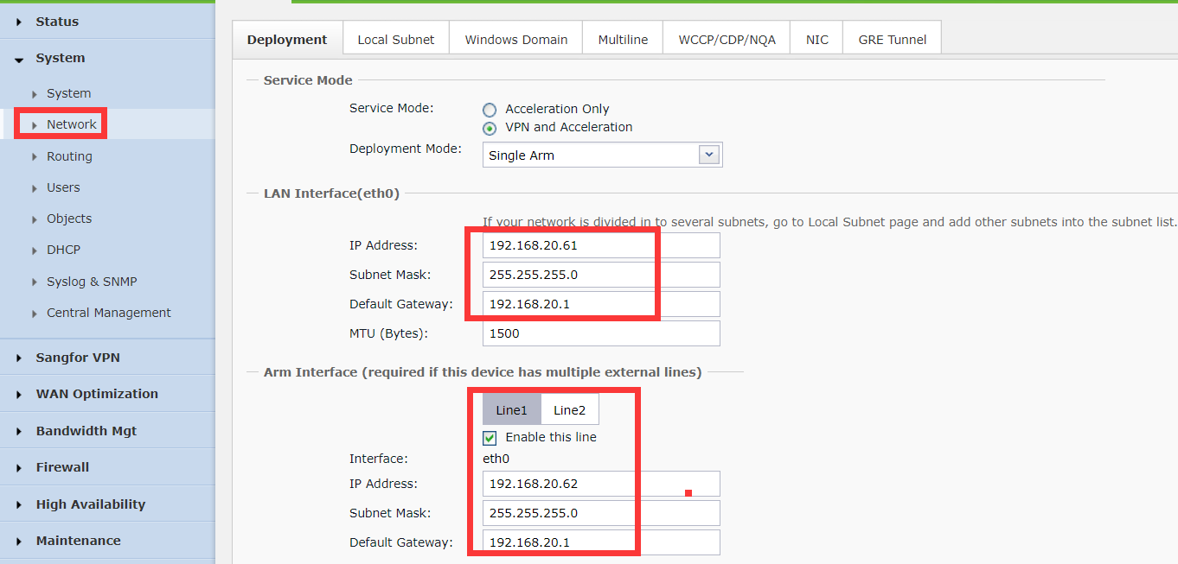

4.4.3 Multiple WAN Policy
DC:
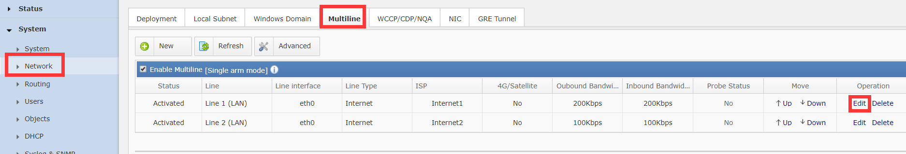
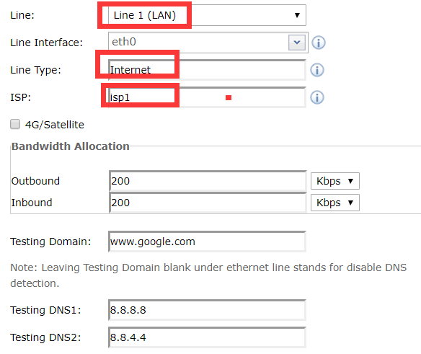
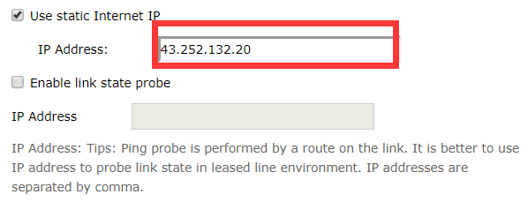
(If line is PPPoE and no static internet IP, don’t check ‘use static internet IP’)

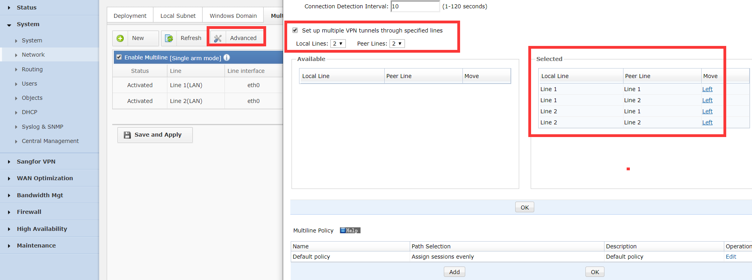
(For this test, all lines are internet ,we can select all pairs and build 2*2 tunnels, in some case, customer has both MPLS and Internet , we need un-select MPLS-Internet )
DRC:
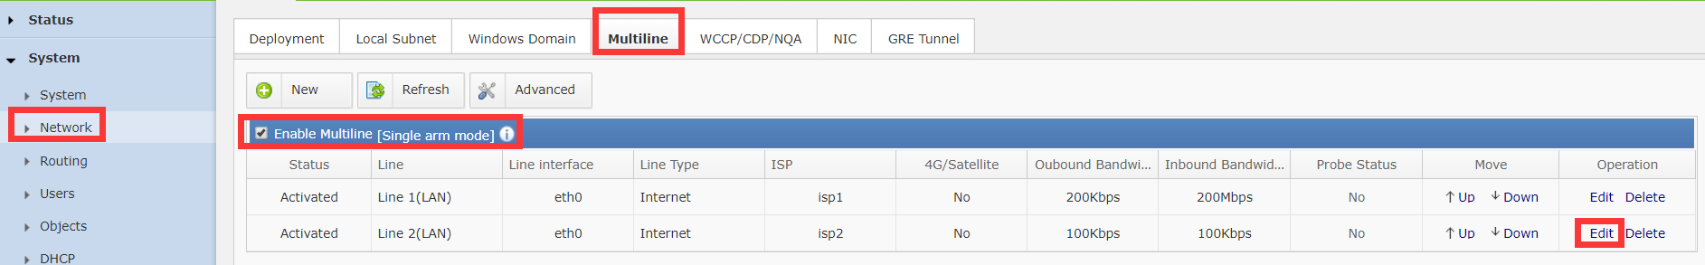
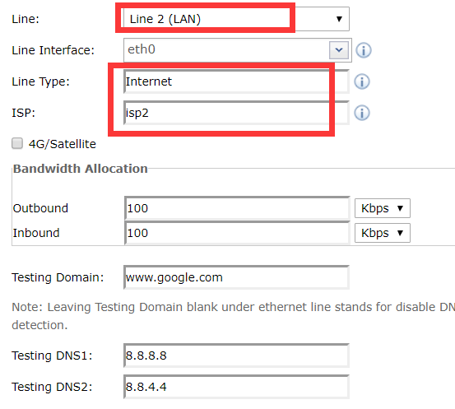
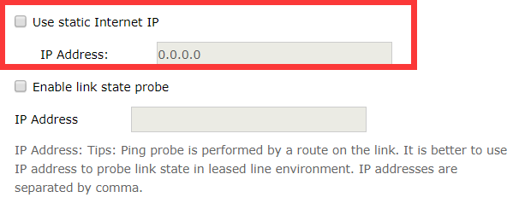
(Line 2 is PPPoE, no static IP)

4.5 Auto VPN
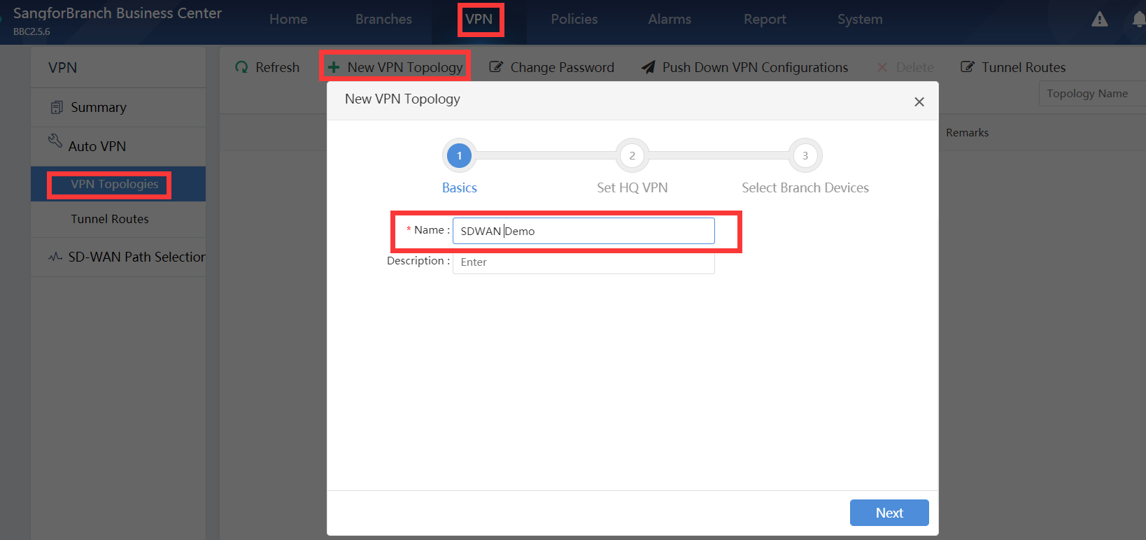
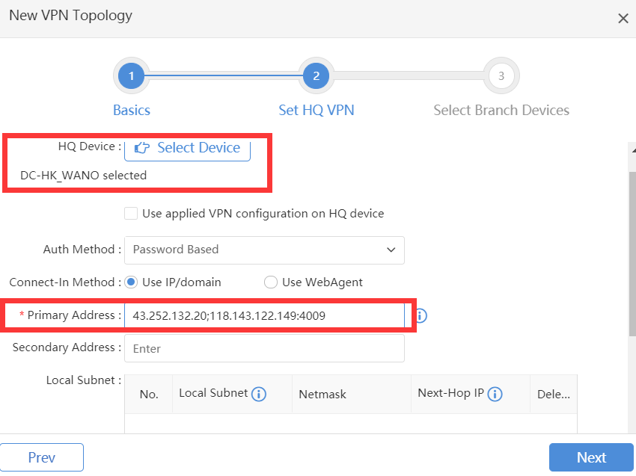
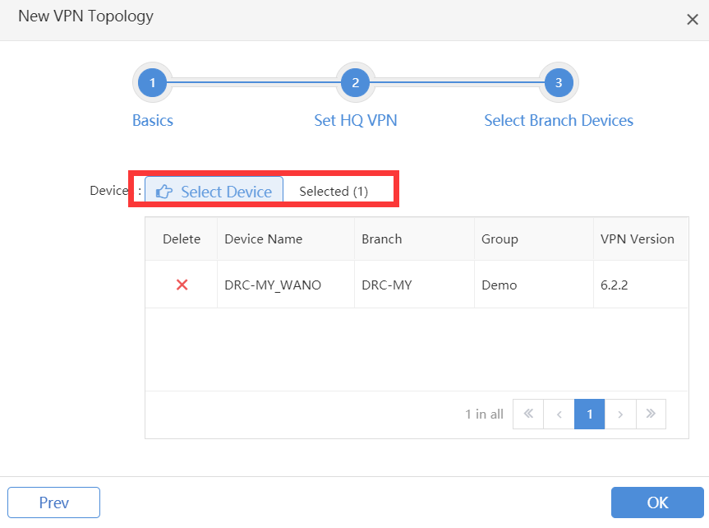

4.6 SD-WAN Path Selection Policy
(If there is no server in branch or drc, just only no need to set sd-wan path selection policy in DC, because traffic branch/DRC->DC match branch/DRC policy, for packets return from DC->branch/DRC will choose the original path)
In this case, the server in DRC and the client in DC, so we just need to set SD-WAN path selection policy in DC
PC(Client)—WANO(Client)<------>WANO(Server)—PC(Server)

4.6.1 Add LAN Service
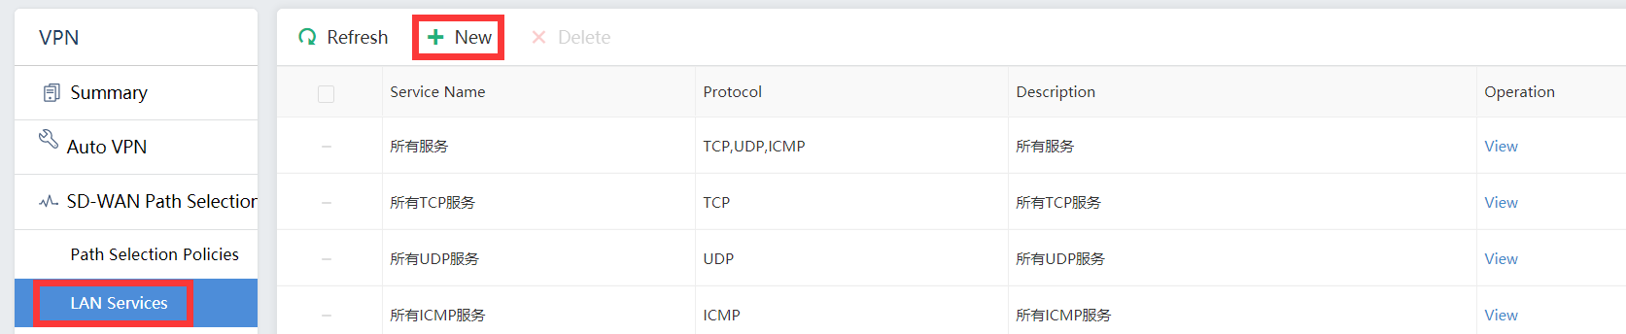
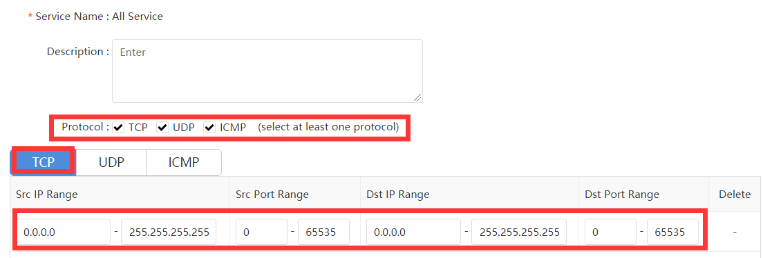
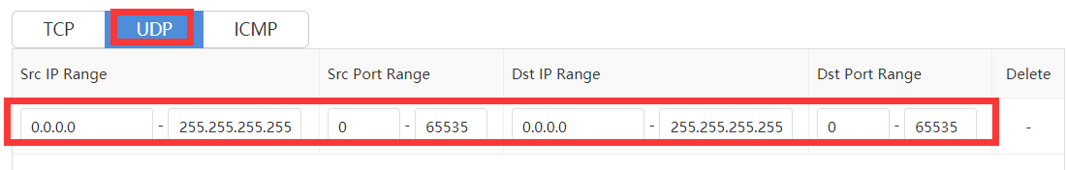
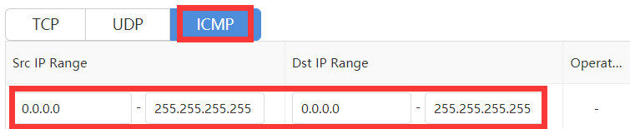

4.6.2 Specified Line and other line backup
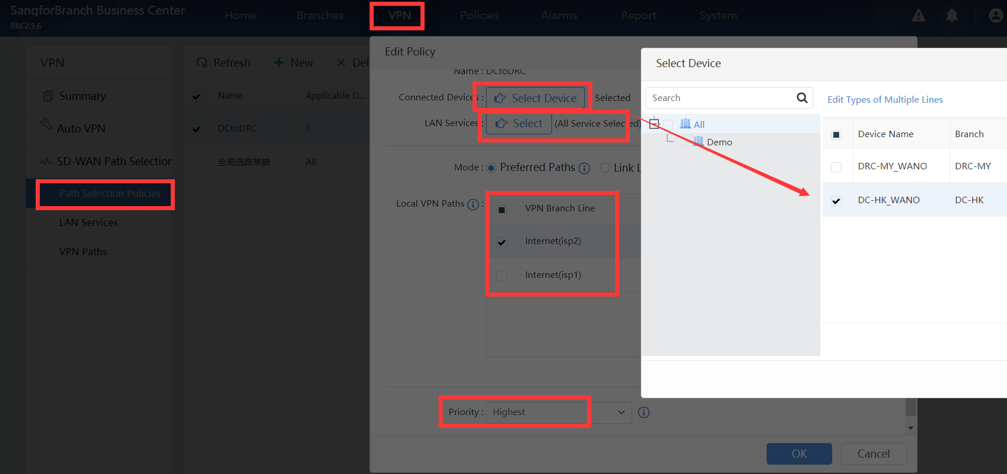
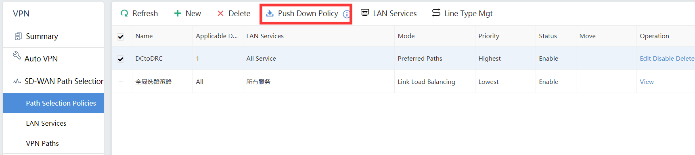

4.6.3 Prefer Optimal Path
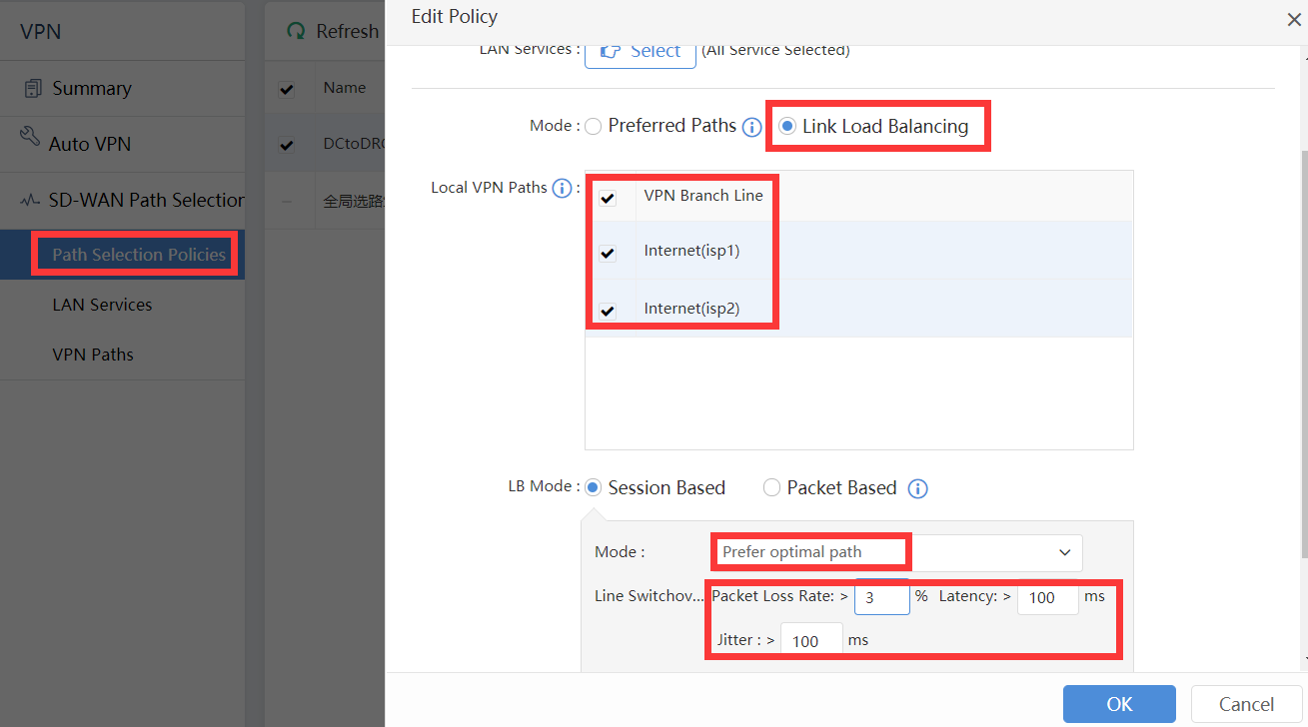

4.6.4 Based on bandwidth ratio
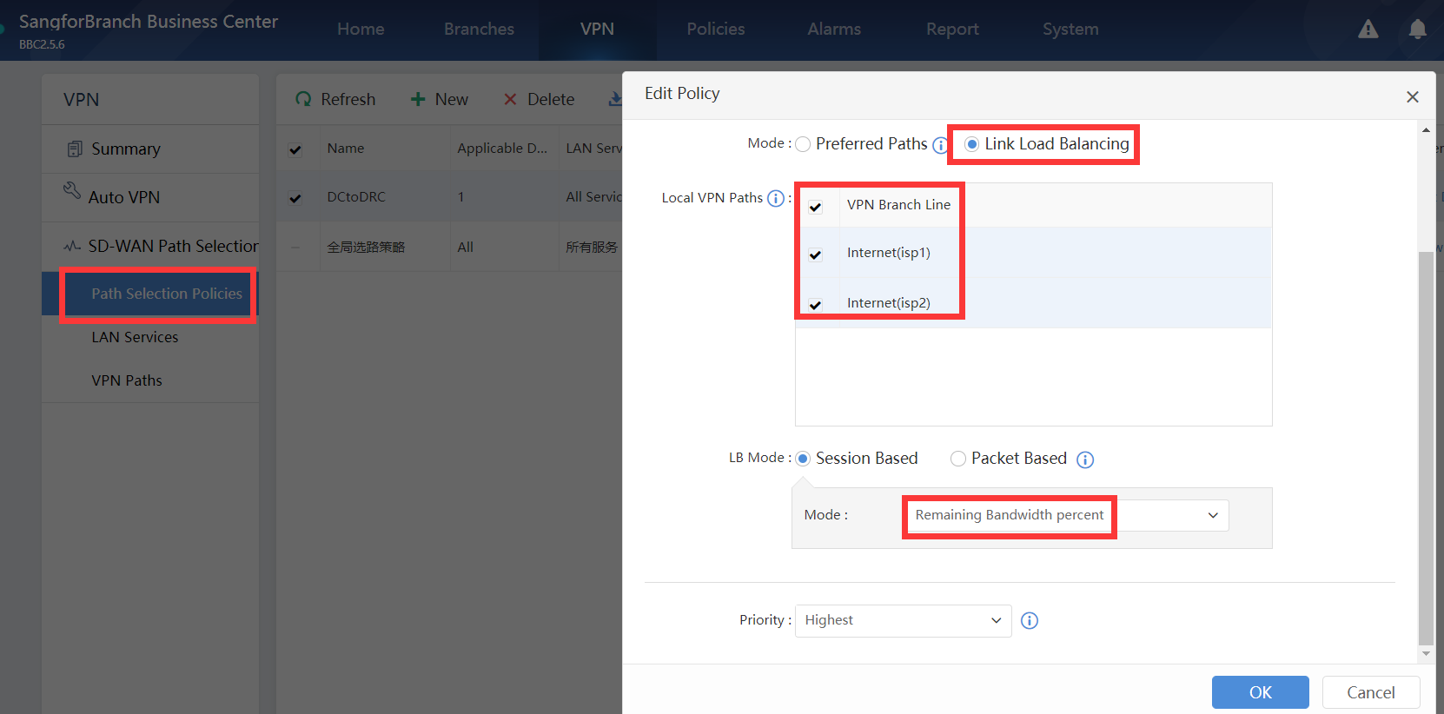

4.6.5 Packets Level Tunnel Bonding/Link Load Balancing
(Just only WANO support packets level VPN tunnel bonding)
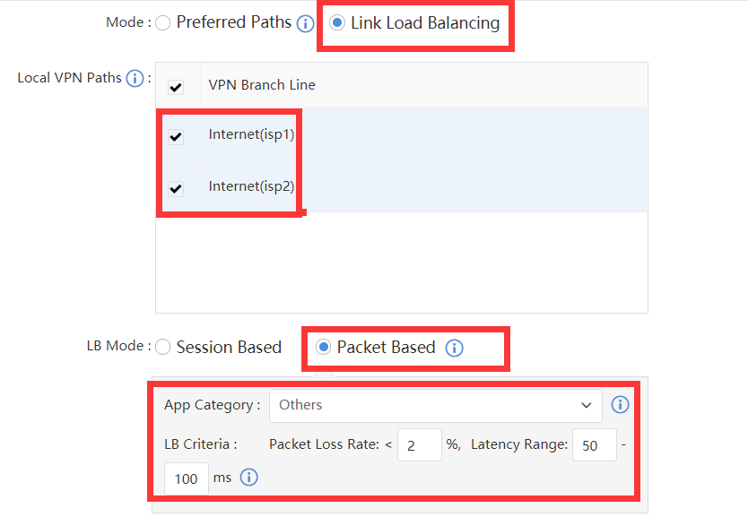

4.7 Unified Policy Update
1. Upload BBC file
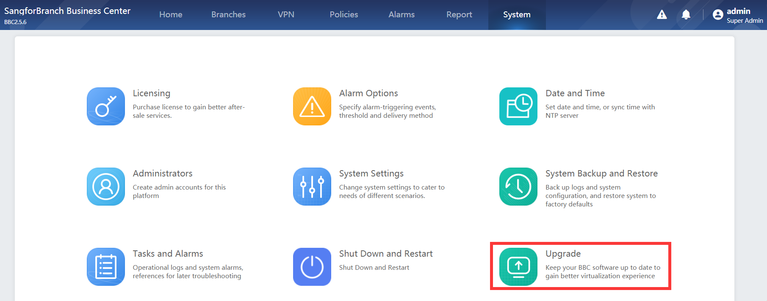
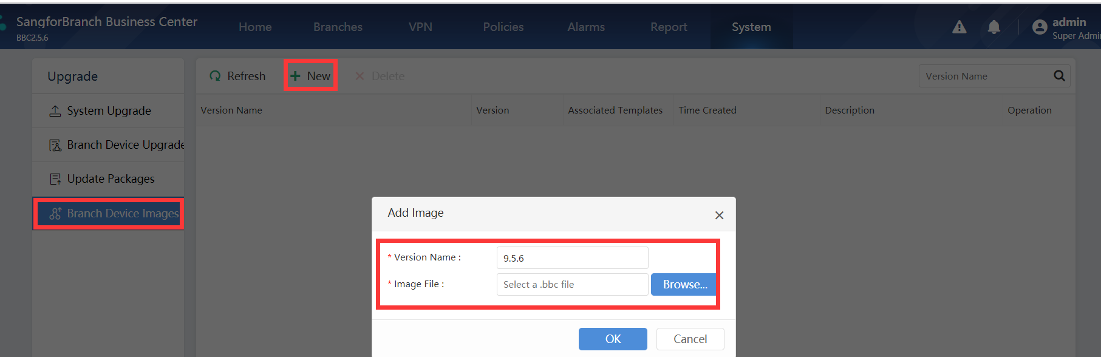
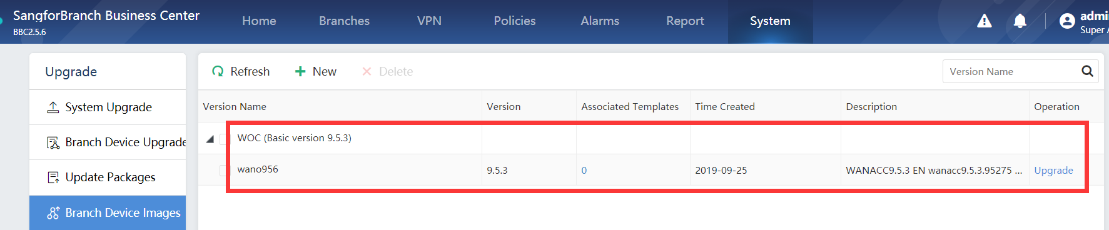
- Upload 9.5.6 firmware
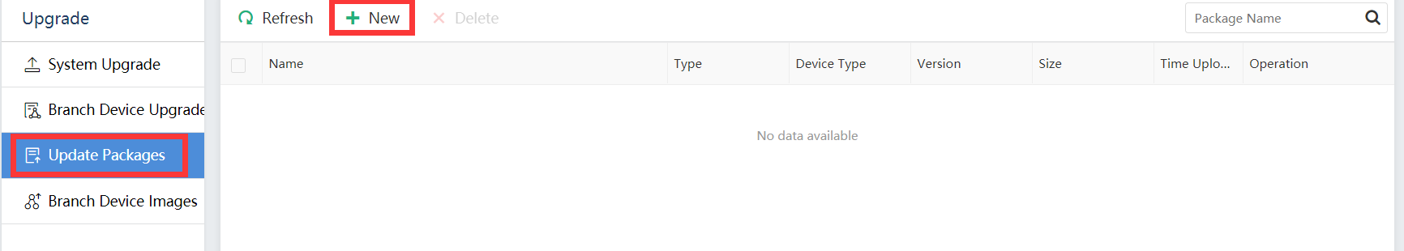
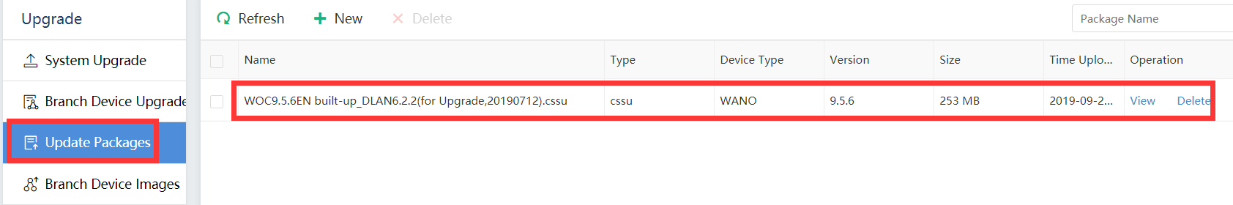
- Upgrade BBC file to 9.5.6
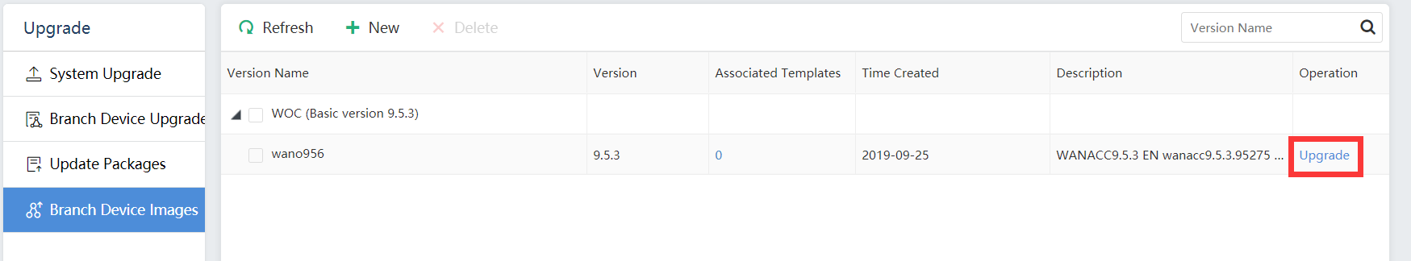
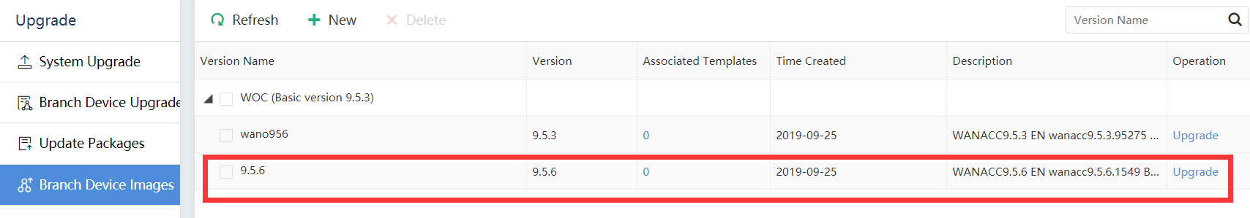
- Unified policy update
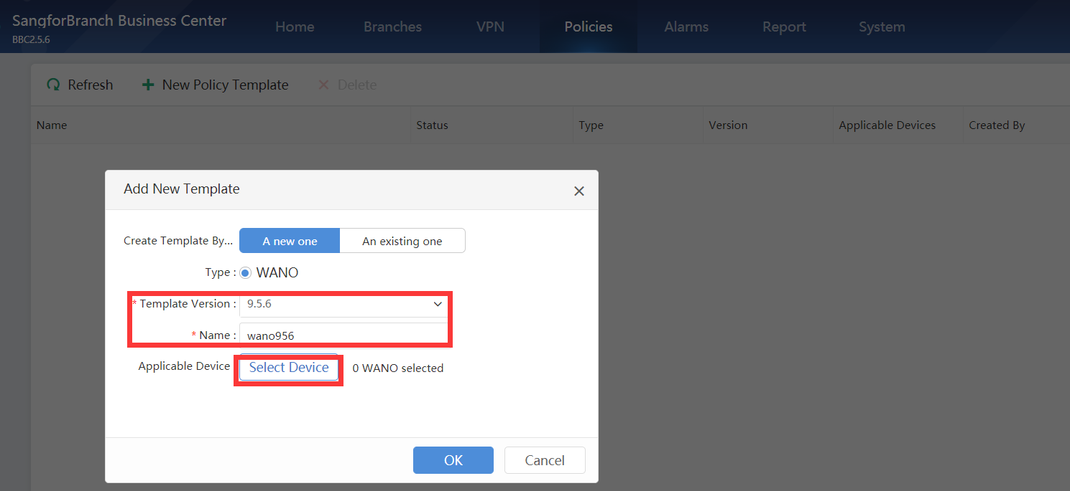
- Edit policy
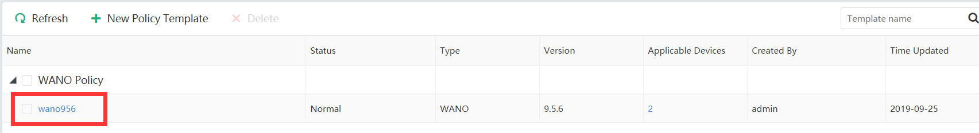

5 Testing & troubleshooting
(Please notice the unit showing in BBC is KBps, 1KBps=8Kbps, ISP bandwidth is bps.)

5.1 VPN Testing
VPN status check:
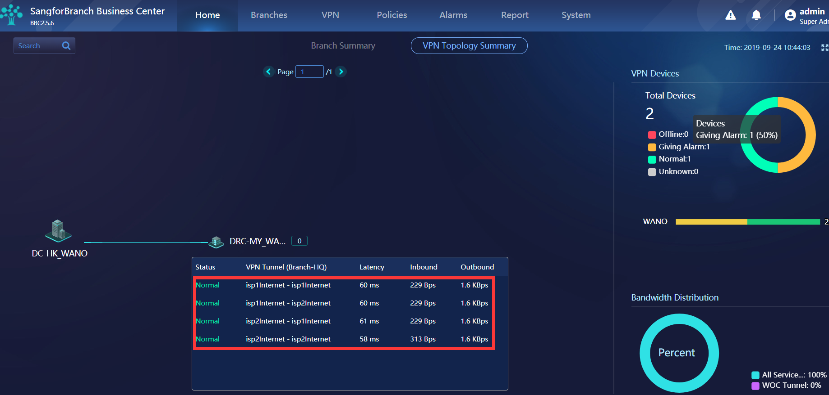
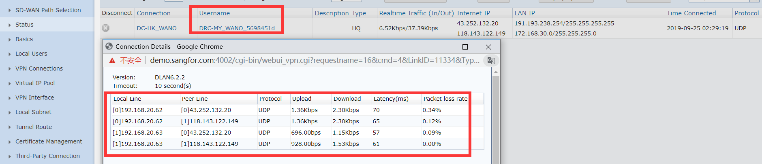

Reachable test:
Test ping or business access from user to server
Quality test:
- Test ping or user experience of business
- VPN speed test tool
Server side:
(1) Allow traffic: iptables -A INPUT -p tcp --dport 4008 -j ACCEPT
(2) Start service: conn_test_server -p 4008
(3) Close port after testing:
iptables -D INPUT -p tcp --dport 4008 -j ACCEPT
Client side:
(1) Start testing: conn_test_client -p 4008 -i xxx.xxx.xxx.xxx -c 100

Troubleshooting:
- Check whether configuration has successful push to device
Don’t forget click “push down VPN configuration” from BBC
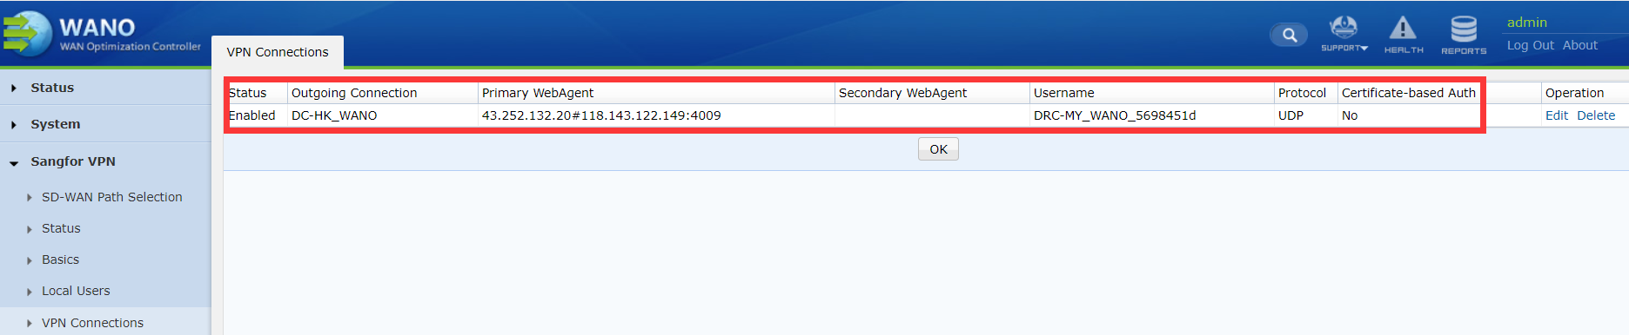
- Can’t build VPN tunnel
- VPN service port (default 4009) UDP & TCP reachable
(telnet test TCP port, capture packets in service side test UDP port)
- Check webagent & VPN username password
- Check VPN logs in both side device
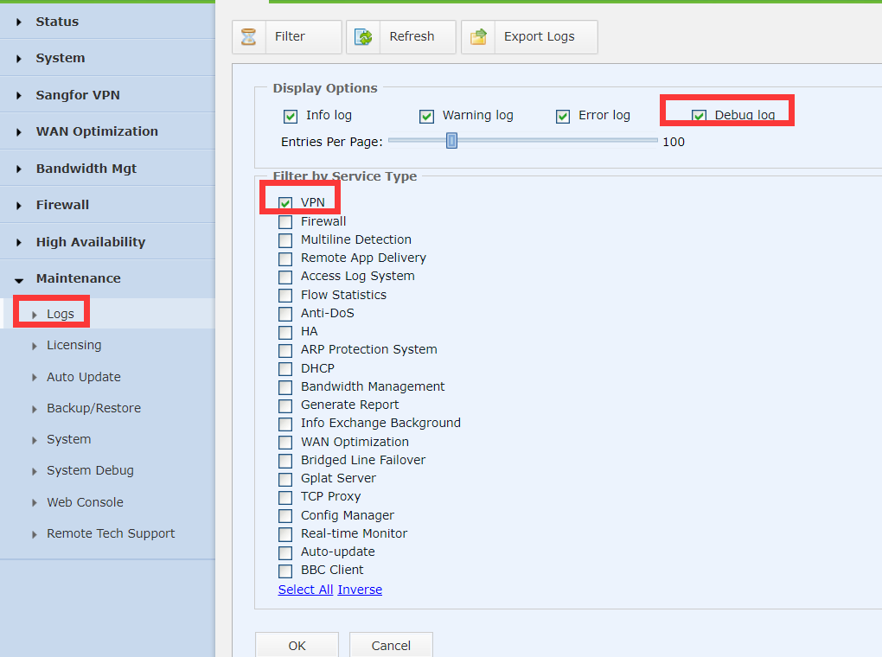

- VPN is unstable issue
- Latency & packets loss testing
(ping HQ public IP, intranet IP and internet public IP 8.8.8.8 from branch to HQ and HQ to branch)
- Change transmission protocol in vpn client side
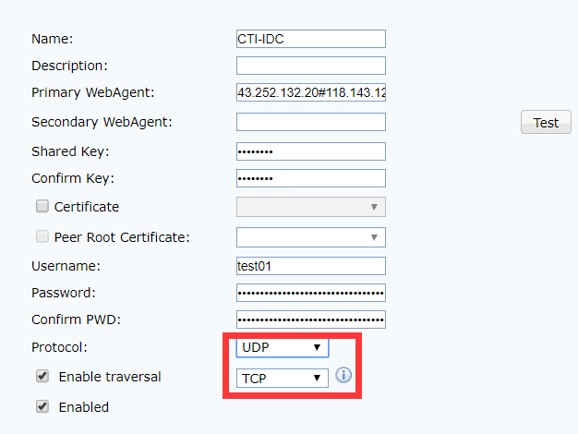
(In packets loss environment, TCP protocol may has high latency issue, UDP protocol may has high packets loss issue)
- Some user can’t visit some server
- Check both side VPN local subnet
- Check both side route to destination IP address
- Capture packets in both side vpntun/eth0 interface

4. VPN tunnel number issue
a. Check Multiple WAN policy, back to multiple WAN policy
b. Whether some link can’t build VPN, back to issue 1

5.2 SD-WAN path selection testing
PC(Client)—WANO(Client)<------>WANO(Server)—PC(Server)
Just only adjust SD-WAN path selection policy in WANO(Client) and don’t require VPN service restart

5.2.1 JPerf tool introduction:
- Two side prepare a windows PC and PC install JAVA
- Server side run Jperf.bat then run jperf.jar start jperf
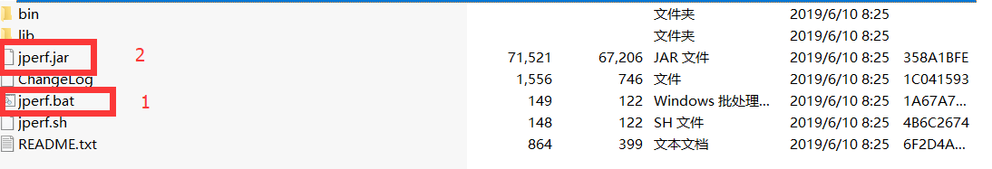
Choose Server and keep default configuration then to start JPerf.
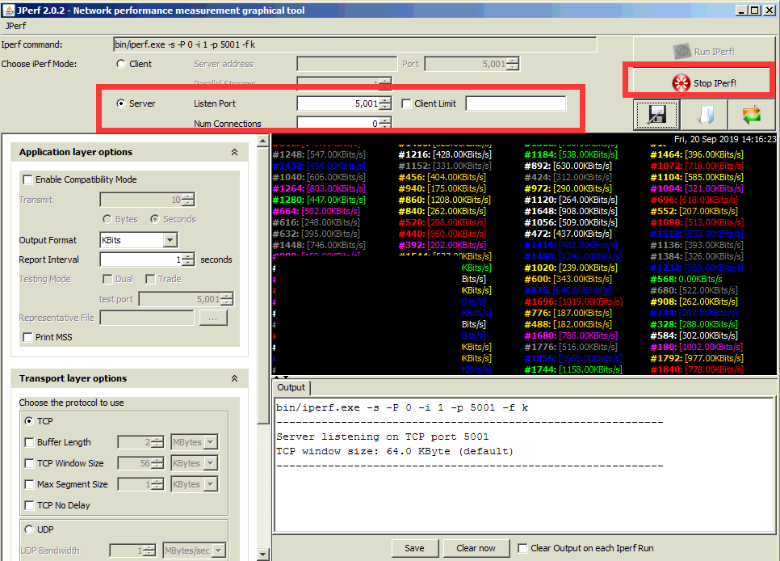
- Client side run Jperf.bat then run jperf.jar to start jperf
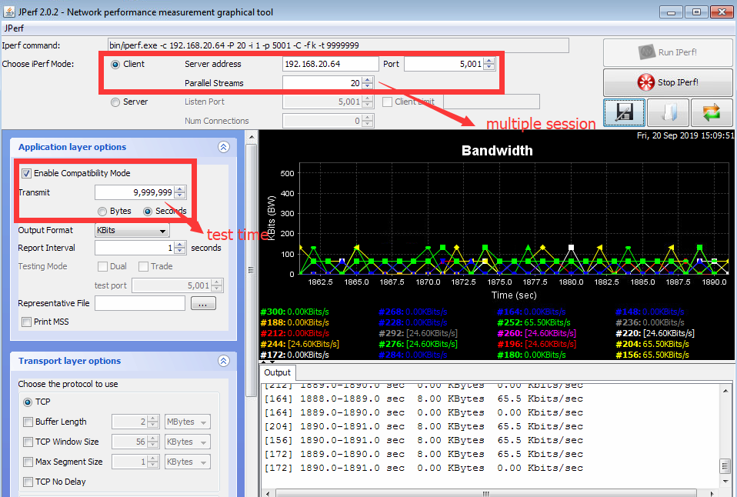

5.2.2 Specified line2 (line2 100Kb)
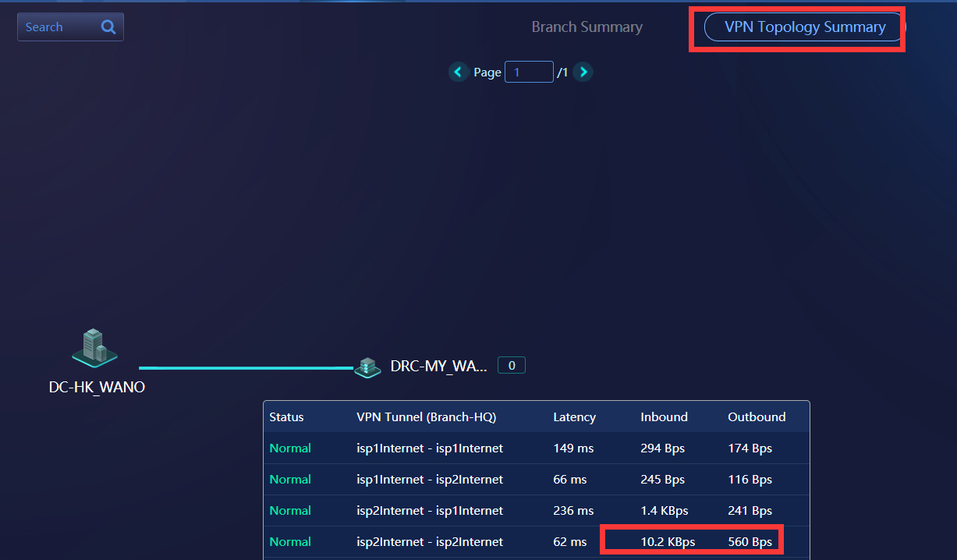
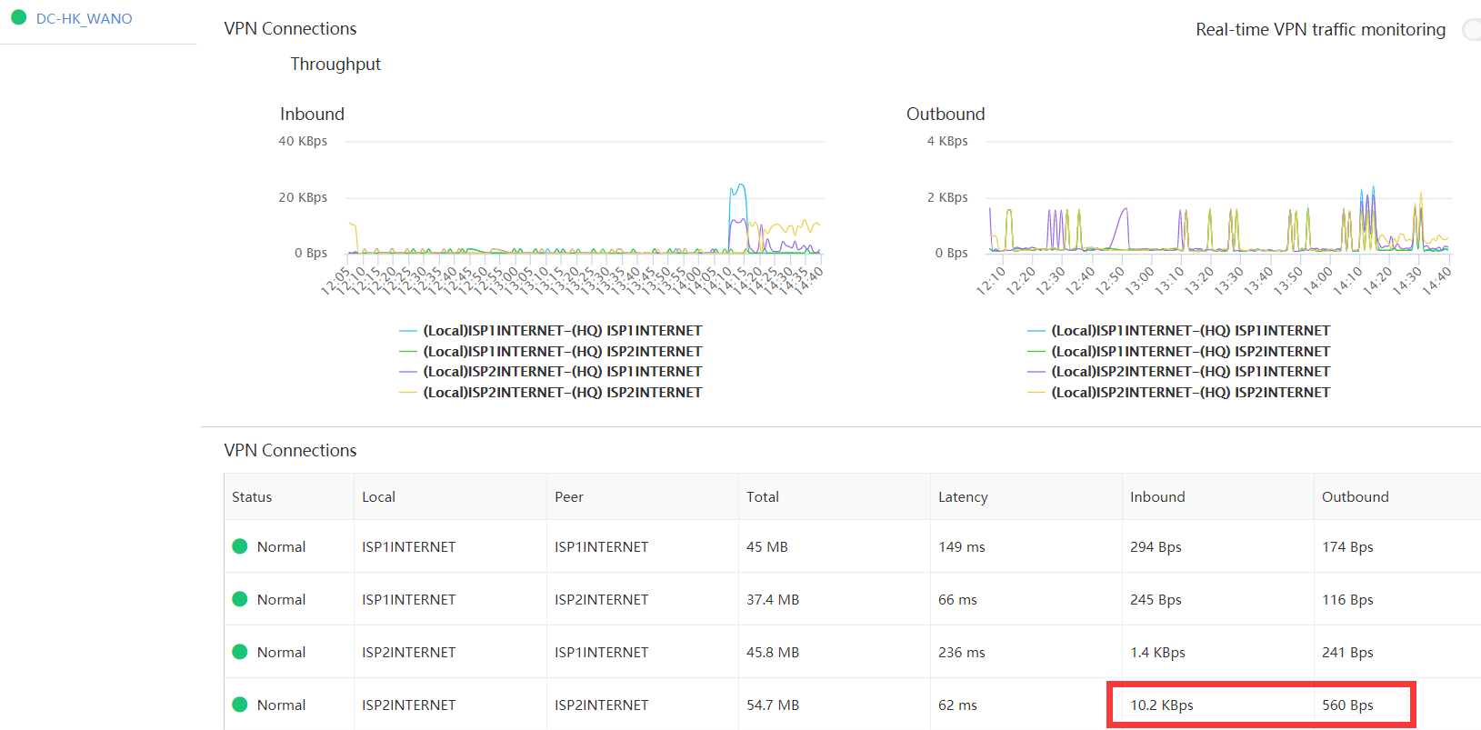

5.2.3 Fail-over test
Using pshell deny line 2 4009 port to disconnect line 2 when using specified line 2 policy.
（iptables -A INPUT -d 172.168.30.37 --dport 4009 -j DROP）
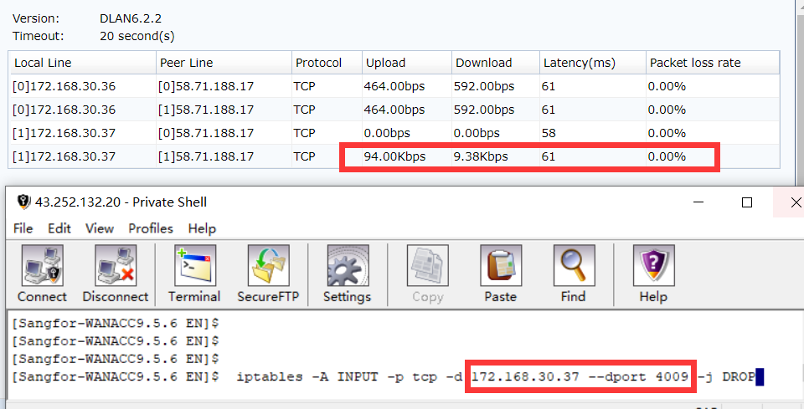
All vpn tunnels in line 2 are disconnect, traffic fail-over to line 1.
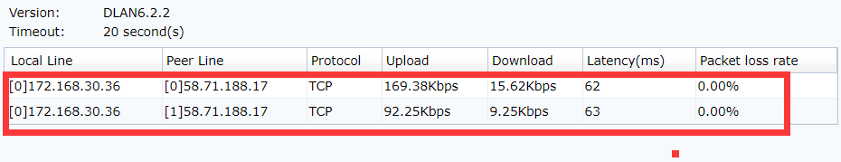
After fail-over test, we must restore iptables rules
（iptables -D INPUT -d 172.168.30.37 --dport 4009 -j DROP）
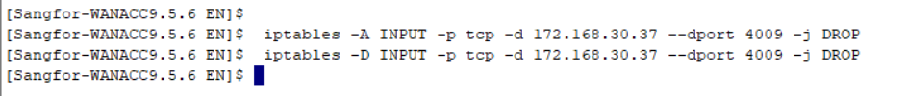

5.2.4 Prefer the optimal path
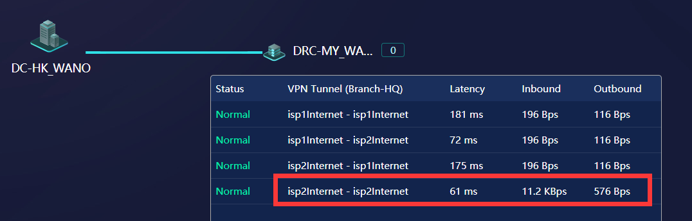
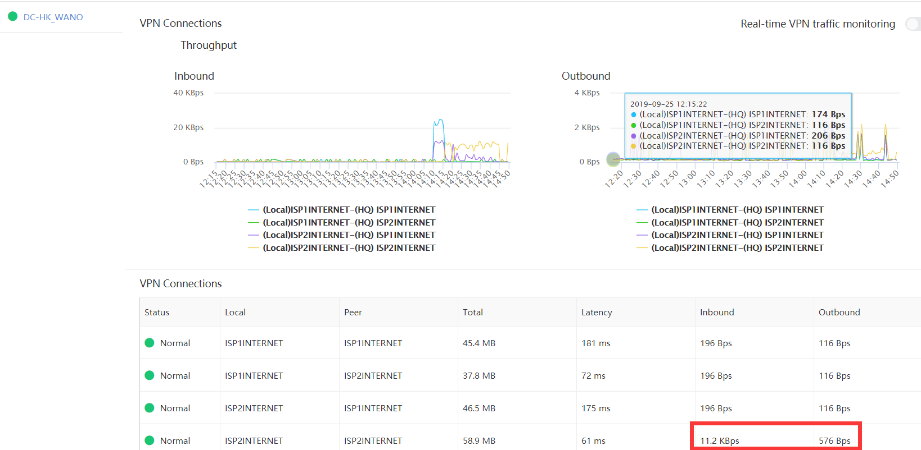

5.2.5 Based on bandwidth ratio test
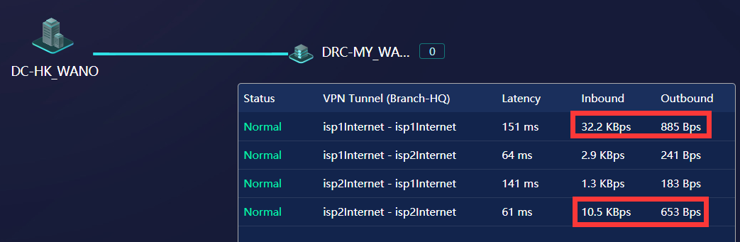
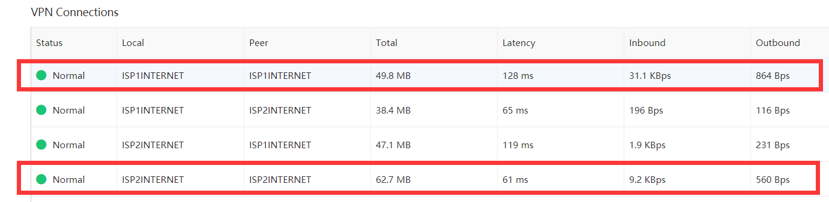

5.2.6 VPN tunnel bonding test
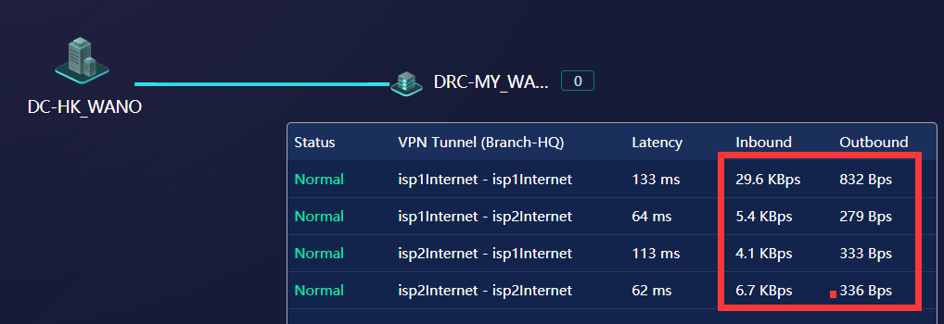
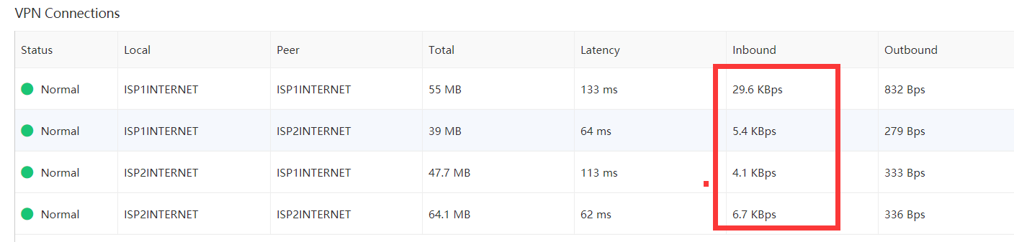

6 POC UAT & Conclusion

