Sangfor Troubleshooting Manual
V1.4

Sangfor Technologies Inc.

Review Records
Document Version | Date | Reviewed By
V1.3 | 2020-04-09 | Xu Gengda
V1.4 | 2020-08-31 | Luo Zhao

■ Copyright Notice
Unless otherwise specified, Sangfor reserves the copyright for all text, document formats, figures, images, methods, and processes in this document. No person or organization shall reproduce or reference any part of this document in any form or by any means without the prior written consent of the Sangfor project team.

Contents
1 Server Faults 5
1.1 Abnormal Server Restart 5
1.2 Abnormal Server Shutdown (Not Restarted) 5
2 Hard Disk Faults 6
3 Switch Faults 8
3.1 Hardware Faults 8
3.2 Switch Backend Faults 9
4 Abnormal Network Interface Status 9
4.1 Network Interface Status Indicator on the Gigabit Switch Is Orange 10
4.2 Network Interface Status Indicator Is Off 10
4.3 Optical Interface Status Indicator Is Off 10
4.4 Replace the Faulty Network Adapter on the Server 11
5 Power Supply Faults 11
5.1 Power Supply of a Server or One Power Supply of a Dual Power Supply Switch Is Faulty 11
5.2 Power Supply of a Single Power Supply Switch (Management/IPMI Access Switch) Is Faulty 12
5.3 PDU Is Powered on After a Power Interruption (Extreme Conditions) 12
6 Public Network Line Faults 12
6.1 Prerequisites for Business Switchover upon a Public Network Line Fault 13
6.2 Business Switchover Operations 13
6.2.1 SCP IP Address Switchover 13
7 Software Faults 15
7.1 Abnormal VM Shutdown 15
7.2 Abnormal VM Network Interface 15
7.3 Conflict Between the Platform IP Address and Peer Dedicated Line IP Address 16
7.4 Abnormal Shutdown of a Virtual Device (vAD/vAF/vSSL/vDas/VBas) 16
7.5 Abnormal Bypass of Tenants' Firewalls 17
7.6 Abnormal Data Collection Monitored by the Platform 17
8 SCP Breakdown 17
8.1 Background 17
8.2 Prerequisites 18
8.3 Operation Instructions for a Dedicated IP Address Pool in the Sharing Zone 19
8.3.1 Modify Network Configurations of the Secondary Node 19
8.3.2 Add the Secondary Node to the Faulty Cluster 19
8.3.3 Configure the IP Addresses of the Secondary Node in the Storage and Tunnel Networks 20
8.3.4 Scale out the Cluster VS Volume 22
8.3.5 Edit the Edge of the Cluster 22
8.3.6 Migrate VMs 22
8.3.7 Verify Business 23
8.3.8 Restore the Faulty Node 23
8.3.9 Business Switchback 23
8.3.10 Restore the Secondary Node 23
8.4 Operation Instructions for Single Node Managing Clusters 24
8.4.1 Modify Network Configurations of the Secondary Node 24
8.4.2 Check Relevant Information 25
8.4.3 Add the Secondary Node to the Faulty Cluster 26
8.4.4 Script Error Troubleshooting 28

- Server Faults
  - Abnormal Server Restart
  - View the IP address assignment table, go to the IPMI page, and collect IPMI logs.
  - Check whether the virtual machines (VMs) running on the faulty node are properly started. If the VMs are not properly started, migrate them to other nodes in the cluster.
  - Modify the Virtual Local Area Network (VLAN) configuration of the switch interface connected to the secondary node and change the IP address of the secondary node. Enable the secondary node and add it to the cluster.
  - Migrate all VMs running on the faulty node to the secondary node to prevent the recurrence of the abnormal restart.
  - Ask the data center O&M personnel to provide IPMI logs. Provide the remote environment.
  - Contact Sangfor technical personnel to remotely troubleshoot the server fault. Sangfor technical personnel will collect kernel and fault information and ask R&D personnel for processing.
  - After the fault is rectified, add the original node to the cluster and migrate business back to the original node.
  - Delete the secondary node from the cluster.
  - Abnormal Server Shutdown (Not Restarted)
  - View the physical cabling table. Modify the VLAN configuration of the switch interface connected to the secondary node to ensure that the configuration is the same as that of the faulty node. Change the IP address of the secondary node, enable the secondary node, and add it to the cluster.
  - Log in to the Sangfor Hyper-Converged Infrastructure (HCI) cluster and check whether the HA mode is enabled for all VMs, that is, check whether VM breakdown logs exist. If the HA mode is not enabled for a VM, manually enable the HA mode for the VM on the secondary node.
  - Check whether the power supply to the faulty server is normal. If the power supply is abnormal, remove and insert the power cable or replace the power module.
  - If the power supply is normal but the server does not start, check whether you can go to the IPMI page. If you can go to the IPMI page, collect logs on the IPMI page.
  - Provide the remote environment and contact Sangfor technical personnel for processing.
  - After the fault is rectified, add the original node to the cluster and migrate business back to the original node.
  - Delete the secondary node from the cluster.
- Hard Disk Faults
To check hard disks for faults, use aDeploy for inspection or view faults on Sangfor HCI.
Data stored in Sangfor virtual storage (VS) has two copies. When only one hard disk is faulty, VS can still be used. You only need to replace the faulty hard disk.
Prerequisite: The hard disk LED is turned on. The position of a faulty hard disk is displayed during inspection or on Sangfor HCI. You can log in to Sangfor HCI, go to Storage > Virtual Storage in the top navigation bar, click Physical Disks in the left-side navigation pane, click the faulty disk, and then click Turn on Disk LED to turn on the hard disk LED.
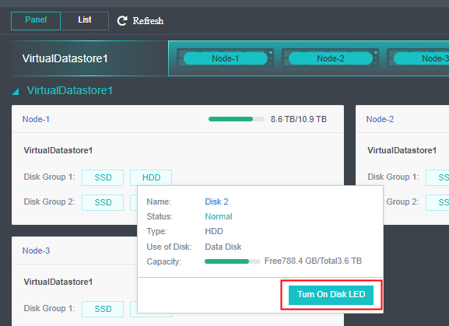
- Locate the hard disk whose LED is on, remove it, and insert a signed hard disk.: Before you insert a new hard disk, ensure that the hard disk has been signed. To check whether a hard disk is signed, run the vs_disk_verify/dev/sdx command in the backend. If OK is returned, the hard disk is signed.
- After the new hard disk is inserted, check whether the hard disk LED is normal on the IPMI page.
- If not, replace it with another hard disk.
- If yes, proceed with the next step.
- Replace the hard disk on Sangfor HCI.
- Click the faulty hard disk. After the hard disk is removed, the hard disk is displayed in red on Sangfor HCI.
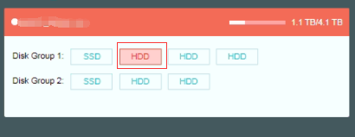
- Verify that the hard disk replacement dialog box appears.
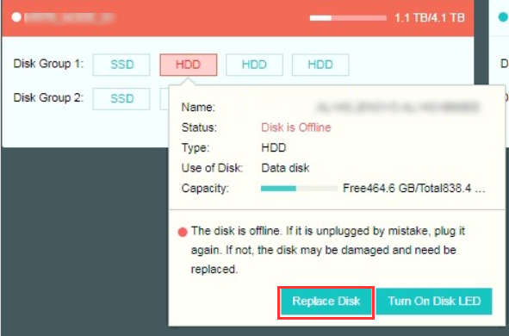
- Click Change Disk. The dialog box shown in the following figure appears.
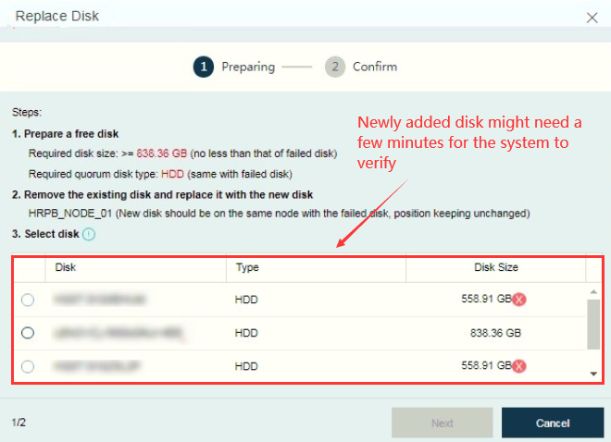
- Select a hard disk and click Next Step. Click Start. The tasks list will appear hard disk replacement task and VS data synchronization.
- Wait for the tasks to complete. Then, hard disk replacement is completed.
- If you encounter any problems during the preceding process, contact Sangfor technical support for processing as soon as possible.
- Switch Faults
Except for the IPMI switch, stacking and link aggregation are performed for the management, tunnel, and storage switches to ensure redundancy. Therefore, business is not affected when only one switch is faulty. However, to prevent multiple points of failure in a long time, we recommend that you repair the switch as soon as possible to ensure link redundancy.
  - Hardware Faults
    - Check whether the power supply to the switch is normal. If the power supply is abnormal, remove and insert the power cable or replace the power module.
    - If the power supply is normal but the switch does not start, check whether business running on the switch can be accessed. Check whether the load of other switches is normal.
    - If a standby switch exists, import the switch configurations that have been backed up to the standby switch and move the standby switch to the rack.
    - To move the standby switch to the rack, perform the following steps:
      - (Important) Set the stacking priority of the standby switch to be lower than that of the running switch.
      - Connect the two switches using a stacking cable and view the switch stacking status. Ensure that stacking is successful and the original running switch is the active switch in the stack.
      - Configure cross-switch link aggregation.
      - Connect and test each cable.
    - Contact technical support of the switch manufacturer and send the faulty switch for repair.
  - Switch Backend Faults
- For other faults such as ineffective switch configurations and failure to go to the switch management and configuration pages, contact Sangfor technical support or the switch manufacturer for processing.
- If the faulty switch is replaced with a standby switch, power on the standby switch and move it to the rack again by performing the following steps:
    - Stack the standby switch and the running switch and set the priority of the standby switch to be lower than that of the running switch.
    - Connect a stacking cable. After stacking is completed, connect the other stacking cable.
    - Connect other cables after all interfaces on the standby switch are disabled.
    - After the standby switch is configured, enable interfaces one by one and check whether data and business are normal.
- Abnormal Network Interface Status
Except for the IPMI interface, the management, tunnel, and storage interfaces are all aggregated on Sangfor HCI. Therefore, business is not affected when only one network interface is faulty. However, to prevent multiple points of failure in a long time, we recommend that you rectify the network interface fault as soon as possible to ensure link redundancy.
  - Network Interface Status Indicator on the Gigabit Switch Is Orange
If the network interface status indicator on the gigabit switch is orange, the network cable is not tightly connected or is in poor contact, resulting in a network negotiation failure. We recommend that you replace the jumper and connect the jumper.
  - Network Interface Status Indicator Is Off
    - Replace the network cable and check whether the fault is rectified.
    - Go to the switch and Sangfor HCI node configuration pages and check whether the electrical interface is disabled.
      - If the electrical interface is disabled, enable it and check whether the fault is rectified.
      - If the fault persists, proceed with the next step.
    - Connect the network cable to another normal electrical interface to determine which electrical interface is faulty.
    - If the electrical interface on the switch is faulty, use another electrical interface after modifying the switch configuration. If the electrical interface on the server is faulty, contact Sangfor to rectify the fault and check whether the server has spare electrical interfaces. If the server has spare electrical interfaces, migrate business to another normal electrical interface to ensure redundancy.
  - Optical Interface Status Indicator Is Off
    - Adjust the optical signal sending and receiving sequence of the optical fibers. Swap the positions of the two LC-LC optical fibers respectively used for sending and receiving optical signals.
    - If the optical interface status indicator is still off, go to the switch and Sangfor HCI node configuration pages and check whether the optical interface is disabled.
      - If the optical interface is disabled, enable it and check whether the fault is rectified.
      - If the fault persists, proceed with the next step.
    - Replace the jumper of the optical fiber.
    - If the optical interface status indicator is still off, connect the optical fiber to another normal optical interface to determine which optical interface is faulty.
    - If the optical interface on the switch is faulty, change the optical interface. If the optical interface on the server is faulty, contact Sangfor to rectify the fault and check whether the server has spare optical interfaces. If the server has spare optical interfaces, migrate business to another normal optical interface to ensure redundancy.
  - Replace the Faulty Network Adapter on the Server
    - View the physical cabling table. Modify the VLAN configuration of the switch interface connected to the secondary node to ensure that the configuration is the same as that of the faulty node. Change the IP address of the secondary node, enable the secondary node, and add it to the cluster.
    - Migrate VMs running on the faulty node to the secondary node.
    - Remove the server with a faulty network adapter, disassemble the server with the assistance of onsite O&M personnel in the data center, and replace the network adapter.
    - After verifying that the optical interface is normal, connect the network cable and move the server to the rack again. Add the node to the cluster.
    - Migrate VMs back to the node.
    - Delete the secondary node from the cluster
- Power Supply Faults
  - Power Supply of a Server or One Power Supply of a Dual Power Supply Switch Is Faulty
Such faults are classified as follows:
- Power Indicator of the Power Module Is Off
Troubleshooting procedure:
- Remove and insert the power plug and the corresponding power distribution unit (PDU) power cord plug. If the power indicator turns to green, the fault was caused by a loose power cable. If the power indicator turns to orange, follow the instructions in the following to process the fault.
- If the power indicator is still off, replace the power cable. If the fault persists, the power supply is faulty. Remove the power module for repair.
- Power Indicator of the Power Module Is Orange
Troubleshooting procedure:
- Remove the power cable and insert it after 1 minute. If the power indicator turns to green, the fault was caused by a loose power cable.
- If the power indicator is still orange, remove the power cable and then remove the power module. After 1 minute, insert the power module and connect the power cable. If the power indicator turns to green, the fault occurred because the power supply did not supply power after being used for a long time. It can still be used only if the power indicator is green.
- If the power indicator is still orange, repeat the preceding step. If the fault persists, contact Sangfor to repair the power module.
  - Power Supply of a Single Power Supply Switch (Management/IPMI Access Switch) Is Faulty
- Remove and insert the PDU power cord plug of the power cable. If the switch starts properly, the fault was caused by a loose power cable.
- If the switch cannot be started, contact Sangfor to repair the power module.
- If a standby switch is available, connect the power cable to the standby switch.
  - PDU Is Powered on After a Power Interruption (Extreme Conditions)
Troubleshooting procedure:
      - Preferentially start the stacked switches. Start the switches with higher priorities and then the switches with lower priorities. If not, stacking may fail.
      - Start non-stacked switches.
      - Ensure that switches are properly stacked and required parameters are properly set. Then, start the server.
      - Contact Sangfor technical support to check whether services are normal. Assist in enabling the services.
- Public Network Line Faults
  - Prerequisites for Business Switchover upon a Public Network Line Fault
- The data center supports multiple lines.
- Multiple IPSec lines are configured for the virtual private network (VPN) device.
  - Business Switchover Operations

6.2.1 SCP IP Address Switchover
Customers in the Guangzhou Sangfor Cloud Platform (SCP) area can directly access the SCP address through a jump server.
- Go to Resources > Network > Elastic IP Pools in the top navigation bar. On the Elastic IP Pools tab, click Create Elastic IP Pool. In the dialog box that appears, specify the backup CIDR block and gateway, and associate the IP address pool with resource pools that require business switchover.
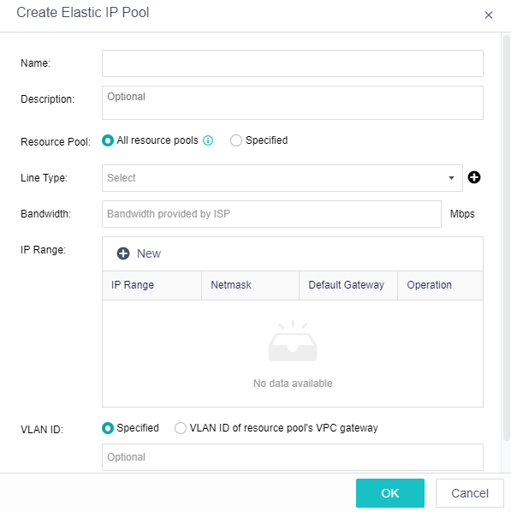
- Log in to the tenant VPC console, locate the tenant who requires a backup line, and check whether the public IP addresses are sufficient. If not, increase the quota.
- On SCP, go to Resources > Networking > Topology in the top navigation bar. Select the tenant who requires business switchover, access the VPC network topology, and assign the backup line IP address to SCP of the tenant.
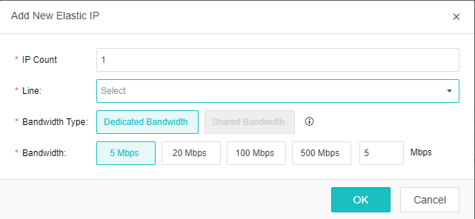
- Click a network egress and click Settings in the lower right corner to go to the public IP address management page. Bind the backup line IP address to the SCP of the tenant and set it as the network egress IP address.
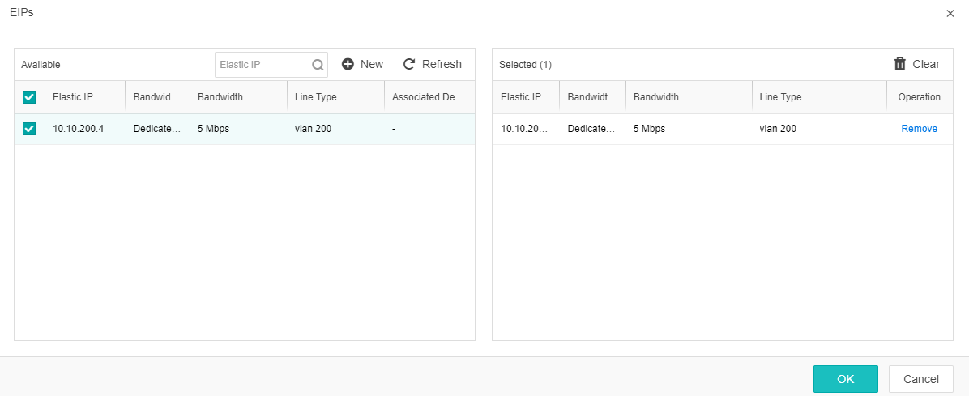
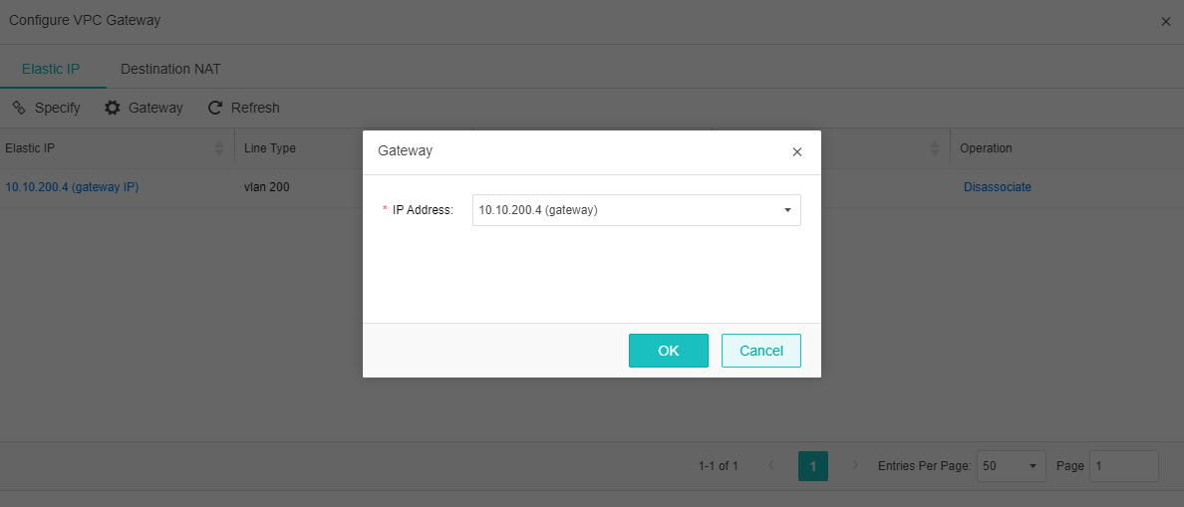
- Perform interface mapping for the bound IP address.
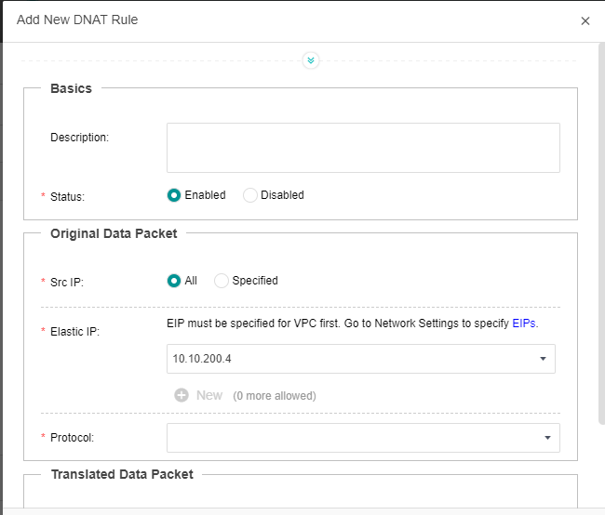
- Contact customers to update the IP address to which A records point the domain name to switch over public network services.
- Software Faults
  - Abnormal VM Shutdown
➢Scenario
A tenant's VM shuts down abnormally. This is because the VM generates core dumps or the process is killed due to libvirtd upgrade or restart.
➢Solution
- Click Power On in the VM section.
- Run nova show $instance_id in the backend.
- Run nova start $instance_id in the backend.
  - Abnormal VM Network Interface
➢Scenario
A network upgrade (SDN restart) causes network disconnection and network adapter exceptions on the VM.
When ethtool eth0 is run on the VM, "Link detected: no" is displayed.
➢Solution
- Run nova stop $instance_uuid.
- Run nova start $instance_uuid.
  - Conflict Between the Platform IP Address and Peer Dedicated Line IP Address
➢Scenario
As tenant firewalls are bypassed, the IP addresses of some custom enterprise dedicated lines conflict, which affects users' business.
➢Solution
- Manually disable and enable the firewalls on the topology page to trigger restoration.
- Run ./xc.sh check_vaf_bypass in the backend to view bypassed firewalls.
- Run ./xc.sh check_vaf_bypass do_recover to restore the firewalls.

7.4 Abnormal Shutdown of a Virtual Device (vAD/vAF/vSSL/vDas/VBas)
➢Scenario
A tenant's virtual device shuts down abnormally. This is because the VM generates core dumps or the process is killed due to libvirtd upgrade or restart.
➢Solution
- Run the following commands in the backend:
sfdev bas-show $sfdev_uuid
das-show
vad-show
vaf-show
vpn-show
- Run the following commands in the backend:
sfdev vaf-update --admin_state_up True
bas-update
das-update
vad-update
vaf-update
vpn-update
woc-update

7.5 Abnormal Bypass of Tenants' Firewalls
➢Scenario
If the rabbitmq-server or sfdev service is abnormal, tenants' firewalls will be bypassed and the firewall function does not take effect.
➢Solution
- Run ./xc.sh check_vaf_bypass in the backend to view bypassed firewalls.
- Run ./xc.sh check_vaf_bypass do_recover to restore the firewalls.

7.6 Abnormal Data Collection Monitored by the Platform
➢Scenario
Due to accumulated messages in the message queue, data collection is abnormal after MongoDB is restarted.
➢Solution
In the backend, shut down the rabbitmq-server service on the secondary node and allow the queue to be scheduled to the primary rabbitmq-server service:
systemctl status rabbitmq-server
systemctl stop rabbitmq-server

8 SCP Breakdown
Applicable scope: The breakdown node has a secondary node outside the cluster, and the major system version of the secondary node is the same as that of the faulty node.

8.1 Background
A memory fault or motherboard hardware fault may cause a Sangfor HCI node to shut down. To minimize the impact on customers' business when the node is broken down due to another hardware fault, Sangfor configures hot backup nodes in and outside the cluster for each data center.
Hot backup node in the cluster: This solution is adopted for customers' clusters that contain more than 10 nodes, single node managing clusters, and sharing clusters. In this solution, the secondary node is added to the cluster. When a fault occurs, automatic HA of VMs is performed.
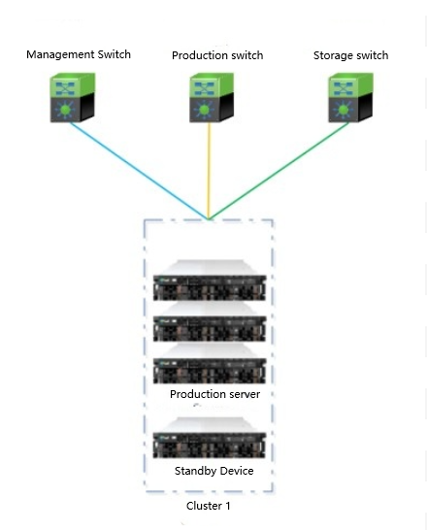
Figure 1 Hot backup node in the cluster
Hot secondary node outside the cluster: This solution is adopted for customers excluded in the preceding scenarios. In this solution, multiple clusters share one secondary node. When a fault occurs in a cluster, network configuration is adjusted to add the secondary node to the cluster.
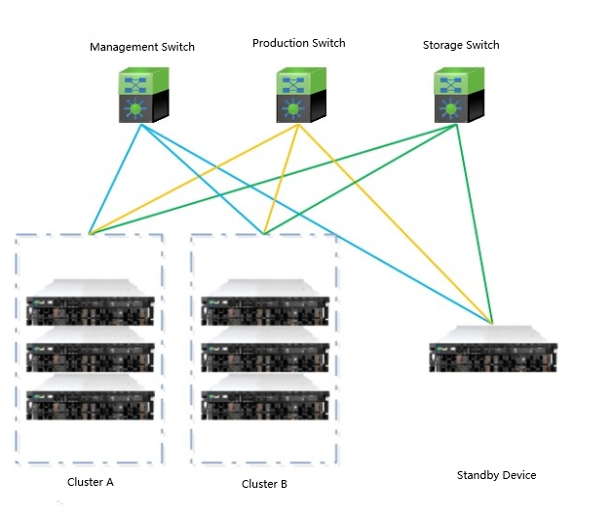
Figure 2 Hot backup node outside the cluster

8.2 Prerequisites
The number of nodes contained in a Sangfor HCI cluster is less than 10.
The cluster version is the same as the major version of the secondary node.
Cascading interfaces between data center switches allow data from VLANs of all clusters.

8.3 Operation Instructions for a Dedicated IP Address Pool in the Sharing Zone

8.3.1 Modify Network Configurations of the Secondary Node
Access the secondary node through the secondary node console or IPMI page, modify the management network IP address and VXLAN IP address of the secondary node, and change the VLAN of storage, tunnel, and management switches connected to the secondary node to the VLAN of the faulty cluster to implement layer 2 connection between the secondary node network and faulty cluster.

Change the IP addresses to those predefined. For more information about the predefined addresses, see the secondary node record table in the following path:
SVN\Equipment Room Deployment\Data Center Management Information Document\Data Center Platform Information\SCP Secondary Node Information\Secondary Node Data.xlsx

8.3.2 Add the Secondary Node to the Faulty Cluster
When a cluster is faulty, nodes cannot be added to the cluster through the web client. Run the corresponding command in the Sangfor HCI cluster backend to add a node.
Run the following command in the /sf directory in the backend of the cluster main control node.
Use the secondary node IP address and the admin password of the secondary node for command execution.
hostHA.pl add 172.24.128.69 -p Admin@123 -ignore 1
On the web client, confirm that the node is added and proceed with the next step.
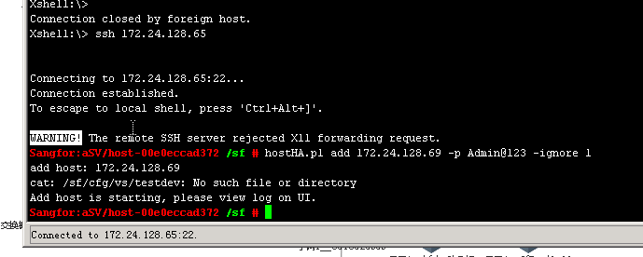

8.3.3 Configure the IP Addresses of the Secondary Node in the Storage and Tunnel Networks
Configure the storage network IP address.
Since the VS volume is abnormal, network addresses need to be assigned through a script but cannot be assigned on the web client. Run the following script in the backend of the secondary node to configure the storage network address. Note that VS networks have two network interfaces. The following shows an example. If the script displays "success", the address is successfully configured. If an exception occurs, contact R&D engineer Tan Libin.
./root/vsts_config_vsnet.py --nics eth1 --storage_ip 10.21.81.34 --Single network interface in the storage network
./root/vsts_config_vsnet.py --nics eth1,eth2 --storage_ip 10.21.81.34 --Dual network interfaces in the storage network
Add the storage network interface after nics and the cluster reserved storage IP address after ip.
Upload the script to the /root directory in the backend of the secondary node and add the execute permission on the script.
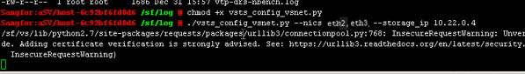
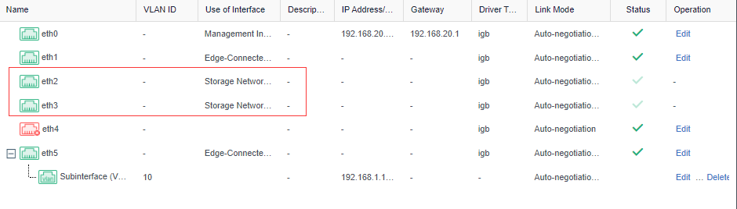
Configure the tunnel network IP address.
Access the Sangfor HCI cluster and go to Nodes > Communication Interfaces in the top navigation bar. Check whether the overlay network interface name, address, and mask of the added secondary node are correct. If not, change the overlay network interface to the real one.
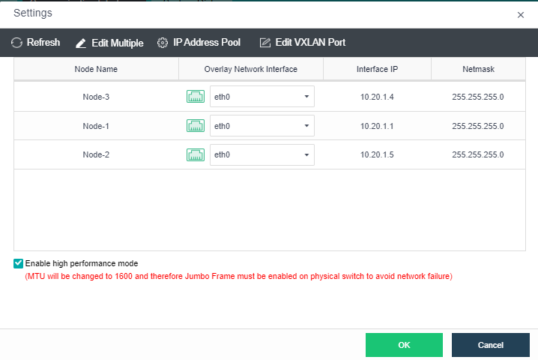
If no IP address pool is configured for the overlay network interface, manually configure the IP address as follows: Go to Nodes > Communication Interfaces > Overlay Interfaces and click Settings in the Operation column.
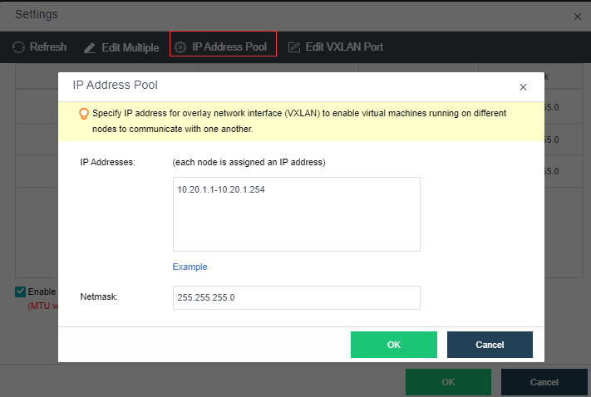
Log in to the backend after the configuration is complete.
In the CLI of the secondary node, access the tunnel interface IP addresses of other Sangfor HCI nodes in the cluster from the secondary node to check whether the network is normal.

8.3.4 Scale out the Cluster VS Volume
On the Virtual Storage tab, click Expand Capacity and add the newly added node to the VS volume.
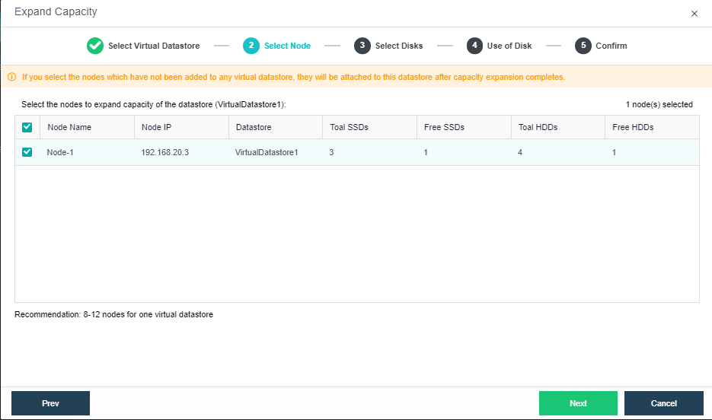

8.3.5 Edit the Edge of the Cluster
In the cluster virtual network, add the network interface of the newly added node to the edge.
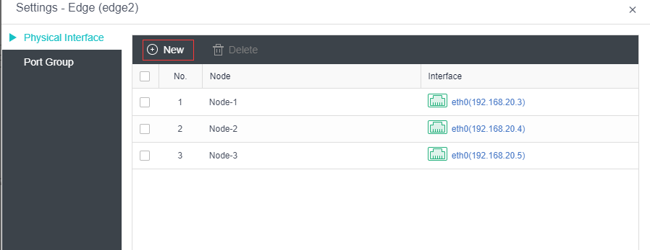

8.3.6 Migrate VMs
Migrate VMs running on the breakdown node to the newly added secondary node.
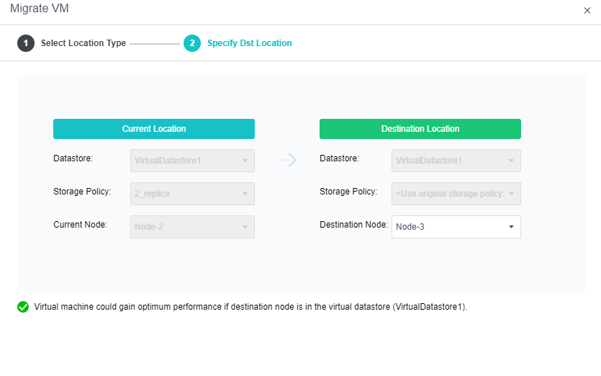

8.3.7 Verify Business
Confirm with the project team whether VM business running on the secondary node id normal.

8.3.8 Restore the Faulty Node
Repair the faulty node and start it after it is repaired.

8.3.9 Business Switchback
Run the restored node for one day. If no fault occurs, switch the business back to the node.

8.3.10 Restore the Secondary Node
- After business is switched back to the original node, set the secondary node to the single node maintenance mode and confirm that no network device or route exists on the secondary node. Then, exit the single node maintenance mode and remove the secondary node from the cluster.
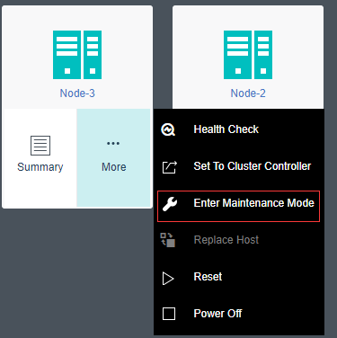

- Restore the network adapter configuration of the secondary node and VLAN configuration of the switch.

8.4 Operation Instructions for Single Node Managing Clusters
When a single node managing cluster is faulty, add the secondary node to the cluster by executing a script in the backend. If the secondary node is added through the web client, the router cannot be started and the network is unreachable.

8.4.1 Modify Network Configurations of the Secondary Node
Access the secondary node through the secondary node console or IPMI page, modify the management network IP address and VXLAN IP address of the secondary node, and change the VLAN of storage, tunnel, and management switches connected to the secondary node to the VLAN of the faulty cluster to implement layer 2 connection between the secondary node network and faulty cluster.
Change the IP addresses to those predefined. For more information about the predefined addresses, see the secondary node record table in the following path:
SVN\Equipment Room Deployment\Data Center Management Information Document\Data Center Platform Information\SCP Secondary Node Information\Secondary Node Data.xlsx

8.4.2 Check Relevant Information

Check Authorization for Nodes Not in the Faulty Cluster
Go to System > Licensing. In the left-side navigation pane, go to Licensing > Cluster License. Click the name of a cluster. On the page that appears, check whether the value of the Host CPUs parameter is the same as the actual number of node CPU cores in the cluster. A data center uses 2U devices. When a node is added to the cluster, two CPU cores will be added. If the node CPU core quota is insufficient, the node will fail to be added, and router HA will fail. The following figure shows authorization.
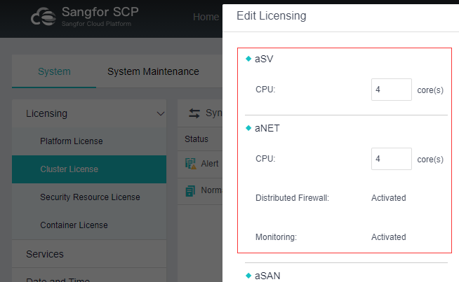
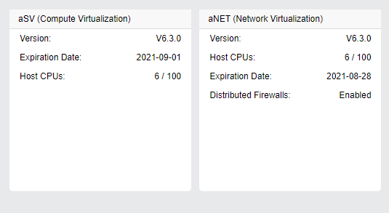

Check Communication for Nodes Not in the Faulty Cluster
Go to Nodes > Communication Interfaces > Overlay Network Interface and click Settings. In the Settings dialog box, click IP Address Pool. In the IP Address Pool dialog box, check whether an IP address pool has been configured and the number of reserved IP addresses is greater than the number of nodes.
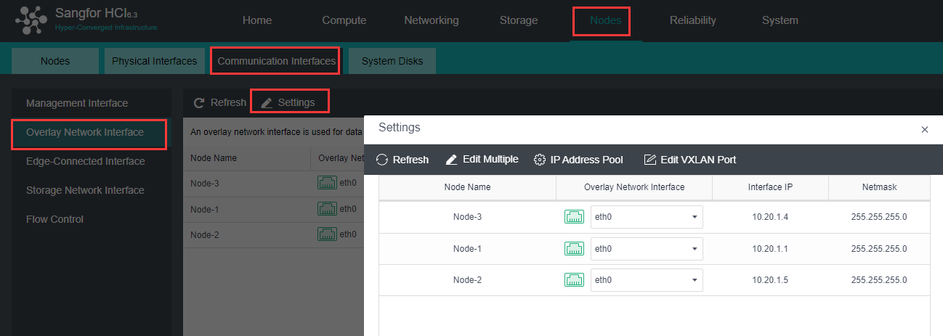
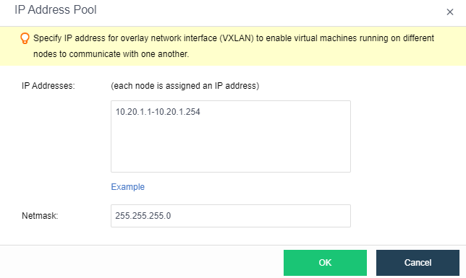

Check the Secondary Node Version and Network Configurations
Check whether the secondary node version is consistent with that of the faulty cluster, the management interface IP address of the secondary node is in the same CIDR block as the faulty cluster and is pingable, and whether the secondary node only has a system disk and does not configure VS or has cleared VS configuration.

8.4.3 Add the Secondary Node to the Faulty Cluster
Contact the delivery team in China to obtain the backup_node_HA_expand_v2.pl script file.

Copy the Script File to the Backend
Upload the script to the backend of the Sangfor HCI cluster main control node (for example, in the /home path) and make the script executable.
chmod +x backup_node_HA.pl

Run the Script
The following table describes the script execution parameters.
Parameter | Type | Mandatory or Optional | Description | Remarks
help/-help/--help/-h | - | - | Prints prompt information. | Help command.
-ip | ipv4 | Mandatory | Secondary node IP address.
-pwd | string | Mandatory | Password of the secondary node. | Special characters in the password must be enclosed using quotation marks.
-nics | string | Mandatory | Storage network interface of the secondary node. | Use a comma (,) to separate two physical network interfaces used to connect to the storage switch.
-fault | string | Mandatory | IP address of the faulty node. | IP address of the faulty node in the cluster.
-f | string | Optional | Indicates whether to forcibly add a node. | Ensure that the secondary node is not added to other clusters. Value 1 of this parameter indicates forcible addition.
For example, the node whose IP address is 200.201.2.1 in a cluster is faulty, and a new node needs to be added to the cluster. The new node's IP address is 200.201.2.2, password is Admin@123, and has the eth0 and eth1 storage network interfaces. According to the preceding parameter table, the configuration command is as follows:
./backup_node_HA.pl -ip 200.201.2.2 -pwd Admin@123 -nics eth0,eth1 -fault 200.201.2.1 -f 1
The following figure shows the execution result.
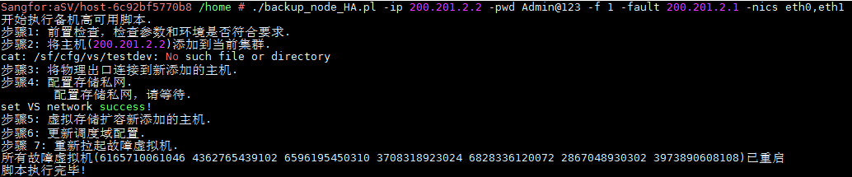

8.4.4 Script Error Troubleshooting
The log file is stored in /sf/log/today/sfvt_backup_node_HA.pl.log. If an execution error occurs, troubleshoot the fault based on error information described in the following table.
Step | Error Information | Description | Troubleshooting
Check relevant information | Parameter check failed. | The corresponding parameter is not entered, or the parameter format does not meet requirements. | Correct the parameter.
Check relevant information | Environment check failed. | 1. The script does not run on the main control node. | Change the running position of the script or switch the main control node.
Check relevant information | Environment check failed. | 2. The faulty node is not in a cluster. | Correct parameters.
Check relevant information | Environment check failed. | 3. The network of the node to be added is not reachable. | Check the switch settings and secondary node IP address.
Add the secondary node to the cluster | Check before adding the secondary node failed. | Check backend logs to locate the fault. | 1. If "Failed to obtain the xxx version information" is displayed, the password may be incorrect.  2. Troubleshoot the fault based on the error information.
Add the secondary node to the cluster | Node addition failed or timed out. | 1. The node to be added already exists in a cluster or has related configurations and cannot be added to the faulty cluster.  2. Calling an API to add the node failed or timed out. | 1. Set the f parameter to 1 to forcibly add the node. Check backend logs to view the detailed causes. Log in to the node to be added and process the error.  2. Check backend logs and process the error based on logs.
Connect the network interface on the secondary node to the edge | Failed to connect the physical network interface to the newly added node. | Failed to call an API to add the network interface on the secondary node to the edge. | Check backend logs and process the error based on logs.
 | The cluster must have two edges. | The number of edges is not 2. | Reconfigure edges.
Configure the VS network | Failed to obtain the private storage network configurations. | The private storage network configurations cannot be obtained from the backend. | Try the operation again. If it still fails, contact Sangfor development personnel for processing.
Configure the VS network | Failed to configure the private storage network. | The private storage network cannot be configured in the backend. | Try the operation again. If it still fails, contact Sangfor development personnel for processing.
Scale out the VS volume | Failed to scale out the VS volume. | VS is not configured for the faulty node. | Correct parameters.
Scale out the VS volume | Failed to add the newly added node to the VS or the operation timed out. | Failed to call an API to scale out the volume. | Check backend logs and process the error based on logs.
Update the scheduling domain | No scheduling domain is configured for the faulty node. | The faulty node does not belong to any scheduling domain. | VMs on the faulty node cannot be started. Manually modify the VM configuration file and scheduling domain configuration file.
Update the scheduling domain | Failed to update the scheduling domain configuration. | Calling an API to update the scheduling domain failed. | Check backend logs and process the error based on logs.

