

Sangfor NGAF
User Manual

Product Version | x.x.x
Document Version | 01
Released on | Jun. 01, 2021

Sangfor Technologies Inc.

Copyright © Sangfor Technologies Inc. 2021. All rights reserved.
Unless otherwise stated or authorized, Sangfor Technologies Inc. (hereinafter referred to as "Sangfor") and its affiliates reserve all intellectual property rights, including but not limited to copyrights, trademarks, patents, and trade secrets, and related rights to text, images, pictures, photographs, audio, videos, charts, colors, and layouts as presented in or concerning this document and content therein. Without prior written consent of Sangfor, this document and content therein must not be reproduced, forwarded, adapted, modified or displayed or distributed by any other means for any purpose.
Disclaimer
Products, services or features described in this document, whether wholly or in part, may be not within your purchase scope or usage scope. The products, services or features you purchase must be subject to the commercial contract and terms as agreed by you and Sangfor. Unless otherwise provided in the contract, Sangfor disclaims warranties of any kind, either express or implied, for the content of this document.
Due to product version upgrades or other reasons, the content of this document will be updated from time to time. Unless otherwise agreed, this document is used for reference only, and all statements, information, and recommendations therein do not constitute any express or implied warranties.

Change Log
Date | Change Description
Jun. 01, 2021 | This is the first release of this document.

Contents
Change Log 1
About This Document 3
1 General Requirements 4
1.1 Document File Name 4
1.2 Product Version 4
1.3 Fonts 4
2 Cover Page Formatting 6
3 Formatting for Headings 7
4 Other Formatting 10
4.1 Body Text 10
4.2 Tables 11
4.3 Notes 13
4.3.1 Note Formatting 13
4.3.2 Note Icons 14
4.4 Steps and Lists 15
4.4.1 Steps 15
4.4.2 Bulleted Lists 15
4.4.3 Numbered Lists 16
4.5 Footer and Header 16
4.6 Table of Contents Formatting 17
5 Importing Formatting Styles 18

About This Document
This document is about the formatting requirements for Sangfor English documentation. The information in this document may change periodically. Check the Change Log page to see what is new in this version.
This document includes all the styles and formatting required for English documentation, and contains the information needed to make each style. You can use the Format Painter tool to copy styles from this sample document and apply them to the document you are translating. You can also import all of the styles directly into the document you are translating (see Importing Formatting Styles).

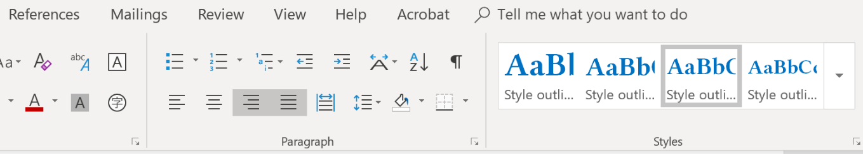
- General Requirements
  - Document File Name
The file name of the document should use the following format:
SANGFOR_Product_Version_Document Title_Language_Date
Examples
- SANGFOR_IAG_V11.9_User Manual_EN_20171225
- SANGFOR_IAG_V11.9_XXXXX_EN_20180110
  - Product Version
Every document should be written with the latest product version unless there are special instructions to use a different version.
  - Fonts
Use the font type "Open Sans" in all Sangfor documentation. Open Sans can be downloaded from the following site:
fonts.google.com/specimen/Open+Sans?preview.text_type=custom

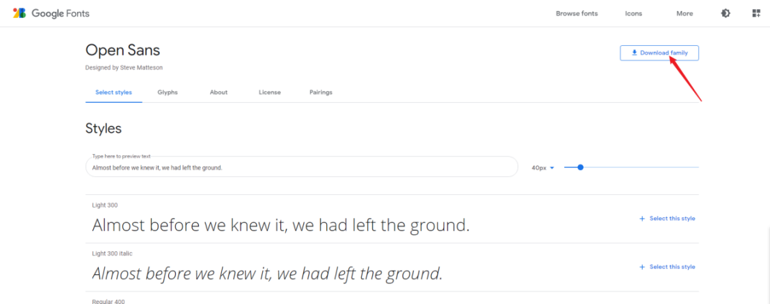

Install the downloaded font family on your computer according to the steps given in the following site:
https://support.microsoft.com/en-us/office/add-a-font-b7c5f17c-4426-4b53-967f-455339c564c1
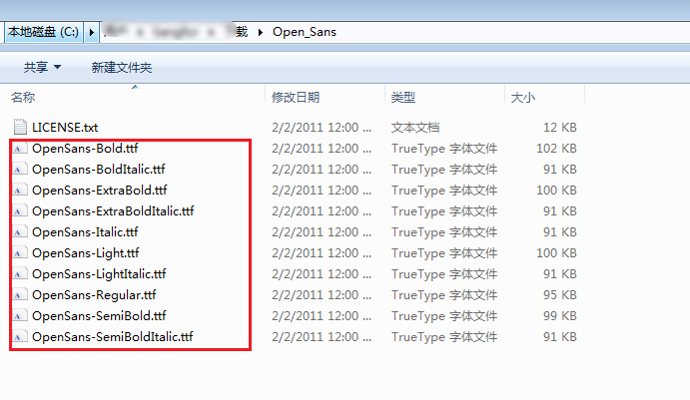
After the Open Sans font family is installed, restart your WPS or Microsoft Word and select the Open Sans font as shown in the screenshot.
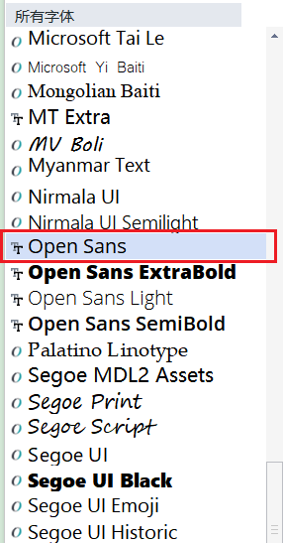

- Cover Page Formatting
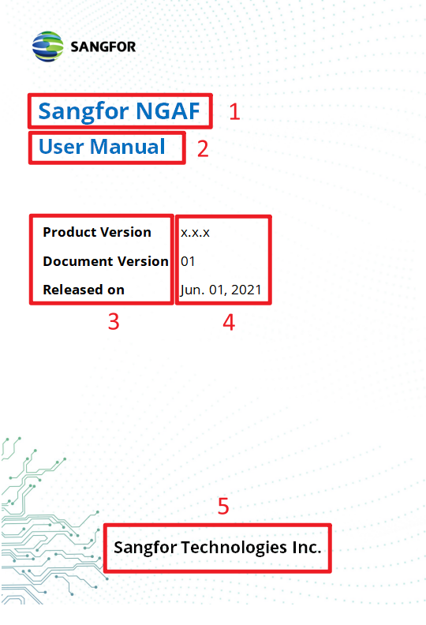
No. | Cover Element | Description
1 | Cover Title  Style Name: SF_Cover Title 1  Sangfor NGAF | Font: Open Sans | Size: 26 | Bold  Color (Custom): Red: 0 | Green: 112 | Blue: 192  Alignment: Left  Paragraph Spacing: before 0, after 0  Line Spacing: Single 1  Indentation: None
2 | Cover Subtitle  Style Name: SF_Cover Subtitle  User Manual | Font: Open Sans | Size: 22 | Bold  Color: Red: 0 | Green: 112 | Blue: 192  Alignment: Left  Paragraph Spacing: before 0, after 0  Line Spacing: Single 1  Indentation: None
3 | Doc Version 1  Style Name: SF_Doc Version 1  [Example] | Font: Open Sans | Size: 15 | Bold  Alignment: Left  Paragraph Spacing: before 0, after 0  Line Spacing: Single 1  Indentation: None
4 | Doc Version 2  Style Name: SF_Doc Version 2  [Example] | Font: Open Sans | Size: 15  Alignment: Left  Paragraph Spacing: before 0, after 0  Line Spacing: Single 1  Indentation: None
5 | Cover Page Bottom  Style Name: SF_Cover Bottom  Sangfor... | Font: Open Sans | Size: 18 | Bold  Alignment: Center  Paragraph Spacing: before 0, after 0  Line Spacing: Single 1  Indentation: None
- Cover Page Formatting

- Formatting for Headings
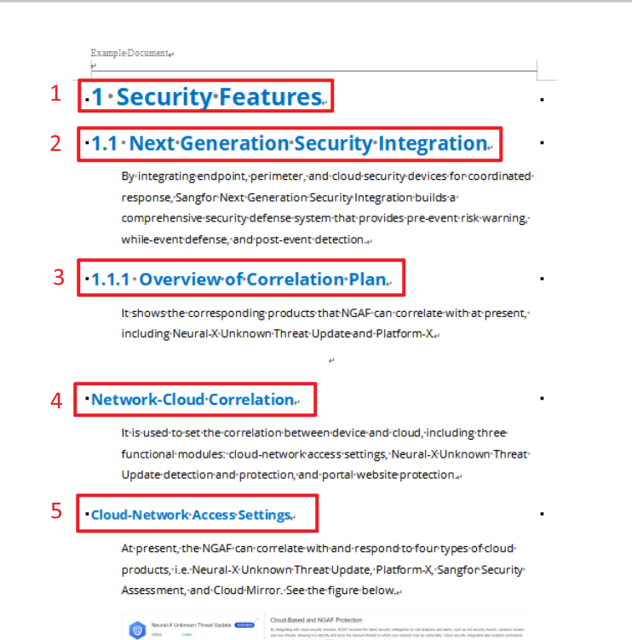

Formatting requirements for headings are as follows:
No. | Heading | Description
1 | Heading 1  Style Name: SF_EN_Heading 1  1 Heading 1 | Font: Open Sans | Size: 22 | Bold  Color (Custom): Red: 0 | Green: 112 | Blue: 192  Alignment: Left  Outline Level: 1 | Numbering: x  Paragraph Spacing: Before 12 pt, After 6 pt  Line Spacing: Single 1  Indentation: None
 | Heading 2  Style Name: SF_EN_Heading 2  1.1 Heading 2 | Font: Open Sans | Size: 18 | Bold  Color: Red: 0 | Green: 112 | Blue: 192  Alignment: Left  Outline Level: 2 | Numbering: x.x  Paragraph Spacing: Before 12 pt, After 6 pt  Line Spacing: Single 1  Indentation: None
 | Heading 3  Style Name: SF_EN_Heading 3  1.1.1 Heading 3 | Font: Open Sans | Size: 16 | Bold  Color: Red: 0 | Green: 112 | Blue: 192  Alignment: Left  Outline Level: 3 | Numbering: x.x.x  Paragraph Spacing: Before 12 pt, After 6 pt  Line Spacing: Single 1  Indentation: None
 | Heading 4  Style Name: SF_EN_Heading 4  Heading 4  Note: Heading 4 is not numbered | Font: Open Sans | Size: 14 | Bold  Alignment: Left  Color: Red: 0 | Green: 112 | Blue: 192  Outline Level: 4  Paragraph Spacing: Before 12 pt, After 6 pt  Line Spacing: Single 1  Indentation: None
 | Heading 5  Style Name: SF_EN_Heading 5  Heading 5  Note: Heading 5 is not numbered. | Font: Open Sans | Size: 12 | Bold  Color: Red: 0 | Green: 112 | Blue: 192  Alignment: Left  Outline Level: 5  Paragraph Spacing: Before 12 pt, After 6 pt  Line Spacing: Single 1  Indentation: None
- Formatting for Headers
- Other Formatting
  - Body Text
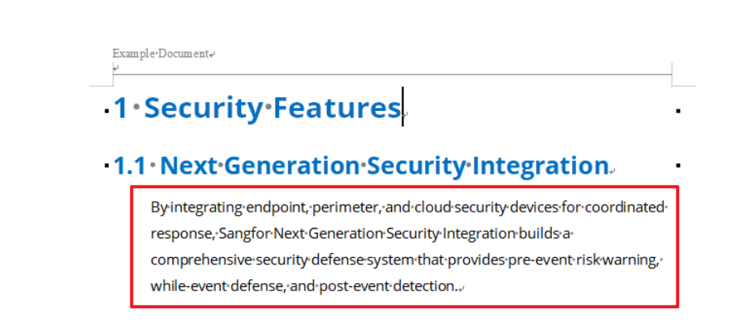
Formatting requirements are as follows:

Style Name: SF_EN_Body Text
Font: Open Sans | Size: 10.5
Alignment: Left
Outline Level: Body text
Paragraph Spacing: Before 2 pt, After 4 pt
Line Spacing: 1.25 Multiple

Indentation: Before text 1 cm

  - Tables
Example:

Widget Name | Description
Compromised Hosts | Displays the hosts that are likely compromised on your network. This widget summarizes the events from threat logs.
Hosts Visiting  Malicious URLs | Displays the frequency with which hosts (IP address/hostnames) on your network have accessed malicious URLs.
Threat Activity | Displays the threats seen on your network. This information is based on signature match the threat database.
- Example Table
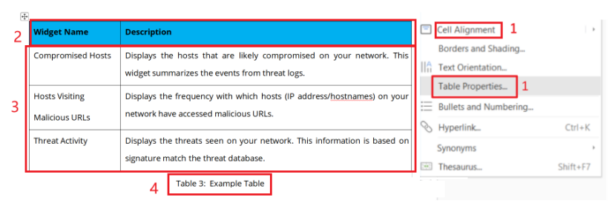
Formatting requirements are as follows:
No. | Table Element | Description
1 | Cell Alignment and Table Properties | Click the icon to select the whole table, right click to select Cell Alignment and Table Properties, and make the following adjustments:  Cell Alignment: Top, Left   Table Properties:  Preferred table width: 15 cm  Indent from left: 0 cm  Alignment: Center
2 | Table Header  Style Name: SF_EN_Table Header  [Example]  Note: Change the cell color of the column header to the following:  Red: 0 | Green: 176 | Blue: 240 | Font: Open Sans | Size: 9  Alignment: Left  Outline Level: Body text  Numbering: None  Paragraph Spacing: Before 2 pt, After 4 pt  Line Spacing: 1.25 Multiple  Indentation: None  Note: If possible, adjust the column width so that text in table headers is on one line.
3 | Table Text  Style Name: SF_EN_Table Text  [Example] | Font: Open Sans | Size: 9  Alignment: Left  Outline Level: Body text  Paragraph Spacing: Before 2 pt, After 4 pt  Line Spacing: 1.25 Multiple  Indentation: None
4 | Table Number  Style Name: SF_EN_Table Number  Table 3: [Example]  Note: Table numbers are optional in English documentation. | Font: Open Sans | Size: 9  Alignment: Center  Outline Level: Body text  Numbering: Table 1  Paragraph Spacing: Before 4 pt, After 12 pt  Line Spacing: 1.25 Multiple  Indentation: None
- Table Formatting
  - Notes
    - Note Formatting
Example:

This is an example of a note. The first line contains the icon only. The icon is copied and pasted directly from the table in Note Icons.
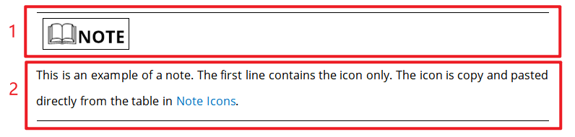
Formatting requirements are as follows:
No. | Note Style | Description
1 | Note Icon  Style Name: SF_EN_Note Icon  Example:  Note: Top border is required above the icon. | Font: Open Sans | Size: 9  Alignment: Left  Outline Level: Body text  Paragraph Spacing: Before 2 pt, After 4 pt  Line Spacing: 1.25 Multiple  Indentation: Before Text 1 cm  Border: Top 
2 | Note Text  Style Name: SF_EN_Note Text  Example:  The note text is written here.  Note: A bottom border is required below the last line of the note. | Font: Open Sans | Size: 9  Alignment: Left  Outline Level: Body text  Paragraph Spacing: Before 2 pt, After 4 pt  Line Spacing: 1.25 Multiple  Indentation: Before Text 1 cm  Border: Bottom 
- Formatting for Notes
    - Note Icons
Chinese Icon | English Icon | Description
 |  | Indicates an imminently hazardous situation which, if not avoided, will result in death or serious injury.
 |  | Indicates a potentially hazardous situation which, if not avoided, could result in death or serious injury.
 |  | Indicates a hazardous situation, which if not avoided, could result in minor or moderate injury.
 |  | Indicates a hazardous situation, which if not avoided, could result in settings failing to take effect, equipment damage, or data loss.  NOTICE addresses practices not related to personal injury.
 |  | Calls attention to important information, best practices, and tips.  NOTE addresses information not related to personal injury or equipment damage.
- Note Icons

  - Steps and Lists
    - Steps
Example:
- Set Reserved IP Addresses...
- View the DHCP operation status...

Style Name: SF_EN_Steps
Formatting requirements are as follows:
Number Format | Text Format
Format: Step 1.  Font: Open Sans | Size: 10.5 | Bold  Number Position: Left Aligned at 1 cm  Text Position:  Tab space after 0.74 cm, Indent at 1 cm | Font: Open Sans | Size: 10.5  Alignment: Left  Outline Level: Body text  Paragraph Spacing: Before 2 pt, After 4 pt  Line Spacing: 1.25 Multiple  Indentation: Before text 1 cm
- Formatting for Steps in Procedures
    - Bulleted Lists
Use a bulleted list for items that do not need to be in a specific order.
Examples:
List item
List item
List item

Style Name: SF_EN_List Bullets
Formatting requirements are as follows:
Bullet Format | Text Format
Bullet Character:   Size: 6.5 | Color: Black  Bullet Position: Indent at 1 cm  Text Position:  Tab space after 1.74 cm, Indent at 1.74 cm | Font: Open Sans | Size: 10.5  Alignment: Left  Outline Level: Body text  Paragraph Spacing: Before 2 pt, After 4 pt  Line Spacing: 1.25 Multiple  Indentation: Before text 1 cm, Special > Hanging 0.74 cm
- Format for Bulleted Lists
    - Numbered Lists
Use a numbered list for items that need to be in a specific order.
Examples:
- List item 1
- List item 2
- List item 3

Style Name: SF_EN_List Numbers
Formatting requirements are as follows:
Number Format | Text Format
Number Format: 1.  Size: 10.5 | Color: Black  Number Position: Left Aligned at 1 cm  Text Position:  Tab space after 1.74 cm, Indent at 1.74 cm | Font: Open Sans | Size: 10.5 Alignment: Left  Outline Level: Body text  Paragraph Spacing: Before 2 pt, After 4 pt  Line Spacing: 1.25 Multiple  Indentation:  Before text 1 cm, Special > Hanging 0.74 cm
- Formatting for Number Lists
  - Footer and Header
Example:

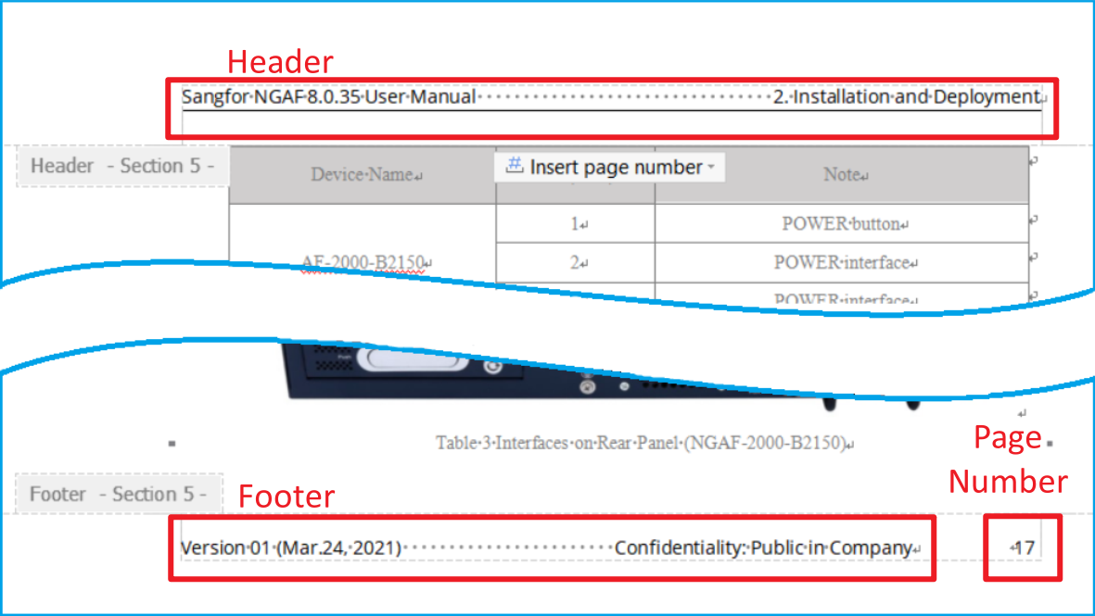

Select the text in the header or footer and set the font and font size as follows:
Font: Open Sans
Size: 9

In the footer, select the page number and set the font and font size as follows:
Font: Open Sans
Size: 9

  - Table of Contents Formatting
Example:
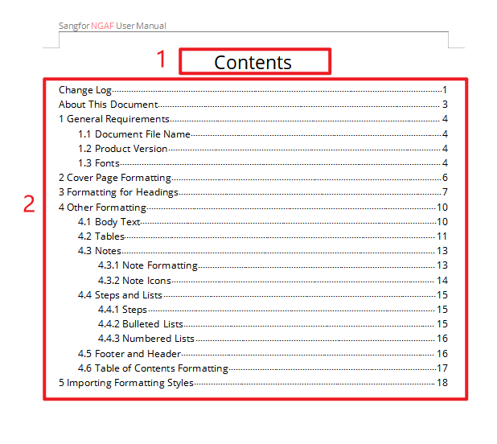
Formatting requirements are as follows:
No. | Contents Element | Description
1 | Contents | Font: Open Sans | Size: 20  Alignment: Center  Paragraph Spacing: Before 12 pt, After 6 pt  Line Spacing: Single 1
2 | Contents Body | In the English document, select the entire table of contents and set the font and font size as follows (this is required every time the table is updated):  Font: Open Sans | Size: 10.5  Paragraph Spacing: Before 2 pt, After 2 pt  Line Spacing: Single 1

- Importing Formatting Styles
The table below contains all of the formatting styles mentioned in this document.
To quickly import these styles into the document that you are translating, do the following:
- Select and copy the entire table below.
- In the document that you are translating, paste the table anywhere in the document. Now, all of the styles are available in the styles pane.
- Delete the table from the document you are translating. The styles are still available in the styles pane after the table is deleted.



