Cloud business market strategies and sales guide for internal and Partners

Cloud business strategic intention and Targets

Strategic intention
Focus on Medium and Larger size customer ,Building a unified digital infrastructure platform ( including PaaS capabilities) for running and protecting any digital apps ( both for traditional applications and Cloud-native apps).Based on the vision ,we expect to offer a extremely reliable ,Secure and simple solution enable IT team have much time focused on business innovation and It effifiency improvement, in stead of management of infrastructure

Sales targets in 2021 (High lights)

- Bottom line target: 9M, 90% increasing rate, Challenging target:11M
- Acquire over 100 order with 4 HCI nodes or the PO more than 25Kusd ,Building the leading industy or scenario solutions with unique values and technical advantages than Nutanix and Vmware in selected market ( Gov,healthcare,manufacturing,Education)
- Have enough quantity of customer reference and peer insights in Garther to improve our brand reputation
- Achieve Successful Managed cloud service partners 50+ at least ( two indicators: 1.Parthers are able to earning the money continually through our Manage cloud business 2.Managed a lot of customer critical applications and data )

- What are the customer’s expectation for infrastructure
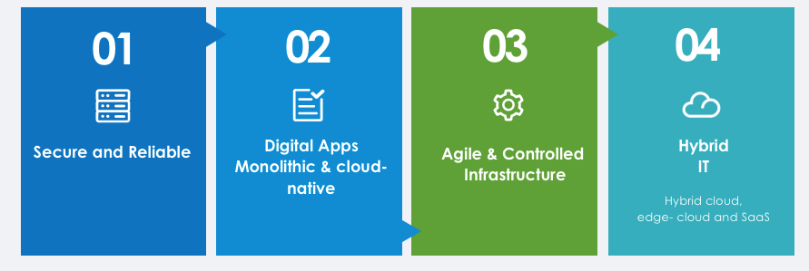

- Higher expectation for Business continuity : Most enterprise-level(top and partial Larger level) companys desire to get Minute-level RTO and 0-level RPO,and most of larger and medium customer(exclude FSI &Internet company) are able to tolerate Hour-level RTO and Minute-level RPO,but hope for them better.

- Application modernization: Gartner predicts that by 2022, more than 75% of orgnizations will be running containerized applications in production,the biggest challenge for most company is how to adopt it and choice the right solution for their infrastructure and application evoluation, besides that, Docker and K8s technology will break the work patterns and enable Develpoing and Operation team to work tightly than before.
- Agile and controlled infrastructure: that means customer hope to have an Agile Resource like public cloud to invest and extend as they need , Controlled Means they also hope to have Control power for sensitive data as well as meet Risk compliance, so I believe most of traditional industry still prefer build their own data center instead of public cloud ,however, they will migrate some of web application to public cloud ensure they are able to focus on critical application management
- Hybrid IT strategy: that including Hybrid Cloud, edge computing and SaaS service. Some local top-level company or global organization are adpoting it. However Kubernetes will redefine the capabilities for applications, Both on-premise and public cloud will become common environmental resource, the company probably developing ,testing their cloud-native applications in local data center but probably launching and running their business in public cloud,that meaning require new capabilities for on-premise platform.
- How can customer fix the problems or adapt to the trends

Key Job | Customer Portrait | Use case and Core Requiremnets | Alternative solution
- Improve the business continuity  - Optimize the Cost and improve the operation efficiency | Medium level Manufacturing  Gov agency  Retail | - Traditional physical DC consolidation  - Improve the performance and reliability for traditional monolithic applictions  - Build self-operation private cloud data center  - Have’t any plan to transformation of cloud native | 1.Computing Virtualization+External storage architecture  2.HCI-Based SDDC
- Application modernization(Service to Cloud-native apps) | Top Entperprise  Hospital  High education  FSI  Internet content Provider  ISV | - Transform the current infrastructure ensure could stand to running Cloud-native application both for now and furture,  - expected to manage the docker and vm in one platform both for IT team and developing team | 1.Docker+K8S  2.Docker Swarm  3.HCI-based K8S solution  4.PaaS service from Public cloud provider
- New built Backup & Disaster Recovery Site | Larger and Top level customers | - Critical applications and DB Remote backup and Business recovery  - Local Vm-level Backup for Vmware | 1.Build a same business site with traditional architecture  2. HCI solution+3rd party backup software as secondary site  3. HCI recovery to HCI site
- Migrate some on-premise applictions to public cloud or backup to Public cloud ,and unified management of the whole resource | Global Enterprise  Education  Telecome  Retail  Medium service | - Except using some SaaS service, They prefer to rent public cloud for backup, OA application, as well as some front-end web application running.  - Looking for infrastructure Manged service | 1.Hybrid cloud provide by 3rd public cloud  2. Managed cloud service provide by local MCP

- What are the sangfor offering and benefits

General Scenario 1: Customer focus on traditional application running reliability and protection (job 1)

Solution overview and benefits
HCI-based SDDC concept was allow customer to build a Simple,Reliable and Secure infrastructure even private cloud, focus on running the traditional applications with vm, Optimize the TCO and simplify the management. It’s really fit for traditional datacenter conslidation without any Cloud-native application, so far,Sangfor HCI has served more than 20000 customers and more than 60% of the suers have migrated their core business to sangfor HCI,the noteable customers including ministry-level government,local top enterprise as well as financial customers
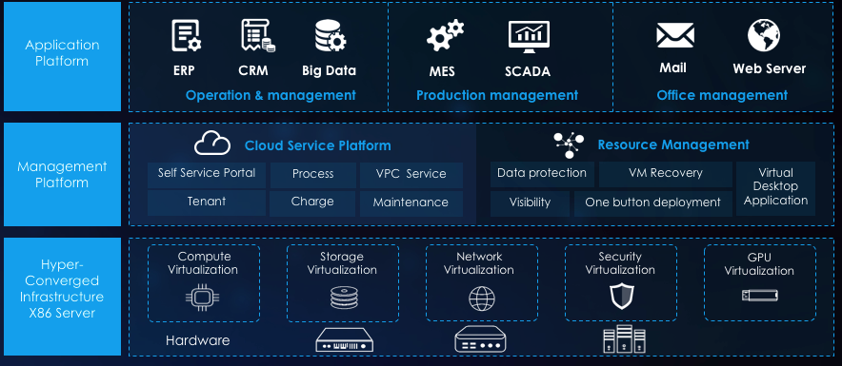

Why choose Sangfor :
- More reliable and secure : Fully redundant architecture from platform to aplications, built in security components and CDP back-up features
- Cost-effective : start with 2 or 3 nodes(Recommend 3 nodes for mission critical applications), investment as need
- Support pure-software delivery and deployment in existing servers ,as well as on-site technical service
- Simplified: Unified and fully virtualized magament platform for whole infrastructure,allow unified management for Vmware cluster and external storage
- Local professional service: provide professional planning consulting,technical delivery support as well as onsite operation service

Related POV tools Index:
- HCI business Main Slide and technical Main slide for customer: https://community.sangfor.com/plugin.php?id=sangfor_databases:index&mod=viewdatabase&tid=1259
- HCI-based solution proposal https://community.sangfor.com/plugin.php?id=sangfor_databases:index&mod=viewdatabase&tid=1260
- HCI Competition Analysis
https://community.sangfor.com/plugin.php?id=sangfor_databases:index&mod=viewdatabase&tid=1261
- Capsule Data center solution brochure
https://community.sangfor.com/plugin.php?id=sangfor_databases:index&mod=viewdatabase&tid=1270
- HCI Notable Cases List
https://community.sangfor.com/plugin.php?id=sangfor_databases:index&mod=viewdatabase&tid=2621
General Scenario 2: Transform or building a new infrastructure in the developing or the production environment both for running monolithic and cloud-native apps (job 2)
Solution overview and benefits
A new vision to help customer building a Smooth evolution digital infrastructure platform for furture whatever the applications is monolithic or cloud-native, the concept is One infrasturecture platform,with dual engines( Docker+VM), running any digital apps reliably and security

The biggest benefits to customer is allow them smoothly move to application modernization start with 3 HCI nodes and integrated full infrastrucsture resource (Storage and network) in one platform( management is separate), and also provide the best bridge for cooperation between Operation and Developing,the new infrastructure allow customer to connect their existing external storage

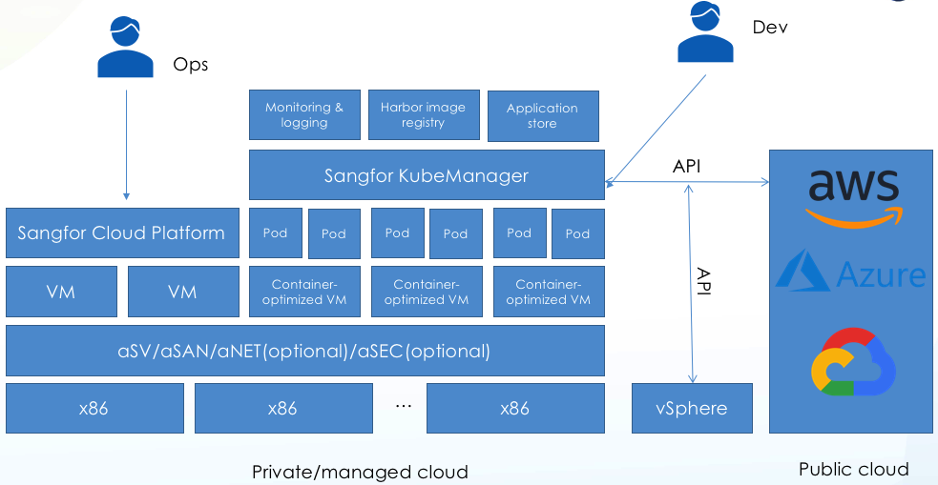
（The pic stands for current architecture ,we are desiging new architecture which the infrastructure OS is Kubernetes and then creat VM orcontainers on it, instead of aSV）

Why choose Sangfor
- Smooth evolution: Running legacy and cloud-native apps at the same time ,offering the whole infrastructure resource for any workloads
- Simplified: Unified management and orchestration both for VMs and containers,integrated image registry and application store
- Highly secure:Provide image scanning and reuse seucirty capabilities on HCI
- Cost-effective: Start from 3 nodes and scale out on deamd
Notice :The first version of PaaS solution are not suitable for the following use case
- DveOps,CI/CD
- Microservice Governance
Related marketing tools Index:
- PaaS solution sales guide and Main slides https://community.sangfor.com/forum.php?mod=viewthread&tid=3970

General Scenario 3: Built new local or remote DR site for mission critical applictions

Solution overview and benefit
Sangfor offers a comphensive disaster recovery solution based on the industry-leading enterprise cloud platform, to enable 1-click failover and failback, optimal RPO and visualized DR management and monitoring. In addition to local backup and CDP, aCloud DR extends its protection off-site and achieves granular protection levels for a wide range of DR objectives, Maximum achieve zero-level RPO and second-level RTO protection

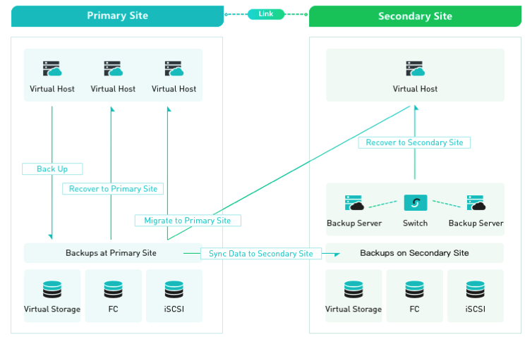
Take the hci to hci DR solution as an example (Active-Passive DR)

DR solution proposal to different scenairos

DR type | Target | Solution Proposal | Performance
Active-Passive（VM-level） | - Local and offsite DR site  - Vm-level backup and DR | Sangfor hci to hci DR solution | RTO=mintues level  RPO=Seconds level
Active-Passive  (File or DB level) | - Local and offsite DR site  - Application file and Database level backup and DR | Sangfor hci+3rd party DR software(Veeam or others) | Results depends on 3rd party DR software
Active-Active | - Local and offsite DR site  - Vm-level backup and DR  - 10Gbps Fiber, RTT<=5ms  - Minimal downtime and 0 data loss | Sangfor Active-active Stretched cluster solution | RTO<=30s  RPO=0
Active-passive for Vmware platform | - Offsite DR site  - Vm-level backup and DR  - Application and database level backup and DR | Sangfor acloud+3rd party DR software(Veeam or others) | Results depend on 3rd party DR software

Why choose Sangfor

- Simple and Quick Ready : offer one stop solution ,unified management and setp-by-step DR configuration wizard
- Less TCO: offer HCI-based DR solution instead of traditional 3-tier infrastructure reduce the investmet and Operation cost
- Professional and Manged service: focus on business continuity and data available,sangfor local service team and partner can offer full life-cycle service support
Related marketing tools Index:

Sangfor hCI Disaster recovery solutions: https://community.sangfor.com/forum.php?mod=viewthread&tid=1268&extra=

General Scenario 4: Looking for public cloud solution for partical business running and data backup (Job 3)
Solution overview
Sangfor managed cloud service Program enables partners to use Sangfor cloud solution on a subscription basis ,More economical, Efficiently driving them successful move to Managed private or hybrid cloud provider, Whatever they are traditional MCP,MSP,MSSP or ISP, that will allow customer can obtain infrastructure resource service like public cloud and get the best service and compliance guarantee than 3rd public cloud
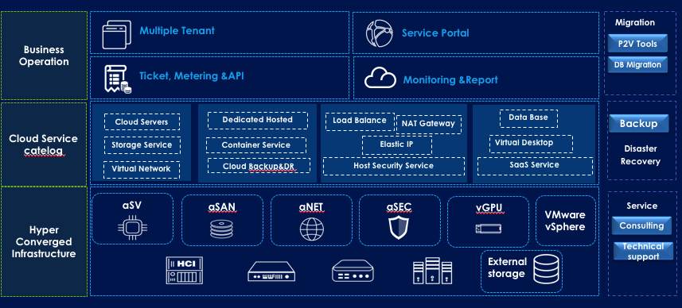

Why Sangfor
- Offer the best and popular service catalog
- Full stack and Simple cloud architecture
- Built-in secure cloud platform,
- Affordable investment start with 3 nodes and Easy to manage & operation
- Professonal service platform,service enablement and technical guarantee
Managed cloud service can cover the following use case
- Looking for public cloud to get IaaS resource ( computing,storage,network,bandwidth and Physical room, physical isolate managed private cloud)
- Looking for Partner to co-location their own data center or partly applictions
- Looking for Partner to co-location their Backup and DR site
- SaaS for ISV ( incubating)

Related marketing tools Index:
- Sangfor Managed Cloud Service : https://community.sangfor.com/plugin.php?id=sangfor_databases:index&mod=viewdatabase&tid=3335
四. Some recommendations for sales stragetgy( available for regions that already have local Managed cloud Provider)

IF faced the following requimrents or competition troubles in project ,Strongly recommend to propose Managed cloud service in frist,Otherwise consider on-premise HCI solution

- Customers are looking for public resource or solution for running their partly applications
- Customer are planning build a new data center ,but have’t enough budget and it manpower and expect the co-location service at the same time
- Remote backup or building DR site for HCI site

五. Tailored solution for specific industries: Manufractruing, Healthcare,High education

Three core elements that are recognized and selected by industry customers
- Showing solution’s capabilities and values in industry language and business scenarios
- Continually identify,developing and packing the differences for industry’s scenarios and business
- Building industry value reference or enter the industy’s ecosystem
So,Strongly recommend to use Industry solution as a communication tool in selected target industry
- Manufacturing solution: https://community.sangfor.com/plugin.php?id=sangfor_databases:index&mod=viewdatabase&tid=3138
- Healthcare solution:
https://community.sangfor.com/plugin.php?id=sangfor_databases:index&mod=viewdatabase&tid=3139
- High education Solution:
https://community.sangfor.com/forum.php?mod=viewthread&tid=3755&extra=

HQ already took some following actions to support you and cooperate with you

- Jointly insight and research industry customer’s requirements including research template provide, customer meeting as well as experience sharing
- Jointly designing and continually updates our industry solution, brochure as well as best case story
- Working together with you identify the major technical gaps as well as ISV certificated and then driven RD team to achieve it
- Industry’s background and selling methods enablement make sure your are more professional

The Major industry includes Manufacturing, Healthcare ,High education, might have some new industry in future, in here I also would like to share the HQ PIC for industry ,make sure you are able to find the right person



