Ransomware case study-3

Indovickers

Executive Summary:
Customer: Indovickers
Industry: Furniture
Location: Indonesia

Customer overview:
Indovickers was established in 1989 and since then has created a tradition of excellence in providing quality furniture and equipment for both office and hospitality business our assortment of office furniture offers comfort which would ultimately promote efficiency during working hours.

Over our 30 years of experience, we have perfected the combination of form, function and implemented it in our vast array of products. Our goal is to contribute to Indonesia's furniture industry by supplying world-class quality furniture for offices, hotels, institutions and public areas.

Business pain points:
1. 10 Applications server were under attack for more twice during 2018-2020
2. Data and System recovery for both sides took around 2-4 weeks, manually input the data to the system
3. Existing Antivirus doesn’t work properly to mitigate malware attacks. Had performing scan regularly with negative result of malware
4. User often unable to access internet due to bad IP reputation, google verified user by popping out captcha
5. Beforehand, traffic between both sides not fully protected due to the use of VPN that bypassed firewall protection
6. Mismatch rules found due to misunderstanding of policy rules definitions by IT Administrator.

Sangfor solution:
NGAF+ES+HCI

Benefits:
1. Perform full network security assessment from network topology, policy rules, endpoint to uncover the contagious host
2. Redefined policy, specifically allow trusted host/port/protocol while denying not necessary port/protocol
3. All Incoming/outgoing traffic flowing through NGAF, activate SSL to replace existing open source SSL VPN
4. Proposed and using Sangfor Endpoint Secure replace existing Kaspersky AV, performing full scanning and analyze the correlation through firewall Cleaning more than 10 infected Hosts
5. Designing quick data system recovery through Sangfor HCI for the 2nd phase project.

Customer feedback:

“We used Kaspersky AV before, but we were attacked by hackers twice in last two years. Each attack caused us to restore the system and data for more than 3 weeks, which caused us a lot of headaches. Therefore, this time we decided to use Sangfor's NGAF + ES network-endpoint integration anti-ransomware solution. In the second phase, we plan to add HCI to quickly restore data. We appreciate sangfor's timely response service to us, which is much faster than other vendors' responses.”

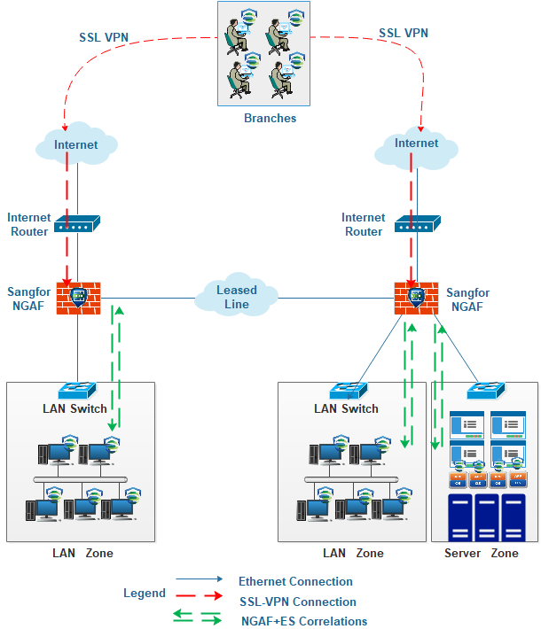
Server Zone

