Sangfor Ransomware Solution

Sangfor Technologies

Purpose of Document
This document provides a Sangfor Technologies solution proposal , including solution highlights and product descriptions.
Document Information
Author: Fan Yue
Creation Date: 4th March 2021
Last Updated:
Version:
Revision History
Date | Author | Summary of Changes | Version
4/3/2021 | Fan Yue | 1st revision | 1
8/3/2021 | Greta | 2nd revision | 2

目 录
Contents
1.Backgrounds 4
2. Rethinking the construction of network security from ransomware 5
2.1.The old security management measures cannot be applied to the new business 5
2.2.It is difficult to configure an overly complex security system strategy 6
2.3 Lack of in-depth monitoring of boundaries and endpoints 6
2.4.Difficulty in response, I don’t know how to start 7
3. Sangfor Ransomware solution: 7
3.1.Before incident- risk assessment of the boundary and the endpoint 7
3.2.During incident-Exclusive defense against ransomware 8
3.3.After incident-Comprehensive and full in-depth inspection 9
3.4.Ransomware Disposal Center 10
4. Product value: 11
4.1.Sangfor NGAF 11
4.2.Sangfor ES 12
4.3.Sangofr Cyber Command: 13
4.4.Sangfor Neural-X 14
4.5.Sangfor's artificial intelligence antivirus engine--Engine Zero 15
5. About Sangfor 15
Awards: 16

1.Backgrounds
Since the outbreak of WannaCry, ransomware has been a major security threat to all enterprises and organizations. The industrialization of ransomware has become increasingly mature, and technology continues to evolve. The damage ransomware causes to business and data is almost irrecoverable, while attack scopes have been expanding. . Ransomware has been fine-tuning their primary targets to take advantage of a wide range of enterprises in every industry, meaning the threat of ransomware can not be ignored.
The use of symmetric and asymmetric encryption algorithms for ransomware makes recovery and decryption more difficult. Ransom payment methods have also begun to combine various digital currencies. Ransomware becomes industrialized with the advent of customizable ransomware as a service (RaaS), providing criminals with a low-cost, highly customizable ransomware templates that can’t be decrypted, are deployed easily and make production, dissemination and proxying easy and fast. ,
In view of the current global ransomware crisis, Sangfor Technologies provides a total-ransomware solution for a wide range of industry users, and corresponding solutions based on modern network security construction.

2. Rethinking the construction of network security as pertains to Ransomware
Judging from past ransomware incidents and confirmed attacks on enterprises and organizations, 61% of ransomware attacks spread through RDP blasting, and 21% of ransomware attacks exploited Eternal Blue's high-risk vulnerabilities. A ransomware virus infects a device through exposed surfaces of the network, and while trying to spread laterally to peripheral devices, it identifies core data and seeks a time node to maximize the benefits and trigger encryption. Even if the ransomware can be removed after it is deployed, the encrypted data can’t be restored. Therefore, it is necessary to build a comprehensive monitoring and defense response system focused on preventing the propagation and infiltration of ransomware. .
Rransomware affects a wide range of systems,including private networks that are physically separated from the Internet. The main reasons for its success are:

2.1.Traditional security management measures can’t be applied to new business
As more businesses are founded, more are becoming cloud-based and Internet-based, some have different business operating systems, applications, and middleware , and various protocols and applications with weak passwords at different levels, exposing the network to fewer common risks and vulnerabilities.As there is no security baseline construction covering new services, various high-risk vulnerabilities continue to emerge.

2.2. Configuring an overly complex security system strategy

Among users affected byransomware , there are also users with relatively high security investment and complete equipment purchases, with many high-risk services which must be enabled. With frequent business changes and the replacement of operation and maintenance personnel, the security management of borders and endpoints cannot be refined management and control while exposing high-risk services, causing stacked security devices to become useless. It is necessary to provide best-practice configuration of multiple integrated security systems s to combat mainstream threats like ransomware, combine exclusive protection capabilities and comprehensive protection with adaptive services.

2.3 Lack of in-depth boundary and endpoint monitoring
Ransomwarespreads horizontally before it breaks out. As ransomware technology continues to evolve, viruses have begun to use hidden tunnels, variants and packers, DGA dynamic domain name algorithms, fileless attacks, and other countermeasures to avoid detection. In-depth detection is required at endpoints and endpoints, providing the ability to monitor and coordinate evidence, locate the source of the attack, prevent the ransomwarefrom escaping and continuing to spread, and finally developing into a security incident.
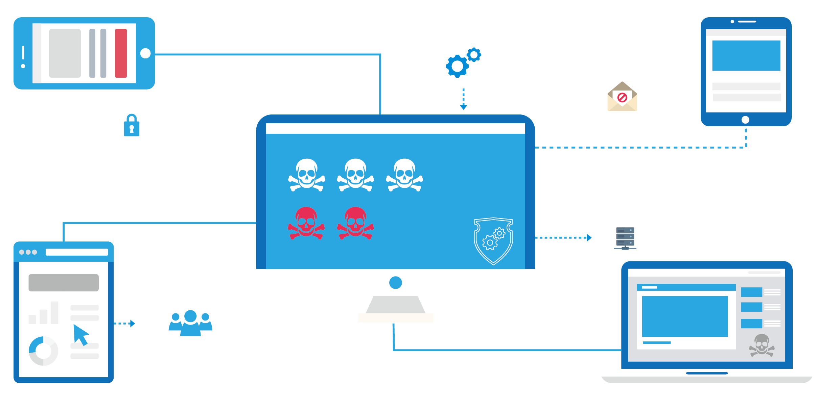

2.4. Difficult & Confusing Response
Under normal circumstances, ransomware has a clear goal and will only trigger encryption when it comes into contact with core data or key business systems. There is a lack of effective solutions adept at dealing with suspicious incidents and compromised hosts on the network, making location of the virus difficult or impossible.

3. Sangfor Ransomware Solution:
Sangfor’s ransomware solution was designed based on detailed analysis of ransomware incidents, Sangfor provides assistance before, during and after ransomware incidents, and a ransomware processing center to track ransomware countermeasures.

3.1.Pre-incident risk assessment of the boundaries and endpoint
Sangfor’s solution discovers any vulnerabilities in the boundaries and network endpoints like device services, ports, high-risk vulnerabilities, weak passwords, weak device security policies and related configuration checks on the endpoint side, high-risk vulnerabilities in systems and applications, and rrefers to endpoint security baselines to block the entry of ransomware.
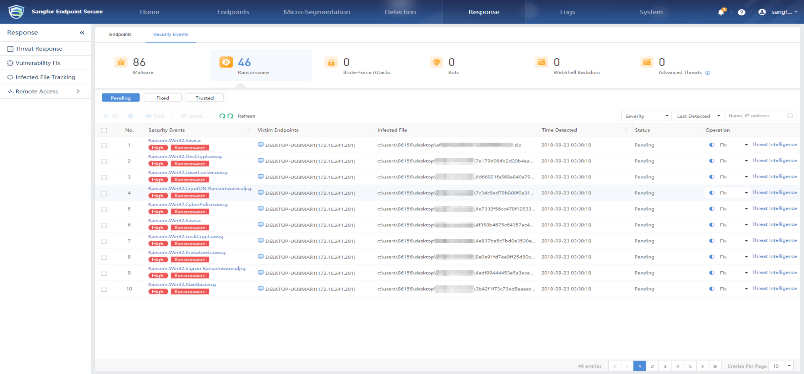

3.2.Mid-incident defense against ransomware
Ransomware attempts to escape security equipment defense methods by lurking in the network for a long period of time, performing low-frequency blasting and distributed blasting. It is difficult for traditional security equipment to defend against attacks employing statistical frequency distribution.
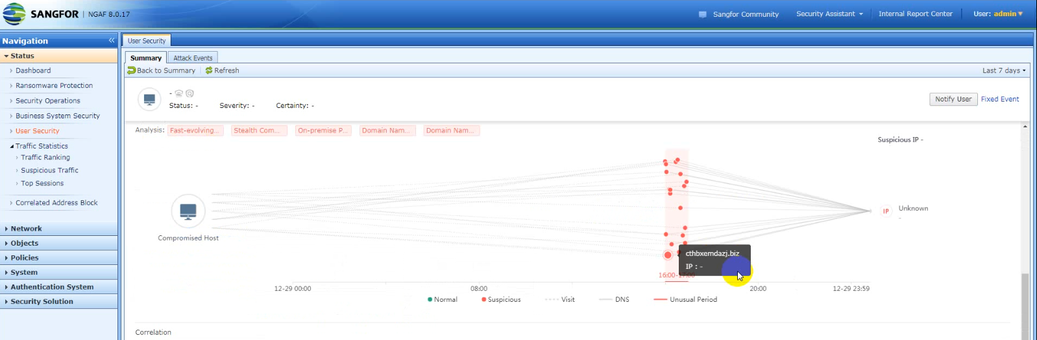

3.3. Post incidentcomprehensive inspection
Through in-depth inspection of traffic at endpoints, problematic devices are identified and process-level file detectionis carried out on the endpoint side. The border locates the lost host and proves the network behavior. 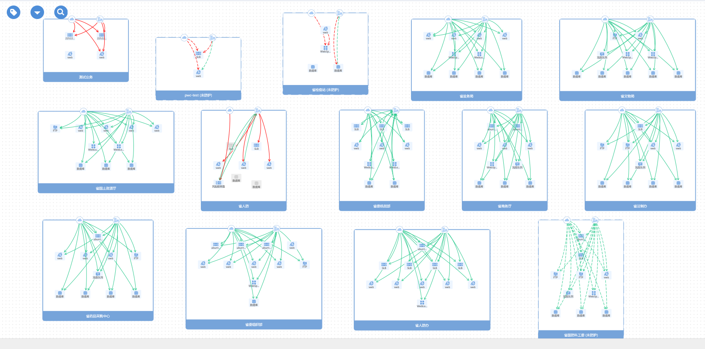

3.4. Ransomware Disposal Center
Sangfor’s solution tracks the full life-cycle of each ransomware event, and provides effective disposal methods through Sangfor NGAF, which provides one-click disposal of vulnerabilities, with the disposal status clearly visible through the reporting center.

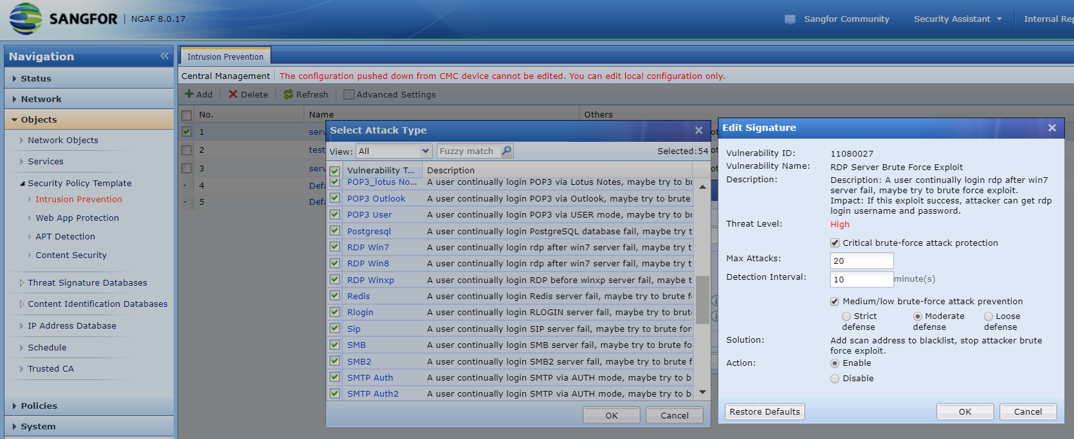

4. Product value:
Sangfor NGAF provides endpoint response and detection, and uses Endpoint Secure and Cyber Command, combined with cloud security capabilities and Engine Zero, to give users comprehensive security protection capabilities by integrating security and simplicity.

4.1. Sangfor NGAF
Sangfor NGAF identifies risks and implements isolation measures for endpoints, and performs in-depth detection of traffic entering and leaving the network. Linking NGAF with Sangfor’s other intelligent systems like Endpoint Secure improves protection capabilities, endpoint detection and response, risk identification, in-depth detection, isolation control, and threat removal capabilities. Cloud security capabilities and threat intelligence captured. The border and the endpoint provide evidence for each other, and cloud intelligence assists in the determination to locate the real source of the attack.
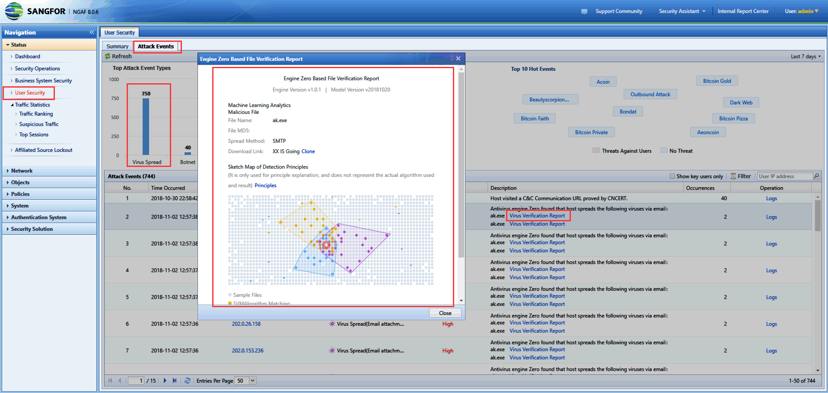

4.2. Sangfor Endpoint Secure
Sangfor Endpoint Secure iidentifies endpoint vulnerabilities performs security baseline inspections, and protects East-West trafficthrough micro-isolation, to combat fileless and featureless ransomwarevariants. The processing of ransomware provides endpoint-side process-level detection, defense, and processing capabilities.
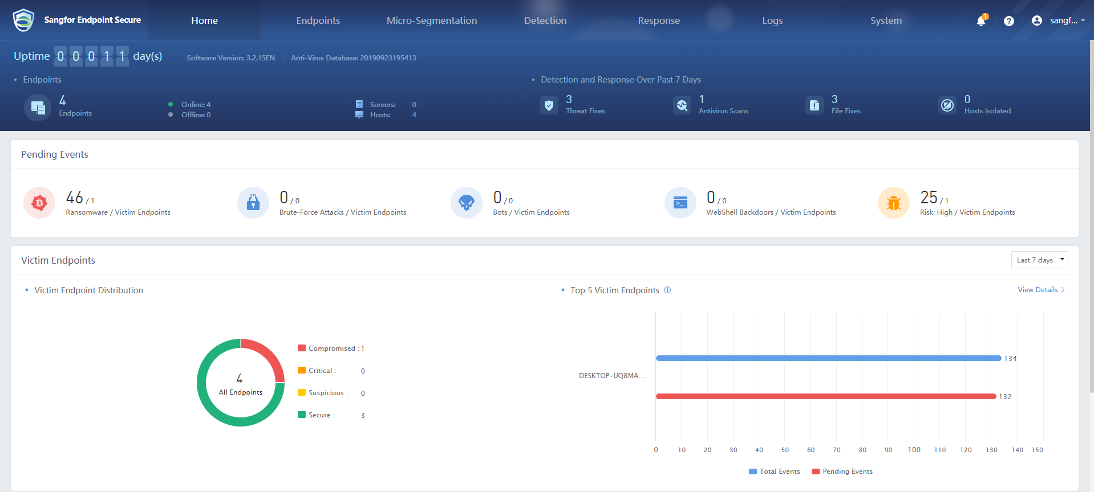

4.3.Sangfor Cyber Command:
Sangfor Cyber Command is responsible for border and endpoint detection, monitoring multiple nodes and aggregating security data for better threat detection. On the basis of border and endpoint detection, it covers the detection of multiple nodes in the entire network and aggregates various security data to analyze and perceive threats. Through tag events, the Scattered security data and traffic bytes are combined to provide traceability and location, risk prediction, and security. Visually knowable ability.

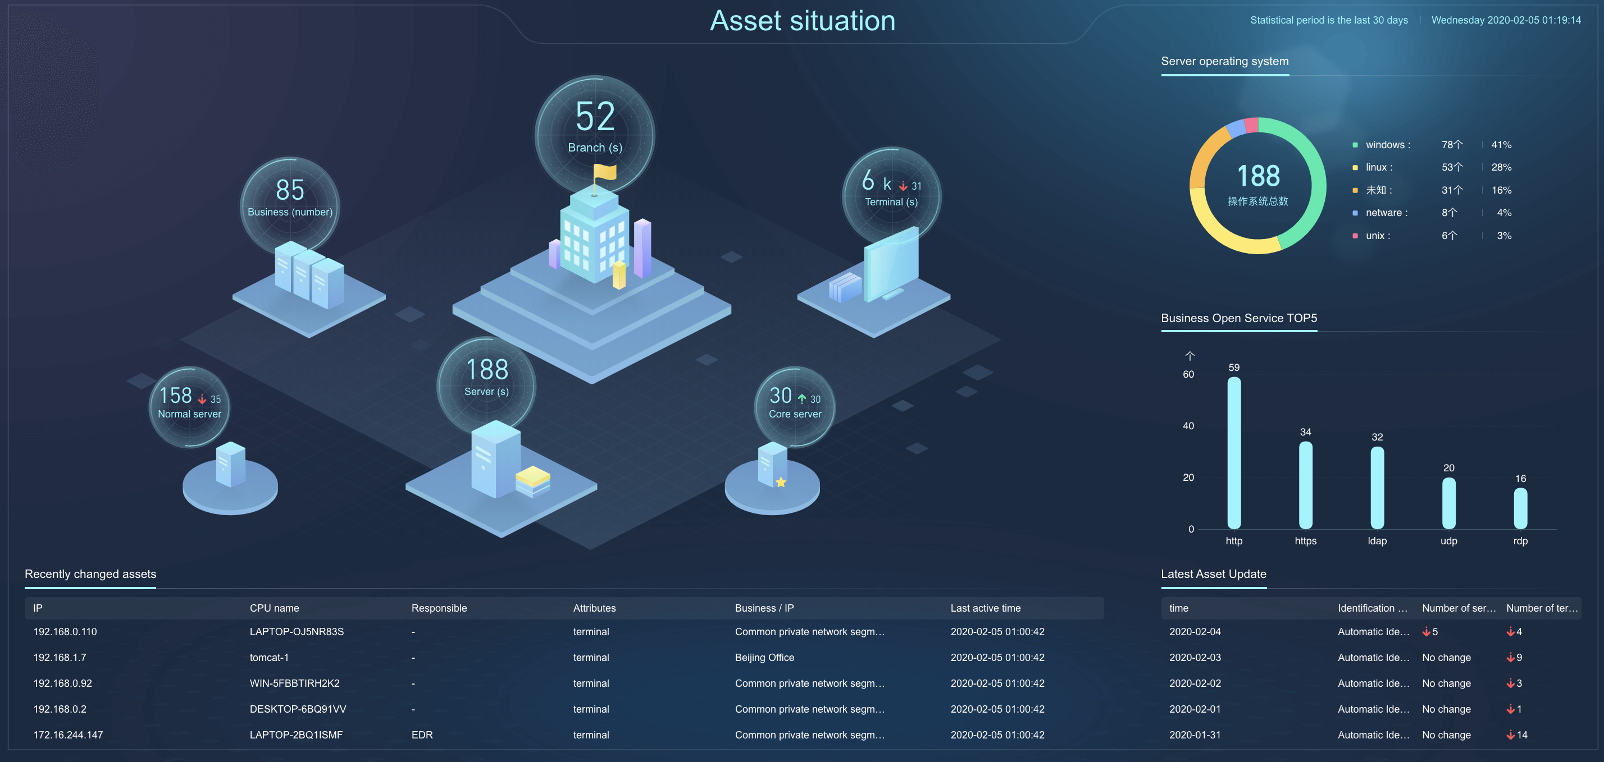

4.4. Sangfor Neural-X
Neural-X-cloud intelligence serviceprovides password brute force protection, vulnerability attack protection and anti-scanning capabilities.. When major incidents and vulnerabilities are detected, cloud security experts will refine security rules and respond in a timely manner, providing application protection, URL rules, application feature recognition library, botnet library and other updates.
TNeural-X-cloud authentication service provides network cloud linkage which actively combats unknown ransomware and corresponding covert communication. In under 5 minutes, global threat hotspotsare captured, analyzed and ruled out or contained. Neural-X also coordinates access to cloud authentication equipment to provide defense and distribute the latest detection information a to help users defend against unknown threats.
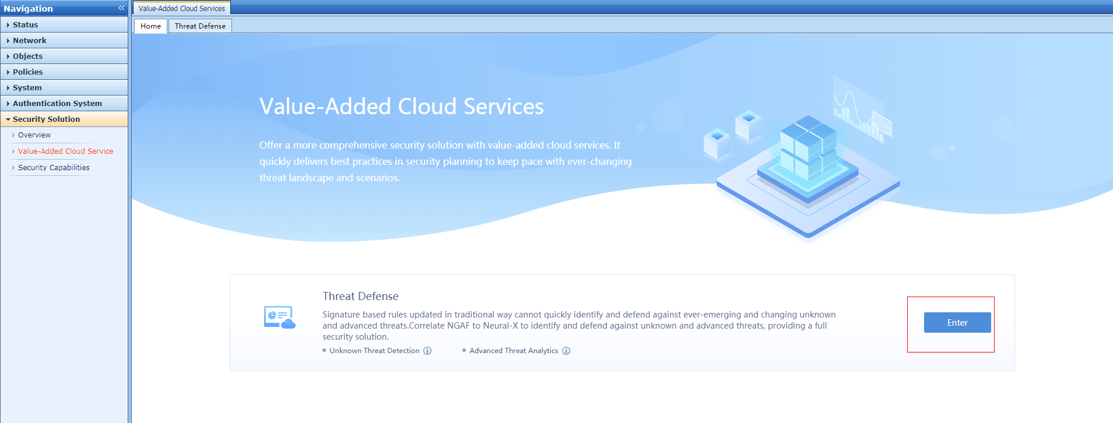

4.5. Sangfor's AI antivirus engine-- Engine Zero
SangforEngine Zero provides general antivirus capabilities through the establishment of high-quality sample sets, refined feature engineering and excellent model design, and fast iterative self-updating capabilities. It can learn in offline scenariosprovides far better results than traditional rule-based matching engines, as it’s able to identify the structure of ransomware and provide fewer false positive alerts.

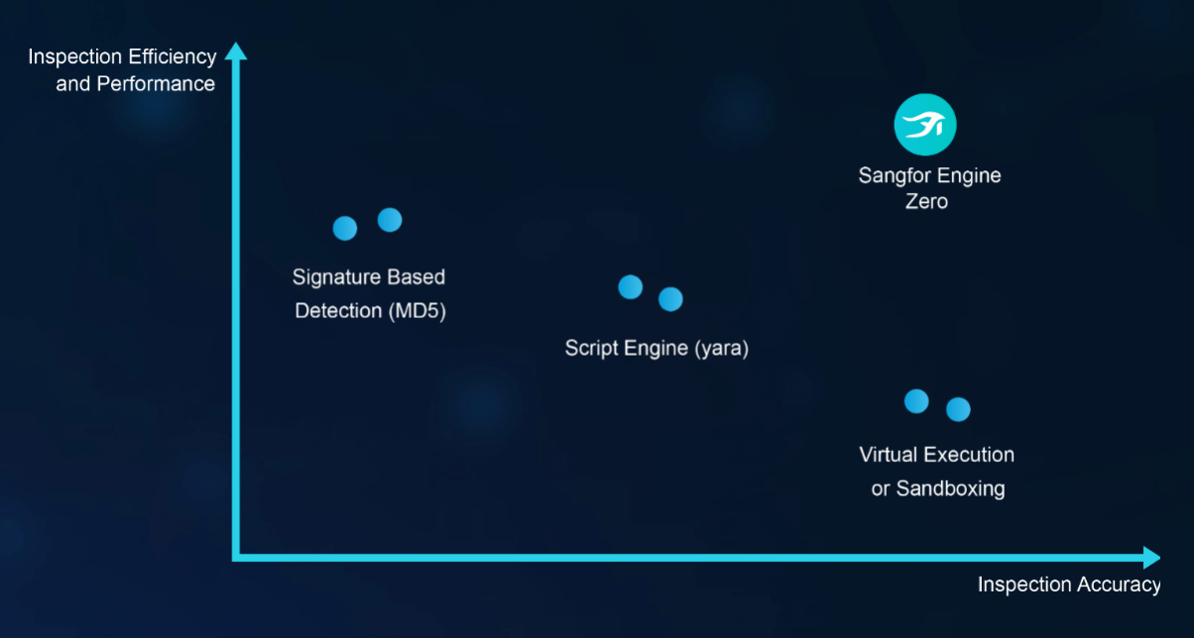

5. About Sangfor
SANGFOR has always had a clear goal. To build high-performance, reliable and absolutely secure networks that underpin the growth of businesses. SANGFOR concentrates on building excellent WAN devices, chiefly for emerging segments. SANGFOR’s products have been designed to offer unparalleled performance, greater choice and greater flexibility while lowering TCO (total cost of ownership). SANGFOR has over 6000 full-time employees worldwide, including 22,000 businesses, among them a number of Fortune 500 enterprises, as well as hundreds of local government and higher-education institutions.
Sangfor Technologies is an APAC-based, global leading vendor of IT infrastructure solutions specializing in Network Security and Cloud Computing. Visit us at www.sangfor.com to learn more about Sangfor’s Security solutions, and let Sangfor make your IT simpler, more secure and valuable.
Awards:
- Deloitte Technology Fast 500 Asia Pacific Awards in 8 consecutive years (2005, 2006, 2007, 2008, 2009, 2010, 2011, 2012)
- Mid-sized Enterprise Gold Award from Standard Chartered Bank
- Network Security Manufacturer in Asia Pacific Award 2009 from Frost & Sullivan
- Year of the Product Award from Computer World for 4 consecutive years
- Best Employer Award 2009 from Fortune
- SANGFOR --The biggest market share in China - 2007, 2008,2009,2010,2011,2012(From IDC)
- SANGFOR SSL VPN--- No.1 for 5 consecutive years in Chinese market share Frost & Sullivan)
- SANGFOR VPN hardware---No.1 in Chinese market share (From IDC)


