

Sangfor aCloud
Disaster Recovery Solution Proposal

Contents
1 Contents 2
2 Background and Overview 4
3 Requirement Analysis 5
3.1 Analysis of Project Requirements 5
3.2 Analysis of Current Business Status 7
3.3 Analysis of Current Network Status 9
3.4 Analysis of Key Parameters 10
3.5 Non-functional Requirements 14
4 Solution Design 15
4.1 General Solution Design 15
4.1.1 Topology Architecture 15
4.1.2 Instruction to Environment Configuration 16
4.1.3 Instruction to Business Access Method 16
4.1.4 Instruction to Major Business Solution 17
4.2 Deployment and Launch 20
4.2.1 Deployment of Site and Link 20
4.2.2 Configuration for Disaster Recovery Plan 22
4.2.3 Network Configuration for Business 23
4.2.4 Monitoring Disaster Recovery Status 24
4.2.5 Recovering to Standby Data Center 25
4.2.6 Migrating to Primary Data Center 26
4.2.7 Disaster Recovery Test 26
5 Key Technologies 30
5.1 Hyper-converged Technologies 30
5.1.1 Server Virtualization aSV 30
5.1.2 Storage Virtualization aSAN 30
5.1.3 Network Virtualization aNET 31
5.2 Core Function Technologies 32
5.2.1 Multi-Copy 32
5.2.2 Backup 33
5.2.3 Continuous Data Protection (CDP) 33
5.2.4 Failure Recovery (HA) 34
5.2.5 Virtual Machine Live Migration 35
5.2.6 Dynamic Resource Scheduling (DRS) 35
5.2.7 Distributed Cluster Load Balance 36
5.2.8 Wide Area Network Acceleration 37
6 Solution Configuration 38
6.1 Disaster Recovery Center 38
6.2 Line and Equipment Cabinet Tenancy 41

Background and Overview
The enterprise data centers are facing more and more risks and threats with the application and the development of ICT. The downtime due to unexpected system failures might cause loss to enterprises' revenue and reputation. In the past of ICT application, due to the management requirements, disperse IT resources were centralized, forming into a highly resource-centralized system. Due to the highly resource-centralized system, once an accident happened, the enterprise business would be interrupted. The interruption of the key business might cause financial loss and data loss which will cause irreversible damage directly to the enterprise. To ensure a 24/7 all-weather operation, a complete business continuity plan is necessary, providing double-guarantee of high availability for business and high reliability for data.
The data center disaster recovery is a part of business reliability technology and refers to building one or more standby data center(s) with the same functions remotely (a certain distance apart), where each data center monitors the health status of another one and synchronizes with the information of business data and business status. When an unexpected failure occurs in the primary data center, the standby data center will recover the business rapidly, bringing the business system to normal.
The Project shall provide a data center disaster recovery solution for xxx and build a unified and proper disaster recovery system for the data center, providing a basic guarantee for high availability for various application business and ensuring the data consistency and completeness.

Requirement Analysis

Analysis of Project Requirements
Users are facing the challenge of how to ensure the continuity of the business system of the enterprise and free the enterprise from various disasters. Based on the understanding of XXX, we analyze the major difficulties as follows:
- Without the protection of redundancy, the application server has the risk of single point failure. Once a failure occurs to the server, the application will be shut down.
- Without the protection of redundancy, the data server has the risk of single point failure. Once a failure occurs to the server, the database will not be accessed.
- The offline backup is just a basic solution for data protection. Based on the backup policy, a day or several hours of data might get lost, data cannot be completely recovered, and the data recovery is time-consuming.
- Business data is partially stored in the local disk of the server which might be affected by viruses and hardware failures, posting a high risk to the data.
- Though the dual-controller is applied for the storage and the hard disk is protected by the RAID technology, the server has the risk of crashes. The redundancy protection measure is recommended.
- The business data is not stored remotely. Once the local data is lost, it shall not be recovered.
- Without a remote disaster recovery system, once a total failure occurs to the equipment room, the business continuity will not be guaranteed.

To solve the above difficulties, the general requirements and challenges of the Project shall be interpreted as: providing a proper solution to various disasters for the primary and standby data center.
There're various disasters. Based on the causes of disasters, generally, we divide the disaster into two kinds, namely physical errors and logical errors. A physical error refers to the system disaster due to the hardware malfunction, such as hardware damage and power failure. A logical error refers to the disaster due to the change in the business tier, such as misoperation, virus infection, blue screen of death due to the patch update, and system crash. These errors might disrupt the availability of the business. The business availability includes two aspects, namely data protection and business continuity.
Different errors are dealt with different solutions. Frequently-used solutions have advantages and disadvantages.
Protection Types | Technical Solutions | Advantages | Disadvantages
Data Protection | Multi-Copy | Store the data in multi-copy to solve the single-point damage problem for the data. | Logical errors in business data shall not be avoided. Disasters such as the blue and black screen of death and misoperations might affect both copies.
Data Protection | Snapshot | Rapidly record the data status and recover to snapshot points to solve logical errors. | The snapshots will be damaged with the medium damage.
Data Protection | Backup | Via the snapshot, the data copy will be stored in another storage medium to solve both the single point damage of data and the logical error. | The backup window and the interval of each backup are too long so that data in a previously short time cannot be recovered.
Data Protection | Continuous Data Protection (CDP) | Backup data in a smaller granularity and record each IO operations to realize zero loss in data and recover previous data in each second. | Require high storage and network performance. Remote transmission is high in cost. Cannot handle malfunctions in the equipment room level.
Data Protection | Remote Backup | Effectively handle malfunctions of the overall equipment room in the original site. | The backup window is long, and the recovery is time-consuming (The RPO and the RTO are long)
Business Continuity | Failure Recovery (HA) | The heartbeat detection solution is applied to provide an automatic recovery function for business malfunctions and to solve the interruption problems inside the business caused by external logical errors. | The business will still be interrupted and require time for reboot and recovery.
Business Continuity | Dual-Machine Hot Standby | Conduct heartbeat detection inside the operation and provide the function of automatic switching and recovery for business to solve the business interruption problem due to the internal process or the external network. The recovery time is short and the RPO is almost zero. | Require high network transmission performance. The network cost might be high if the data volume is large. The long-time running of the backup server might cause waste in resources.
Business Continuity | Distributed Cluster | A plurality of nodes provides calculation power, where the load balance technology is mostly applied to solve the problem of business interruption due to the single point failure. | Cannot handle malfunctions in the equipment room level.
Business Continuity | Remote Disaster Recovery | Effectively handle the malfunctions for the whole equipment room and provide proper RPO and RTO levels. | The business will be interrupted shortly if the protected site is malfunctioned.

The Project provides an overall solution with the above technologies based on the hyper-converged technology to provide a complete disaster recovery solution. The detailed construction shall include:
- The construction of a hyper-converged data center
The primary and standby data centers will be constructed through the advanced hyper-converged technology to provide localized capabilities of multi-copy, snapshot, backup, continuous data protection (CDP), failure recovery (HA), dual-machine hot standby, and distributed cluster. Through the integration of an automatic mechanism for detecting the usage status of the resources in the platform and the health status of hardware, the platform and the business in the platform will function properly and steadily.
- The construction of a disaster recovery solution
On the premise of meeting the classified protection standards, a plurality of copies of the business in the primary data center (AAA) should be stored in the standby data center (BBB) as required, and the standby data center should provide IT infrastructure services including compute, storage, network, and security resources for loading the business switch. The business should be rapidly recovered in the standby data center when the primary data center is maintained on schedule or the business is interrupted unexpectedly. The business should be migrated from the standby data center to the primary data center rapidly after the primary data center is back online.

Analysis of Current Business Status
As far as we know, xxx has N business system(s) in the primary data center (AAA), M of which need the disaster recovery solution. See the following table:
Name of Business Systems | Introduction of System Functions | Regular Working Hours | Quantity and Specifications of Virtual Machines (VMs) | Data Volume | Incremental Data Volume | Operating System | Database | Business System Architecture
Mail System | Receive and send mails in the enterprise | Daily Rush Hours: 10:00 - 16:00 | 1 piece:  8c32G | 1500 GB per VM | 300MB per day | Windows 2008 R2 | SQL Server 2008 R2 | Fully Standalone Architecture
Order System | Add, modify, and query orders generated in offices around the country | Daily Rush Hours: 10:00 - 16:00 | 2 pieces  Frontend: 8c16G  Database: 8c32G | 500 GB per VM | 2 GB per day | CentOS7.2 | Oracle RAC 11g | Frontend  + Database (standalone)
ERP System | Mainly manage resource usage and handle important processes inside the enterprise | Daily Rush Hours: 10:00 - 16:00 | 6 pieces  Web：4c8G  Middleware: 8c16G  Database: 8c32G | 300 GB per VM | 1 GB per day | Windows 2008 R2 | Oracle RAC 11g | Frontend (loading)  + Middleware (loading)  + Database (RAC)
...
...
where the core business system consists of the order system, ERP system, and mail system. See the following pictures for corresponding architecture:
The architecture of the Mail System【Fully Standalone Architecture】:
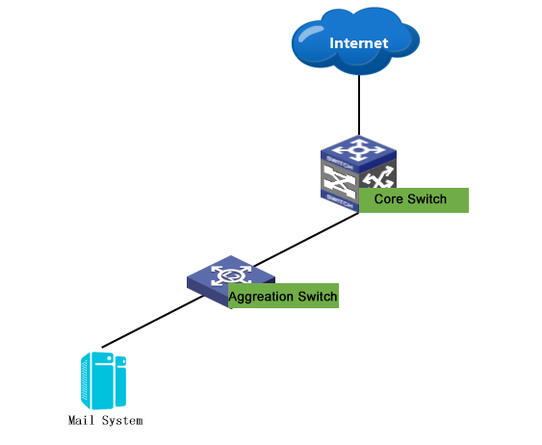
The architecture of the Order System【Frontend + Database (standalone)】:
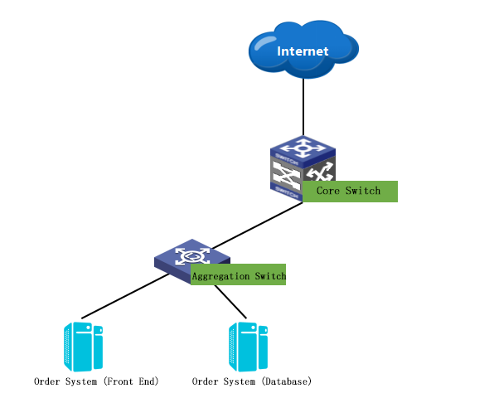
The architecture of the ERP System【Frontend (loading) + Middleware (loading) + Database (RAC)】:
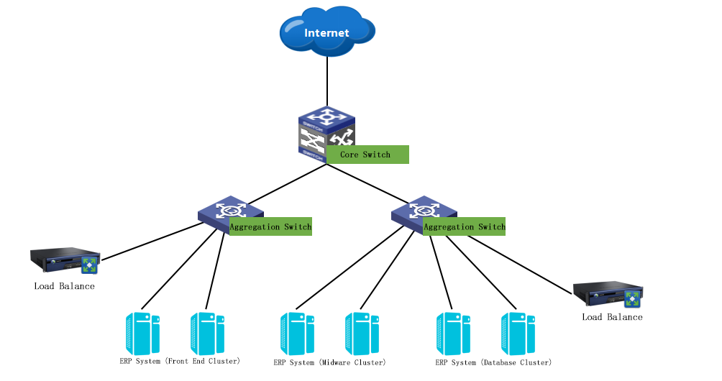
A better understanding of basic information and architectures will deliver a proper plan and design for the disaster recovery solution in the following sections.

Analysis of Current Network Status
According to researches, the xxx's primary data center (AAA) is 20km away from the standby data center(BBB). A dedicated line with the bandwidth of 20Mbps between the data centers will be used as a disaster recovery link.
The network topology of the primary data center (AAA) is as follows:
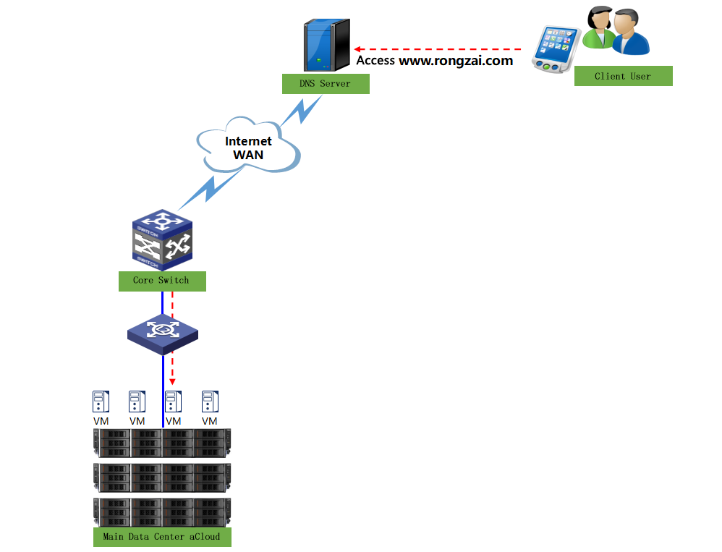
The network topology of the standby data center (BBB) is as follows:
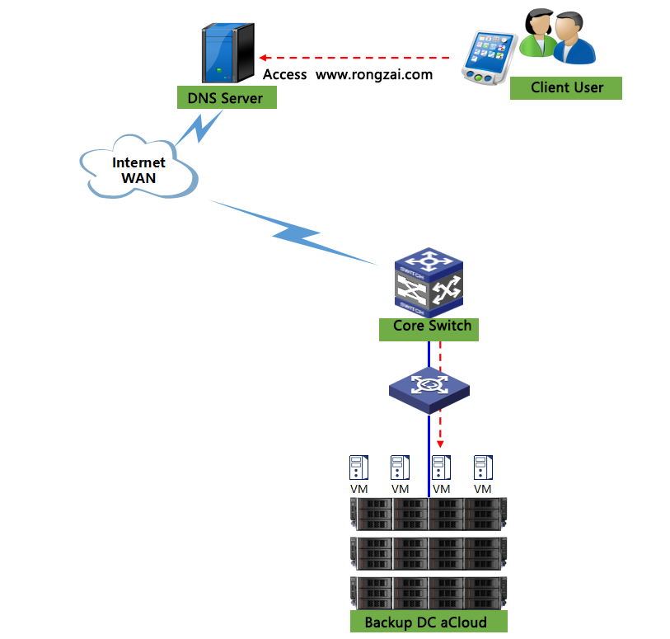
The connection method of the dedicated line is as follows:
In the picture, the link is a dedicated line with the bandwidth of 20Mbps between the primary and standby data centers for synchronization and the transmission of data in disaster recovery status.
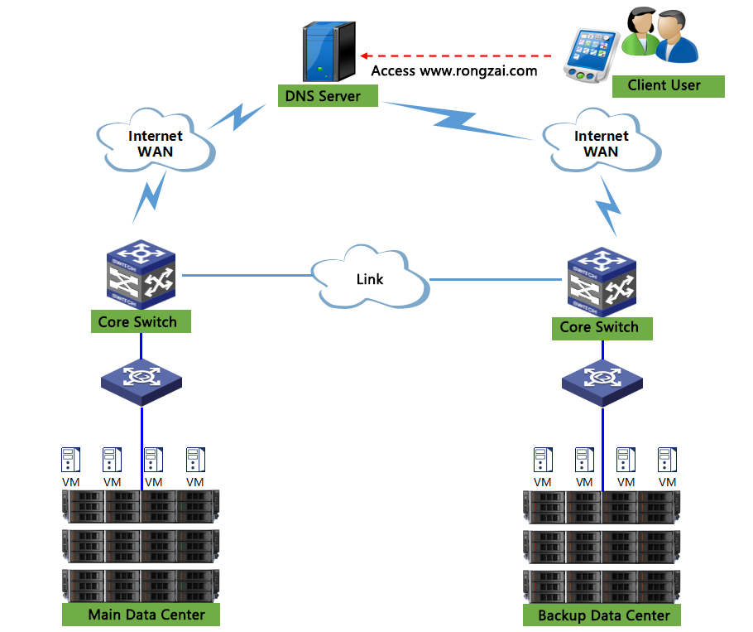

Analysis of Key Parameters
According to the requirements from xxx, a unified disaster recovery system should be constructed between the primary data center (AAA) and the standby data center (BBB) for the production system to ensure the continuity and the availability of the business system in the data center. The system should include a full set of disaster recovery capabilities including management and O&M to completely handle the disasters. The capabilities shall include:
- Status monitoring: via monitoring, observe the proper function of the disaster recovery system and the health status of the business system in the data centers to determine whether to switch or not.
- Recover for local business: if the primary data center is functional and only the business system is irreversibly damaged (delete by accident, virus infection, blue screen of death due to the patch update, etc.), the business system shall be recovered rapidly from the local backup in the primary data center as a matter of priority rather than switch to the standby data center so as to not increase the complexity for the O&M.
- Scheduled malfunction. Switching the business to the remote: on the scenario of scheduled malfunction, the primary data center shall be maintained on schedule. Under this scenario, the system shall be switched to the standby data center to ensure the continuity of the business system. Before switching, the latest data in the primary data center will be synchronized to the standby data center to ensure that data will not be lost in the switching process.
- Unscheduled malfunction. Switching the business to the remote: when a disaster occurs, the primary data center is damaged unexpectedly and cannot be recovered in a short time. To ensure the continuity of the business system, the business system will be switched to the standby data center immediately.
- Switch the business to the local after the malfunction is fixed: after the primary data center is back online from scheduled maintenance or unscheduled disasters, the business system shall be switched from the standby data center to the primary data center, the original environment for the business system. The incremental data generated in the standby data center will be synchronized to the primary data center to ensure that data will not be lost during the switching.
The data center might have many business systems of different importance levels. As a matter of experience, we shall divide them in the following way:
Business Types | Type Description | Construction Requirements | Construction Solutions
Core Business | Class A business. Refer to the business system necessary for enterprise operation, where the business data is the most important asset for the enterprise. Consist of ERP, financial, and order systems. | RPO=Second Level  RTO=Minute Level | Provide local backup with second-level RPO and minute-level RTO - Remote disaster recovery solution
Major Business | Class B business. Refer to the business system for daily internal O&M and usage of the enterprise, which is an important guarantee for improving employee productivity. Consist of mail, BI, and OA systems | RPO=Minute level  RTO=Minute Level | Provide local backup with minute-level RPO and RTO - Remote disaster recovery solution
Common Business | Class C business. Refer to the business that has less impact on productivity, where the continuity requirement can be lowered. Consist of a repository, online learning system, and test business coming soon. | RPO=Hour level  RTO=Hour level | Provide local backup with hour-level RPO and RTO - Remote disaster recovery solution

Based on the analysis of current business status including the data center composition, the network status, the link bandwidth, and the incremental data volume of the business system, different disaster recovery levels are set for each business system. See the following table for N business systems in total:
Name of Business Systems | Business Types | Requirements for Construction Parameters |  |  | Remarks
Name of Business Systems | Business Types | RPO | RTO | Retention Time | Remarks
Mail System | Class C | 1 hour | 1 hour | 1 month | Send and receive mails inside the enterprise. The business interruption will impact the communications inside the enterprise and impact the employee productivity.
Order System | Class A | 1 second | 15 minutes | 1 month | Add, modify, and query orders generated in offices around the country  Orders have written contracts for backup and can be re-entered if the data is lost, which increases the workload and impacts enterprise productivity. But the interruption duration shall be short. The order system is used 24/7 around the country and the business interruption might cause core business crashes for the enterprise.
ERP System | Class A | 1 second | 15 minutes | 1 month | Mainly manage resource usage and handle important processes inside the enterprise.  After the resources managed by the ERP system are entered, no backup will exist. The data is of vital importance and the lost data is hard to trace and find. The resource and process usage are necessary for 24/7 around the country and the interruption shall not last long.
... | ...
... | ...

Introduction of Key Parameters:
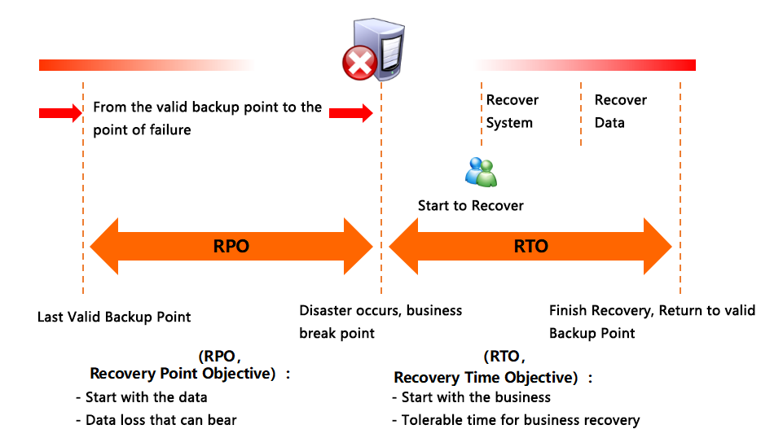
- RPO: refer to the update level where the businesses are recovered functionally and are able to support departments and the system and the production data are recovered from the perspective of the system and the application data. The update level can be the backup data in the previous week or the real-time date of the last transaction. The PRO is not set according to the business scale of the enterprise. It depends on features of the enterprise business and how much the business operation relies on data. Therefore, RPO might be similar for enterprises in the same industry and might be distinct from each other for enterprises in different industries.
- RTO: the duration of business downtime from the interruption due to IT system crashes caused by disasters until the IT system is recovered to support operations of departments and the business is restored functionally. Generally speaking, the shorter the RTO is, the sooner the business shall be recovered to the available status. From the perspective of the management, the shorter the RTO is, the better. However, it means more investment. That is to say, the enterprise needs to purchase faster storage devices or highly available software.
- Retention time: the duration when the copies in multiple times in the primary data center are kept in the standby data center. In case that the business systems in the primary data center are collectively infected with viruses and a disaster occurs in the overall data center to the extent that the data center cannot provide the operating environment, if only a copy is stored in the standby data center, the infected data will be synchronized to the standby data center, causing logical errors in the application layer and damage to the business. If a plurality of copies of the primary data center are stored in the standby data center and the retention time is set, any one of the copies in the standby data center can be chosen to recover when such a disaster occurs.

Non-functional Requirements
Based on the features of the xxx business system and users’ requirements, the solution is designed in accordance with the following principles:
High performance: Improve the processing capability of the system to the utmost so that the system will stay ahead in the country in three to five years. Make sure that the solution is evolvable so as to adapt to the development of disaster recovery (DR) technologies in the future.
High reliability: To further enhance the disaster-tolerant capability of key business data, the stability and the reliability shall be fully considered in the design stage to ensure that key data can be sent to the standby data center steadily and continuously. The business should be recovered via the backup data under any circumstances.
Extensibility: The design should not only meet the current requirements but also be easy to apply with the latest technology and upgrade to protect the current investment, considering the development of the business.
Maintainability: The solution should be easy to manage, maintain, operate, learn, use, and configure, and malfunctions should be easy to spot.
Security: The security of the processes including transmission and storage shall be considered in the design because the transmission and storage involve data backup of the key business system.
Cost effectiveness: The construction of the disaster recovery system shall take practicability into consideration as a matter of priority to meet the practical requirement and the foresight for different business systems and choose the most cost-effective design.

Solution Design

General Solution Design

Topology Architecture
Based on hyper-converged technology, the solution is to realize a Local Backup-Remote Disaster Recovery system at the virtual machine (VM) level for N business systems of xxx. Upon the completion of the disaster recovery system, the primary data center and the standby data center can switch and recover to each other and both the primary and standby data center can operate in virtual machines (VMs).
Based on the analysis of the network of the primary and standby data centers and current business system in previous section, the general topology diagram is designed as follows:
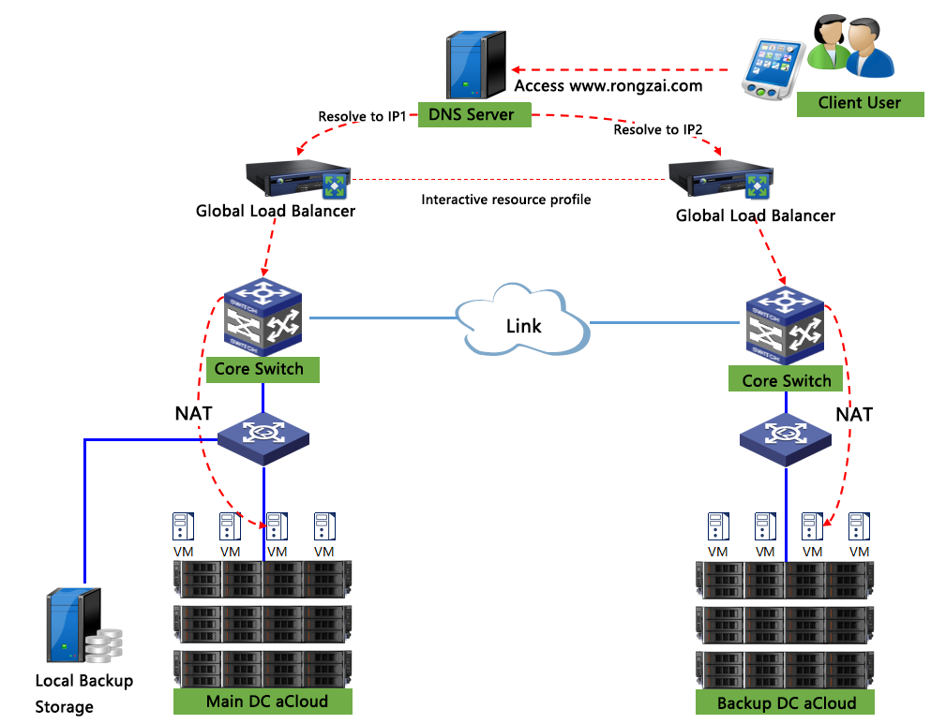
As the above diagram, both the primary and the standby data centers are constructed with the aCloud hyper-converged architecture, where the business system operates in the hyper-converged platform as VMs. The global server load balancing monitors the health status of the VMs in both centers and provides loading service with accessible links. Via the accessible links, the status and data information can be synchronously transmitted. The VMs will be backed up to the local backup storage in a fixed frequency (per second, hourly, or daily according to the specific business types). Based on the configured RPO level, the VMs will synchronize data to the aCloud platform in the standby data center, existing as the DR standby machine. Users can configure the peripheral networks for the DR standby machine through the WYDIWYG virtual network topology.
Under normal situations, VMs operate on the aCloud platform in the primary data center and the DR standby machine on the aCloud platform in the standby data center is disabled. Under different scenarios, the following operations can be conducted:
- Use the DR monitoring center and business monitoring center to monitor the health status of the business and the disaster recovery system and detect and handle the anomalies in time.
- If a single VM malfunctions and is damaged irreversibly, the VM will be recovered from the local backup storage as a matter of priority.
- When the primary data center is maintained on schedule or an unscheduled malfunction occurs to the extent that the aCloud platform cannot provide service, the business will switch to the aCloud platform in the standby data center and the DR standby machine will be enabled rapidly to recover the business.
- When the primary data center is back online, the VM on aCloud in the standby data center will be migrated to the primary data center, and the business will be recovered rapidly. At this time, only the incremental data of the VM generated when the standby data center was running will be migrated back to the primary data center.

Instruction to Environment Configuration
Based on the analysis of key parameters in the previous section combined with the specific environment and link conditions of xxx, the specific environment configuration is as follows:
Hardware Configuration
aCloud cluster in the primary data center: 5 * aServer 2105
Specifications:

aCloud cluster in the standby data center: 3 * aServer 2105
Specifications:

External storage for local backup: 1 * aStor-2100 storage server
Specifications:

Global loading device:
Specifications:

Link Configuration
DR Link: 20 Mbps special line from China Telecom
Specifications:

VM Configuration
Virtual Machine Name | Remote Disaster Recovery Parameter | Local Backup Parameter
Mail System | RPO: 1 hour | Local Backup Interval: 1 hour
Order System (Frontend) | RPO: 10 seconds | Local Backup Interval: 5 seconds
Order System (Database) | RPO: 10 seconds | Local Backup Interval: 5 seconds
ERP System (Frontend) | RPO: 1 second | Local Backup Interval: 1 second
ERP System (Middleware) | RPO: 1 second | Local Backup Interval: 1 second
ERP System (Database) | RPO: 1 second | Local Backup Interval: 1 second
...
...

Instruction to Business Access Method
- Internet Access Domain
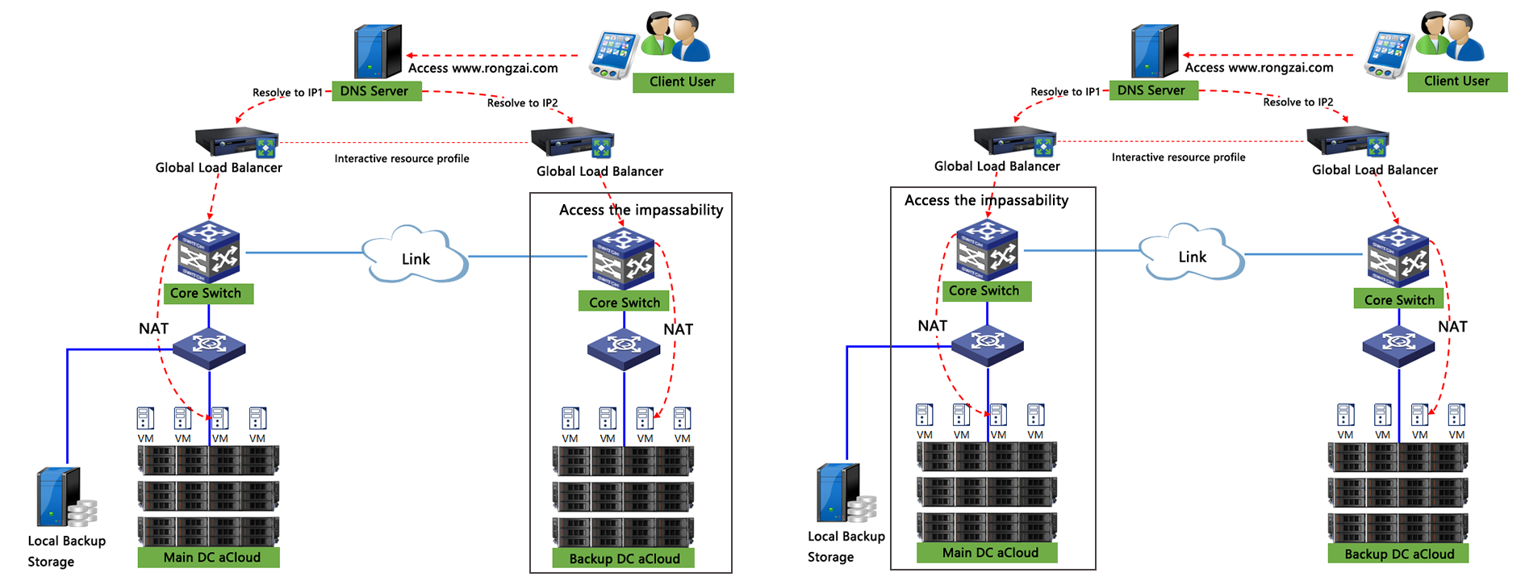
Users access the DNS server through the domain. Under normal situations, the VMs in the primary data center are enabled and provide service but the DR standby machine in the standby data center is disabled. Through the global server load balancing, the DNS server obtains the information that the VMs in the primary data center are accessible and resolves the domain name as IP1 (uuu.uu.uu.u). After address resolution, users can access the VMs in the primary data center.
After the DR switching, the VMs in the primary data center are disabled but the DR standby machine in the standby data center is enabled and provides service. Through the global server load balancing, the DNS server obtains the information that the VMs in the primary data center are inaccessible but the VMs in the standby data center are accessible. The DNS server resolves the domain name as IP2 (uu.u.uuu.uuu). After address resolution, users can access the VMs in the standby data center.
Because of the configuration for address translation, the IP address for the same business in the primary and standby data centers will not be modified before or after the DR switching.

Instruction to Major Business Solution
- DR Design for Mail System
The mail system is a business system with a standalone architecture where the application and the database are on the same VM. The DR design at the VM level for this type of business system can be:
- Uniformly manage the major DR operations (backup, synchronization, recovery, and migration) to simplify the O&M work
- DR design for the complete machine. The business can be recovered in the complete machine level, effectively lowering RTO.

- DR Design for Order System
The order system has a business architecture where each of the frontend and the database is on a VM respectively. The DR design at the VM level for both VMs can be:
- Uniformly manage the major DR operations (backup, synchronization, recovery, and migration) to simplify the O&M work
- DR design for the complete machine. The frontend and the database can be recovered in the complete machine level so that the whole business can be recovered, effectively lowering RTO.

- DR design for ERP System
The ERP system has a business architecture where the frontend, middleware, and database all support loading function. Based on the connectively and traffic loading, the load balancing function can load the traffic, realizing a pseudo-dual-active solution with zero RPO and the RTO at the second level.
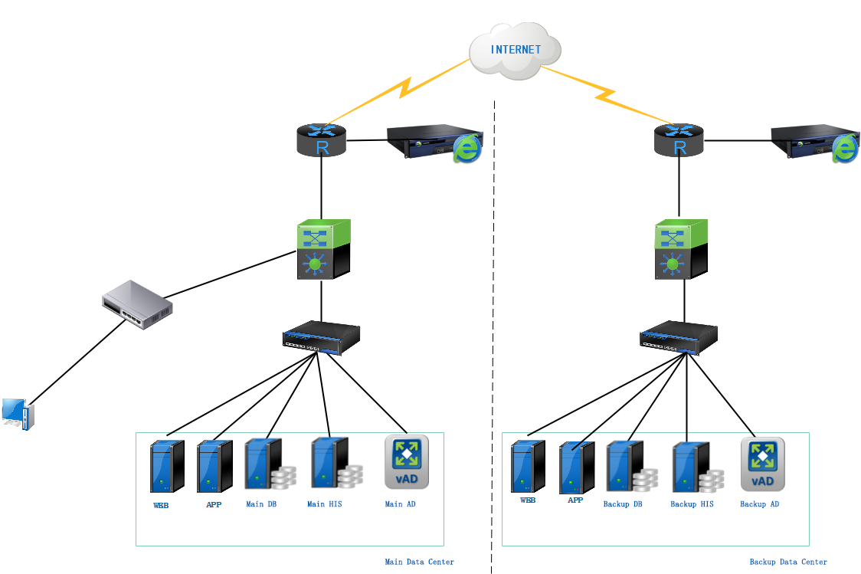
As shown in the picture, data is not stored on VMs on frontend and middleware. The VMs can be deployed on the primary and standby data centers, loading traffic through load balancing function. Based on the features, the clustering database is applied with its own data sync method. In this solution, the Oracle RAC architecture synchronizes data and switches through the Data Guard solution and the SQL Server database synchronizes data and switches through the SQL Server AlwaysOn solution. The detailed implementation solution is as follows:
- Instruction to Oracle Data Guard
Data Guard is an effective and comprehensive solution that ensures high availability, data protection, and disaster recovery for enterprise data.
The standby database of the Data Guard solution can be located on the remote DR site thousands of miles away from the production data center, or in the same city or in the same equipment room. If the production database becomes unavailable because of a planned or an unplanned outage, Data Guard can switch any standby database to the production role, thus minimizing the downtime associated with the outage.
Data Guard is an ideal supplement for Oracle RAC and can be used in combination with other Oracle high availability (HA) solutions (such as Oracle Flashback, Oracle Recovery Manager(RMAN), and new database options(including Oracle Active Data Guard and Oracle Advanced Compression) for Oracle Database 11g) to provide a highest level data protection, data availability, and resource utilization.
See the following schematic diagram for Oracle Data Guard:
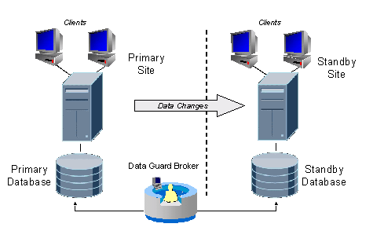
In some situations, a business cannot afford to lose data. In some circumstances, some applications require maximum database performance and can tolerate some small amount of data loss. To meet various requirements, Data Guard provides three distinct modes of data protection:
Maximum protection - This mode offers the highest level of data protection. Data is synchronously transmitted to the standby database from the primary database, and transactions are not committed on the primary database unless the redo data is available on at least one standby database configured in this mode. If the last standby database configured in this mode becomes unavailable, processing stops on the primary database. The mode guarantees no data loss even multiple failures occur.
Maximum availability - This mode is similar to the maximum protection mode, including the guarantee of no data loss. However, if a standby database becomes unavailable (for example, due to network connectivity problems), processing continues on the primary database. When the fault is corrected, the standby database is resynchronized with the primary database. This mode guarantees no data loss if a single fault (such as network failure, primary data center failure) occurs.
Maximum performance - this mode offers slightly less data protection on the primary database, but higher performance than maximum availability mode. In this mode, as the primary database processes transactions, redo data is asynchronously shipped to the standby database. The commit operation on the primary database does not wait for the standby database to acknowledge receipt of redo data before completing write operations on the primary database. There's a risk of a potential loss of data.
Users can choose the proper protection mode according to their needs. The construction here is illustrated with the example of maximum performance by default. The switch method is attached following the document.
- Introduction to SQL Server AlwaysOn
The primary data center is the production site, where SQL Server availability group is consists of local Node1 and local Node2 and a remote Node3. The primary domain controller provides a shared directory as an arbitrator to configure the arbitration of most nodes. The synchronous mode is applied for the data transmission between Node1 and Node2. The automatic failover mode is applied. When Node1 is down, Node2 will take over the business automatically.
Node3 is configured in the DR data center without the vote permission. When a disaster occurs to the production site, the manual failover will switch the database to the standby data center. By default, the standby data center is applied with the synchronization mode of asynchronous commit (the synchronization mode is applied when the network allows).
Each of the two domain controllers is the primary domain controller node and the auxiliary domain controller node respectively to form the failover cluster for windows.

Deployment and Launch

Deployment of Site and Link
Add the DR cloud environment to the site management and deploy the link between the sites so that the primary data center and the standby data center can properly communicate and data can be transmitted between the centers.
See the following comprehensive view for the physical architecture:
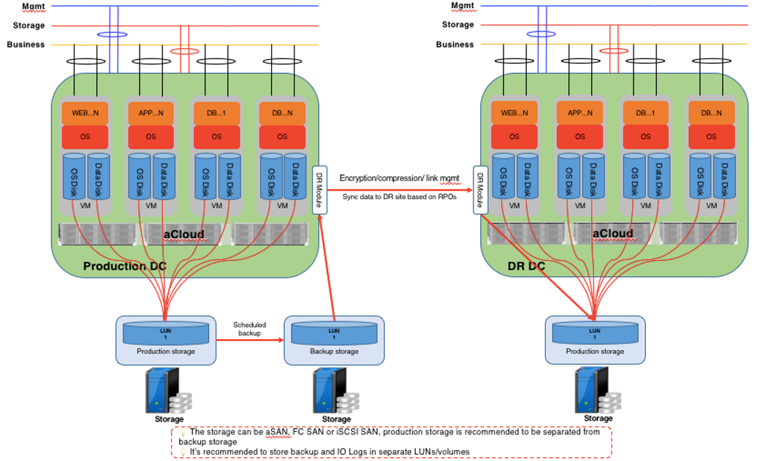
Based on the physical architecture topology in the previous section, both primary and standby data centers are applied with the hyper-converged architecture to provide basic resources for compute, network, and storage. In this solution, the hyper-converged aSAN is applied as the production storage for VMs and sss FC/iSCSI storage is applied as the backup storage for the primary data center for storing automatic local backup data and IO logs of CDP. Meanwhile, the DR module on the platform will synchronize the data to the standby data center. The hyper-converged aSan is used in the standby data center as target storage for DR and operation location after the VM is recovered.
According to the environment configuration, the DR link between the primary and the standby data centers is configured in layer-2 link/layer-3 link.
- Layer-2 Link
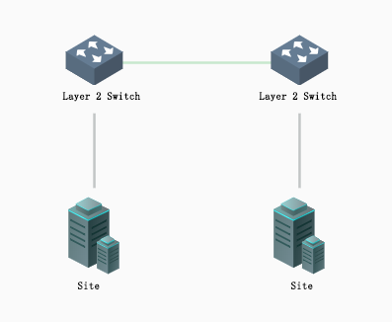
The DR link synchronously transmits data. In this solution, the primary and standby data centers use the management interfaces as DR interfaces, which are linked through a layer-2 link. IPs of both centers are in the same segment so that they can be pinged to each other.
DR interface IP of the primary data center is uuu.uu.uu.u Mask: 255.255.255.0
DR interface IP of the standby data center is uuu.uu.uu.u Mask: 255.255.255.0
- Layer-3 Link
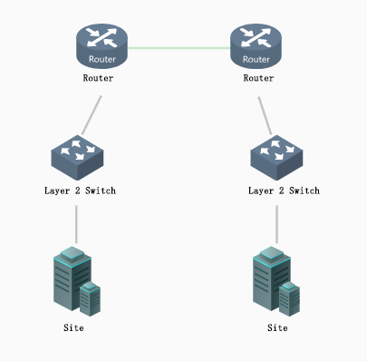
The DR link synchronously transmits data. In this solution, the primary and standby data centers use the management interfaces as DR interfaces, which are linked through a layer-3 link. IPs of the centers are in the different segments and cannot link to the public network directly and can communicate with each other through NAT.
DR interface IP of the primary data center is uuu.u.uu.u Mask: 255.255.255.0 Route in the next hop: uuu.u.uu.u IP of the site connected with the router under NAT: uu.uu.u.uuu Mask: 255.255.255.0
DR interface IP of the backup data center is uuu.uuu.u.uu Mask: 255.255.255.0 Route in the next hop: uuu.uu.uu.u IP of the site connected with the router under NAT: uuu.u.uu.uu Mask: 255.255.255.0

Configuration for Disaster Recovery Plan
Based on the analysis of the business system and the general design, the DR plans shall be made for M system(s). The DR solution shall backup and synchronize the data according to the DR plans. The specific configuration is as follows:
Name of DR Plan | Primary Site | Standby Site | Cloud Host under Protection | RPO | Remote DR Location | Local Backup Frequency | Local Backup Location | Storage Location of IO Logs
DR plan for the mail system | AAA | BBB | Mail System | 1 hour | Virtual Storage | 5 seconds | FC | FC
DR plan for the order system | AAA | BBB | Order System (Frontend)  Order System (Database) | 10 s | Virtual Storage | 5 seconds | FC | FC
DR plan for the ERP system | AAA | BBB | ERP System (Frontend 1)  ERP System (Frontend 2)  ERP System (Middleware 1)  ERP System (Middleware 2)  ERP System (Database 1)  ERP System (Database 2) | 1 second | Virtual Storage | 1 second | FC | FC
...

Network Configuration for Business
Configure the network for the DR standby machine (reserve resources for VMs in the standby data center) on the standby data center in advance to shorten the time for configuring the network after the VM is recovered in the standby data center.
The virtual network topology of the primary data center is as follows:
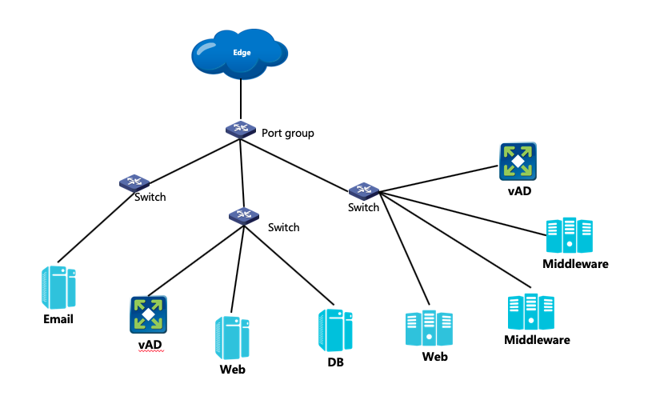
The virtual network topology of the standby data center is as follows:
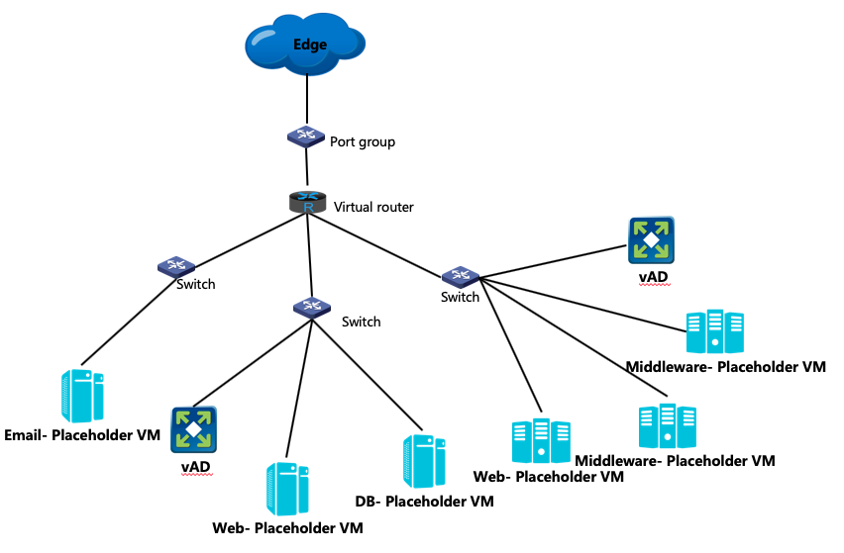
The egress networks for the primary and the standby data center are different. To ensure that the IPs of the VMs are not changed in networks of both centers, the address resolution shall be configured in the virtual router according to the business access method in the previous section. The specific configuration is shown as follows:
VM | IP of VMs Accessed by the Primary Data Center | Address Translation Rule of the Standby Data Center | IP of VMs Accessed by the Standby Data Center
Mail System | 10.2.2.20 | Destination Address Translation  Source IP: 192.168.21.220  Destination IP: 10.2.2.20  Destination Port: All | 192.168.21.220
Order System (Frontend) | 10.2.2.21 | Destination Address Translation  Source IP: 192.168.21.220  Destination IP: 10.2.2.20  Destination Port: All | 192.168.21.221
Order System (Database) | 10.2.2.22 | Destination Address Translation  Source IP: 192.168.21.220  Destination IP: 10.2.2.20  Destination Port: All | 192.168.21.222
...

Monitoring Disaster Recovery Status
The DR monitoring center shall be used to display the DR health status of VMs in each DR plan to ensure that the anomaly can be detected and handled in time.
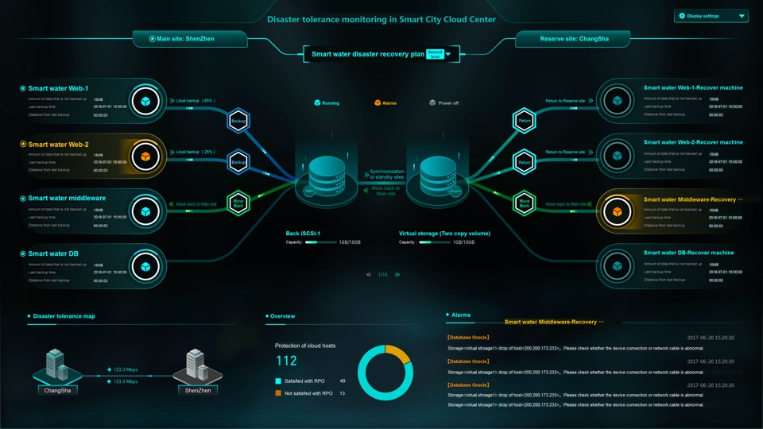
The business monitoring center shall be used to monitor the status of the business system to ensure that potential anomaly in the business system can be found in time and the countermeasures are taken, which will help to judge whether the DR switching is necessary.

Recovering to Standby Data Center
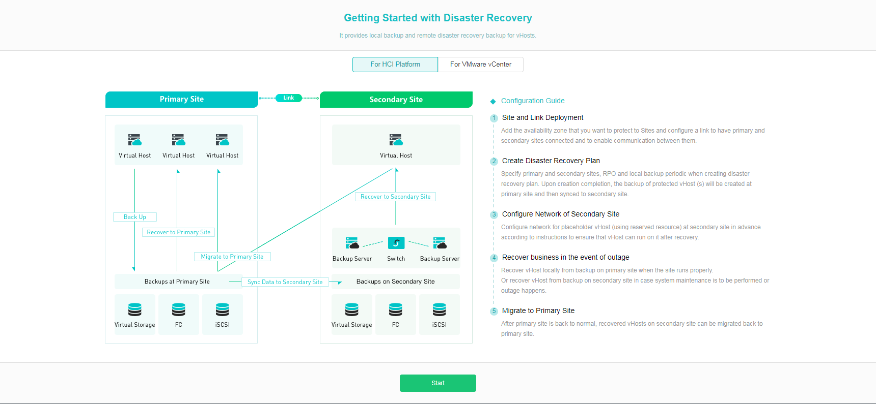
When the primary data center is functional but the VMs crash, the primary data center will back up the data and recover the cloud host to the primary data center rapidly. When the primary data center is maintained on schedule or a disaster occurs, the standby data center shall back up the data and recover the cloud host to the standby data center rapidly. Where:
scheduled recovery: shut down the cloud host in the primary data center immediately, synchronize the latest data to the standby data center, and pull the DR standby machine in the standby data center automatically after the data synchronization.
disaster recovery: pull up the DR standby machine immediately in the standby data center. The data that hasn't synchronized to the standby data center yet will be lost.

Migrating to Primary Data Center
After the maintenance for the primary data center is ended or the primary data center is back online after the disaster, the cloud host recovered in the standby data center will be migrated to the primary data center.
The cloud host in the standby data center will be shut down immediately in the migration. The latest data will be synchronized to the primary data center and the VM will be recovered in the primary data center automatically after the data migration.

Disaster Recovery Test
The DR solution will back up the cloud host under protection in the local and synchronize the data to the standby data center after the successful deployment of the site and link and the configuration of DR plans and business networks. The DR system is normal when there're data in the primary and the standby data center, the DR status is "Under Protection", and the RPO status is "Available".
Before the launch, the DR test shall be conducted in the last stage to make sure that the recovery and migration processes are effective. The test includes:
- A single VM can be recovered rapidly from local backup data.
- The data of the VM will not be lost in the two processes of recovery to the standby site on schedule and migration to the primary site.
- After the recovery to the standby site, the VM can access to the network according to the configured topology so that the business is back online.
Test content:
Item | About This Manual | Test Purpose | Successful or Not? | Response Time | Remarks
Data duplication function | Add new test data for the business system configured with the DR plan, and then shut it down. | Verify whether the added data is synchronized to the remote according to the configured RPO
Restoring to the Standby Site for DR | Choose the latest recovery point of the DR data in the standby site and use the "disaster recovery" method to switch the VM to the standby site | Verify whether the VM can be pulled up from the standby site and the business can directly access the newly-added data according to the configured RPO
Recover from the local backup data | Choose the latest recovery point of the backup data in the primary site and use the "recover to a brand new VM" method to recover from the local backup | Verify whether the VM can be recovered from local backup data and the business can directly access the newly-added data according to the configured local backup frequency
Recover to the standby site on schedule | Use the "recover on schedule" method to switch the VM to the standby site | Verify whether the VM can be pulled up from the standby site and the business can directly access the newly-added data
Migrate to the primary site | Add new test data in the VM pulled up from the standby site and then migrate to the primary site | Verify whether the VM can be pulled up from the primary site and the business can directly access the newly-added data

After the launch of the DR system, in addition to using the monitor center to obtain the operating status and DR status of the business, the DR test shall be conducted on a regular basis of six months to make sure that the user is at his/her best to deal with disasters and that the system can switch in crucial times to recover the business back online fastly. The experience can be accumulated in the test and the DR process and time can be handled better.
Test Process Template | Start Time | End Time | Successful or Not? | Duration | Remarks
Test Process rrr | December 31,2018 | January 3,2018 | Yes | 3 days
Test Process ttt | June 30,2019 | July 3,2019 | Yes | 3 days
Test Process rrr
Item | About This Manual | Test Purpose | Successful or Not? | Response Time | Remarks
Data duplication function | Add new test data for the business system configured with the DR plan, and then shut it down. | Verify whether the added data is synchronized to the remote according to the configured RPO
Recover from the local backup data | Choose the latest recovery point of the backup data in the primary site and use the "recover to a brand new VM" method to recover from the local backup | Verify whether the VM can be recovered from local backup data and the business can directly access the newly-added data according to the configured local backup frequency
Recover to the standby site on schedule | Use the "recover on schedule" method to switch the VM to the standby site | Verify whether the VM can be pulled up from the standby site and the business can directly access the newly-added data
Migrate to the primary site | Add new test data in the VM pulled up from the standby site and then migrate to the primary site | Verify whether the VM can be pulled up from the primary site and the business can directly access the newly-added data

Test Process ttt:
Item | About This Manual | Test Purpose | Successful or Not? | Response Time | Remarks
Data duplication function | Add new test data for the business system configured with the DR plan, and then shut it down. | Verify whether the added data is synchronized to the remote according to the configured RPO
Restoring to the Standby Site for DR | Choose the latest recovery point of the DR data in the standby site and use the "disaster recovery" method to switch the VM to the standby site | Verify whether the VM can be pulled up from the standby site and the business can directly access the newly-added data according to the configured RPO
Recover from the local backup data | Choose the latest recovery point of the backup data in the primary site and use the "recover to a brand new VM" method to recover from the local backup | Verify whether the VM can be recovered from local backup data and the business can directly access the newly-added data according to the configured local backup frequency
Migrate to the primary site | Add new test data in the VM pulled up from the standby site and then migrate to the primary site | Verify whether the VM can be pulled up from the primary site and the business can directly access the newly-added data

Key Technologies

Hyper-converged Technologies

Server Virtualization aSV
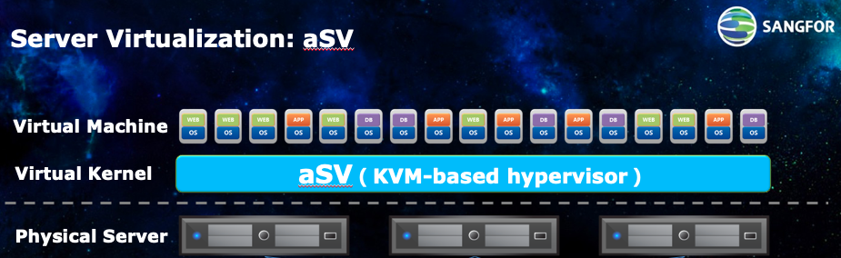
The compute resource pool of the Sangfor Hyper-Converged Architecture is provided by Sangfor server virtualization software aSV. aSV, applied with the X86 virtualization technology with the bare metal architecture, abstracts and transforms the physical resources of servers including CPUs, memory, and I/O, into logical resources that can be managed, dispatched, and distributed uniformly. Based on the logical resources, the operating environment where several servers can run simultaneously and independently is constructed in the physical servers. In this way, the resources are made full use of and can be dynamically distributed more flexibly, such as hot migration and high availability (HA), thus lowering operating cost, increasing flexibility, and improving the business response speed.

Storage Virtualization aSAN
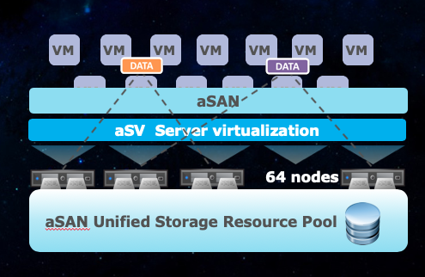
Sangfor storage virtualization aSan, based on cluster design, organizes the hard disk storage on the servers into a unified virtual shared resources pool for storage - Server SAN Distributed Storage System - to realize the data storage in high reliability and high performance. The distributed storage system is consistent with the independent shared storage in functions. A piece of data will be stored simultaneously in disks of various physical servers, thus improving data reliability. In addition, SSD cache can greatly improve the IO performance of the server disks, realizing high-performance storage. Meanwhile, users don't need to buy SAN network devices (FC SAN or iSCSI SAN) to connect the computer servers with the storage device because the storage and the compute are combined in the same hardware platform through aSAN.

Network Virtualization aNET
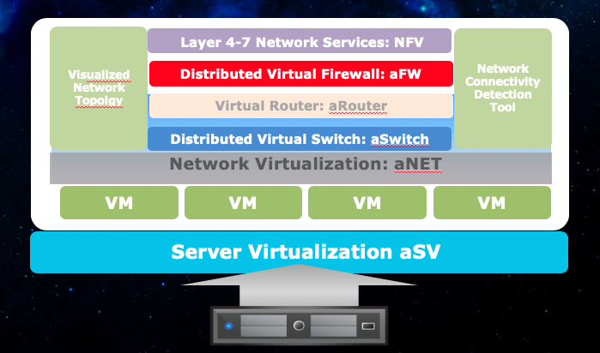
Sangfor Net Virtualization aNet, through a brand-new network management method, solves various management and O&M problems in traditional hardware networks and helps operators in the data center to improve the agility and cost-efficiency tremendously.
Sangfor Network Virtualization aNet solution, combined with server virtualization aSV, provides a combination of logical network devices, connection, and service between the VM and the physical network, including virtual networks and security devices, namely distributed virtual switch aSwitch, virtual router aRouter, virtual next-generation firewall vNGAF, virtual application delivery vAD, virtual vSSL VPN, and virtual WAN optimization controller vWOC. In addition, aNet solution supports enhanced network protocols such as VxLAN to realize the full connection with physical networks and simplify the configuration management for the networks. Moreover, through the virtualization management platform, aNet realizes the network management functions including deployment for network topology and network failure detection.
In this way, virtual network aNet can rapidly complete the network deployment for different applications, automatically adjust the network configuration, troubleshoot network failures, improve the management and O&M efficiency for the network, improve network readiness and expansibility speed, and lower the construction cost for the physical networks in the data center.

Core Function Technologies

Multi-Copy
A mechanism of multi-copy across hosts ensures data reliability. That is to say, a piece of data has 2-3 copies in different hosts. When the host in the cluster malfunctions and cannot provide services, there is an identical copy in another host so that users' business will not be affected. A new data will be written into 2 copies simultaneously and the data will be read from just one of the copies.
When one of the hosts is shut down temporarily and the 2 copies are inconsistent, through bitmap comparison, only the inconsistent part will be fixed, and the copies will be recovered so that both copies will be consistent and the window time for the copy difference will be minimized, lowering the risk.

Backup
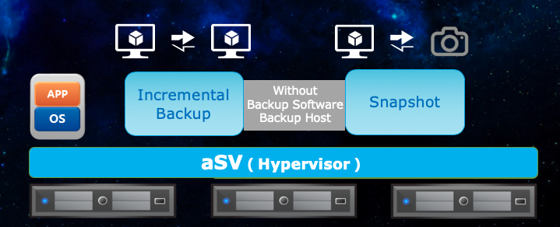
Fast agentless disk backup will protect your data and incremental backup will reduce the backup storage and lower the backup cost.
- Additional backup software or servers are unnecessary. The backup software and server are integrated into the platform which is easy to operate. With just one button, users can obtain the backup function and the platform will conduct the incremental backup automatically.
- Compared with snapshot backup, the rapid backup has a 60% increase in performance, and the performance will not be lost after the backup.
- Provide manual backup function and automatic backup function on an hourly, daily, or weekly basis, ensuring the data security of the files in VMs.

Continuous Data Protection (CDP)
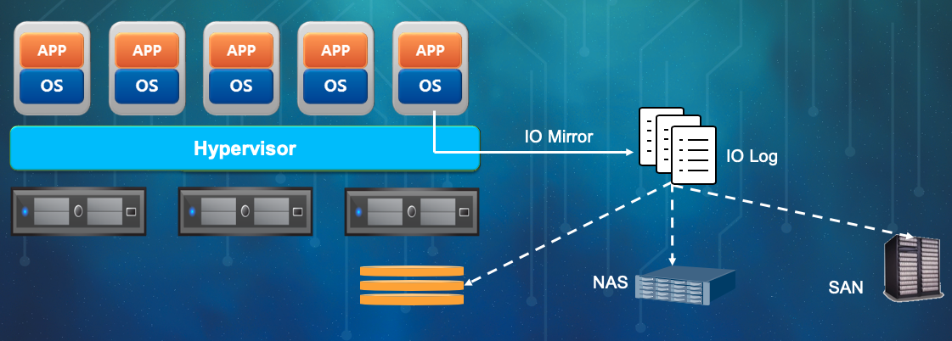
For specific VMs, real-time CDP will be enabled. Through the IO mirroring method, the IO change in VMs will be tracked and recorded. If the VM losses any data or malfunctions, the VM can be recovered to any recovery point for backup (RPO≈0, RTO<5min).
The CDP function is integrated into the platform and can be obtained through just one button conveniently. The business in VMs will not be affected even if CDP is interrupted by backup storage offline or suspended due to busy storage IO, because the IO process of CDP has nothing to do with the production storage.

Failure Recovery (HA)
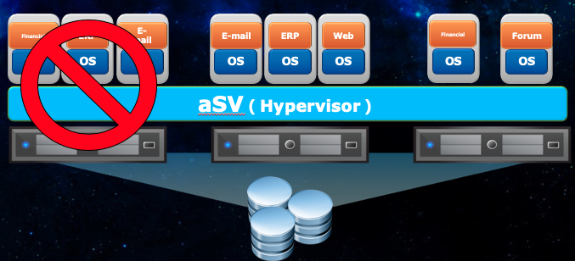
Under the environment of enterprise cloud architecture, if physical failures occur, such as the network cable of the physical host with HA-enabled VMs is plug off or the storage is inaccessible, the VMs will be switched to another host and reboot to ensure that the businesses in the VMs are normal.
- Realize high availability for businesses in the overall data center. The expensive and complex traditional cluster solution is unnecessary.
- Lower the business downtime caused by hardware and software failure to the utmost.
- Improve the protection strength for the overall basic architecture.

Virtual Machine Live Migration
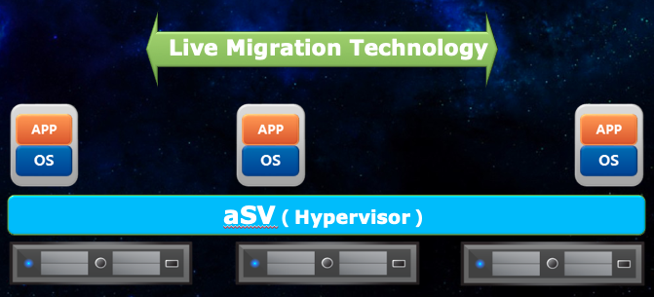
Provide an online migration function for VMs without packet loss. The operating path and storage location of the enabled VM can be migrated without interrupting the business.
- Require no external storage: aSan distributed shared storage solution supports not only common live migration for VMs but also the live migration for VM with storage mirrorings
- Zero downtime: scheduled maintenance for hardware, upgrade, or migration will not interrupt the business
- Compatible with external storage: support Fiber Channel and iSCSI SAN environment

Dynamic Resource Scheduling (DRS)
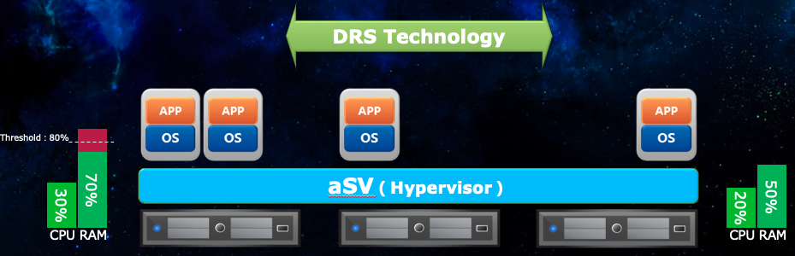
Support DRS function. DRS monitors the host according to the resource threshold. Once resources in one of the host are overloaded, the VM on the host will be live-migrated to another host with idle resources to ensure sufficient resources for business continuity.
- Require no proxy program and the DRS function will be realized
- Set the threshold. When the resource utilization exceeds the threshold, the migration for VMs will be triggered
- Automatic load balancing for cluster business, which will decrease the utilization rate for resources in the highly-loaded host in the cluster

Distributed Cluster Load Balance
The AD component integrated into the enterprise cloud platform ensures 24/7 business continuity to eliminate the technical defects of the automatic reboot of HA and VMs caused by failures.
Combined with the distributed architecture of the hyper-converged platform, the AD component will automatically schedule the traffic for the distributed business system and eliminate the single point failure for the business system from the hardware layer to the application layer, ensuring zero downtime for the business.

Wide Area Network Acceleration
The database synchronization across data centers occupies lots of bandwidth resources with enormous data volume. The deployment of WOC devices can greatly compress the data to be transmitted and reduce traffic. When the Web or the App service unit communicates across data centers, through the protocol optimization and flow-cache technologies, the WOC device will be accelerated. When the Web and App service unit require a large number of bandwidth resources, the database synchronization will be guaranteed as a matter of priority.
Sangfor WOC database DR optimization solution can improve the transmission speed for data, greatly shorten the time spent for daily DR backup, improve the DR efficiency, as well as lower RTO and accelerate the data recovery.
Sangfor Technologies, as the largest cutting-edge network device provider with the best innovation ability in China, provides network solutions of fast and intelligent application delivery to help the business users improve their bandwidth value.
- TCP window extension: through the optimization of transmission protocols, the TCP window is extended to increase the TCP throughput and accelerate the transmission.
- Data compression: for DR transmission data, high-efficiency stream compression methods such as LZO and GZIP is applied to decrease the DR transmission data volume and improve backup efficiency.
- Byte-level data de-duplication: the data optimization technology based on code-stream features is applied. The byte-level data de-duplication will be conducted for DR data and greatly reduce DR data. Optimize for global backup, incremental backup, and differential backup.
- Match the code stream features at byte level for transmission data and judge whether the data is duplicated.
- In the sending end, completely reduce the big data block backed up in the global backup and differential backup.
- At the byte level, de-duplicate the data block modified in the differential backup, the differential backup, and the incremental backup. It has been proven in tests that the method can greatly reduce the transmission data and improve the DR efficiency.
- For newly added data block in the DR backup, the data compression technology is applied to reduce redundancy.
- Link optimization: the public network line is used to construct the DR network. The DR efficiency might be compromised due to the bad quality of the public network. The built-in link optimization module in Sangfor WOC optimizes transmission protocols and mechanisms, ensuring high-speed transmission for DR data in high packet loss and latency, especially effective for the across-carriers environment.

Solution Configuration

Disaster Recovery Center
S/N | Proposed Application | Application Purpose | Recommended Model | Parameters | Quantity | Remarks
1 | 1. Same-City data DR (Server Storage)
2 | Cloud platform hardware for distributed compute and storage | Hyper-converged all-in-one Machine | aServer-P-2305 | 2* Intel Gold 6132 (2.6GHz 14-Core 35MB 120W)/256GB/2*128GB SSD/2*480GB SSD/6*4TB SATA 7.2K/6*GE+2*10GE NIC with Optical Module/Guide Rail/Activated and Available Remote Management/Redundant Power Supply/Chinese National Standard Power Line/DVD (Optional) | 5 | Protect Oracle Database and application programs
3 | Cloud platform software for distributed compute and storage | Cloud platform | aCloud | Compute virtualization, distributed storage software, and network virtualization software | 1
4 | Distributed backup storage | Storage all-in-one machine | aStor-EDS1210 | 2*Intel E5*2360v4, 32G memory, 2*480GB SSD+8*4TB SATA, 4×10G+4x1G Network Port, Dual Power Supply. | 3 | Backup storage
5 | Distributed backup storage software | Distributed storage software | EDS | Software functions: Sangfor Mass-Data Storage Management Software Basic software package: snapshot, quota, and topology management, intelligent cache, intelligent hierarchy, bucket management, user management. Based on the hard disk capacity 1T/Each License | 48 | Backup storage software
6 | Tape library | Tape library | Tape library | Quantum I40 Tape Library LTO Tape Library, 25 slots, 2*LTO5FC Driver, 2*Cleaning Cartridge, 20 pieces of 1.5T Tape | 1
 | 2. Access to Switches
7 | Access to switches via a dedicated line | The IDC production center to the same-city DR equipment room | S6720-30C-EI-24S-AC | 24*10GE SFP+ Port(21* 10 Gigabit SFP Module)  6*100GE QSFP28 Port or 40GE QSFP+Port  Switching capacity: 2.16TBPS/19.44tBPS, packet forwarding rate: 720 Mpps, Dual power supply | 2 | Primary line, China Telecom /Standby line, China Unicom
8 | Core switches | DR equipment room |  | 48-port 10GE SFP+, 2*40GE QSFP+Port | 2
9 | Businesses access to switches | DR equipment room |  | 48-port 10GE SFP+, 2*40GE QSFP+Port | 2
10 | Storage switches | DR equipment room |  | 48-port 10GE SFP+, 2*40GE QSFP+Port | 2
11 | Cloud management switches | DR equipment room |  | 24-port gigabit switch | 2
12 | BMC out-of-band management switches | DR equipment room |  | 24-port gigabit switch | 2
13 | Firewall | DR equipment room egress for Office-dedicated network |  |  | 2
14 | Load balance | Application load balance | AD-1000-G642 | Layer 4 throughput (default port): 21Gbps. Layer 4 throughput maximum performance(custom port):21Gbps. Concurrent connection: 9400000. Layer 4 Connection establishment CPS: 340000. Layer 7 Connection establishment RPS: 150000. Layer 7 Connection establishment RPS (Connection pool activated): 300000. Power: redundant power supply. Size: 2U. Ports: 6*electrical ports, 4 optical ports, and 2*10 Gigabit. | 2
 | Others
15 | Database synchronization | Same-city database replication | ODG | Oracle DataGuard | 1 | The IDC to the database of same-city DR equipment room
16 | Backup Software | Database backup |  |  | 1 | DR equipment room
17 | System integration |  |  | Server system deployment, database deployment, database migration, database test, storage implementation, business system cutover, and new database test(Hundson System) | 1 | The system is integrated with technical support service via phones for 1 year

Note: the quotation is just for reference. Market factors might cause fluctuations in prices. The price shall subject to the actual price in the procurement. The list of the solution shall be modified according to the details before the implementation.

Line and Equipment Cabinet Tenancy
3. Line Estimation
Point to point | Functions | Recommended Carriers | Quantity | Bandwidth | Remarks
IDC production center -> Same-city DR equipment room | Same-city database replication | China Telecom | 1 | >10 | Stage 1 Database DR
IDC production center -> Same-city DR equipment room | Same-city database replication | China Unicom | 1 | >4 | Stage 1 Database DR
IDC production center -> Remote DR equipment room | Remote database replication | China Telecom | 1 | >6 | Stage 2 Database DR
IDC production center -> Remote DR equipment room | Remote database replication | China Unicom | 1 | >4 | Stage 2 Database DR (optional)
Office center -> Same-city DR equipment room | Trading rooms to the same city and same-city O&M equipment room | China Telecom | 1 | >6 | Stage 1 Database DR
Office center -> Same-city DR equipment room | Trading rooms to the same city and same-city O&M equipment room | China Unicom | 1 | >2 | Stage 1 database DR (optional)
Office center -> Remote DR equipment room | Remote O&M equipment room | China Telecom | 1 | >2 | Stage 2 Database DR
Office center -> Remote DR equipment room | Remote O&M equipment room | China Unicom | 1 | >2 | Stage 2 Database DR (optional)
Shanghai Stock Exchange -> Same-city DR equipment room | Offers in Shanghai, same-city DR, primary line | China Telecom | 1 | >4 | Stage 2
Shanghai Stock Exchange -> Same-city DR equipment room | Offers in Shanghai, same-city DR, standby line | China Unicom | 1 | >2 | Stage 2 (Optional)
Shenzhen Stock Exchange to the same-city DR equipment room | Offers in Shenzhen, same-city DR, primary line | China Telecom | 1 | >6 | Stage 2
Shenzhen Stock Exchange to the same-city DR equipment room | Offers in Shenzhen, same-city DR, standby line | China Unicom | 1 | >4 | Stage 2 (Optional)
DR equipment room -> Internet | Site and online trading business | China Telecom | 1 | >50 | Stage 2
DR equipment room ->Internet | Site and online trading business | China Unicom | 1 | >20 | Stage 2 (Optional)
4. Equipment cabinet
Same-city DR Equipment cabinet | Same-city DR Equipment cabinet | Dr. Peng Equipment Room | 2 | 48U | Standard server cabinet (800mm width × 1100mm depth)
Remote DR equipment cabinet | Remote database DR | Group equipment room | 1 |  | Stage 2

Note: some lines are not necessary for the stage 1. Lines shall be chosen specifically based on the business development of the proprietor.

