SANGFOR AD Pre-POC

Environment Check List
Project name:________________Customer name:_______________Contact:______________

Scenario:
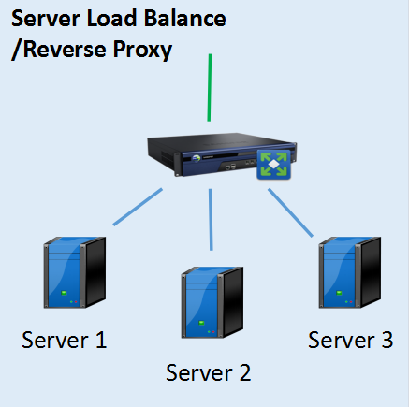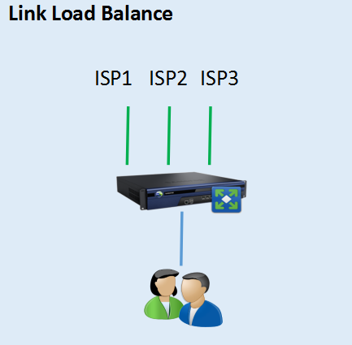
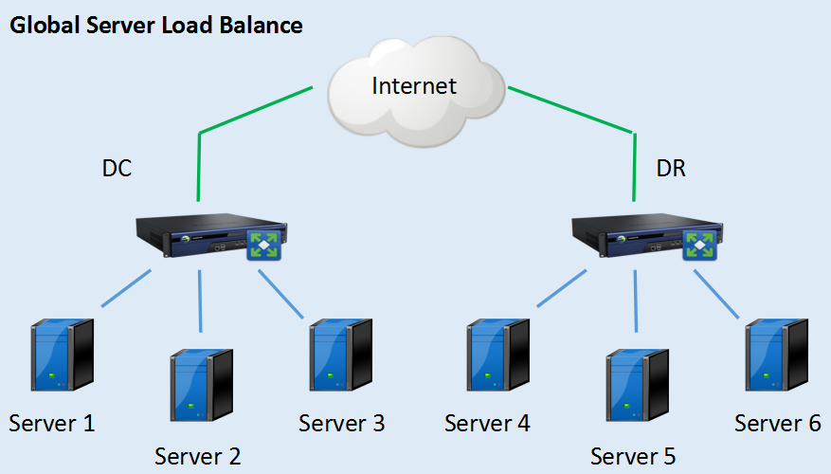

Server Load Balance:
1.Business system name：______________________________(ERP,OA,Database,FTP,DNS,Mail...)
2.System protocol:______________________________(HTTP,HTTPS,FTP,SMTP,ORACLE/MYSQL...)
3.Total server number:______________________________
4.Total server throughput:_____________________Concurrent connections is ______________
(Use traffic monitor device evaluate or evaluate based on link throughput )
5.Whether server requires client source IP or not?
______Yes,does server support X-Forward-For method________Yes, ________No
______No,don’t need.
6.Whether customer has SSL Off Load requirement?
___________Yes, SSL server throughput is_______________
___________No,don’t need

Link Load Balance:
Link quantity:___________________________
Link total throughput:____________________
Link type:_________10/100/1000 Base-T, ________SFP, _______10G +SFP, _______40G +SFP

Common:
- HA requirements:____________________
- GSLB Data center quantity:_____________________
- Special protocol traffic need cross through AD:
__________________________(PPTP,BGP,VRF,PPPoE,L2TP,MPLS)
- Expect deployment mode:__________________(Gateway Mode or Single Arm Mode)

Current Topology:

