SANGFOR SSL VPN Technical Proposal
For XXX

***********************************************************************************************************************
Edited by ： xxx
Update time: 2018-11-26
Rights reserved by: Sangfor Technologies Inc.

***********************************************************************************************************************
Content
Content 2
1 Introduction of SANGFOR SSL VPN 3
2 SANGFOR SSL VPN Solution 4
2.1 RAPID 4
2.1.1 Less Bandwidth Requirement 4
2.1.2 Smooth Performance under Harsh Network Environments 4
2.1.3 Access Optimization on Tablets and Mobile Devices 5
2.1.4 Full Utilization of Resources 5
2.2 SECURE 5
2.2.1 Identity Authentication 5
2.2.2 Transmission Security 6
2.3 SIMPLE 6
2.3.1 Application Virtualization Delivers Applications as On-demand Service 6
2.3.2 SANGFOR Remote Application® for Application Virtualization 6
2.3.3 Smooth Access from Tablets and Smart Phones 7
2.3.4 Flexible Deployment 7
3 EasyConnect Remote Access and Mobile Office for Enterprises 7
3.1 Sangfor EasyConnect 8
3.2 How EasyConnect works? 8
4 Solutions for xxx 10
4.1 Possible Challenges: 10
4.2 SANGFOR Solution: 10
4.3 Achievements (Gartner & F&S) 11
5 About Sangfor 12

Introduction of SANGFOR SSL VPN
Sangfor SSL VPN provides support for remote user to access the enterprise network from anywhere as long as you are connected to the Internet. Remote access is provided through a Secure Socket Layer (SSL) enabled by a SSL VPN gateway.

The SSL VPN gateway allows remote users to establish a secure Virtual Private Network (VPN) tunnel using a web browser.

This feature provides a comprehensive solution that allows easy access to a broad range of web resources and web-enabled applications:

(e.g.: Easy Connect) using native HTTP over SSL (HTTPS) browser support.

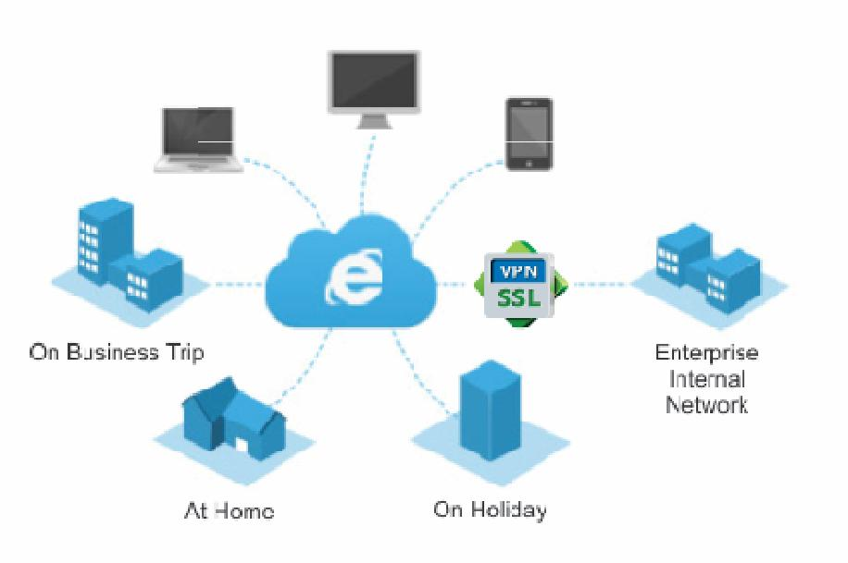
Sangfor SSL VPN provides SSL VPN remote-access connectivity from almost any Internet-enabled location using a web browser or a APP that natively support SSL encryption. This feature allows your Company to extend access to its secure enterprise network to any authorized user by providing remote-access connectivity to corporate resources.

SANGFOR SSL VPN Solution
By using the exclusive acceleration technology of SANGFOR SSL VPN, enterprises are able to provide users with a satisfied and efficient remote access experience, which improves the work productivity of remote workforces.

RAPID

Less Bandwidth Requirement
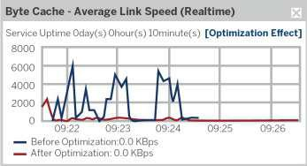
Compression is commonly used in other solutions but not enough to offer a high-speed SSL VPN connection. SANGFOR SSL VPN innovate by adopting the Byte Cache technology into SSL VPN sessions, which effectively eliminates 30-90% of redundant traffics on SSL VPN links and improves the access speed of remote users.

Smooth Performance under Harsh Network Environments
Under harsh network environments such as cross-border and cross -operator with high packet loss rate or high latency, the access speed would be significantly lower than one had expected.
SANGFOR SSL VPN employs HTP (High-speed Transfer Protocol) to smooth the transfer environment and minimize the negative impact of packet loss and latency. End users are able to consistently enjoy a favorable access experience.

Access Optimization on Tablets and Mobile Devices
In order to solve the display and slow connection problems that tablets and mobile devices users might encounter when accessing browser-based applications, SANGFOR SSL VPN not only optimizes the page display and mobile access, but also provides various image optimization policies such as image filtering and compression to prevent the problems mentioned above.

Full Utilization of Resources
Considering real-life deployment, SANGFOR SSL VPN is also equipped with Intelligent Link Selector. The Intelligent Link Selector can automatically select the optimal link for remote access when there are multiple links.

SECURE

Identity Authentication
Authentication
--Support up to 8 types of authentication methods.
--User name/password, LDAP, RADIUS, CA (Certification Authority).
--Certificate/USB key based authentication, Dynamic token, Hardware ID, SMS.

Host Checker
Endpoint detection and scanning of operating system, registry files, personal firewall, anti-virus files, user-customized security rules and other security policies prior to user login as well as during SSL VPN session.

Account Binding
Binds SSL VPN user accounts to authorized applications accounts for account compliance and management.

Cache Cleanup
Wipes off any cached data when the SSL VPN session terminates, which avoids data leakage if any remote users are accessing SSL VPN with a public endpoint.

Transmission Security
Tunnel Encryption
SSL Session Encryption

Dedicated SSL VPN Tunnel
Provides the flexibility of disconnecting all other Internet connections but SSL VPN session to prevent intrusions and attacks from Internet.

Man-in-the-middle Attack Detection
Detects and alerts if the endpoint is suffering from Man-in-the-middle" Attack before it is connected to the Intranet.

SIMPLE
SANGFOR SSL VPN simplifies the account/authentication by allowing administrators to do seamless combination with the LDAP/RADIUS servers and supporting SSO (single-sign- on) with published applications.

Application Virtualization Delivers Applications as On-demand Service
With new diversity of endpoints and business applications, IT managers have always been looking for a better remote access solution. This way business applications can be securely delivered to remote workforces as an on-demand service via a browser, with no limitation to remote workspaces, application types or available endpoints. SANGFOR SSL VPN Remote Application is the solution.

SANGFOR Remote Application® for Application Virtualization
--Interfaces of published applications are pushed to endpoints screens as virtual access windows, so end users are able to remotely access the applications through a browser.

--Operation and control on applications occur in the server end, no business data will be stored locally.

With SANGFOR Remote Application, business applications are virtualized, centralized and managed in the datacenter and instantly delivered as a service to those users in need. Since everything occurs within the virtual application servers, users are virtually operating in the enterprise network, which prevents any possibility of data leakage.

Smooth Access from Tablets and Smart Phones
As business applications are delivered to remote workforce as on-demand service, remote workforces can now access any published applications freely from any endpoints with a browser including mobile devices, no matter the applications are based on Windows or in the form of B/S and C/S.

Flexible Deployment
Various deployment features are offered for consolidating it into the existing IT infrastructure with typical functions such as the asymmetrical cluster and cloud cluster. Asymmetrical cluster supports robust clustering of different hardware models for scalability. Cloud cluster assigns SSL VPN requests to the fastest and most healthy appliance when SSL VPNs are deployed in multiple data centers that are located in different places.

EasyConnect Remote Access and Mobile Office for Enterprises
With Sangfor EasyConnect APP, you are able to access any business applications (Lotus notes, Exchange, OA, SAP, ERP, CRM, etc.) remotely from your smartphones and tablets.
Remote and mobile connectivity has always been of value to enterprises. With the increasing popularity of smartphones and tablets, there is an ever increasing demand for a convenient and secure approach for remote access to corporate data to perform business activities. However, as the enterprises are expanding the network infrastructure to the remote workforce, IT managers can find it extremely difficult to provide full application availability for tablets and smartphones due to resource compatibility, OS support and security concerns.

Sangfor EasyConnect
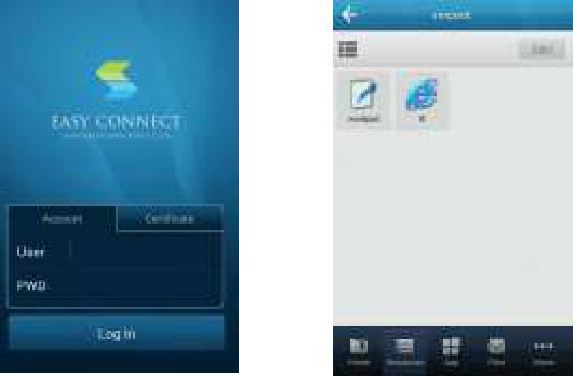
Sangfor EasyConnect, is the tailor-made APP for remote users to access business applications with mobile devices anytime and anywhere, as long as there is a network connection. Remote users are now able to work anywhere.

How EasyConnect works?
EasyConnect is the perfect mobile office solution for business organizations, especially for those that require superior connectivity for remote branches and business travelers. The APP leverage Sangfor’s unique remote application technology to simplify mobile and remote access. To work properly, remote application service needs the following components:
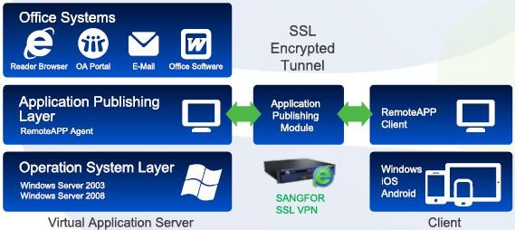

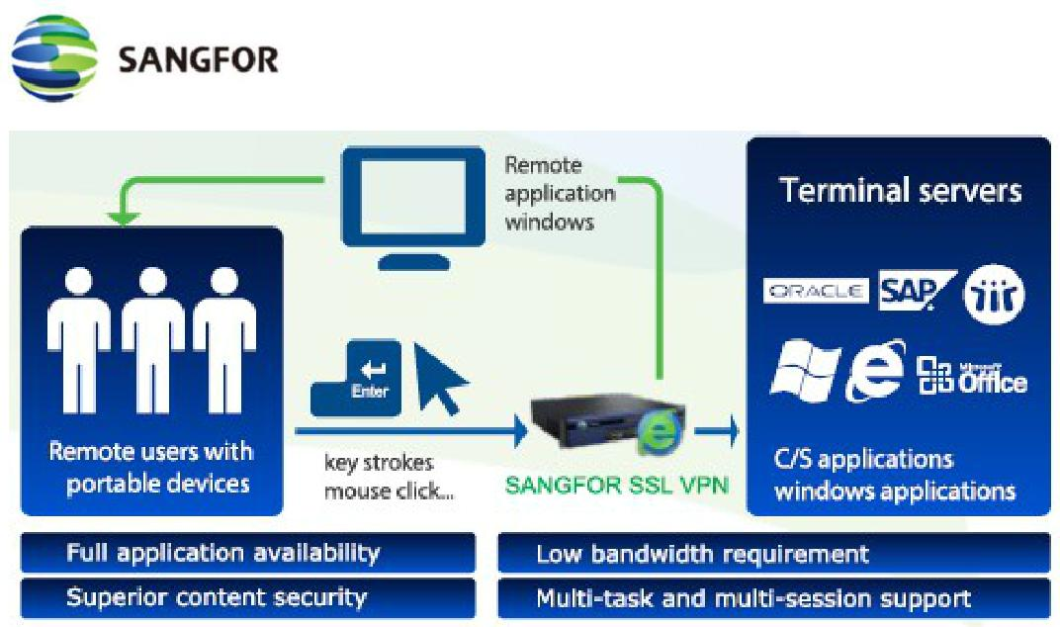

With the remote application enabled, published application interfaces are available on the mobile screens. Thus, users will operate on the virtualized graphical interfaces. Furthermore, since all processes are conducted in the virtual application servers, by all means users are virtually operating within the corporate network only, avoiding any possibility of information leakage.

Remote Application Module
The core of remote application service that is embedded in SSL VPN device, in charge of identity authentication, obtaining resource information from remote servers, data processing and so on.

RemoteApp Agent
One ActiveX control that should be installed on remote application server and plays the role of
providing remote application service and monitoring server status. By default, auto-start is enabled.

Application Client Program
Application client should be installed on the remote application server before publishing the application (such as MS Office, WordPad).

RemoteApp Client
A SSL VPN client that should be installed on client end and provides service of connecting to remote server.

Solutions for xxx

Possible Challenges:

- Increase use of mobile devices for work
- User’s authentication and tracking
- Security of the information
Information Network Platform is one of the most efficient way to collaborate for customer. Relying on a complete set of meticulously divided and organically combined information system, customer achieved effective integration of internal resources, rapid execution of upper decisions and efficient exchange of external information. But how could they ensure timely exchange of information, prompt follow-up of business and fast implementation of mobile office business?

The effectiveness of information means constant leading of business, while the characteristics of mobile office means that customer cannot use its original network of dedicated line to ensure efficient transmission. With application systems hanging in the public network and access through the open network of internet, important data, servers, or even the entire intranet security will be seriously threatened.

SANGFOR Solution:

SSL VPN provides easy access and fast networking. For mobile office, SSL VPN has a unique advantage, which is without installing any client software, but by simply opening your browser and enters the corresponding URL, you will be able to complete the establishment of SSL VPN tunnels after a simple login authentication.

Without any complex configuration, SSL VPN products can seamlessly integrate with smartphones, tablets and other mobile devices. For NCSC, SSL VPN will be the best solution.

In the aspect of data security protection, besides multiple security encryption methods, Sangfor SSL VPN also provides a dual-factor authentication mechanism of dynamic token and account password combined to ensure the security of identity authentication.

With mobile users all over the country, Sangfor SSL VPN has many network acceleration technologies.

During SSL VPN access, the system will automatically detect the line speed and allow the end user to access using the fastest route, which is particularly suitable for inter-carrier network environment.
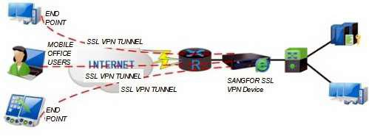

Through the combination of password and dynamic token authentication, as well as the integration of optimization technology and intelligent routing, Sangfor SSL VPN can ensure great access experience for staff, even for those located in different regions.

Rapid, Secure and Simple
With the development of cloud computing and mobile devices, modern workforces have become increasingly mobilized and distributed. This trend requires business organizations to prepare its IT infrastructure to facilitate a secure and efficient remote access to business resources with full efforts.

SANGFOR understands those business challenges and is committed to provide solutions for those increasing demands of modern enterprises. Compared with other existing SSL VPN solutions, SANGFOR SSL VPN offers the best level business driven solution with extraordinary access speed and security technologies.

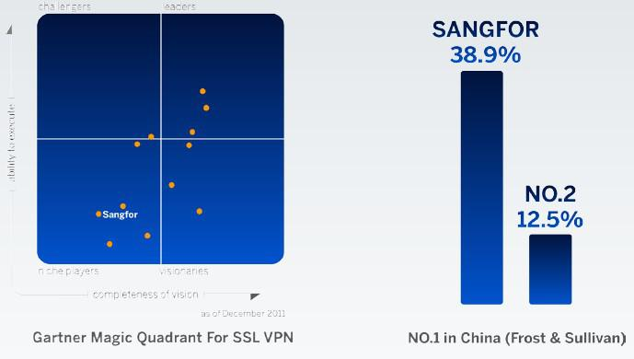
Achievements (Gartner & F&S)

About Sangfor
Since its establishment in 2000, SANGFOR has had a clear goal: To build high-performance, reliable and absolute secure networks that underpin the growth of our customers’ businesses. SANGFOR concentrates on excellence in WAN devices (IAM, WANO, NGFW, SSL VPN, Enterprise WLAN), chiefly for emerging segments, rather than producing good-enough products for all parts of the network. From the start, SANGFOR’s products have been designed to offer unparalleled performance, greater choice and greater flexibility while lowering TCO (Total cost of ownership) .
SANGFOR has over 4000 full-time employees worldwide. Its customers include more than 21,000 businesses, among them a number of Fortune 500 members, as well as two hundreds of local Indonesian customers including FBSI, Enterprise, Government and higher-education institutions.
Awards:
1. Deloitte Technology Fast 500 Asia Pacific Awards in 8 consecutive years (2005-2012)
2.Mid-sized Enterprise Gold Award from Standard Chartered Bank
3.Network Security Manufacturer in Asia Pacific Award 2009 from Frost & Sullivan
4.Year of the Product Award from Computer World for 4 consecutive years
5.Best Employer Award 2015 from Fortune
6.SANGFOR IAM--The biggest market share in China – 2007~2016(From IDC)
7.SANGFOR SSL VPN--- No.1 for 2 consecutive years in Chinese market share (From Frost&Sullivan)
8.SANGFOR VPN hardware---No.1 in Chinese market share(From IDC)
9.SANGFOR WANO---No.1 Chinese vendor in the WAN optimization market,2013~2014 (From Frost & Sullivan)
10.SANGFOR WANO reviewed by Gartner Magic Quadrant for WAN Optimization-2013~2016


