How do partners learn online courses on e-learning portal?

Sangfor e-learning portal is equipped with massive online courses for presales managers, sales managers and technical engineers.
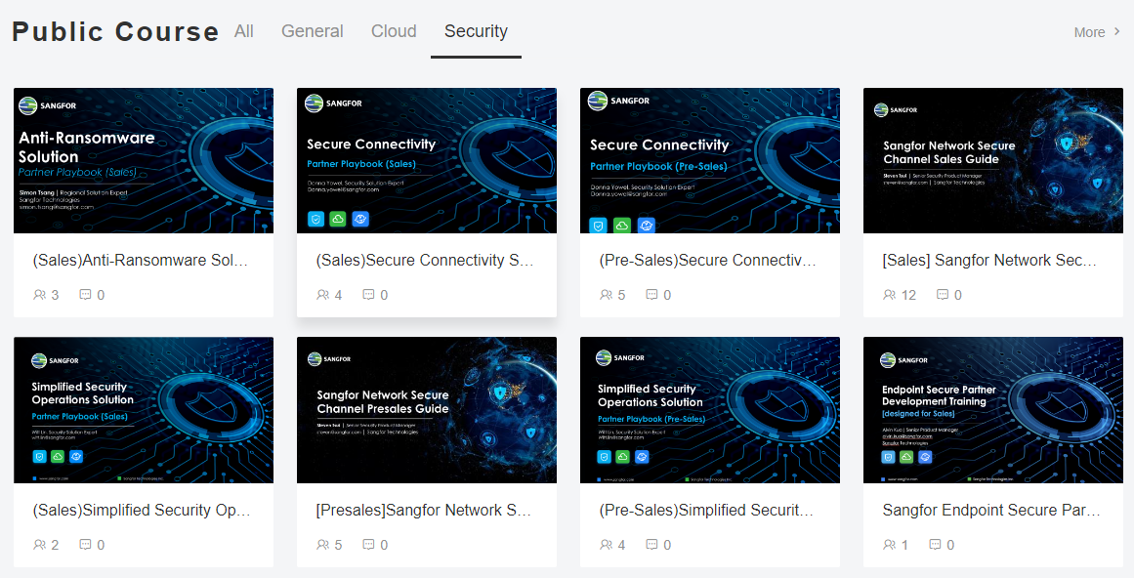
Here I would like to show you how verified partners join the online courses with the guides below.
If you have no account in the community, please check step 8 to step 9.
Step 1. Login Sangfor Support Community.
Step 2. Click Partner E-learning at the right-side bar.
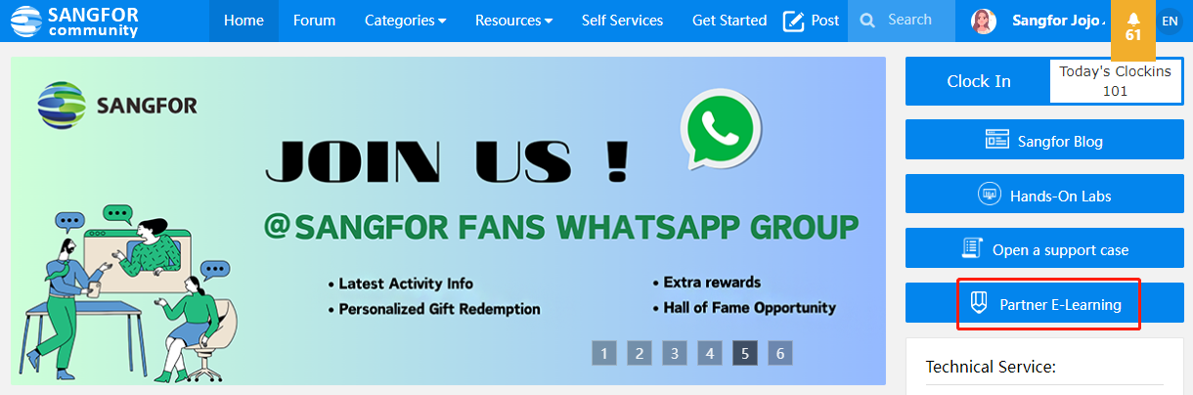
Step 3. You will be guided to the homepage of the E-learning portal.
Your community account will be automatically logged in.
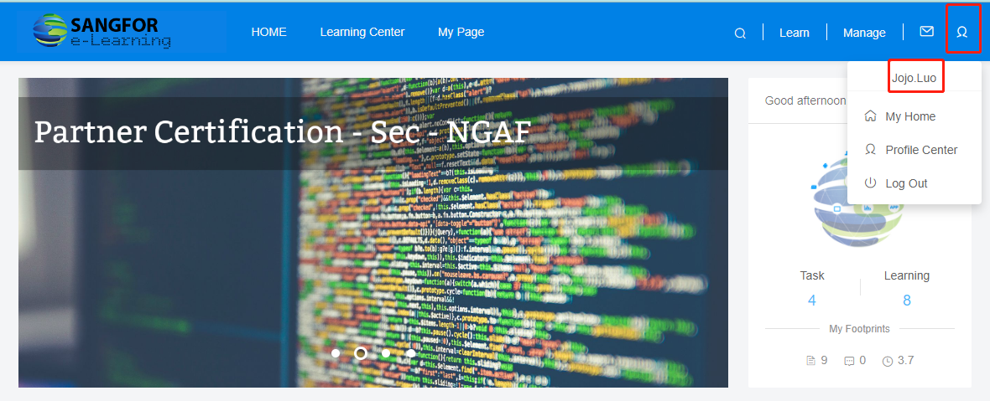

Step 4. Scroll the screen with the mouse and move to the Public Course tab.
Step 5. Choose the course you want to study.
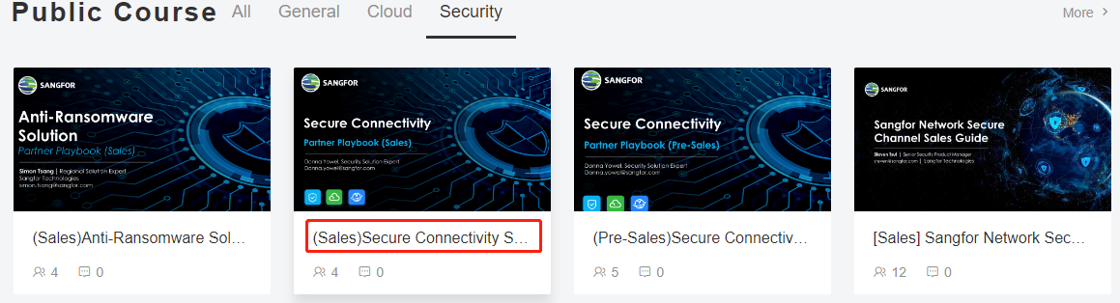
Step 6. Click Enroll to join the course.

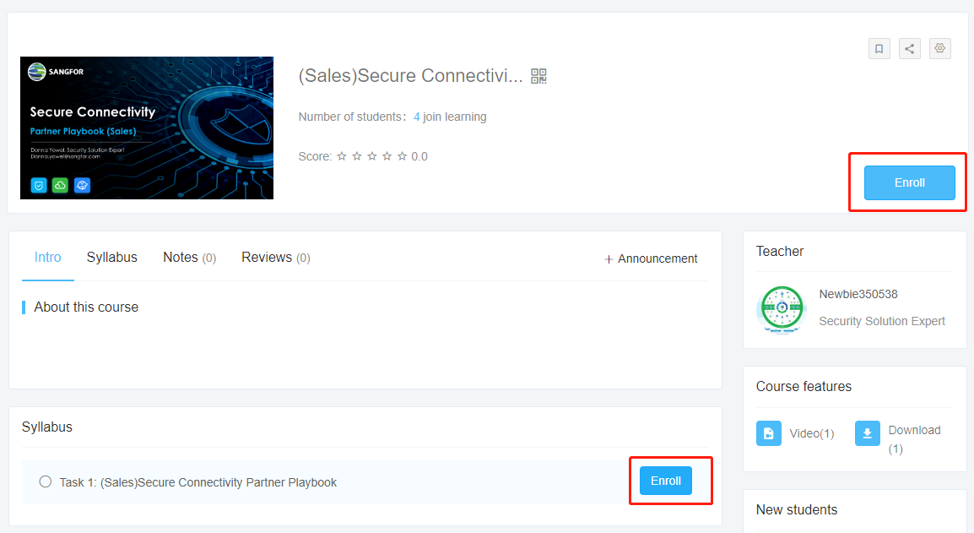

Step 7. After that, click Start to watch the video tutorial and download the training material.
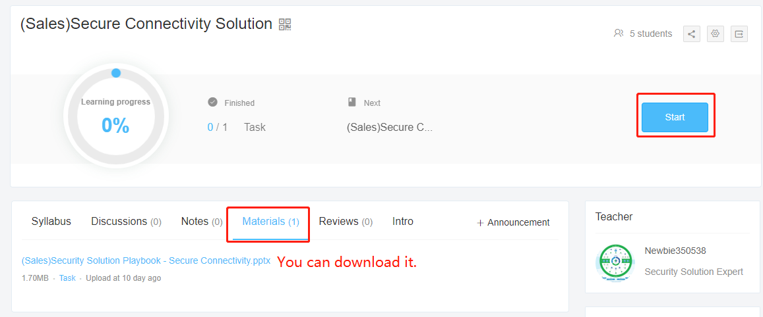

<<<<<<<<<<<<<<<<<<<<<<<<<<<<<<<<<<<<<<<<<<<<<<<<<<<<<<<<<<<<<<<<<<<<<<<<<<<<<<<<<<<<<<<<<<<<<<<<<<<<

If you haven’t registered an account, please follow two steps below to complete partner verification.
Step 8. Please register an account first with your company email and then apply for partner verification.
NOTE: The partnership verification will fail if you register an account with personal email.
Step 9. Complete the verification step when you see the pop-up window after you login your account.
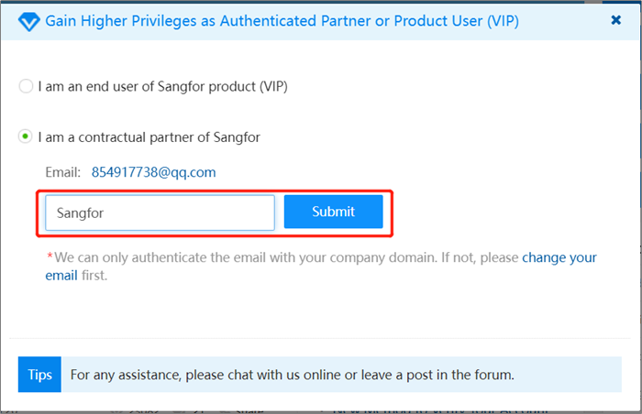
After entering your company name, you may face two situations：
①Your account is automatically processed, you can use E-learning immediately by following the previous 7 steps.
②Your verification will fail because your company information is not associated with our verification system. Your request will be manually handled within 24 hours.

If you're in a hurry, please reach out to Elaine.xiang@sangfor.com for help.

