FBH6 Server installation instructions

1.1 Front Panel

Appearance
Figure1-1 Front view

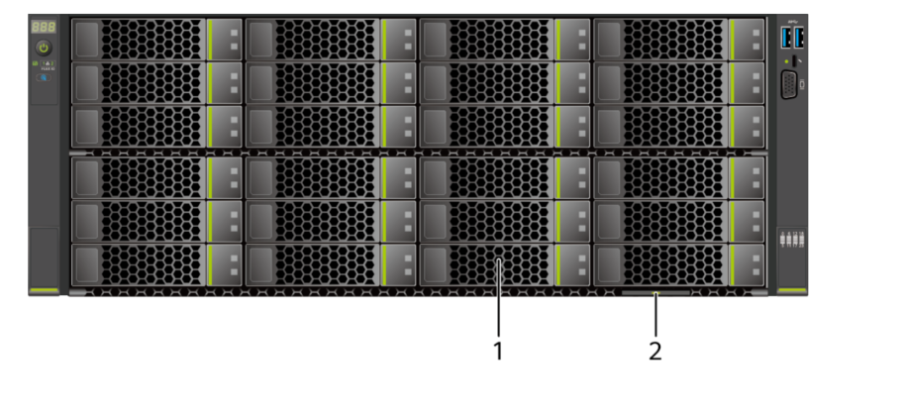

1 | Drive | 2 | Slide-out label plate (with an SN label)

1.2 Rear Panel

Appearance

Figure 1-2 Rear view
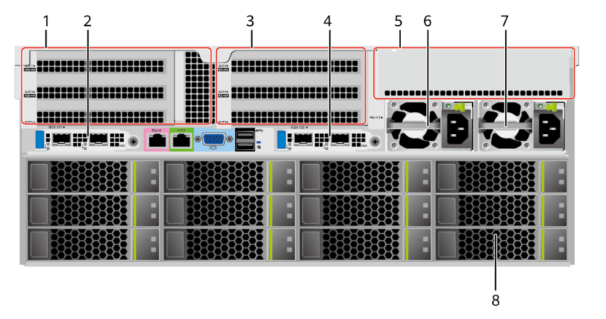

1 | I/O module 1 | 2 | (Optional) FlexIO card 1  NOTE  The FlexIO card slot supports only OCP 3.0 network adapters.
3 | I/O module 2 | 4 | (Optional) FlexIO card 2  NOTE  The FlexIO card slot supports only OCP 3.0 network adapters.
5 | I/O module 3 | 6 | PSU 1
7 | Power supply 2 | 8 | Rear drive

1.3 Indicators and Buttons

Indicator and Button Positions
Figure 1-3Indicators and buttons on the front panel
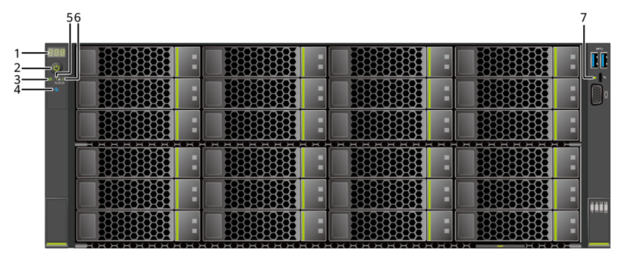

1 | Fault diagnosis LED | 2 | Power button/indicator
3 | Health status indicator | 4 | UID button/indicator
5 | FlexIO card 1 presence  indicator | 6 | FlexIO card 2 presence  indicator
7 | iBMC direct connect management port indicator | - | -
1.4 Indicator and Button Descriptions

Table 1-1 Description of indicators and buttons on the front panel

Silkscreen | Indicator and Button | Description
 | Fault diagnosis LED | ⚫ ---: The device is operating properly.  ⚫ Error code: A component is faulty.
 | Power  button/indicator | Power indicator:  ⚫ Off: The device is not powered on.  ⚫ Steady green: The device is powered on.  ⚫ Blinking yellow: The iBMC is starting. The power button is locked and cannot be pressed. The iBMC is started in about 1 minute, and then the power indicator is steady yellow.  ⚫ Steady yellow: The device is standby. Power button:  ⚫ When the device is powered on, you can press this button to gracefully shut down the OS.  NOTE  For different OSs, you may need to shut down the OS as prompted.  ⚫ When the device is powered on, you can hold down this button for 6 seconds to forcibly power off the device.  ⚫ When the power indicator is steady yellow, you can press this button to power on the device.
 | Health status  indicator | ⚫ Off: The device is powered off or is faulty.  ⚫ Blinking red at 1 Hz: A major alarm has been generated on the system.  ⚫ Blinking red at 5 Hz: A critical alarm has been generated on the system.  ⚫ Steady green: The device is operating properly.
 | UID  button/indicator | The UID button/indicator helps identify and locate a device.  UID indicator:  ⚫ Off: The device is not being located.  ⚫ Blinking or steady blue: The device is being located.  UID button:  ⚫ You can control the UID indicator status by pressing the UID button or using the iBMC.  ⚫ You can press this button to turn on or off the UID indicator.  ⚫ You can press and hold down this button for 4 to  6 seconds to reset the iBMC.
 | FlexIO card  presence  indicator | Indicates whether the FlexIO card is detected.  ⚫ Off: The FlexIO card is not detected.  ⚫ Blinking green at 0.5 Hz: The FlexIO card is detected but is not powered on.  ⚫ Blinking green at 2 Hz: The FlexIO card is detected and has just been inserted.  ⚫ Steady green: The FlexIO card is detected and the power supply is normal.
 | iBMC direct  connect  management  port indicator | Indicates the status when the iBMC direct connect management port connects to a terminal (local PC or Android mobile phone):  ⚫ Off: No terminal is connected.  ⚫ Blinking green at short intervals for 3 seconds and then off: The port is disabled.  ⚫ Steady green: The terminal is connected.  Indicates the status when the iBMC direct connect management port connects to a USB device:  ⚫ Blinking red at long intervals: The job fails or an error is reported when the job is complete.  ⚫ Blinking green at short intervals: The job is being executed.  ⚫ Blinking green at short intervals for 3 seconds and then off: The port is disabled.  ⚫ Steady green: The server configuration file is being copied from the USB device or the job is successfully completed.

2.1 Installing the Static Rail Kit
The static rail kit applies to cabinets with a distance of 543.5 mm to 848.5 mm (21.40 in. to 33.41 in.) between the front and rear mounting bars.
Procedure
Step 1 Tighten the three dowel pins at the front and rear ends of the guide rail. For details, seeFigure 2-1
⚫ There are three types of dowel pins: diameters of 6.8 mm, 8.7 mm, and 9.2 mm. Select dowel pins based on the size of the mounting bars.
⚫ Choose dowel pins with the largest diameter that can pass through the holes.

Figure 2-1 Installing dowel pins
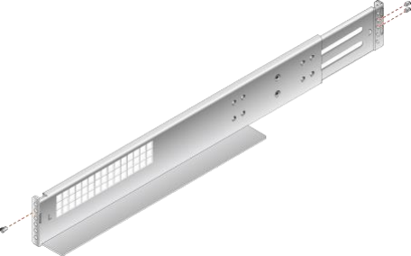

Step 2 Place the rail horizontally in the planned position. Stretch the rail on both sides of the cabinet
based on the cabinet length. Align the fixing holes of the rail with the installation holes of the
rails on the inner side of the cabinet. Insert the dowel pins at the front and rear of the rail into
the square holes. Then, pre-position the rail. See (1) inFigure 2-2.
The rail marked with an L is the left rail, and that marked with an R is the right one. Do not install the device in the wrong position.
Step 3 Tighten the four screws at the front and rear ends of the guide rail. See (2) inFigure 2-2.

Figure 2-2Installing a static rail
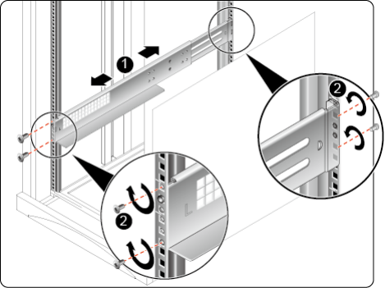

Step 4 Install the other guide rail in the same way.
----End

2.2 Installing a Server

2.2.1 Installing the Server on L-Shaped Guide Rails or Static Rail Kit

Procedure
Step 1

⚫ Before installing the server, ensure that the L-shaped guide rails or static rail kit is properly installed.
⚫ The servers are stackable onto L-shaped guide rails or the static rail kit.

Install the server.

At least four people are required to move the device. Otherwise, personal injury or device damage may occur.

1. At least four people are required to lift the server vertically from both sides, place it on the guide rails, and push it into the cabinet. See (1) inFigure 2-3.
2. Press the mounting ears on both sides of the server against the mounting bars, open the baffle plate of the captive screws on the mounting ears, and tighten the captive screws. See (2) inFigure 2-3.

Figure 2-3 Installing a server
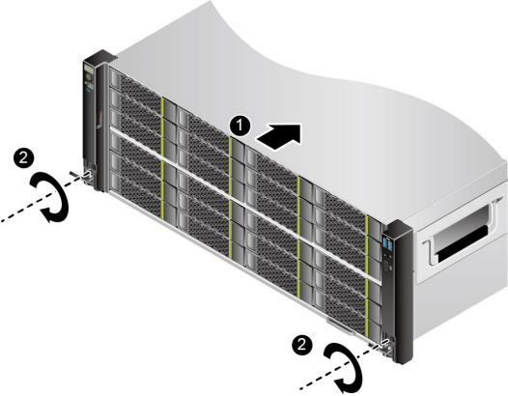

Step 2 Connect external cables as required, such as network cables, VGA cables, and USB devices.
Step 3 Connect the cables to the PSU.
Step 4 Power on the server.
Step 5 Check indicator status.
----End

2.2.2 Removing the Static Rail Kit

Procedure
Step 1 Power off the server.
Step 2 Remove the cables from the PSU.
Step 3 Remove the server.

Step 4 Place the server on the ESD workstation.
Step 5 Remove the static rail kit.
1. Loosen the four screws at the front and rear ends of the guide rail. See (1) inFigure 2-4.
2. Shorten and remove the guide rail, as shown by (2) inFigure 2-4.

Figure 2-4 Removing a static rail
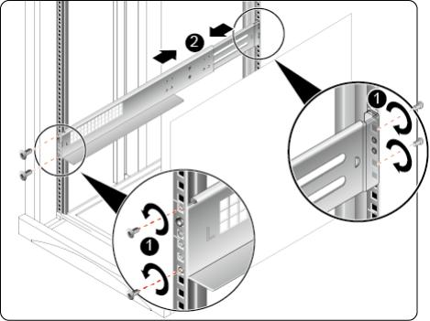

3. Remove the other guide rail in the same way.
----End

