F6H 12 Server installation instructions

Front Panel

1.1 Appearance
12 x 3.5" drive configuration

Figure1-1 Front view
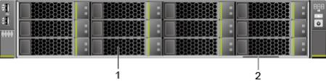
1 | Drives | 2 | Slide-out label plate (with an SN label)

1.2 Indicators and Buttons
Indicator and Button Positions

Figure 1-2 Indicators and buttons on the front panel
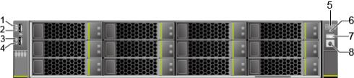

Port Positions

Figure1-2 Ports on the rear panel
1 | Connection status indicator for 10GE LOM port 1 | 2 | Connection status indicator for 10GE LOM port 2
3 | Connection status indicator for GE LOM port 1 | 4 | Connection status indicator for GE LOM port 2
5 | Fault diagnosis LED | 6 | Health status indicator
7 | UID button/indicator | 8 | Power button/indicator

1.3 Indicators
Indicator Positions

Figure 1-3 Indicators on the rear panel
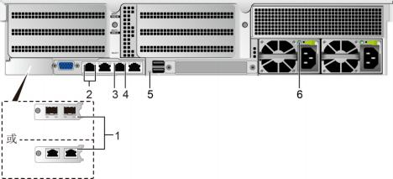

1 | LOM port indicator | 2 | LOM port indicator
3 | Data transmission status indicator of the management network port | 4 | Connection status indicator of the management network port
5 | UID Indicator | 6 | PSU indicator

1.4 Installing a Server

1.4.1 Installing a Server on L-Shaped Guide Rails or the Static Rail Kit

Procedure
Step 1

Before installing the server, properly install the L-shaped guide rails or static rail kit. For
Details.
The servers are stackable onto L-shaped guide rails or static rail kit.

Install the server.

At least two people are required to move the device. Otherwise, personal injury or device damage may occur.

1. Lift the server, place it on guide rails, and slide it into the chassis. At least two people are required to move the server. See (1) inFigure 1-4.
2. Align the mounting ears on both sides of the server with the mounting bars and tighten the captive screws on the mounting ears. See (2) inFigure 1-4.

Figure1-4 Installing a server
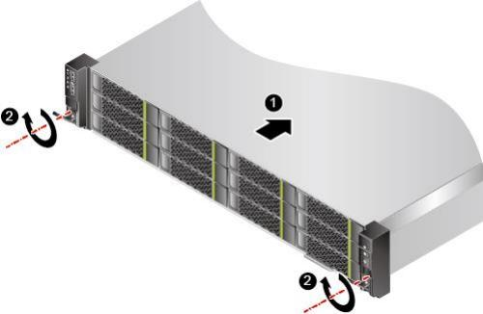

Step 2 Connect external cables as required, such as network cables, VGA cables, and USB devices.
Step 3 Connect the power cables to the PSUs.
Step 4 Power on the server.
Step 5 Check indicator status.
----End

1.5 Removing a Server

Removing a Server from L-Shaped Guide Rails or the Static Rail Kit
Procedure
Step 1 Power off the server. For details, see 8.4.2 Power-Off Procedure.
Step 2 Remove the power cables from the PSUs.
For details, see 1-5 Removing PSU Cables.
Step 3 Remove external cables as required, such as network cables, VGA cables, and USB devices.
Step 4 Remove the server.

⚫ When removing a device, wear protective gloves to avoid burns.
⚫ At least two people are required to move the device. Otherwise, personal injury or device damage may occur.

1. Loosen the captive screws on the front panel. See (1) inFigure 1-5.
2. Slide out part of the server from the chassis. See (2) inFigure 1-5.
3. Remove the server from the chassis and place it on the ESD workstation. At least two people are required to handle the server.

Figure1-5 Removing the server
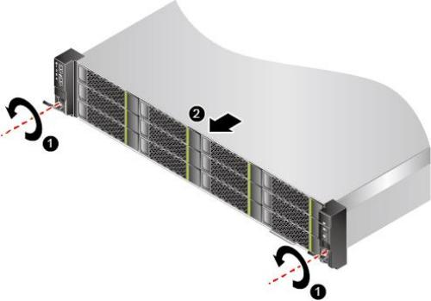

Step 5 Place the removed server in an ESD bag.

Place only one server in an ESD bag.

----End

1.6 Removing the Static Rail Kit

Procedure
Step 1 Power off the server.
For details, see8.4.2Power-Off Procedure.
Step 2 Remove the power cables from the PSUs.
For details, see8.5.7Removing PSU Cables.
Step 3 Remove the server.
For details, see8.4.3.1Removing a Server from L-Shaped Guide Rails or the Static Rail Kit.
Step 4 Remove the static rail kit.
1. Loosen the M6 screw from the lowest square hole at the rear of the guide rail. See (1) in Figure 1-6.
Perform this operation only when M6 screws are installed.
2. Remove the plugs from the two square holes. See (2) inFigure 1-6.

3. Lift the rail slightly to separate the hook from the square hole, and then shrink and remove the rail. See (3) and (4) inFigure 1-6.

Figure1-6Removing a static rail
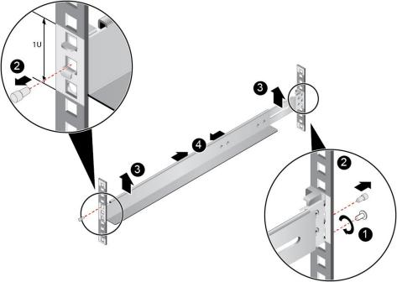

4. Remove the other rail in the same way.
----End

1.7 Field Replaceable Units

Removing the Chassis Cover

Procedure
Step 1 Power off the server.
Step 2 Remove the power cables from the PSUs.
Step 3 Remove the server.
Step 4 Place the server on the ESD workstation.
Step 5 Remove the chassis cover.
1. Use a flat-head screwdriver to loosen the latch screw of the cover counterclockwise. See
(1) inFigure 1-7.

⚫ If no flat-head screwdriver is available onsite, you can use a Phillips screwdriver (PH2.0 is recommended).

⚫ Do not use an electric screwdriver. Otherwise, the lock slot of the chassis cover may be damaged due to high rotational speed.

2. Open the ejector lever on the cover and the cover moves backwards automatically. See
(2) inFigure 1-7.
3. Lift the chassis cover. See (3) inFigure 1-7.

Figure1-7 Removing the chassis cover

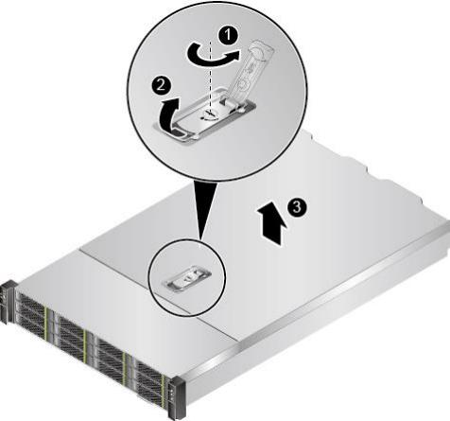

----End

3. Logging in to the iBMC Web Interface
The following instructions use a Windows 7 PC and IE 11.0 browser as an example to log in to the iBMC web interface. A remotely controlled local PC requires the same browser and Java runtime environment.

Category | Description | Default Value
iBMC Network port | IP address and subnet mask of the network port | Default IP address: 192.168.10.10  Default subnet mask: 255.255.255.0
iBMC Login credentials | Username and password | Default solution 1 username: admin  Default solution 1 password: admin  Default solution 2 username: sangfor  Default solution 2 password: S#AN$6fo81r

Step 1: Configure the IP address of the client (such as PC) to connect to the iBMC network port.

Step 2: Use a network cable (crossover cable or twisted pair) to connect the local PC to the server’s iBMC network port. Figure 3-1 shows the network diagram.

Figure 3-1 Network diagram
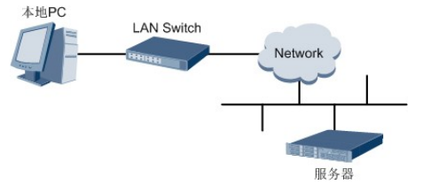
Step 3: Open Internet Explorer on the PC and enter the iBMC System’s IP address in the address bar, for example, "https://192.168.10.10".

Step 4: Press the "Enter" key, and a security alert pops up, as shown in Figure 3-1.

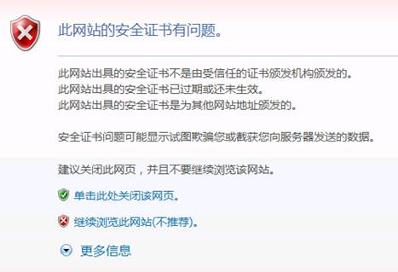

Step 5: Click "Continue to this website", and the login interface appears, as shown in Figure 3-2.

Figure 3-2 Login interface
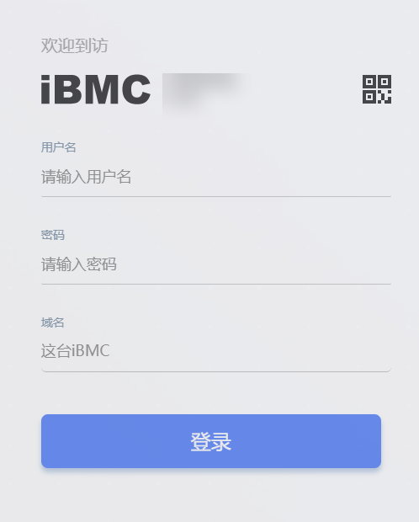

Step 6: Enter the username and password to log in to the iBMC System. The default username is “sangfor”, and the default password is “S#AN$6fo81r”.

Note: The account will be locked after multiple unsuccessful login attempts in accordance with the account lockout policy. The account unlocks after the lockout time is reached.

Step 7: In the Domain Name drop-down list, select “This iBMC”.

Step 8: Click “Sign In”.

The iBMC web interface appears after successful login.

F6H 36 Server installation instructions

1.Front Panel

Appearance
Figure1-1 Front view

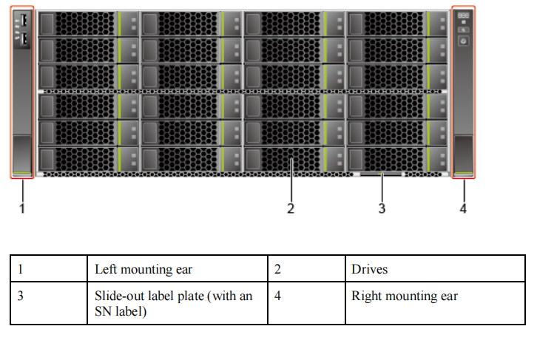1.2 Indicators and Buttons

Indicator and Button Positions
Figure 1-2 Indicators and buttons on the front panel

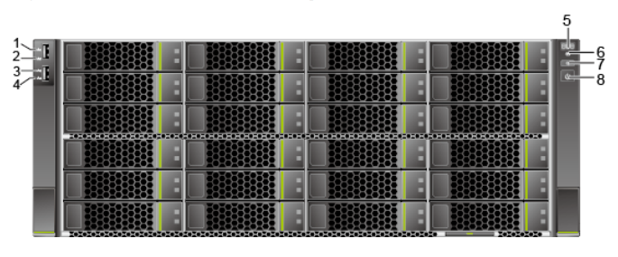

1 | LOM port 1 connection status  indicator | 2 | LOM port 2 connection status  indicator
3 | LOM port 3 connection status  indicator | 4 | LOM port 4
5 | Fault diagnosis LED | 6 | Health status indicator
7 | UID button/indicator | 8 | Power button/indicator

Indicator and Button Descriptions
Table 1-1 Description of indicators and buttons on the front panel
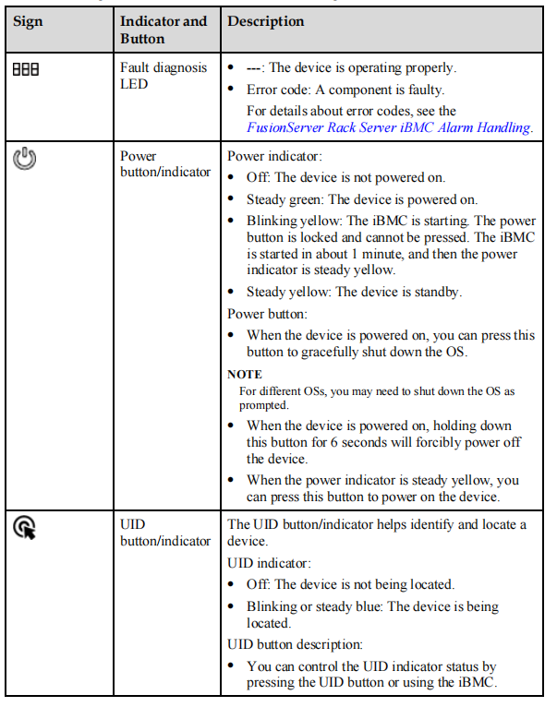

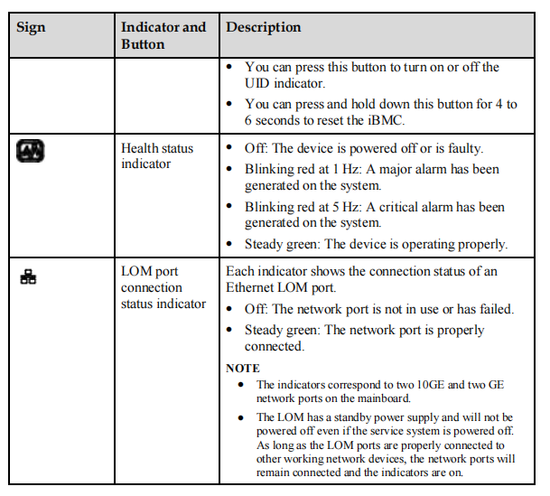
1.3 Rear Panel
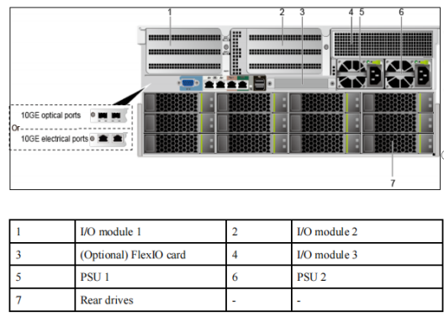

2.Installing the Static Rail Kit
The static rail kit applies to cabinets with a distance of 543.5 mm to 848.5 mm (21.40 in. to
33.41 in.) between the front and rear mounting bars.
Procedure
Step 1 Tighten the three dowel pins at the front and rear ends of the rail. See Figure 2-1.
⚫ There are three types of dowel pins: diameters of 6.8 mm, 8.7 mm, and 9.2 mm. Select dowel pins
based on the size of the mounting bars.
⚫ Choose dowel pins with the largest diameter that can pass through the holes.
Figure2-1 Installing dowel pins
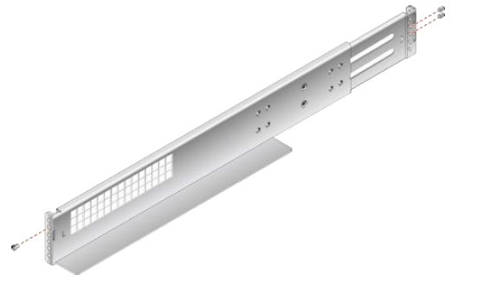

Step 2 Place the rail horizontally in the planned position. Stretch the rail on both sides of the cabinet
based on the cabinet length. Align the fixing holes of the rail with the installation holes of the
rails on the inner side of the cabinet. Insert the dowel pins at the front and rear of the rail into
the square holes. Then, pre-position the rail. See (1) in Figure 2-2
The rail marked with an L is the left rail, and that marked with an R is the right one. Do not install the
device in the wrong position.
Step 3 Tighten the four screws at the front and rear of the rail. See (2) in Figure 2-2
Figure 2-2 Installing a static rail
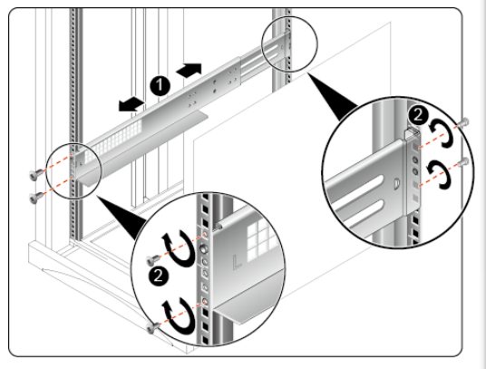
Step 4 Install the other rail in the same way.
----End

3.Installing a Server on L-Shaped Guide Rails or the Static Rail Kit
Before installing the server, properly install the L-shaped guide rails or static rail kit. For
details,
Procedure
Step 1 Install the server.
At least four people are required to move the device. Otherwise, personal injury or device
damage may occur.
1. Lift the server, place it on guide rails, and slide it into the chassis. At least four people
are required to move the server. See (1) in Figure 3-1.
2. Align the mounting ears on both sides of the server with the mounting bars and tighten
the captive screws on the mounting ears. See (2) in Figure3-1.
Figure 3-1 Installing a server
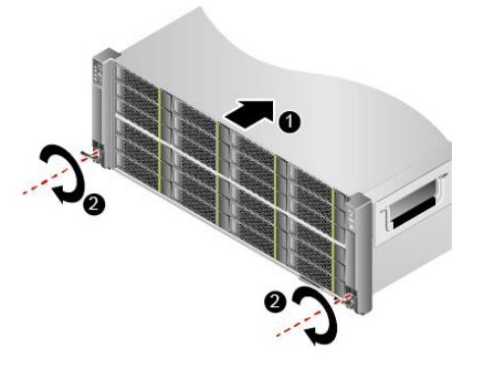
Step 2 Connect external cables as required, such as network cables, VGA cables, and USB devices.
Step 3 Connect the power cables to the PSUs.
Step 4 Power on the server.
Step 5 Check indicator status.
----End

4.Removing the Static Rail Kit
Procedure
Step 1 Power off the server.
Step 2 Remove the power cables from the PSUs.
Step 3 Remove the server.
Step 4 Remove the static rail kit.
1. Loosen the four screws at the front and rear of the rail. See (1) in Figure 4-1
2. Shrink and remove the rail. See (2) in Figure 4-1
Figure4-1 Removing a static rail
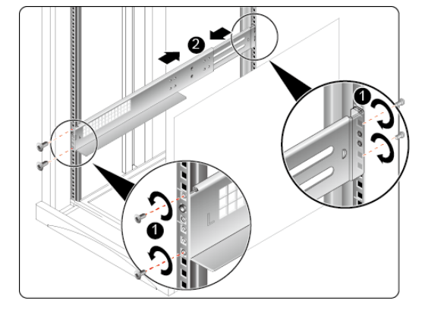3. Remove the other rail in the same way.
----End

5. Logging in to the iBMC Web Interface
The following instructions use a Windows 7 PC and IE 11.0 browser as an example to log in to the iBMC web interface. A remotely controlled local PC requires the same browser and Java runtime environment.

Category | Description | Default Value
iBMC Network port | IP address and subnet mask of the network port | Default IP address: 192.168.10.10  Default subnet mask: 255.255.255.0
iBMC Login credentials | Username and password | Default solution 1 username: admin  Default solution 1 password: admin  Default solution 2 username: sangfor  Default solution 2 password: S#AN$6fo81r

Step 1: Configure the IP address of the client (such as PC) to connect to the iBMC network port.

Step 2: Use a network cable (crossover cable or twisted pair) to connect the local PC to the server’s iBMC network port. Figure 5-1 shows the network diagram.

Figure5-1 Network diagram
Step 3: Open Internet Explorer on the PC and enter the iBMC System’s IP address in the address bar, for example, "https://192.168.10.10".

Step 4: Press the "Enter" key, and a security alert pops up, as shown in Figure 5-2.

Figure 5-2

Step 5: Click "Continue to this website", and the login interface appears, as shown in Figure 5-3.

Figure 5-3 Login interface

Step 6: Enter the username and password to log in to the iBMC System. The default username is “sangfor”, and the default password is “S#AN$6fo81r”.

Note: The account will be locked after multiple unsuccessful login attempts in accordance with the account lockout policy. The account unlocks after the lockout time is reached.

Step 7: In the Domain Name drop-down list, select “This iBMC”.

Step 8: Click “Sign In”.

The iBMC web interface appears after successful login.

