FBH Server installation instructions

1.Appearance

1.1 12 x 3.5" drive configuration
Figure 1-1 Front view

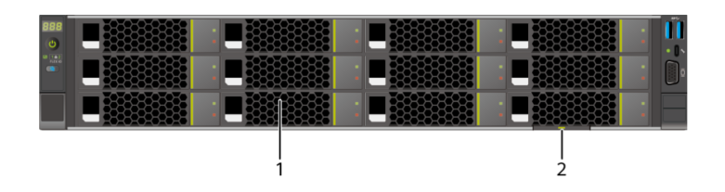

1 | Drive | 2 | Slide-out label plate (with an SN label)

1.2 Indicator and Button Positions
Figure 1-2 Indicators and buttons on the front panel

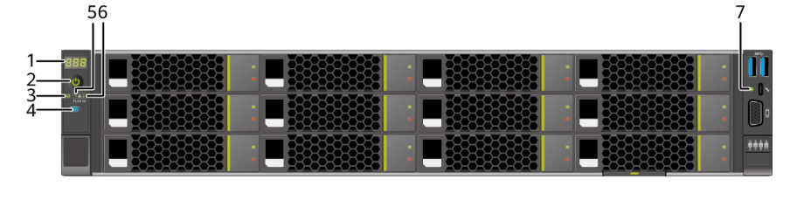

1 | Fault diagnosis LED | 2 | Power button/indicator
3 | Health status indicator | 4 | UID button/indicator
5 | FlexIO card 1 presence  indicator | 6 | FlexIO card 2 presence  indicator
7 | iBMC direct connect management port indicator | - | -

1.3 Rear Panel Appearance
Figure1-3 Rear view
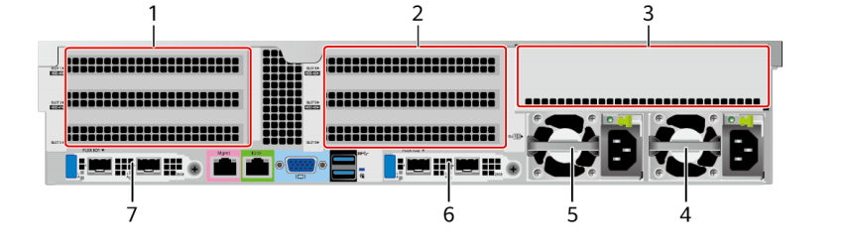

1 | I/O module 1 | 2 | I/O module 2
3 | I/O module 3 | 4 | Power supply 2
5 | PSU 1 | 6 | (Optional) FlexIO card 2  NOTE  The FlexIO card slot supports only OCP 3.0 network adapters.
7 | (Optional) FlexIO card 1  NOTE  The FlexIO card slot supports only OCP 3.0 network adapters. | - | -

1.4 Indicator and Button Descriptions

Table 1-1 Description of indicators and buttons on the front panel

[Azure]  Available | Indicator/Butt on | Description
 | Fault Diagnosis LED | ⚫ ---: The device is operating properly.  ⚫ Error code: A component is faulty.
 | Power  Button/Indicato r | Power indicator:  ⚫ Off: The device is not powered on.  ⚫ Steady green: The device is powered on.  ⚫ Blinking yellow: The iBMC is starting. The power button is locked and cannot be pressed. The iBMC is started in about 1 minute, and then the power indicator is steady yellow.  ⚫ Steady yellow: The device is standby. Power button:  ⚫ When the device is powered on, you can press this
button to gracefully shut down the OS.
NOTE
For different OSs, you may need to shut down the OS as prompted.
⚫ When the device is powered on, you can hold down this button for 6 seconds to forcibly power off the device.
⚫ When the power indicator is steady yellow, you can press this button to power on the device.
 | Health status  indicator | ⚫ Off: The device is powered off or is faulty.  ⚫ Blinking red at 1 Hz: A major alarm has been generated on the system.  ⚫ Blinking red at 5 Hz: A critical alarm has been generated on the system.  ⚫ Steady green: The device is operating properly.
 | UID  Button/Indicato r | The UID button/indicator helps identify and locate a device.  UID indicator:  ⚫ Off: The device is not being located.  ⚫ Blinking or steady blue: The device is being located.  UID button:  ⚫ You can control the UID indicator status by pressing the UID button or using the iBMC.  ⚫ You can press this button to turn on or off the UID indicator.  ⚫ You can press and hold down this button for 4 to  6 seconds to reset the iBMC.
 | FlexIO card  presence  indicator | ⚫ Off: The FlexIO card is not detected.  ⚫ Blinking green at 0.5 Hz: The FlexIO card is detected but is not powered on.  ⚫ Blinking green at 2 Hz: The FlexIO card is detected and has just been inserted.  ⚫ Steady green: The FlexIO card is detected and the power supply is normal.

2.1 Installing the Static Rail Kit
The static rail kit applies to cabinets with a distance of 543.5 mm to 848.5 mm (21.40 in. to 33.41 in.) between the front and rear mounting bars.
Procedure
Step 1 Place the rail horizontally in the planned position. Stretch the rail on both sides of the cabinet
based on the cabinet length, keeping it in contact with the mounting bar in the cabinet, and
hook the rail. See (1) inFigure 2-1.
The distance between the three holes in each mounting bar for the guide rail must be within 1 U. Step 2 Use the plug delivered with the guide rail to secure the guide rail.
⚫ Front end of the guide rail: Plug the first square hole in the upper part of the guide rail. The second square hole is used to secure the captive screws on the mounting ears on both sides of the server. See (2) inFigure 2-1.
⚫ Rear end of the guide rail: Plug the second square hole. See (3) inFigure 2-1.
Step 3 On the first lower square hole at the rear of the rail, insert an M6 screw. See (4) inFigure2-1

Although the static rail kit does not need screws for installation, you can perform this operation to improve the shockproof level and fastening degree of the server.

Figure 2-1 Installing a static rail
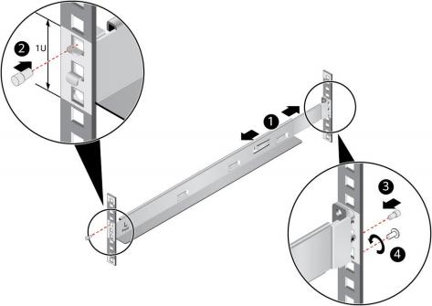

Step 4 Install the other guide rail in the same way.
----End

2.2 Installing the Ball Bearing Rail Kit
The ball bearing rail kit applies to cabinets with a distance of 609 mm to 950 mm (23.98 in. to 37.40 in.) between the front and rear mounting bars.
Procedure
Step 1 Push the release latch on the front of the rail and pull out the hook. See (1) and (2) inFigure 2-2.
Step 2 Insert the positioning pin at the rear of the rail into the hole on the rear column of the cabinet.
See (3) inFigure 2-2.
Step 3 Keep the rail horizontal, and push the front end of the rail until it is inserted into the hole on
the front column of the cabinet. See (4) inFigure2-2.
Step 4 Hook the rail. See (5) inFigure 2-2.

Figure 2-2 Installing a ball bearing rail
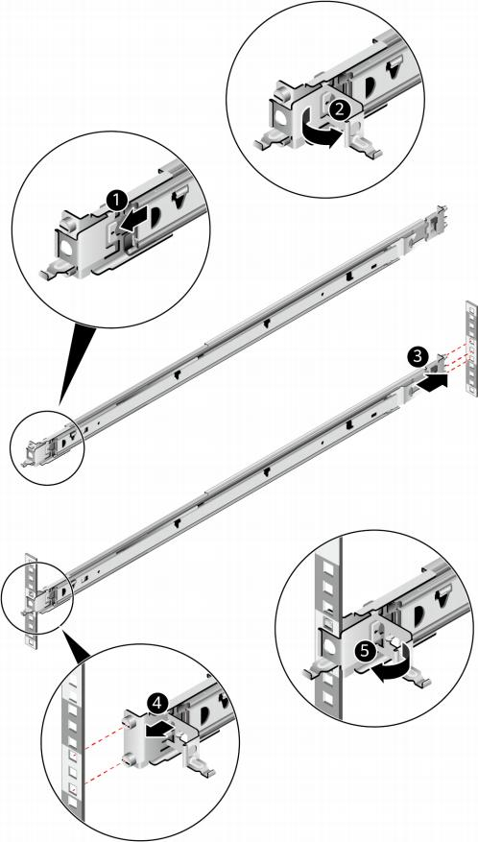

Step 5 Install the other guide rail in the same way.
----End

2.3 Installing a Server on the Ball Bearing Rail Kit

Procedure
Step 1

Install the server.

At least two people are required to move the device. Otherwise, personal injury or device damage may occur.

1. Pull out the inner rails as far as they will go.

Figure 2-3 Pulling out an inner rail
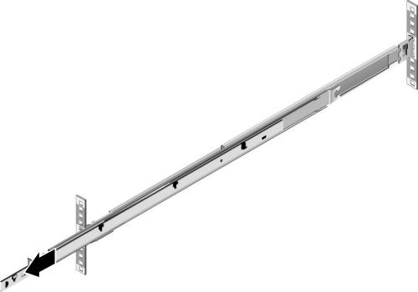

2. At least two people are required to lift the server vertically from both sides, align the two mounting screws at the rear of the server with the fixing holes on the inner rails, and place the server vertically at the rear of the server. Then push the server horizontally as far as it will go. SeeFigure 2-4.

Figure 2-4 Securing the server to inner rails (1)
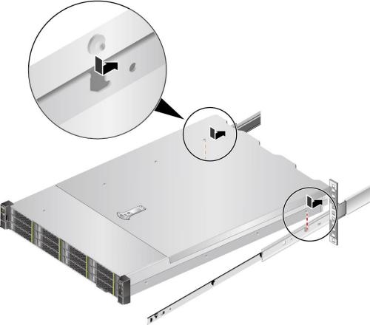

3. Aligning the six mounting screws at the front of the server with the fixing holes on the inner rails, place the server vertically to ensure that the server is secured to the inner rails. SeeFigure 2-5.

Figure 2-5 Securing a server to inner rails (2)
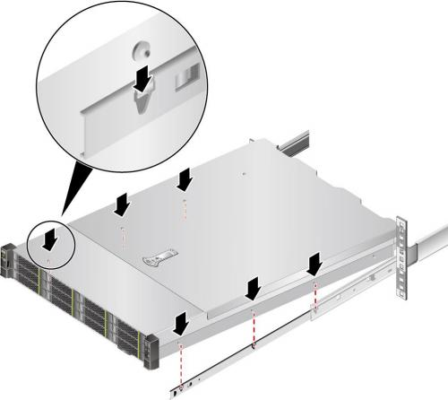

4. Unlock the release latches on both sides of the inner rails and push the server as far as it will go. See (1) and (2) inFigure 2-6.

Figure 2-6 Pushing the server into the ball bearing rail kit
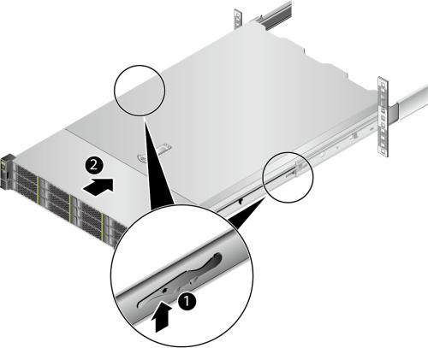

5. Open the baffle plate of the captive screws on the mounting ears and tighten the captive screws.

Figure 2-7 Securing a server
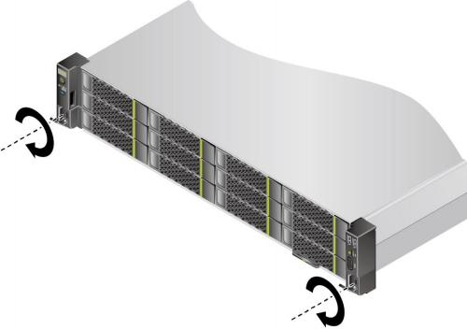

Step 2 Install a cable management arm (CMA).
1. Insert the bracket on the right of the CMA into the right guide rail. See (1) inFigure 2-8.
2. Insert the internal bracket on the left of the CMA into the left guide rail. See (2) in Figure 2-8.
3. Insert the external bracket on the left of the CMA into the left guide rail. See (3) in Figure 2-8.

Figure 2-8 Installing a CMA
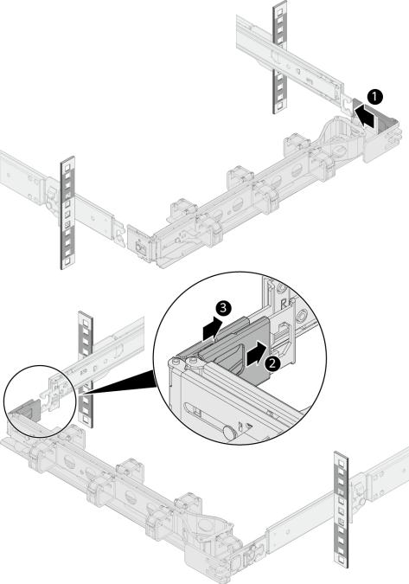

Step 3 Connect external cables as required, such as network cables, VGA cables, and USB devices.
Step 4 Connect the cables to the PSU.
Step 5 Power on the server.
Step 6 Check indicator status.

----End

2.4 Removing a Server from the Ball Bearing Rail Kit
Figure 2-9 Removing a server from the ball bearing rail kit (1)

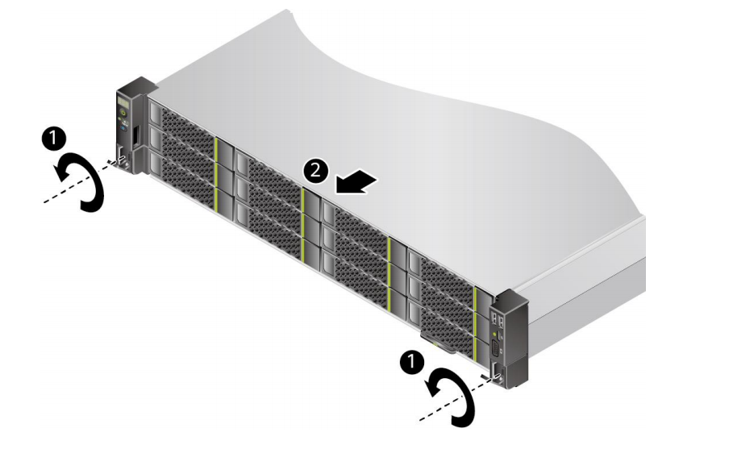

3.Logging In to the iBMC WebUI

Scenario
Log in to the iBMC WebUI. The following uses Internet Explorer 11.0 as an example.
⚫ A maximum of four users can log in to the WebUI at the same time.
⚫ By default, the system timeout period is 5 minutes. If no operation is performed on the WebUI within 5 minutes, the user will be automatically logged out of the WebUI.

⚫ The system locks a user account if the number of consecutive incorrect password attempts reaches the maximum for the user account. The user account is automatically unlocked after the locking duration reaches the value specified.
⚫ For security purposes, change the initial password upon the first login and change the password periodically.
⚫ If resources fail to be obtained due to unstable network connection, the iBMC WebUI may be displayed abnormally. If this occurs, refresh the browser and log in to the iBMC WebUI again.
⚫ If TLS version is set to Only TLS 1.3 on the User & Security > Security Management page, the following browser versions are not supported:
⚫ All Internet Explorer versions
⚫ Safari 11.0 to 12.0
⚫ Microsoft Edge 12 to 18
⚫ Before using Internet Explorer to log in to the iBMC WebUI, enable the compatibility view and select "Use TLS 1.2".
⚫ Enable the compatibility view:
⚫ Click in the upper right corner of the browser.
1. On the shortcut menu displayed, click Compatibility View Settings.
2. In the Compatibility View Settings dialog box displayed, enter the iBMC IP address in the Add this website text box and click Add.
3. Deselect Use Microsoft compatibility lists.
After the iBMC IP address is added to the compatibility view, improper display on the iBMC WebUI will be rectified.
⚫ Select "Use TLS 1.2" as follows:
⚫ Choose Internet Options > Advanced.
1. In the Security area, select Use TLS 1.2.

Procedure
Step 1 Check that the client (for example, a local PC) used to access the iBMC meets the operating
environment requirements.
If you want to use the Java Integrated Remote Console, ensure that the Java Runtime Environment (JRE) meets requirement.

Table 3-1 Operating environment

OS | Web Browser | Java Runtime  Environment (JRE)
Windows 7 (32-bit)  Windows 7 (64-bit) | Internet Explorer 11.0 or later  Mozilla Firefox 63.0 or later  Google Chrome 70.0 or later | AdoptOpenJDK 8u222 JRE AdoptOpenJDK 11.0.6 JRE
Windows 8 (32-bit)  Windows 8 (64-bit) |  | AdoptOpenJDK 8u222 JRE AdoptOpenJDK 11.0.6 JRE
Windows Server 2008 R2 (64-bit) |  | AdoptOpenJDK 8u222 JRE AdoptOpenJDK 11.0.6 JRE
Windows Server 2012 (64-bit) |  | AdoptOpenJDK 8u222 JRE AdoptOpenJDK 11.0.6 JRE
Windows Server 2012 R2 (64-bit) |  | AdoptOpenJDK 8u222 JRE AdoptOpenJDK 11.0.6 JRE
Windows Server 2016 (64-bit) |  | AdoptOpenJDK 8u222 JRE AdoptOpenJDK 11.0.6 JRE
Windows 10 (64-bit) | Internet Explorer 11.0 or later | AdoptOpenJDK 8u222 JRE AdoptOpenJDK 11.0.6 JRE
Windows 10 (64-bit) | Microsoft Edge | AdoptOpenJDK 8u222 JRE AdoptOpenJDK 11.0.6 JRE
Windows 10 (64-bit) | Mozilla Firefox 63.0 or later | AdoptOpenJDK 8u222 JRE AdoptOpenJDK 11.0.6 JRE
Windows 10 (64-bit) | Google Chrome 70.0 or later | AdoptOpenJDK 8u222 JRE AdoptOpenJDK 11.0.6 JRE
CentOS 7 | Mozilla Firefox 63.0 or later | AdoptOpenJDK 8u222 JRE AdoptOpenJDK 11.0.6 JRE
MAC OS X v10.7 | Safari 11.0 and later  Mozilla Firefox 63.0 or later | AdoptOpenJDK 8u222 JRE AdoptOpenJDK 11.0.6 JRE

Step 2 Configure an IP address and subnet mask or route information for the local PC to enable
communication with the iBMC management network port.
Step 3 Connect the local PC to the iBMC using any of the following methods:
⚫ Connect the local PC to the iBMC management network port using a network cable.
⚫ Connect the local PC to the iBMC management network port over a LAN.
⚫ Connect the local PC to the iBMC direct connect management port using a USB Type-C cable.
⚫ Only servers configured with the iBMC direct management port support this operation.
⚫ If you use a USB Type-C cable to connect the local PC to the iBMC direct connect management port, the local PC can run only Windows 10.
Step 4 Choose Control Panel > Network and Internet > Network Connections, and check
whether the local PC is connected to the iBMC network.
⚫ If the local PC is connected to the iBMC using a USB Type-C cable, the iBMC network name is Remote NDS Compatible Device.
⚫ If the local PC is connected to the iBMC using a network cable or over a LAN, the iBMC network name varies depending on the NIC used on the local PC.
⚫ If yes, go toStep 5.
⚫ If no, contact technical support for assistance.
Step 5 Open Internet Explorer, enter https://iBMC management network port IP address in the
address box, and press Enter.

⚫ If the local PC is connected to the iBMC direct connect management port using a USB Type-C cable, the IP address of the iBMC management network port is 169.254.1.5.
⚫ If the local PC is connected to the iBMC management network port using a network cable or over a LAN, the default IP address of the iBMC management network port is 192.168.2.100.
⚫ Enter the IP address of the iBMC management network port based on actual situation:
⚫ If an IPv6 address is used, use [] to enclose the IPv6 address, for example, [fc00::64].
⚫ If an IPv4 address is used, enter the IPv4 address, for example, 192.168.100.1.
A security alert dialog box is displayed.
Figure 3-1 Security warning
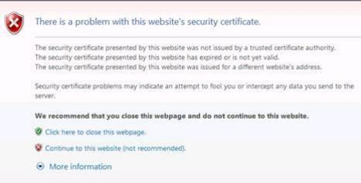

⚫ If a security alert is displayed, you can ignore this message or perform any of the following to shield this alert:
⚫ Import a trust certificate and a root certificate to the iBMC.
For details, see "Importing the iBMC Trust Certificate and Root Certificate" in the iBMC user guide of the server you use.
⚫ If no trust certificate is available and network security can be ensured, add the iBMC to the Exception Site List on Java Control Panel or reduce the Java security level.
This operation poses security risks. Exercise caution when performing this operation. Step 6 Click Continue to this website (not recommended).
The iBMC login page is displayed.

Figure 3-2 iBMC login page
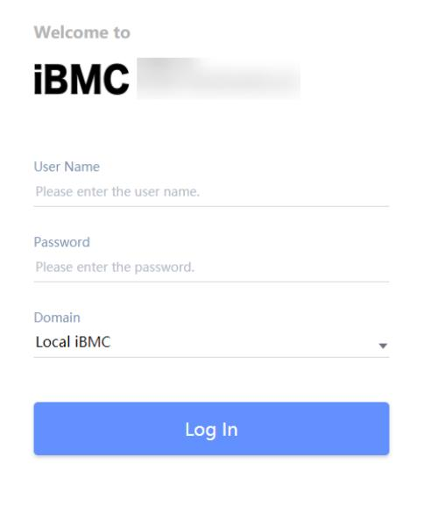

Table 3-2 User login

Parameter | Description
Username | Username for logging in to the iBMC WebUI.  ⚫ When Domain is Local iBMC, the maximum length of the user name is 20 characters.  ⚫ When Domain is not Local iBMC, the maximum length of the user name is 255 characters.  Pay attention to the following points when logging in to the system:  ⚫ When you log in to the iBMC as a local user, you can set Domain to Local iBMC or Automatic matching.

Parameter | Description
⚫ To log in as an LDAP user, the user name can be in either ofthe following formats:
− LDAP user name (In this case, Domain can be Automatic
matching or a specified domain.)
− LDAP user name@Domain name (In this case, Domain can
be Automatic matching or a specified domain.)
⚫ To log in as a Kerberos user, the user name can be in either of the following formats:
− Kerberos user name (in this case, Domain can be Automatic
matching or a specified domain)
− Kerberos user name@domain name (in this case, Domain
can be Automatic matching or a specified domain, and uppercase letters must be used in the domain name)
⚫ Both Kerberos user name and Kerberos user name@Domain name formats support single sign-on (SSO).
Password | Password of the login user. For security purposes, periodically change your login password.  NOTE  When you log in to the iBMC WebUI as an LDAP or Kerberos user, the password can contain a maximum of 255 characters.

Step 7 Log in to the iBMC WebUI.

⚫ ⚫
⚫

Log in to the WebUI as a local user. Logging in as a Lightweight Directory Access Protocol (LDAP) User To log in to the iBMC WebUI as a Kerberos user, perform the following steps:

----End

Log in to the WebUI as a local user.
Step 1 (Optional) On the login page, switch to the target language.
Step 2 Enter the user name and password for logging in to the iBMC WebUI. For details, seeTable
3-2.
The default user name for logging in to the iBMC system is Administrator, and the default password is Admin@9000.
Step 3 Select Local iBMC or Automatic matching from the Domain drop-down list. Step 4 Click Log In.
After the login is successful, the Home page is displayed.

⚫ If you use Internet Explorer to log in to the iBMC WebUI for the first time after an upgrade, the system may display a message indicating that the login fails due to incorrect user name or password. If this occurs, press Ctrl+Shift+Delete, and click Delete in the dialog box displayed to clear the cache of Internet Explorer. Then, attempt to log in again.
⚫ If you cannot log in to the iBMC WebUI using Internet Explorer, choose Tools > Internet Options > Advanced and click Reset. Then you can log in to the iBMC WebUI.
----End

Logging in as a Lightweight Directory Access Protocol (LDAP) User
Before login, ensure that the following settings meet the requirements:
⚫ A domain controller exists on the network, and a user domain and LDAP users have been created on the domain controller.
For details about how to create a domain controller, a user domain, and LDAP users who belong to the user domain, see related documents about the domain controller. The iBMC provides only the access function for LDAP users.
⚫ On the User & Security > LDAP page of the iBMC WebUI, the LDAP function is
enabled, and the user domain and the LDAP user who belong to the user domain are set. Step 1 (Optional) On the iBMC login page, switch to the target language.
Step 2 Enter the LDAP user name and password for logging in to the iBMC WebUI. For details, see
Table 3-2.
⚫ To log in as an LDAP user, the user name can be in either of the following formats:
⚫ LDAP user name (In this case, Domain can be Automatic matching or a specified domain.)
⚫ LDAP user name@Domain name (In this case, Domain can be Automatic matching or a specified domain.)
⚫ When you log in to the iBMC WebUI over LDAP, the password can contain a maximum of 255 characters.
Step 3 Select the LDAP user domain from the Domain drop-down list.
The Domain drop-down list contains the following options:
⚫ This iBMC: Select this option to log in as a local user. The system automatically locates the user from the local user list.
⚫ Configured domain servers: Select a domain server to log in as an LDAP user. The system automatically locates the user from the domain server.
⚫ Automatic matching: If this option is selected, the system searches for the user from the local user list first. If no match is found, the system searches from the domain servers in the sequence displayed in the Domain drop-down list.
Step 4 Click Log In.
After the login is successful, the Home page is displayed.
----End

To log in to the iBMC WebUI as a Kerberos user, perform the following steps:
Kerberos environment:
⚫ The client supports the Windows 10 64-bit operating system and the Internet Explorer 11 browser.
⚫ The Kerberos server supports the Windows Server 2012 R2 64-bit and Windows Server 2016 64-bit OSs.
Before login, ensure that the following settings meet the requirements:
⚫ Kerberos is enabled and Kerberos function and user group are configured on the User & Security > Kerberos page of the iBMC WebUI.
⚫ The Kerberos user group and user have been created on the Kerberos server, and the user has been added to the Kerberos user group. This user is a user of the client OS.
Kerberos users can log in to the WebUI in either of the following modes:
⚫ Logging in as a Kerberos domain user
a. On the iBMC login page, switch to the target language.
b. Enter the Kerberos user name and password for logging in to the iBMC WebUI. For details, seeTable 3-2.
c. In the Domain drop-down list, select a Kerberos user domain (for example, ADMIN.COM(KRB)) or Automatic matching.
d. Click Log In.
After the login is successful, the Home page is displayed.
⚫ Logging in over SSO
a. Use the Kerberos user name and password configured on the Kerberos server to log in to the client OS.
b. Enter the FQDN of the iBMC in the address box of the browser, for example, https://host name.domain name.
The iBMC login page is displayed.
c. Click SSO.
After the login is successful, the Home page is displayed.

